Social Due Diligence Report

Project Number: 53271-001
July 2021

Republic of Uzbekistan: Central Asia Regional Economic Cooperation Corridor 2 (Bukhara-Miskin-Urgench-Khiva) Railway Electrification Project

Prepared by O’zbekiston Temir Yo’llari (UTY), Republic of Uzbekistan for the Asian Development Bank.

This social due diligence report is a document of the borrower. The views expressed herein do not necessarily represent those of ADB's Board of Directors, Management, or staff, and may be preliminary in nature.

In preparing any country program or strategy, financing any project, or by making any designation of or reference to a particular territory or geographic area in this document, the Asian Development Bank does not intend to make any judgments as to the legal or other status of any territory or area.
Table of Contents

Executive Summary 7
I. PROJECT OVERVIEW 10
A. Project Area 10
B. Project Rationale 11
C. Details of Project Components covered by this SDDR 12
II. OBJECTIVE OF THE DUE DILIGENCE PROCESS 12
A. Purpose of Due Diligence 12
B. Methodology Adopted for the SDDR 13
III. FINDINGS 15
A. Description of the Existing and Associated Facilities 15
B. Basis of Assessment 25
C. Categorization of the Project 26
D. Confirmed Absence of Additional LAR Impacts on Existing and Additional Facilities 26
IV. RECOMMENDATIONS AND CORRECTIVE ACTIONS 28
A. Information Disclosure, Stakeholder Engagement and Grievance Redress 28
B. Monitoring and Assessment 30
Appendix 1. Institutional Arrangement 32
Appendix 2. Meeting with Project Stakeholders 35
Appendix 3. Structures located in vicinity of BMUK railway ROW 37
Appendix 5. Copy of Original letter of Design Institute 52
Appendix 6. English translation of Design Institute letter 53
Appendix 7. Public Information Brochure 54
Appendix 8. PIB distribution 58
Appendix 9. Information on Traction Substations and Sectioning Posts subject to replacement of transformers 66

Abbreviations and Acronyms

ADB |  | Asian Development Bank
AH |  | affected household
BMUK |  | Bukhara-Miskin-Urgench-Khiva
CAREC |  | Central Asia Regional Economic Cooperation
CC |  | Civil Code
COM |  | Cabinet of Ministers
DDR |  | due diligence report
DMS |  | detailed measurement survey
DP |  | displaced person
DPR |  | dva provoda rel’s liniya
EA |  | executing agency
EIMP |  | environment impact management plan
ESIA |  | environment and social impact assessment
EPSL |  | external power supply line
GRC |  | grievance redress commission
GRM |  | grievance redress mechanism
GOU |  | Government of Uzbekistan
IEE |  | initial environmental examination
IFI |  | international financial institution
IOL |  | inventory of losses
IP |  | indigenous people
IVS |  | international valuation standards
LC |  | Land Code
LAR |  | land acquisition and resettlement
LARP |  | land acquisition and resettlement plan
MLARO |  | Municipality Land Acquisition and Resettlement Office
MoF |  | Ministry of Finance
NENU |  | Joint Stock Company National Electric Network of Uzbekistan
NGO |  | non-governmental organization
OM |  | operations manual
PIU |  | project implementing unit
PIU-ET |  | Project Implementation Unit for Electrification and Renewal of Rolling Stock
ROW |  | right of way
RUz |  | Republic of Uzbekistan
SDDR |  | social due diligence report
SES |  | socio-economic survey
SPS |  | Safeguard Policy Statement
SSMR |  | semi-annual social monitoring report
TA |  | technical assistance
TL |  | transmission line
TSS |  | traction sub-station
UTY |  | O’zbekiston Temir Yo’llari
UZB |  | Uzbekistan
UZS |  | Uzbek Som (National currency of the Republic of Uzbekistan)
WB |  | World Bank
WSSS |  | Water Supply and Sewerage System

Definition of Terms

Displaced Persons (DP) | members of the affected households or those who experience full or partial, permanent or temporary physical displacement (relocation, loss of residential land, or loss of shelter) and economic displacement (loss of land, assets, access to assets, income sources, or means of livelihoods) resulting from (i) involuntary acquisition of land, or (ii) involuntary restrictions on land use or on access to legally designated parks and protected areas. DPs could be of three types: (i) persons with formal legal rights to land lost in its entirety or in part; (ii) persons who lost the land they occupy in its entirety or in part who have no formal legal rights to such land, but who have claims to such lands that are recognized or recognizable under national laws; and (iii) persons who lost the land they occupy in its entirety or in part who have neither formal legal rights nor recognized or recognizable claims to such land. In the project, affected persons are similar to the economic displaced persons as per ADB SPS 2009.
Detailed Measurement Survey (DMS) | with the aid of the approved detailed engineering design, this activity involves the finalization and/or validation of the results of the inventory of losses (IOL), severity of impacts, and list of DPs. The final cost of resettlement can be determined following completion of the DMS.
Compensation | payment in cash or in kind to replace losses of lands, housing, income and other assets caused by the Project. All compensation is based on the principle of replacement cost, which is a method of valuing assets to replace the loss at current market rates, plus any transaction costs such as administrative charges, taxes, registration and titling costs.
Cut-off Date | The date after which people will not be considered eligible for compensation i.e. they are not included in the list of DPs as defined by the census. Normally, the cut-off date is the date of the detailed measurement survey which will be based on the detailed and final engineering design.
DPR | Russian acronym for Два провода - рельс линия (ДПР), which refers to power transmission cables installed alongside the electrified railway to provide power to facilities such as railway stations. This is separate to the contact wire which feeds trains with electric power for traction.
Encroachers | people who move into the Project area after the cut-off date and are therefore not eligible for compensation or other rehabilitation measures provided by the Project.
Entitlements | the range of measures comprising cash or in-kind compensation, relocation cost, income rehabilitation assistance, transfer assistance, income substitution/business restoration, which are due to DPs, depending on the type, extent and nature of their losses, and which suffice to restore their social and economic base.
Eligible Person | any person who resided in the Project area before the cut-off date that suffers from (i) loss of house, (ii) loss of assets or ability to access such assets, permanently or temporarily, or (iii) loss of income sources or livelihood, will be entitled to compensation and/or assistance.
Khokomiyat | local government authority that interfaces between local communities and the government at the regional and national level. It has ultimate administrative and legal authority over local populations residing within its jurisdiction.
Income  Restoration | re-establishment of sources of income and livelihood of the affected households.
Income Restoration Program | a program designed with various activities that aim to support displaced persons to recover their income/livelihood to the pre-Project levels. The program is designed to address the specific needs of the affected persons based on the socioeconomic (SES) survey and consultations.
Inventory of Losses (IOL) | a process in which all fixed assets (i.e. lands used for residence, commerce, agriculture; houses; kiosks, stalls and shops; ancillary structures, such as fences, gates, paved areas and wells, affected trees and crops etc.) with commercial value and sources of income and livelihood inside the Project right-of-way (Project area) are identified, measured, their owners identified, their exact location determined, and their replacement costs calculated.
Illegal/Non  Legalizable | households, individuals or entities that have not registered their business, agriculture, residential and orchard and those who have no recognizable rights or claims to the land that they are occupying. These include people using private or state land without permission, permit or grant i.e. those people without legal lease to land and/or structures occupied and/or used by them. ADB SPS explicitly states that such people are entitled to compensation for their non-land assets provided they have been occupying/using the land/asset before the cut-off date.
Makhalla | a local level community-based organization recognized official by the GoU that serves as the interface between state and community and is responsible for facilitating a range of social support facilities and ensuring the internal social and cultural cohesiveness of its members. Makhalla leaders are elected by their local communities.
Land Acquisition | process whereby an individual, household, firm or private institution is compelled by a public agency to alienate all or part of the land/assets for public purposes in return for in-kind replacement or compensation at replacement costs.
Land Acquisition & Resettlement Plan (LARP) | a time-bound action plan with budget setting out compensation for affected land/assets and resettlement strategies, objectives, entitlement, actions, responsibilities, monitoring and evaluation.
Rehabilitation | additional support provided to DPs losing productive assets, income, employment or sources of living, to supplement payment of compensation for acquired assets, in order to achieve, at a minimum, full restoration of living standards and quality of life.
Replacement cost | the calculation of full replacement cost will be based on the following elements: (i) fair market value; (ii) transaction costs; (iii) interest accrued, (iv) transitional and restoration costs; and (v) other applicable payments, if any.
Reserve Fund Land | land owned by the state and controlled by the district administration that may be rented, mainly for agricultural use.
Resettlement | all measures taken to mitigate all adverse impacts of the Project on DP’s property and/or livelihood. It includes compensation, relocation (where relevant), and rehabilitation as needed.
Severely Affected | affected households or persons who will (i) lose 10% or more of their total productive land and/or assets, (ii) have to relocate; and/or (iii) lose 10% or more of their total income sources due to the Project.
Sharecropper | a person who cultivates land s/he does not own for an agreed proportion of the crop or harvest.
Significant impact | major impacts defined as; (i) being physically relocated from a house, or (ii) losing 10% or more of their income generating assets.
Vulnerable | anyone who might suffer disproportionately or face the risk of being marginalized from the effects of resettlement and includes; (i) female-headed households with dependents; (ii) disabled heads of household; (iii) poor households; (iv) landless; (v) elderly households with no means of support; (vi) households without security of tenure; (vii) ethnic minorities; and (viii) small farmers (with landholdings of two acres or less).

Executive Summary

- The Government of Uzbekistan (the government) and Joint tock Company O’zbekiston Temir Yo’llari (UTY) have requested the Asian Development Bank (ADB) and the Asian Infrastructure Investment Bank (AIIB) to co-finance the Central Asia Regional Economic Cooperation (CAREC) Corridor 2 (Bukhara-Miskin-Urgench-Khiva) Railway Electrification Project (the project).

- The main project objective is to electrify 465 km of the existing railway line linking the major urban centers of Bukhara, Miskin, Urgench and Khiva (BMUK) in western Uzbekistan.

- The project will upgrade railway infrastructure along and adjacent the BMUK line, including (i) construction of eight (8) traction substations, (ii) construction of eight (8) section posts, (iii) supply and installation of catenary systems, (iv) supply and installation of signaling, telecoms, and supervisory control and data acquisition (SCADA) systems, (v) construction of external power supply, (vi) purchase of maintenance equipment and machinery, and (vii) procurement of specialized wires for catenary system. In addition, minor upgrades will be made to electrification infrastructure on adjacent lines extending from Bukhara to Tashkent, and from Samarkand to the border with Afghanistan.
- The project will also create and promote a tourism economic corridor by (i) marketing of railways in conjunction with wider efforts of Uzbekistan to attract tourists, (ii) supporting municipalities along the railway corridor with the development of transit-oriented development around the stations, (iii) supporting municipalities along the railway corridor with a planned, sustainable development of tourism with particular attention to the promotion of the sustainability of new tourist facilities and eco-tourism, (iv) implementation of an electronic ticketing system to allow tourists and domestic passengers easier means of booking tickets, and (v) strengthening of women participation in economic activities related to tourism, for example tourist information centers and sales of local crafts.
- The project will enable the operation of high-speed trains with speeds of up to 250 kilometers per hour, vastly cutting travel time. The top tourist destinations of Tashkent, Samarkand, Bukhara, and Khiva will all be connected by high-speed rail, significantly improving the attractiveness of Uzbekistan as a tourism destination. The project is strongly aligned with the strategy of the Government to diversify the economy and develop the tourism sector in the Khorezm region.
- The possible social impacts of the project at large were analysed, assessed and subdivided as components with and without confirmed land acquisition and resettlement (LAR) impacts. The project as a whole is categorized “B” for involuntary resettlement in the context of ADB Safeguard Policy Statement (2009). Components with LAR impact are covered under two Land Acquisition and Resettlement Plans (LARP): LARP 1 for the construction of traction substations and sectioning posts, and LARP 2 to cover external power supply. On the other hand, this Social Due Diligence Report (SDDR) covers the project components with confirmed absence of LAR impacts (para. 9).

- As per ADB Safeguards Policy Statement (2009), for projects involving facilities and/or business activities that already exist or are under construction before ADB’s involvement, ADB requires the borrower/client to conduct an assessment to identify past or present safeguards concerns related to the impacts on the environment, involuntary resettlement and Indigenous Peoples. Where noncompliance is identified, ADB and the borrower/client agree on a corrective action plan (CAP), implementation schedule, and sufficient funds to bring the project into compliance with the safeguard policy requirements.
- The project components with confirmed absence of LAR impacts and covered under the SDDR are listed below:
  - Upgrades on BMUK railway on the existing alignment, involving (i) installation of catenary system, (ii) installation of signaling, telecommunications, and SCADA systems, and (iii) construction of safety fence on each side of the railway.
  - Upgrading and providing equipment for the Urgench and Bukhara depots
  - Small works on adjacent railway lines to the BMUK line, upgrading 12 existing traction substations, upgrading 9 sectioning posts and constructing two new sectioning posts.
- The SDDR provides description of project components, assessment of scope of project impact and categorization based on the desk reviews and findings of the field surveys undertaken within the project affected area during the field trips carried out in June 2019, December 2019, August 2020 and January-February 2021.

- Social Safeguards Team comprising environment and resettlement experts prepared a Public Information Booklet that contains all relevant information regarding project scope, objectives, eligibility to compensation, GRM, environment protection HSE instruction, including contact details for GRM focal person at PIU-ET. In August 24-28 2020 700 copies of the Public Information Brochure were distributed among all Khokimiyats located within project area and Bukhara, Urgench, Miskin and Khiva Railway stations. The Team followed COVID-19 preventative measures on social distancing, facial masks, and use of hand sanitization. The Uzbek version of the Public Information Brochure is provided in Appendix 7. The photos of PIB distribution are provided at Appendix 8.
- The SDDR describes the roles and responsibilities of the Project Implementation Unit (PIU), O’zbekiston Temir Yo’llari (UTY) as the Executing Agency (EA), relevant State Agencies and local government units. It also provides a description of the grievance redress mechanism (GRM) established within the framework of the project.
- The key findings and result of project impact minimization initiatives summarized below served as the background for the decision to prepare SDDR for those project components free of additional LAR impacts (para. 9):
  - Upgrades on the existing BMUK railway will be carried out within the ROW already owned by the UTY. Electricity poles to be installed along the railway within 9.5 meters from the central line can be and will be installed on the vacant territory and will not impact a single structure, garden, or farm land used for the growing of annual or perennial crops. Installation of signaling, telecommunications, and SCADA systems on the BMUK railway will also take place fully on existing ROW owned by the UTY. Construction of safety fence on each side of the railway will be within 5 meters width from central line and within the project ROW
  - Upgrading of two depots will take place on completely fenced territory of Urgench and Bukhara depots will not require acquisition of any land or assets.
  - Small works to be undertaken on traction substations and sectioning posts on adjacent sections of railway track will all be done on existing ROW.
- In summary, the scope of works apply to existing facilities and land of UTY and will not cause any additional impact on private land or assets. Therefore, no new cases of physical resettlement or economic displacement are expected as a result of the proposed civil works for these components.
- The SDDR is based on the preliminary design. The SDDR summarizes the further due diligence and corrective actions required during the project implementation.:
- Additional efforts during detailed design and construction process to ensure that installation of poles is well justified and LAR impacts are completely eliminated
- Adherence to social impact management plan and preventive measures during civil works to immediately address any social and or environmental issues that may arise during construction phase
- Preparation of a corrective action plan (CAP) in case of any impact to private assets is incurred for any unexpected reason during the construction process
- Monitoring of unanticipated or emerging LAR issues that may occur during the implementation of the project and preparation of corresponding further corrective actions.

- During the entire project cycle established Grievance Redress Commission (GRC) will be operating to address and expedite any social and/or environment issues arising during the civil works. Regular monitoring will be undertaken by the UTY PIU and social safeguards specialists of the Engineering and Works Supervision Consultant.
- Monthly progress reports will cover project related civil works. Semi-annual monitoring reports will also be prepared and submitted to ADB and AIIB to keep them and UTY abreast of issues in the course of actions and work in progress.

PROJECT OVERVIEW

Project Area
- The main project area is located in the western part of Uzbekistan. The total length of the electrified railway between Bukhara and Khiva will be about 465 km, mainly passing through the areas of Bukhara and Khorezm provinces, with two (2) short crossings of the Turtkul district area of Karakalpakstan, closer to the Khorezm province (Figures 1, 2 and 3).

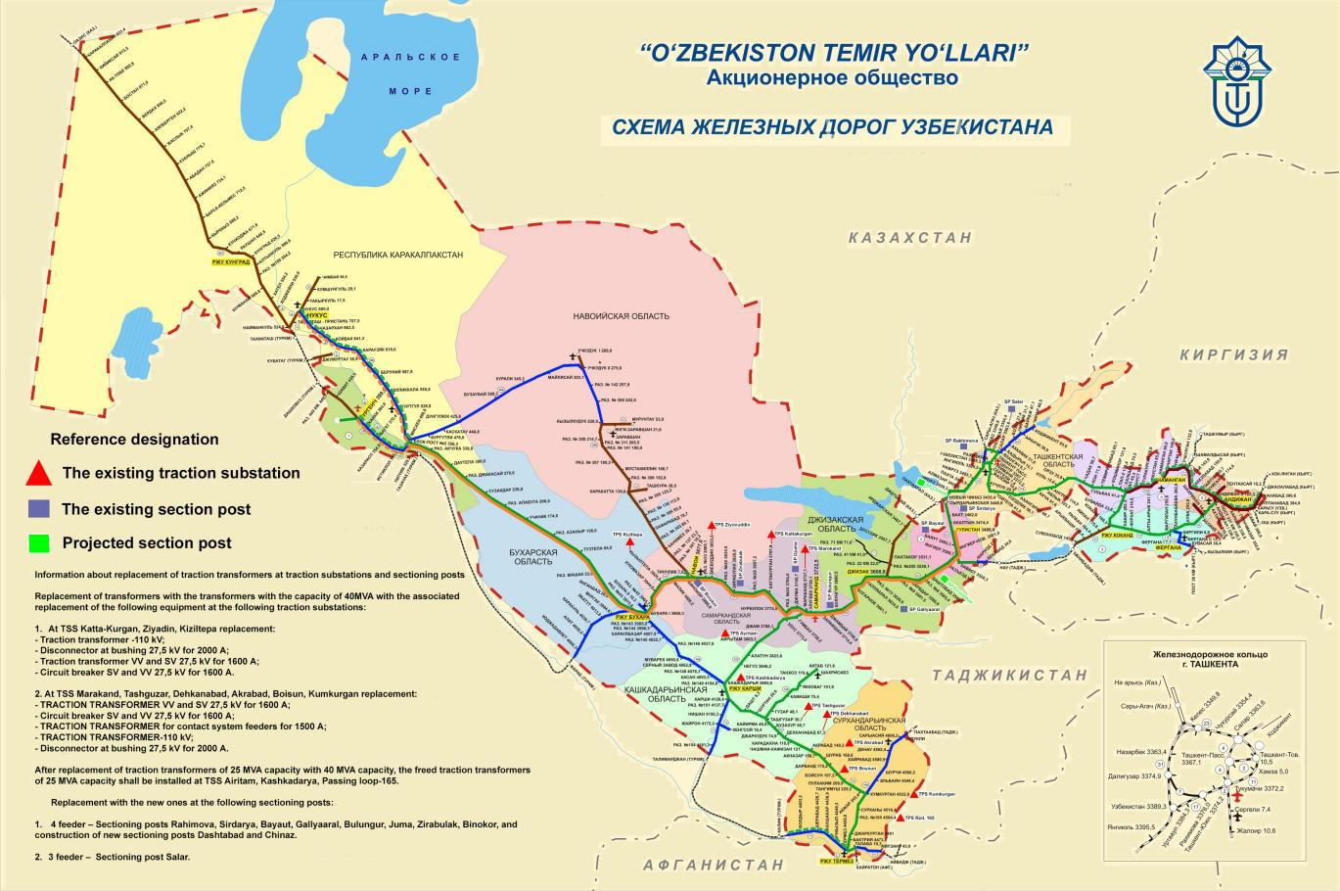
Figure 1: Map of the Uzbekistan Railway Network
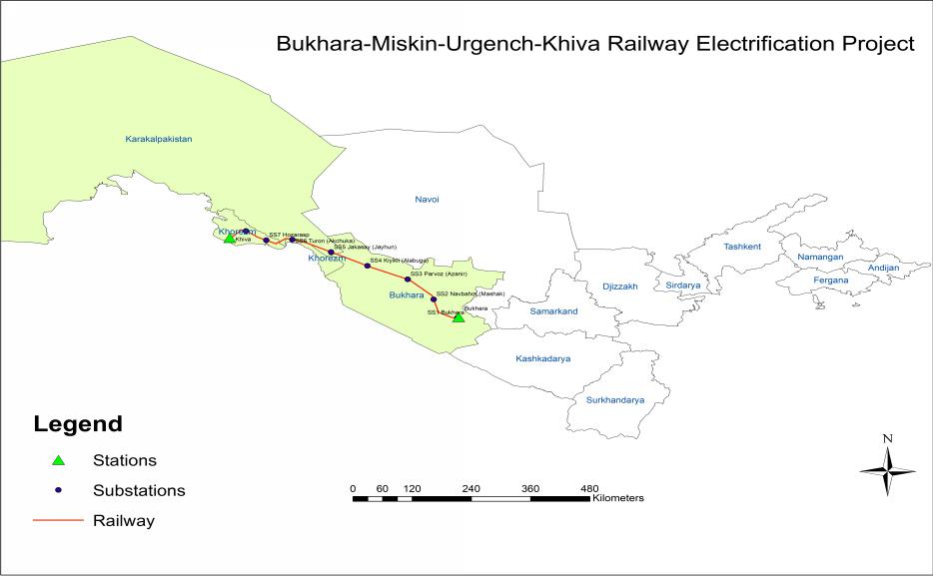
Figure 2: BMUK Railway
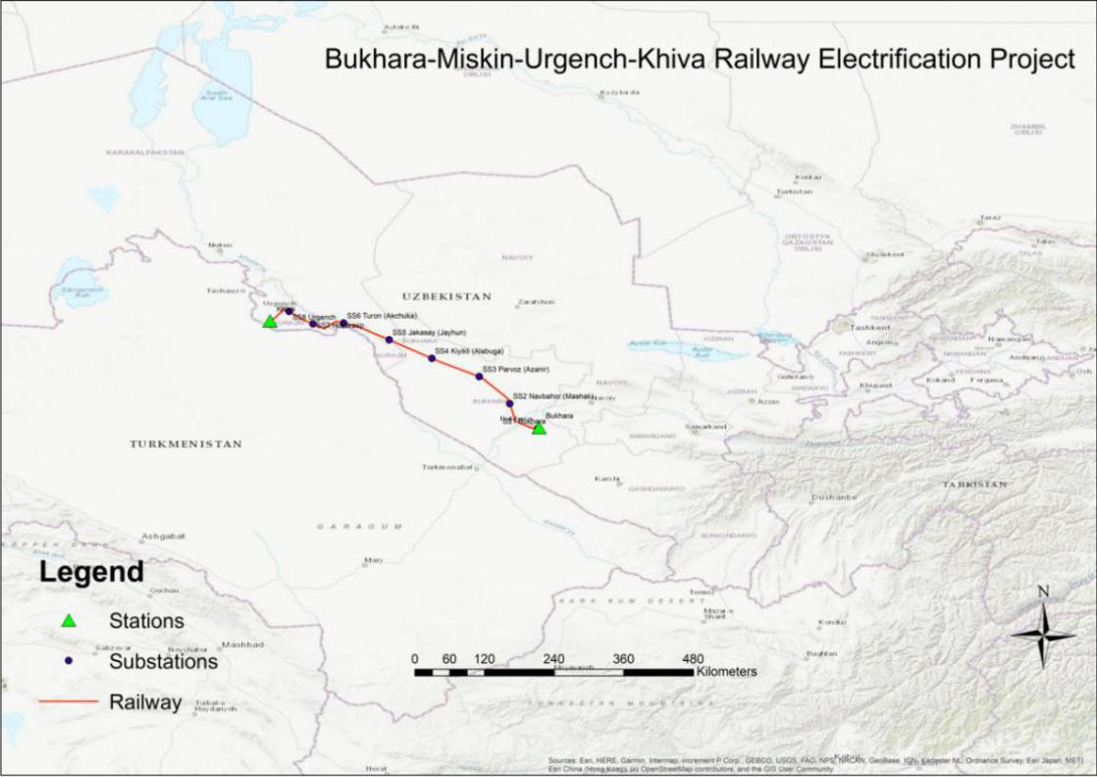
Figure 3: Topographic map of the BUMK Railway

Project Rationale
- The outcome of the project is : railway services for freight and passengers in Western Uzbekistan improved. The project includes two outputs:
  - Output 1: Railway infrastructure along and adjacent the Bukhara–Miskin–Urgench–Khiva line upgraded. This includes (i) construction of 8 traction substations, (ii) construction of 8 section posts, (iii) supply and installation of catenary systems, (iv) supply and installation of signaling, telecoms, and supervisory control and data acquisition (SCADA) systems, (v) construction of external power supply, (vi) purchase of maintenance equipment and machinery, and (vii) procurement of specialized wires for catenary system. In addition, minor upgrades will be made to electrification infrastructure on adjacent lines extending from Bukhara to Tashkent, and from Samarkand to the border with Afghanistan.
  - Output 2: Tourism economic corridor Bukhara–Miskin–Urgench–Khiva developed. The project will support UTY and the government with (i) marketing of railways in conjunction with wider efforts of Uzbekistan to attract tourists, (ii) supporting municipalities along the railway corridor with the development of transit-oriented development around the stations, (iii) supporting municipalities along the railway corridor with a planned, sustainable development of tourism with particular attention to the promotion of the sustainability of new tourist facilities and eco-tourism, (iv) implementation of an electronic ticketing system to allow tourists and domestic passengers easier means of booking tickets, and (v) strengthening of women participation in economic activities related to tourism, for example tourist information centers and sales of local crafts.

- The Asian Development Bank (ADB) and the Asian Infrastructure Investment Bank (AIIB) have both been invited by the Government of Uzbekistan (GoU) and O’zbekiston Temir Yo’llari (UTY) to help co-finance the project.

Details of Project Components covered by this SDDR

- Considering social impact the components were analysed, assessed and subdivided as sub-projects (components) with and without confirmed LAR impacts. Components with LAR impact are covered under two LARPs: LARP 1 for the construction of traction substations and sectioning posts, and LARP 2 to cover external power supply.

- This SDDR covers the project components which were believed to be free of LAR impacts, in particular:
  - Electrification of BMUK railway on the existing alignment, involving (i) installation of catenary system, (ii) installation of signaling, telecommunications, and SCADA systems, (iii) construction of safety fence on each side of the railway within 5 meters width from central line within the existing ROW.
  - Upgrading and providing equipment for the Urgench and Bukhara depots - No LAR Impact - because within UTY owned land.
  - On adjacent railway lines to the BMUK line, upgrading 12 existing traction substations, upgrading 9 sectioning posts and constructing two new sectioning posts on adjacent railway sections, all on existing ROW. The upgrades will primarily be done via the procurement of higher capacity transformers, which will allow higher-output locomotives to be run, and more trains to be run on the route and contribute to higher traffic output on the BMUK line.
- The possible social and LAR impact assessed during the desk study and field surveys confirmed that the scope of all works for the above listed project components will take place within the project right-of-way (ROW), owned by UTY and no social or LAR impact are expected during the entire project cycle in these 3 project components.

OBJECTIVE OF THE DUE DILIGENCE PROCESS

Purpose of Due Diligence

- A Social Due Diligence was undertaken by UTY with the support of transaction technical assistance (TRTA) consultants mobilized by ADB, to (i) ascertain if the components proposed to be funded under the project on existing/associated facilities have past or present safeguards concerns related to involuntary resettlement or will require additional land acquisition and/or resettlement, and (ii) identify any corrective actions required on the part of UTY and the Government with regards to the existing facilities and sites. The consultants paid attention to the assessment of public communication strategy and assessment of public awareness within the project influence area. This social due diligence report (SDDR) summarizes the outcome of this assessment. In addition, the SDDR suggests preventive and mitigation measures for the proposed activities during final design and built operations.

- The SDDR describes the screening activities carried out for the proposed project aiming to determine scope of project impact, identify presence and/or absence of potential social and/or economic impacts and determine appropriate mitigation measures and responsibilities of the project stakeholders.

Methodology Adopted for the SDDR

- The SDDR follows the methodology outlined in the ADB Safeguards Policy Statement (SPS 2009) and relevant laws and regulations of the Government of the Republic of Uzbekistan. The experiences of other studies in preparing SDDR documentation for infrastructure sector have also been reviewed, alongside the experience gained by PIU-ET through the implementation of other similar projects. This SDDR was prepared based on field investigation, consultation meetings with communities within the project influence area, review of available data and information acquired by the UTY and ADB.

- The SDDR covers the description of existing social conditions and impacts of the activities proposed for project construction of four components, assessment of social impact, quality of community consultations, GRM procedures, activities to eliminate temporary disturbance of economic activity of private farms and local population, permanent impact on project affected assets and unexpected impact remedy during the construction works.

- The first field visits were conducted by the National Social Safeguards and Resettlement Consultant on July 10, 2019. During the field visits, Consultants on-site examined the locations both depots in Bukhara and Urgench. The trip on special train carried out on December 3-5, 2019 allowed the Team to travel through the entire ROW of the newly constructed railway and examine all locations and spots that might have raised even a slight concerns in terms of possible social and/or environmental impact risk.

- The resettlement team used the aerial photos (Google maps and KMZ files), land allocation documents of the ROW that helped to identify the boundaries of railway ROW and territory of both depots already owned by UTY.

- During the field trip the TRTA Consultants, representatives of UTY, ADB and AIIB conducted the required surveys based on the current design. In 2020, additional on-site observation visits were undertaken by the National Social Safeguards Consultant and the representatives of UTY. The purpose of these site visits was to double check several specific locations that according to Google Maps hinted on possible impact on some structures, partially located within the boundaries of a sanitary zone of the BMUK railway.

- Social Safeguards Team comprising environment and resettlement experts prepared a Public Information Booklet that contains all relevant information regarding project scope, objectives, eligibility to compensation, GRM, environment protection HSE instruction, including contact details for GRM focal person at PIU-ET. In 24-28 August 2020, 700 copies of the Public Information Brochure were distributed among all Khokimiyats located within project area and Bukhara, Urgench, Miskin and Khiva Railway stations. The Team followed COVID-19 preventative measures on social distancing, facial masks, and use of hand sanitization. The Uzbek version of the Public Information Brochure and photos of booklet distributions are provided at Appendices 7 and 8 respectively.

- The site visits confirmed that all components will be constructed within existing facilities and land already allocated to UTY. Hence, no additional land acquisition or allocation is needed for implementation of the given project.

- In December 2020 the project was added with an additional component aiming to upgrade traction substations and sectioning posts on adjacent sections of railway lines. This mainly involves replacement of transformers with higher capacity (40MVA) ones to provide more electric power to trains. The TRTA Safeguards Team conducted relevant desk study followed with field visits in January 30-Februry 2, 2021. The Team carried out visual observation of each sectioning post and traction substation and confirmed absence of any possible social impact.

- The Team confirmed that land allocation is completed on (12) traction substations and nine (9) sectioning posts. In case of two (2) sectioning posts, land allocation is underway, but preliminarily selected area of land (10 m X 10 m) is located within the territory of existing traction substations. Therefore, in both cases these areas are free from any private use and no APs/AHs are expected.

FINDINGS

Description of the Existing and Associated Facilities

Upgrade of the BMUK line

- The main scope of the project is to electrify the 465 km section of existing railway track between Bukhara and Khiva. This route comprises several subsections which were constructed at different time periods. The below description summarizes the state of each of these subsections, counting from Bukhara and moving westwards to Khiva:

  - The double-line railway track on the section Bukhara – Passing loop 43, with a length of 5.6 km, and further the single-line track from Passing loop 43 in the direction of Hodjadavlet station (near the border with Turkmenistan), were constructed in 1884. The track’s earth embankments, which comprise primarily of loess-like loams and sandy clay, were constructed from soils sourced from local deposits and excavation pits. Over the extended period of operation, the railway track ballast has repeatedly been lifted, with the total thickness of the ballast now reaching up to 90cm. According to survey results of the section Bukhara-km 399 + 000 of the railway carried out by the design institute, the track is however in satisfactory condition.

  - During late 2017, under the project "Construction of the railway line Bukhara-Miskin", the construction of a 342.9 km railway line was completed. On the section from the Passing loop 43 at the 4.5 m intersection to km 398 + 170 (in the direction of Hodjadavlet), a second track was laid to the right of the existing line. From km 398 + 170 in the direction of Miskin station, the track was laid in a new direction.

  - A single-track railway line between Miskin station and Istiklol station, with a length of 26.8 km, was constructed in 2004 under the project “Construction of a new railway line Navoi-Uchkuduk-Sultanuizdag-Nukus and combined bridge over the Amudarya river with railway access tracks and road approaches”, according to category III parameters. The sub-grade (earth embankment) on the right-bank section of the Amu Darya River – consists of sandy soils of lateral reserves and excavations; whereas on the left bank, it consists mainly of sandy clay and loam. The width of the sub-grade is 6.0 m. Over the period 2005 to 2016, the capital repair of the tracks was not carried out.

  - The single-track railway line from Istiklol station to Urgench station was built between 1950-1951. The total length of the main track at the section from Istiklol station to Urgench station is 54.9 km.

  - The single-track railway line Urgench-Khiva was constructed in 2017 through the project “Construction of railway line Urgench-Khiva” as per category I parameters. The sub-grade is primarily sandy clay and loess-type loam sourced from the track side deposits. The total length of the main track is 33.3 km.

- Major parameters of the BMUK railway line are provided in table below.

Table 1: Parameters of the BMUK railway
Name of indicator | Unit | Section Bukhara-Urgench-Miskin-Khiva |  |  |  | Total
 |  | Station Bukhara-km 355+916 | km355+916-km372+240/km341+167 (station Istiklol) | Station Istiklol-station Urgench | Station Urgench-station Khiva
Operational length | km | 347.60 | 15.50 | 55.35 | 33.3 | 451.75
Type of traction power |  | Electric locomotives
Width of sub-grade (earth embankment) at the open line sections | m | 7.6 | 7.6 | 7.6 | 7.6 | -
Railroad intersection with local roads

- guarded level crossings with the crossing obstruction devices (COD) existing) | pc | 14 | 2 | 1 | 11 | 41
- reconstruction of non-guarded level crossings into the guarded level crossings with installation of COD | pc | - | 3 | 10 | - | 13
Source: National Feasibility Study, 2019
- There are ten (10) railway stations between the cities of Bukhara and Khiva: Bukhara, Yangiabad, Yakhshilik, Qorlitog, Hizirbobo, Istiqlol, Hazarasp, Dautepa, Bagat, Hanka, Urgench, and Khiva. Most of the stations are newly constructed or rehabilitated. There are also five passing loops on the alignment: Navbakhor, Parvoz, Kiyikli, Jayhun, and Turon. Telecom systems, signaling systems, and SCADA systems will be installed at all stations and passing loops.

- More than two-thirds of the alignment passes through desert areas. The alignment also passes through settlements in areas close to Bukhara Urgench, and Khiva cities in Khorezm Province.
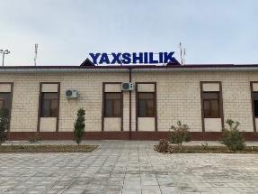 | 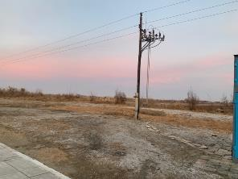
Yakhshilik station in Bukhara province | Outskirts of Yashlik station
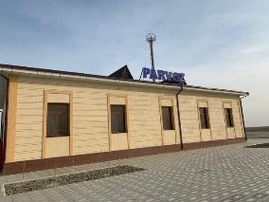 | 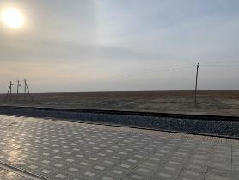
Passing Loop Parvoz | Outskirts of Parvoz Passing Loop
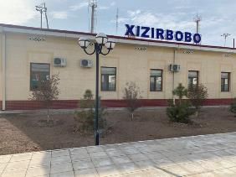 | 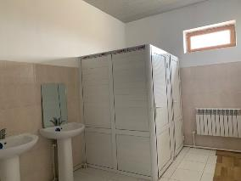
Hizirbobo station | Sanitarian facilities at Hizirbobo station
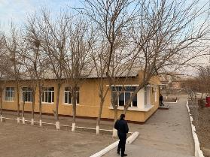 | 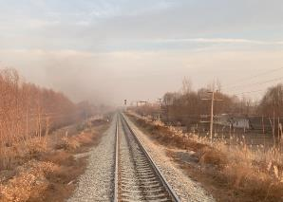
Hazarasp station | Railway to Hazarasp station
Figure 4: View of railway stations

- In general, the existing ROW covers at least a 10 meter distance from the center of the single railway line in each direction. However at certain locations with higher population density, a narrower ROW was put in place to avoid unnecessary resettlement at the time the railway was constructed.

- Through the project, (i) installation of catenary system, (ii) installation of signaling, telecommunications, and SCADA systems, (iii) construction of safety fence will take place, all within this existing ROW.

  - Installation of catenary system involves the installation of poles on either side of the railway including four branch lines adjacent to the main line, all will be located within the existing ROW of the present railway line. No involuntary resettlement impact is anticipated during the construction phase.

  - For installation of signalling, telecommunications and SCADA systems, works include the digging of approximately 50-70 cm deep trenches for the installation of cables within the ROW.

  - Safety fences will be erected at a distance of 5m from the center line.

- Due diligence revealed however one possible additional LAR impact which may be caused by the project, if not designed well. This involves the installation of so-called “DPR” lines, which are electric cables used to supply stations and other facilities with electricity. DPR lines are typically installed on arms which protrude in the opposite direction of the catenary which feeds the trains with electricity (Figure 5). According to the local regulations, DPR as any other electrical line have special safety requirements, particularly: the edge of DPR line must have a distance of 4 meters from the nearest building (roof, balcony) horizontally and 3 meters vertically.

- Taking into account also the length of the DPR itself, the total safety zone from the railway axis in case of DPR hanging is almost 9.5 meters in average = 3.3m (distance of installed pillar from the axis of railway) + 0.5m (length of pillar) + 1.70m (length of the DPR) + 4m (safety distance from then edge of DPR line). Within this safety zone of 9.5 meters, no residential buildings and structures can be constructed. In order to ensure the keeping of 10m buffer zone (5m from the axis into two sides), additional technical inspections have been conducted to adjust the design of DPR in populated areas and minimize the impact.
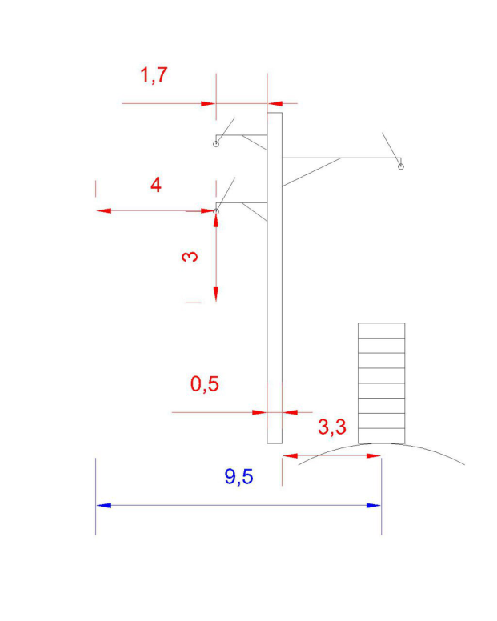 | 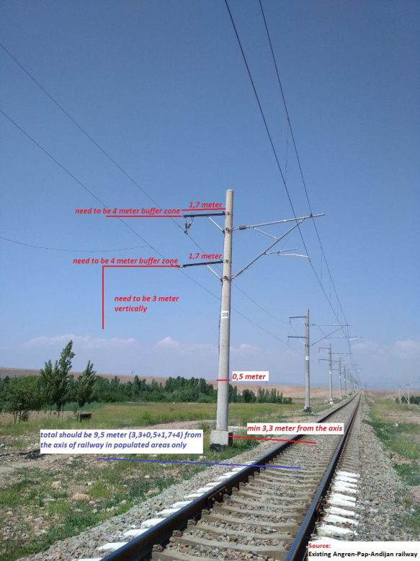
Figure 5: Norms for installation of DPR
- The Safeguard Team used the final detailed design schema with location of pylons which was superimposed on Google Maps in order to detect any possible impact to private assets or structures. While working on assessment of social (IR) and environmental aspects of construction of catenary system the Social Team prepared Google KMZ files with the installation of buffer zone 9.5 m from the axis of the railway. According to the detailed analysis, 33 structures (excluding UTY structures) were identified within the 9.5 meter buzzer zone required for electric pylons to be installed for electrification of BMUK railway.
- In coordination with UTY-PIU the TRTA Safeguards Consultants submitted to Design Institute the electronic and hard copy of the materials describing these 33 structures considered as potentially affected.
- The follow up meetings were held with Design Institute in order to discuss the emerged potential threats and find possible solutions to completely eliminate any impacts to structures and avoid physical resettlement.
- The potential impact risks were analysed and mitigation measure suggested by Design Institute was further reviewed and specified. The solution provided by the Design Institute is to select vacant area for each and every pylon to be placed on land vacant free from any permanent or temporary structures or any assets.
- Specific attention was paid to two (2) locations (hereinafter referred as point # 3 and point # 4) where some structures are located opposite to each other on both sides of the railway.
- Design institute examined these locations on design drawings and defined that these structures are not located straight opposite to each other that allows instillation of pylons further from these structures without causing any impact.
- The Design Institute confirmed in written format and accepted this solution as feasible and efficient mitigation measure to fully eliminate any possible risks of impact to structures located in vicinity and within the railway project ROW.
- The Design Institute confirmed the following:
  - All electrification structures are located in the right of way will be intentionally identified (determined) during the process of construction of railway electrification line.
  - In order to avoid resettlement of people and demolishing of structures along the high speed railway line, during development of the design, the contact system masts will be located on the side of track where there are no buildings, at the sections specified by ADB experts.
  - Points 3 and 4 are not residential buildings. Point 3 is signalling cabinets and two-wire rail line 27.5kV going above this structure does not interfere safety rules and will not require demolishing of the structure.
  - For the purpose of construction of the designed fencing in the right of way there is a free space at the distance of more than five (5) meters of the track axis.
- As a result, LAR impacts were avoided and project activities in the 3 project components are confined within the available ROW.

Bukhara and Urgench Depots

- Similar to current arrangements, the 465 km long BMUK railway after electrification will be served by locomotives from the Bukhara and Urgench depots.

- The traction of trains on this section area is currently provided as follows:
  - for passenger traffic:
- by diesel electrics TEP70 of the Urgench depot under the shoulder scheme on the Urgench – Miskin section, with the replacement of locomotive crews at Miskin station;
- by diesel electrics TEP70 of the Bukhara depot on the Miskin – Bukhara section, with the replacement of locomotive crews at Miskin station.
  - for freight traffic:
- by diesel electrics 2TE10M, 3ТE10М of the Urgench depot under the shoulder scheme on the Urgench to Miskin section, with the replacement of locomotive crews at Miskin station;
- by diesel electrics 2TE10M, 3TE10М of the Bukhara depot on the Miskin – Bukhara section is provided with the replacement of locomotive crews at Miskin station.

- The maintenance of TO-2 and equipment operating in the Bukhara, Miskin, and Urgench depots. The current repair of TR-1 and maintenance of TO-3 diesel electrics is carried out in the Bukhara and Urgench depots. The main data of the locomotive stock and the list of existing buildings and structures is provided in table below.

Table 2: The main data of the locomotive stock

No. | Name of buildings and structures | Production capacity, brief characteristics  (building dimensions, number of bays)
 |  | Bukhara depot | Urgench depot
1 | Depot ТО-2 and servicing | 51,2x24x9 м | 48х24х9м
2 | ТО-3 shop of train locomotives | 61х24х11,5 | 49х27х12,2
3 | ТР-1 shop of train locomotives | 61х24х11,5 | 60х24х15,5
4 | TО-4 shop | 45х7,0х7,5м | -
5 | Number of repair bays | 3 | 3
6 | Diesel fuel warehouse, m³ | 5000 | 3000
7 | Oil warehouse, m³ | 450 | 360
8 | Dry sand warehouse, m³ | - | 1000
9 | Sand drying device, m³/day | 20,0 | 20,0
10 | Rest house for locomotive crews, pc./places | 1/36 | 1/48

- Description of activities planning under the project in Bukhara and Urgench depots is provided in below table.

Table 3: List of activities planned under the project component

No | Name of designed and reconstructed buildings and structures | Note
Urgench Depot
1. | Reconstruction of LMD (Locomotives maintenance depot)  (Shop TO-2 and servicing) for maintenance of electric locomotives (platforms for maintenance, installation of machine for wheel-set turning without roll-out). | plan dimensions  48x24x9 m
Bukhara Depot
2.  3. | Installation of technological equipment in the shops TO-3 and TR-1 for maintenance of electric locomotives.  Reconstruction of the building of TO-3 shop (platforms for maintenance of electric locomotives) | plan dimensions  61х24х11,5 m

- The maintenance shop TO-2 and servicing of electric locomotives with control vision system (CVS) at the Urgench depot is designed for the basic maintenance of locomotives between the planned inspection and maintenance during operation phase. The technical inspections of locomotives are combined with the servicing of equipment: sand supply, grease and cleaning materials.

- The reconstruction of the TR-1 and TO-3 workshops in the Bukhara locomotive depot is necessary for electric locomotive maintenance, including the installation of 4.2 m height platforms for the inspection and maintenance of auxiliary equipment located on the roof of the electric locomotives.

- The project includes procurement and installation of equipment for electric locomotive maintenance and its installation in the Bukhara and Urgench depots. Other civil works regarding workshop rehabilitation and construction of additional platforms will be implemented utilizing the UTY’s funds.

- Since Bukhara and Urgench depots are already operating facilities, and only some project activities will be implemented there, social audit was conducted in both depots. The results of social audit confirmed that no land acquisition is required for reconstruction of depots. Therefore, no LAR impacts are expected as a result of the project activities at the Bukhara and Urgench depots.

- Bukhara depot is located on 2.6 ha and is fully fenced. The territory of Urgench depot occupies 10.05 ha of fully fenced territory. Both depots are equipped with persons employed in managerial posts and specialized maintenance staff, involved in the regular maintenance and repair of locomotives and machinery equipment at the depot facilities. In both depots the staff operate in shifts, and are provided with food and lodging. Social aspects are managed by Occupational Health and Safety Engineer at the same time responsible for implementation of OH&S requirements in each depot.

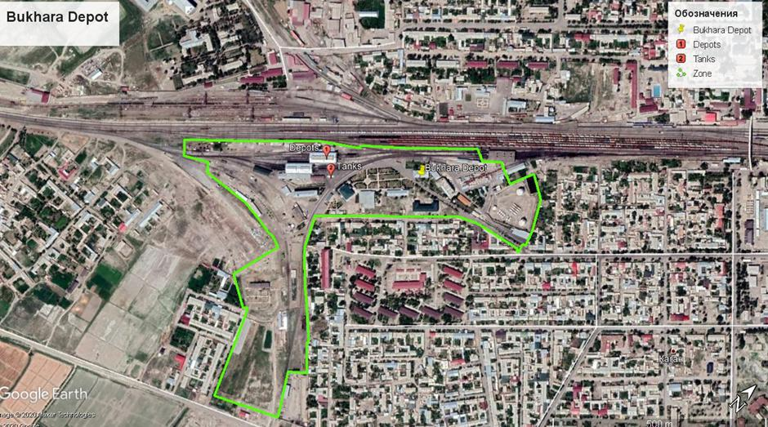
Figure 6: Location of Bukhara depot

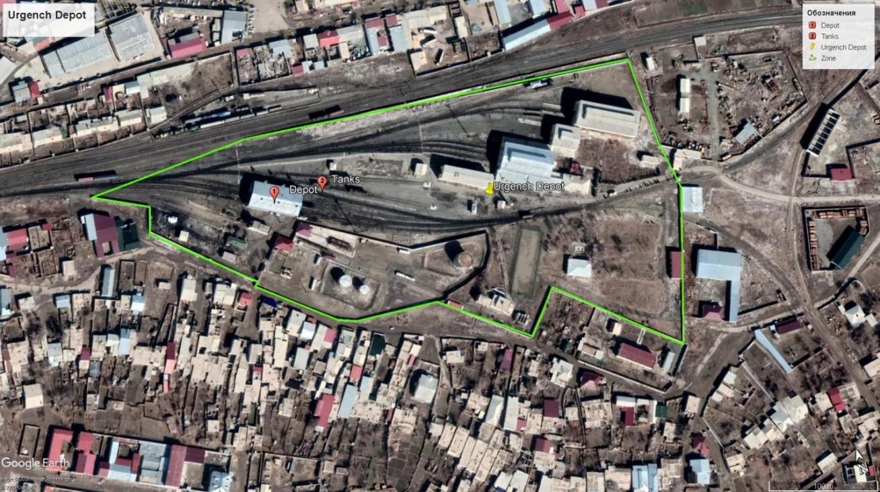
Figure 7: Location of Urgench depot

Small works on traction substations and sectioning posts on adjacent railway sections
- Small works on 12 traction substations and 11 sectioning posts will take place in those locations as shown in Table 4, and will mainly involve the replacement of electric transformers with higher capacity ones.

Table 4: Location and land allocation status of Section Posts and Traction Substations subject to replacement for capacity upgrade purposes

# | Substation | Type | Province | District | Land allocation | Area, (ha)
 | Salar | Section Post | Tashkent | Tashkent city | Yes | 0.47
 | S.Rahimov | Section Post |  |  | Yes | 0.012
 | Chinaz | Section Post |  | Chinaz | No | Not built
 | Syrdarya | Section Post | Syrdarya | Syrdarya | Yes | 0.0025
 | Bayaut | Section Post |  | Bayaut | Yes | 0.008
 | Dashtabad | Section Post | Jizzakh | Dashtabad | No | Not built
 | Gallaaral | Section Post |  | Gallaaral | Yes | 0.025
 | Bulungur | Section Post | Samarkand | Bulungur | Yes | 0.026
 | Marokand | Traction  SubStation |  | Pastargon | Yes | 0.78
 | Juma | Section Post |  |  | Yes | 0.025
 | Kattakurgan | Traction  SubStation |  | Kattakurgan | Yes | 0.97
 | Zirabulok | Section Post |  | Narpay | Yes | 0.024
 | Ziyadin | Traction  SubStation |  | Pakhtachi | Yes | 0.98
 | Binokor | Section Post | Navoi | Karmana | Yes | 0.025
 | Kyzyltepa | Traction  SubStation |  | Kyzyltepa | Yes | 0.55
 | Ayritam | Traction  SubStation | Kashkadarya | Chirokchi | Yes | 0.78
 | Kashkadarya | Traction  SubStation |  | Karshi | Yes | 0.81
 | Tashguzar | Traction  SubStation |  | Guzor | Yes | 0.89
 | Dekhkanabad | Traction  SubStation |  | Dehkanabad | Yes | 0.83
 | Akrabat | Traction  SubStation |  |  | Yes | 0.83
 | Boysun | Traction  SubStation | Surkhandarya | Boysun | Yes | 0.9313
 | Kumkurgan | Traction  SubStation |  | Kumkurgan | Yes | 0.79
 | Razezd 165 | Traction  SubStation |  | Jarkurgan | Yes | 0.96
Total: 23 |  | Section Post-11 | 7 | 20 | - | 10.72
Traction
SubStation-12

- The Social Safeguards Team of the TRTA Consultant, composed by Ms. Madina Khalmirzaeva (Environment Specialist) and Mr. Mamanbek Reimov (Social Safeguards and Resettlement Specialist) conducted thorough desk study of available materials.

- The desk study confirmed that activities requiring upgrade of sectioning posts and traction substation will not require acquisition additional land from private users, or possessors. The area of land allocated to the existing sectioning posts and traction substations are sufficient and no extra land is required for the replacement of transformers. Therefore, the results of desk study have already confirmed that new land acquisition is not required for project purposes.

- To ensure the desk study results were accurate and reliable and exclude the possibility of any social impact, the TRTA Team conducted field visits from 30 January to 2 February 2021.

- The team carried out visual observation of each sectioning post and traction substations and ensured that none of these locations are, and will not be used by private persons, as these objects are mainly located in deserted area, far from settlements, and in addition these objects are protected with standard metal bars, installed around these objects including sanitary zone (for health and safety purposes).

- The results of desk study and field visit confirmed absence of any social /LAR impacts in all 23 locations of sectioning posts and traction substations selected for works. The information on the replacement of traction transformers at traction substations and sectioning posts are provided in Appendix 9.

Basis of Assessment

- The impact assessment survey for this SDDR was carried out based on the exiting design for electrification of BMUK railway. The following provided the basis for the assessment:

- Assessment of Required buffer and sanitary zone for the railway Land: The final detailed design schema with location of pylons have been superimposed on Google maps in order to detect any possible impact to private assets or structures.

- Normative Basis: The social impact assessment of the proposed project was carried out in accordance with the UZB regulations and norms for construction and operation of railway electrification lines; particularly:

- The Government KMK 2.10.08-97 (1997) provides standard and guidance for design, construction, and operation of transmission line particularly having a voltage of 0.4-500 kV with its requirement for permanent and temporary land acquisition for transmission line.
- Resolution of COM № 93 on “Rules of protection of transmission facilities” (17 May, 2010) provides safety rules for TL protection, and
- The Government requirement “СанПин РУз” N 0236-07 (2007) provides sanitary norms and safety regulations for the population living near the high voltage transmission lines.

- According to the above regulations, the impacts on land acquisition and involuntary resettlement are categorized as permanent impacts only in terms of land acquisition within the 10m corridor (5m from the axis into two sides) buffer zone for electrification of main track Bukhara-Miskin-Urgench-Khiva (452 km) in case of 27.5 kV voltage of the transmission lines (KMK 2.10.08-97, Table 1) . For the safe operation of TLs sanitary-safety zone of the same 5m is required for the population living near the high voltage transmission lines.

- National legislation defines the rules of acquisition privately used land and assets for the purposes of public and state needs and determines principles for valuation and compensation at full replacement value of all project affected assets (land, structures, perennials) after the valuation report prepared by appraisal companies at the expense of an applicant.

- Resolution of Cabinet of Ministers № 146 (25 May 2011) is aimed at improving the procedure for granting land plots, protecting the rights of legal entities and individuals on land, improving the architecture of settlements and the efficient use of their land for construction in accordance with the Land Code and the Town Planning Code. This resolution has approved two Regulations: (i) Regulation on the procedure for granting land for urban development and other non-agricultural purposes, (ii) Regulation on the procedure of compensation for land possessors, users, tenants and owners, as well as losses of agriculture and forestry.

- The results of the above-described examinations and studies were undertaken based on the final approved design by the Social Safeguards Consultants and the representatives of the UTY. These activities permitted determination and confirmation of the scope of project impact and to develop relevant mitigation measures to be undertaken during the construction works.

- The studies and examinations undertaken by the Consultant and PIU-ET, confirmed that the component will not cause any additional impact on privately utilized land or assets. Therefore, no new cases of physical resettlement or economic displacement are expected as a result of the proposed civil works.

Categorization of the Project

- In accordance with ADB’s 2009 Safeguard Policy Statement, the project is categorized as “B” for Involuntary Resettlement Impact.

- No Indigenous People Plan is required as no impact on indigenous people is confirmed within the scope of the entire project neither for the specific sub-project of BMUK railway electrification and reconstruction of Bukhara and Urgench Depots.

Confirmed Absence of Additional LAR Impacts on Existing and Additional Facilities

- The due diligence confirmed that no past, pending or future IR/LAR impacts and additional impact is expected from the 3 project components summarized in the table below.

Table 5. Summary of Component, Facilities, and LAR impact

# | Component | Province | District | Name of Facility | LAR impact | Land allocation
a | Electrification of BMUK railway | Bukhara, Khorezm, Republic of Karakalpakstan | Kagan,  Rumitan,  Peshku,  Turtkul,  Tuproqkala,  Hozarasp,  Urgench | Railway | No | UTY RoW zone
b1 | Reconstruction of Bukhara depot | Bukhara | Kagan | Bukhara Depot | No | Existing Depot (exiting facility) attached to UTY land
b2 | Reconstruction of Urgench depot | Khorezm | Urgench | Urgench depot | No | Existing Depot (exiting facility) attached to UTY land
c | Small works on traction substations and sectioning posts on adjacent railway sections | Tashkent, Syrdarya, Jizzakh, Samarkand, Navoi, Kashkadarya, Surkhandarya |  | Traction substations and sectioning posts | No | Existing traction substations

- During the field surveys, the TRTA Consultants examined all data available with UTY regional offices and compared with the information available at the local Cadaster office. Appendix 2 provides the names, positions and contact details of project stakeholders met during preparation of this SDDR.

- However, if for any reason an impact will be triggered in these components before the completion of civil works and the construction of the entire project, that will entail any new land acquisition needs or loss of privately utilized assets causing loss of income, the civil works in the component/section with unanticipated/emerging LAR impact will immediately be suspended until a corresponding corrective action plan (CAP) is prepared, disclosed and agreed with the UTY and ADB and implemented.

- Relevant on-site surveys will be conducted that will include DMS census and SES of DPs, demarcation of land allocation, inventory of all project affected assets and valuation for the determination of estimated amount of cash compensation for all eligible DPs. Entitlements and provision of support to all eligible DPs will follow the provisions and standards in the approved LARPs under the project.

- Construction works will be continued once the approved CAP implementation is completed and relevant compliance report prepared.

- To ensure that the Project fully complies with ADB SPS 2009 requirements, the Consultant provided additional training to PIU-ET designated staff in the project area. In addition, PIU-ET, if needed, will be assisted in the process of establishing GRC at Khokomiyat levels. The GRCs will maintain grievance logs and the GRC members at local level will accept and process if any grievances or complaints are raised in relation to any component of the Project.

- The results of provided training, establishment of GRCs on PIU-ET and Khokomiyat levels, information disclosure and consultation activities conducted, and any emerging/unanticipated social impacts during the implementation of the Project will be described in the semi-annual social monitoring reports to be submitted to ADB for review and disclosure.

RECOMMENDATIONS AND CORRECTIVE ACTIONS

- The findings of the SDDR referring to the absence of IR impacts will be reconfirmed following the detailed design.

- The following major activities will be carried out during the entire project cycle.

Information Disclosure, Stakeholder Engagement and Grievance Redress

- UTY is requested to continue stakeholder engagement and information disclosure during the course of project implementation. The objectives of the stakeholder consultation process are to disseminate information on the project and its expected impact and outcome among primary and secondary stakeholders and to gather information on relevant issues so that the feedback received can be used to address prevailing issues at the early stages of project design. Another important objective is to determine the extent of the concerns amongst the community, to address these at the project level and to suggest appropriate mitigation measures on any adverse impacts at the earliest stages of project design.

- The plant contractors are in charge of regularly disseminating information within the project influence area on pending works, project related schedule, health and safety measures to be followed during the civil works and operational phase.

- The following information shall be disclosed in public places to keep local population aware of the different activities under the Project:
- Public Information Brochure
- Information about the proposed project needs and benefits
- GRM mechanism and it benefits in the process of grievance redress and timely resolution of any social and/or environmental complaints
- Environmental issues
- Schedule of civil works
- Contact details of GRC at Khokomiyat level
- Any important information during the project implementation and operation phase.

- Grievance Redress Mechanism. The APs will have the right to file complaints and query any aspect of land acquisition compensation and resettlement. PIU (UTY) acts as the GRM secretary to make sure that the GRM is operational to effectively handle environmental and social concerns of project affected persons. PIU will ensure that grievances and complaints on any aspect of the land acquisition, compensation, and resettlement are addressed in a timely and satisfactory manner. All possible avenues are made available to the APs to resolve their grievances at the project level. Under the established project level grievance mechanism, affected households may appeal any decision, practice or activity connected with the assessment or valuation of land or other assets, acquisition and compensation. After discussion with all parties, the following multi-level GRM is proposed for the project and is described below in Table 6.

Table 6: Grievance Redress Cycle
Level/Steps | Process
Level 1- any station of railway BUMK or khokimiyat | The aggrieved person applies to any station of railway BUMK. Head of station or designated officer will be in charge for receiving and registration complaints. PIU representatives at the construction site will collect information about received complaints from supervising stations on daily base. The alternative entry point for complaints will be also khokimiyats due to their obligations defined by national legislation: (i) khokimiyats of the respective rayons (cities) are obliged to notify owners of residential, production and other buildings, constructions and plantings on the made decision in writing for signature not later than six months prior to demolition, (ii) there is a 1st deputy of khokim responsible for industry, capital construction communications and utilities, who is usually responsible for any issues/complaints regarding the construction and land allocation; he works closely with the head of stations, and in case of complaints they will inform each other.  After registration of received complaints, PIU representatives will review nature/specificity of the complaint and will forward it to relevant party for resolving. In parallel, PIU representative will inform PIU in Tashkent about received complaint and further actions undertaken for its solution. Depending on nature of complaint it may go to Contractor, Land Cadastre, Mahala or district branch of Nature Protection Committee. For example, complaints related to resettlement issues may be forwarded to Land Cadastre, Khokimyiat and Mahallas. In case of environmental issue, compliant will be forwarded to Contractor or District Nature Protection Committee. PIU representatives will be assisted by EWS consultant and PIU’s Safeguards Specialist in GRM implementation. At this level complaint should be resolved during 2 weeks.
Level 2 - UTY’s secretariat in Tashkent | In case the grievance was not redressed on the first stage or applicant is not satisfied with the decision made/solution, s/he can submit the grievance directly to UTY’s secretariat in Tashkent. In accordance with established procedure, the secretariat will review the compliant and will forward complaints to respective department to made decision on its redress. In case the grievance is not related directly to the project, the further instance will be recommended to the applicant where s/he should apply for the decision making.  In case, if the compliant is required more time and resources for resolution, the UTY may establish complaint handling team with following members such as representatives from UTY area representative office, district Khokimyiat: cadastral department and Mahalla or village assembly of Citizens or/and farmer’s councils, or/and women association. All complaints will be resolved in 15 days, and in case additional details are required, a maximum of 30 days will be used to resolve and close the complaint with prior notification of complainant.

- Grievance Redress Commission. During the entire project cycle a Grievance Redress Commission (GRC) shall be kept operational to address timely social and/or environment issues if any are raised during the civil works. During the implementation of the project, any complaints from the local population will be considered through the grievance redress mechanism established within the framework of the project and applied to both social and environmental protective measures. The GRC shall correspond to the GRM and consist of:
- Level 1: Head of station, and representative of the relevant Khokimiyat/ Makhalla or village assembly of Citizens or/and farmer’s councils, or/and women association
- Level 2: Head, PIU-ET, Safeguards officer, PIU-ET and Representative of the relevant Khokimiyat/ mahalla or village assembly of Citizens or/and farmer’s councils, or/and women association

- Accountability Mechanism. The aggrieved persons can also use the ADB Accountability Mechanism (AM) through the direct citizens’ application to the Headquarters in Manila, particularly to the Complaints Receiving Officer, Accountability Mechanism, Asian Development Bank Headquarters 6 ADB Avenue, Mandaluyong City 1550, Philippines Email: amcro@adb.org , Fax +63-2-636-2086. AM is the last resort and ADB has its availability as a recourse in case other mechanisms for dealing with harmful project effects are not successful. GRM is required by SPS and the use of project level GRM should be encouraged as first recourse.

Monitoring and Assessment

- PIU-ET and the Engineering and Works Supervision Consultant under the loan shall perform monitoring of the project implementation and ensure that established GRC is fully accessible to communities within the project affected area.

- Completeness and regularity of information update within project influence area shall be routinely monitored by designated staff of the PIU-ET in relevant Khokimiyats.

- The Engineering and Works Supervision Consultant under the loan shall assist PIU-ET with conducting internal monitoring and the preparation of monitoring reports, in particular, the preparation and submission of monthly progress reports, and semi-annual social monitoring reports.

- Semi-annual social monitoring reports in English will be uploaded to the ADB’s website, while the Russian version will be uploaded on the official website of UTY.

- Regular monitoring will be undertaken by the Engineering and Works Supervision Consultant under the loan and UTY. Monthly progress reports and semi-annual social safeguards reports will cover the process of electrification and reconstruction of depots and related social issues, if any are raised during the civil works, to keep UTY abreast of these issues in the course of actions and work progress.

- No involuntary resettlement impact is anticipated in the 4 components during the construction phase due to the project activities mainly involving the installation of signaling equipment within the ROW of the existing railway lines. All civil works will be organized in a way that no new impact will be incurred by any person and/or farmer using land parcels in the vicinity of project influence area.

- During construction, all necessary measures will be taken to avoid temporary impacts such as loss of access leading to livelihoods or any other types of restrictions mentioned above. The PIU-ET and Consultant will closely monitor the implementation phase to ensure compliance with ADB's social safeguard measures, as well as national legislation.

- If any unforeseen impacts or additional consequences are identified during the course of the project implementation requiring acquisition of land/assets under private use, the PIU-ET will prepare a corresponding corrective action plan (CAP) in accordance with the ADB SPS 2009, as well as relevant national legislation. Until such planning documents are developed, reviewed, approved and disclosed by ADB, PIU-ET will not commence implementation of any specific component or section in which the consequences of involuntary resettlement have been identified.

- The completion of CAP implementation will be documented through a CAP implementation compliance report(s) prepared by ADB consultants and approved by ADB.

- Engineering and Works Supervision Consultant /PIU should work closely with all DPs in weekly base and all DPs (who are entitled for compensation) should write the official statement indicating bank account details to UTY/Khokimiyat, consultant forwards it to UTY for the payment procedure to commence through the accountancy department.

Appendix 1. Institutional Arrangement

- Country legislation lists State Agencies and Institutions responsible for project implementation including involuntary resettlement, land acquisition and compensation procedures are as follows:

- Regional and rayon Khokimiyats;
- Regional Committee on land acquisition;
- Regional department of the State Committee of the Republic of Uzbekistan on Land Resources, Geodesy, Cartography and State Cadaster;
- Regional valuation committee;
- Regional department of the State Committee of the Republic of Uzbekistan for Nature Protection;
- Regional sanitary-and-epidemiologic services;
- Regional fire inspection agency.

- These institutions have all appropriate opportunities and authorities to implement measures on resettlement and compensation of losses issues. Project implementation will not require any activity to improve their institutional potential.

- Apart from the above listed State Agencies, non-governmental organizations (NGO) and Makhalla can be involved in resettlement procedures in order to ensure guarantees of rights and interests of displaced persons.

Legal Framework Regulating Involuntary Resettlement

- Procedures, functions and authorities of organizations which are responsible for implementation of acquisition of land for non-agricultural purposes are determined by the RCM of the RUz #146 as for 25.05.2011 “On measures of improvement of the order of land acquisition for town planning and non-agricultural purposes”.

- The architecture and construction of the region (city) department:

- Prepare an offer on allocation of a land plot with indication of its total area, situation of buildings and constructions, location of pipelines and networks;
- Prepare documents on allocation of a land plot (layout of a land plot, draft of the general layout of arbitrary scale, photographs (15x20) of a land plot coupled with surrounding objects);
- Co-ordinate documents on sitting and conditions of acquisition of a land plot with legal entities or individuals whose land plots are seized, with superior authorized bodies whose land plots are seized, with the land resources and state cadaster, nature protection, state sanitary and fire inspection committees, if a land plot located at irrigated areas then with agricultural and water resources committees;
- Prepare the following documents:

- documents on allocation of the object, the map with borders of a land plot, reports of organizations where documents on sitting are matched, the list of displaced persons with indication of people who would like to obtain new land plots or apartments, the list of houses and constructions that should be demolished;
- the act determining other losses of owners, users and tenants of land plots and damages of the agricultural and forestry production (if it is required);
- the act of the technical inspection of a land plot if it is seized from the forestry production land ownership (if it is required);
- The report of the State Committee of the Republic of Uzbekistan for Nature Protection;
- The report on compliance of sitting with land laws prepared by the land resources and state cadaster of the region (town) department;
- Documents on matching of documentation with legal entities and individuals whose land plots should be seized.
- Monitor the construction project sequence;
- Prepare documents on acquisition of a land plot on a contractual basis with the legal entity or individual;
- Implement drawing borders of a land plot;
- Prepare documents on the right to use land plots.

- State Committee for Architecture and Construction (regional/rayon department) co-ordinates documents on site location.

- The State Committee of the Republic of Uzbekistan on Land Resources, Geodesy, Cartography and State Cadaster:
- Calculate cost of works on allocation of land plots, preparation of documents on sitting and acquisition of land plots;
- Calculate the extent of damages of owners, users and tenants of land plots and losses of agricultural and forestry production;
- Implement programs and measures to improve soil fertility, rational and effective usage and protection of land.

- The Committee on acquisition of regional land plots consider documents on sitting. Draw up a report that includes the following points:
- The list of members of a committee taking part in the meeting;
- Information on presence or absence of buildings and constructions, irrigation and drainage networks, pipelines and network systems, permanent planting;
- Calculation of damages of owners, users and tenants of land plots and losses of agricultural and forestry production (if it is required);
- Description of a land plot;
- Determination of growth class of agricultural land in accordance with it owners, users and tenants;
- Information on provision of individuals with land plots for building houses and other constructions within the resettlement bounds;
- Conditions of allocation of land plots according to the nature protection and cultural heritage requirements;
- Land reclamation issues;
- Removal of fertile soil (if it is required);
- Other issues at option of the committee members;
- Committee report, and
- Consider documents on acquisition of a land plot.

- Regional (municipal) Khokimiyats:

- Ratify sitting for designing;
- Make a decision on acquisition of a land plot with indication:

- to whom, for what purposes and what terms (if acquisition of land is temporary, a particular term is indicated) a land plot is seized and also name of owners, users and tenants whose land plots are seized;
- total area of allocated land plots according to its owners, users and tenants and also quality (growth class) of seized agricultural acres;
- the amount of losses that should be compensated to owners, users and tenants of land plots (if it is required);
- the amount of losses of the agricultural and forestry production (if it is required);
- necessity of reclamation of a land plot, the order of its return to owners, users and tenants whose land plots were seized;
- necessity of removing of fertile soil;
- water protection, ecological, fireproof, sanitary and other requirements.

- Ratify the layout of land plots’ borders.

- The Council of Ministers of the Republic of Uzbekistan ratifies the decision of the regional (municipal) Khokomiyat on acquisition of a land plot.

- Independent valuation committee calculates losses of land owners and users and losses of the agricultural and forestry production due to acquisition of land for governmental and public needs.

- State Committee of the Republic of Uzbekistan for Nature Protection:

- holds ecological assessment expertise of adverse effects from launching objects or introducing technologies
- ratifies object’s location that have adverse effects on soil fertility, and
- elaborates land protection measures in case of necessity to allocate, design, construct and start-up new or reconstructed objects, constructions and also necessity to introduce new technologies that have adverse effects on the land fertility.

- Thus, the major part of the acquisition and allocation of a land plot procedures is implemented by the architecture and construction of the region (town) department, “Uzdaverloyiha” subdivisions and land management services according to the “one window” principle.

Appendix 2. Meeting with Project Stakeholders

The table provides the summary of the representatives of State Agencies at national and local level which the Social Safeguards Team of TRTA met with during the SDDR preparation process.

Table 7. The meetings with project stakeholders during the SDDR preparation
No | Date | Name | Position | Actions | Contact  Phone
1 | August 8, 2020 | Mr. X.M.Malikov | Technical director of  Design Institute | Development measures to eliminate any potential risks of IR /LAR impact within BMUK railway ROW
2 | August 26, 2020 | Doston Matyakubov | Acting Manager Khiva train station | Provision of PIB and project related information including social and environmental issues | +99897-526-2829
3 | August 26, 2020 | Sabir Jumaniyazov | Khokim of City of Khiva | Provision of PIB and project related information including social and environmental issues | +99899-331-5556
4 | August 26, 2020 | Zinat Abdulaev | Head of Engineer Railway Depot Urganch | Provision of PIB and project related information including social and environmental issues | +99897-220-6600
5 | August 26, 2020 | Munis Hamraev | Head of “Uzdaverloyiha” Branch of Khorezm Province | Provision of PIB and project related information including social and environmental issues | +99897-516-1767
6 | August 26, 2020 | Hushnud Ibragimov | Head of Ticket Office of Railway Station “Urgench” | Provision of PIB and project related information including social and environmental issues | +99894-904-0001
7 | August 26, 2020 | Bobur Ismailov | Engineer at Railway Station “Urgench” | Provision of PIB and project related information including social and environmental issues | +99899-508-1717
8 | August 26, 2020 | Amirbek Masharipov | Specialist at Khokimiyat of Khorezm Province | Provision of PIB and project related information including social and environmental issues | +99899-962-2250
9 | August 26, 2020 | Hamdam Mahmudov | Deputy Chairman of the State Committee on Ecology and Environmental Protection (SCEEP) Branch of Khorezm Province | Provision of PIB and project related information including social and environmental issues | +99893-741-0100
10 | August 26, 2020 | Doniyor Reimov | Manager at Miskin Railway Station | Provision of PIB and project related information including social and environmental issues | +99897-500-6474
11 | August 27, 2020 | Ruslan Bobochev | Manager at “Uzdaverloyiha” Branch of Bukhara Province | Provision of PIB and project related information including social and environmental issues | +99894-540-5779
12 | August 27, 2020 | Mirholib Mahmudov | Chairman of SCEEP Branch of Bukhara Province | Provision of PIB and project related information including social and environmental issues | +99898-774-5636
13 | August 27, 2020 | Mahmud Gulyamov | Head of Expertise Department of SCEEP Branch of Bukhara Province | Provision of PIB and project related information including social and environmental issues | +99893-959-5636
14 | August 27, 2020 | Ilhom Zadiev | Lead Engineer of Railway Station “Bukhara” | Provision of PIB and project related information including social and environmental issues | +99893-383-3055
15 | August 27, 2020 | Fozil Shirinov | Specialist | Provision of PIB and project related information including social and environmental issues | +99894-540-1994
16 | August 27, 2020 | Jalol Holmurodov | Lead of Engineer Bukhara Railway Depot | Provision of PIB and project related information including social and environmental issues | +99893-383-3055
17 | August 27, 2020 | Abbos Gaybulayev | Specialist at Bukhara Province Khokimiyat | Provision of PIB and project related information including social and environmental issues | +99891-440-5424  buxoro@exat.uz

Appendix 3. Structures located in vicinity of BMUK railway ROW

# | Type of affected object | Coordinate |  | Located side (relative to the axis)
 |  | Latitude | Longitude
1 | Structure | 39°42'26.48"N | 64°29'30.77"E | Right
2 | Structure | 39°42'26.28"N | 64°29'29.51"E | Right
3 | Structure | 39°42'49.97"N | 64°25'55.68"E | Left
4 | Structure | 39°42'50.78"N | 64°25'55.25"E | Right
5 | Structure | 39°48'34.59"N | 64°12'49.88"E | Left
6 | Structure | 39°49'53.72"N | 64°10'44.21"E | Left
7 | Structure | 41°17'16.39"N | 61°16'44.44"E | Right
8 | Structure | 41°17'15.86"N | 61°16'39.96"E | Right
9 | Structure | 41°17'16.05"N | 61°16'40.61"E | Right
10 | Structure | 41°17'15.94"N | 61°16'39.33"E | Right
11 | Structure | 41°15'19.43"N | 61°12'49.97"E | Right
12 | Structure | 41°16'2.07"N | 61°11'20.26"E | Left
13 | Structure | 41°16'19.36"N | 61°10'40.50"E | Right
14 | Structure | 41°17'54.20"N | 61° 6'48.03"E | Right
15 | Structure | 41°18'18.32"N | 61° 5'48.12"E | Left
16 | Structure | 41°18'57.73"N | 61° 4'14.21"E | Right
17 | Structure | 41°20'38.49"N | 61° 0'7.10"E | Left
18 | Structure | 41°22'28.87"N | 60°55'40.92"E | Right
19 | Structure | 41°23'7.21"N | 60°54'9.60"E | Right
20 | Structure | 41°24'3.75"N | 60°51'56.15"E | Left
21 | Structure | 41°27'45.48"N | 60°46'42.39"E | Right
22 | Structure | 41°28'17.57"N | 60°45'32.58"E | Right
23 | Structure | 41°29'37.55"N | 60°43'12.86"E | Right
24 | Structure | 41°31'52.29"N | 60°39'22.48"E | Left
25 | Structure | 41°32'0.19"N | 60°39'9.34"E | Left
26 | Structure | 41°32'6.98"N | 60°38'48.07"E | Left
27 | Structure | 41°32'13.76"N | 60°37'20.19"E | Right
28 | Structure | 41°32'16.60"N | 60°36'17.71"E | Left
29 | Structure | 41°32'16.72"N | 60°36'16.22"E | Left
30 | Structure | 41°32'17.01"N | 60°36'12.12"E | Left
31 | Structure | 41°28'17.28"N | 60°30'19.17"E | Right
32 | Structure | 41°22'19.36"N | 60°22'46.41"E | Left
33 | Structure | 41°22'20.15"N | 60°22'45.57"E | Left

Appendix 4. Extracts from Google Map showing location of 33 structures avoided 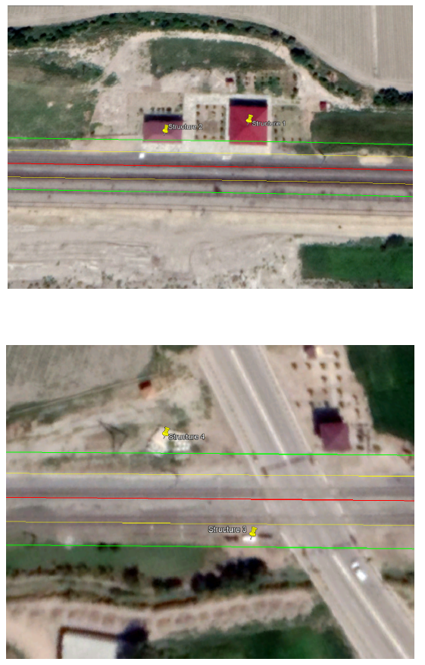
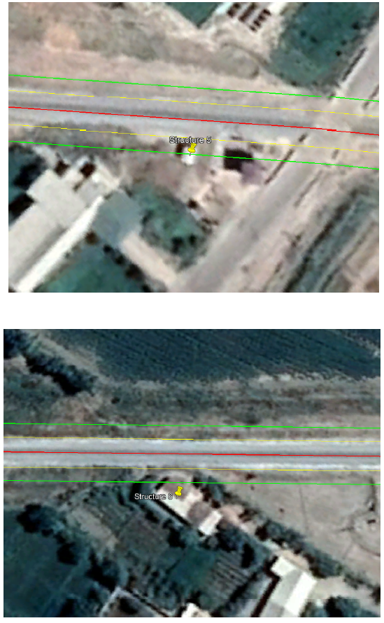
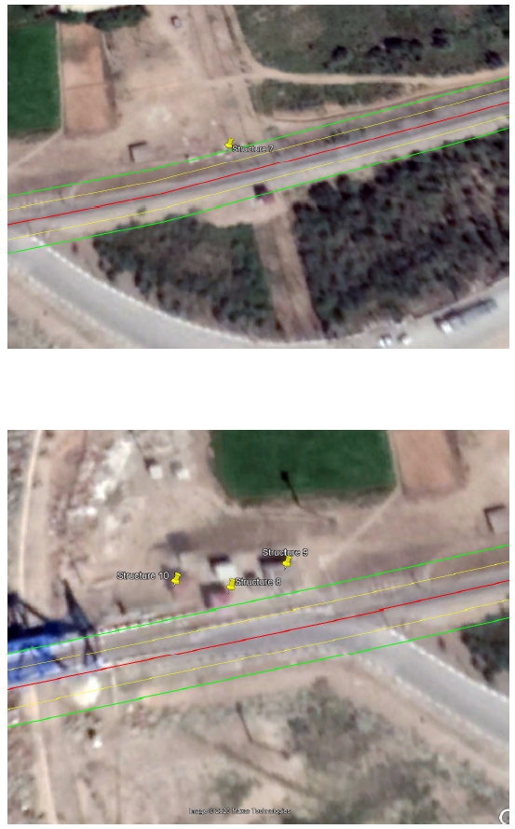
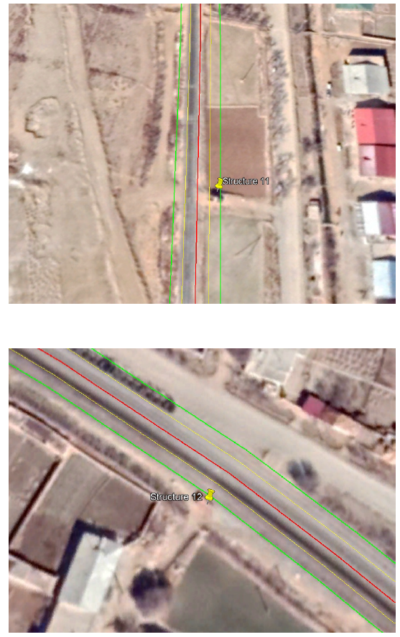
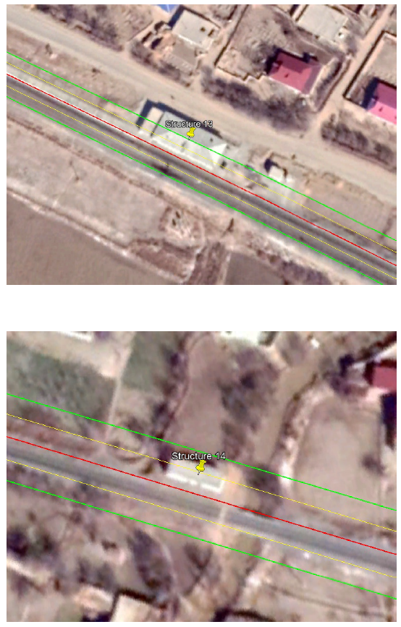

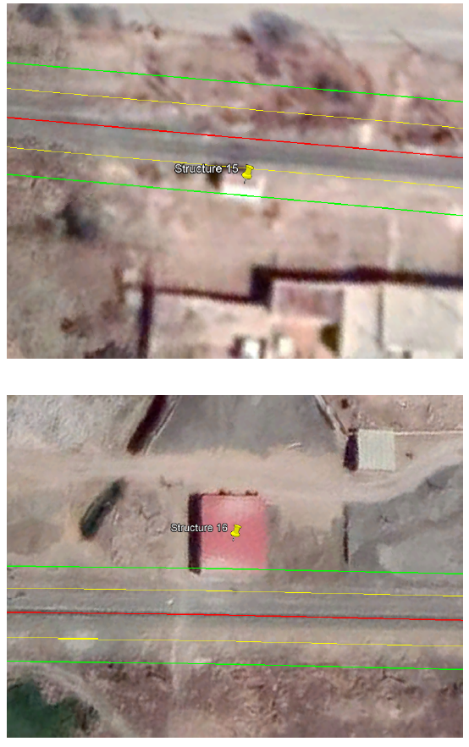
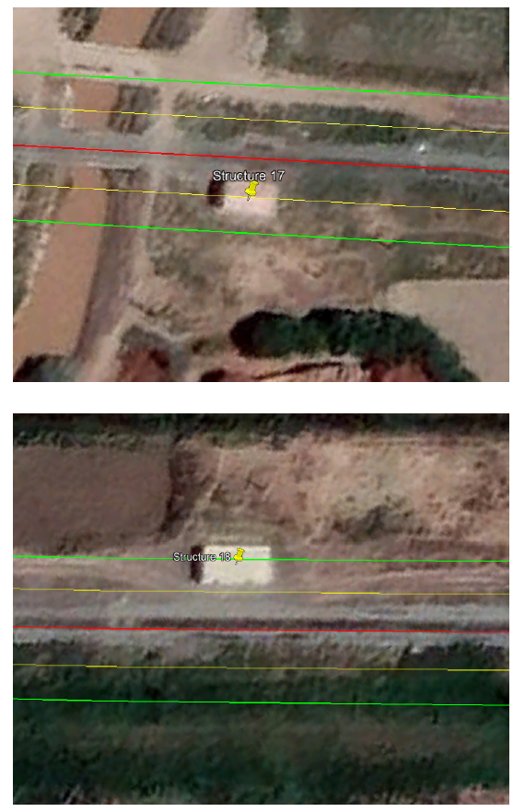

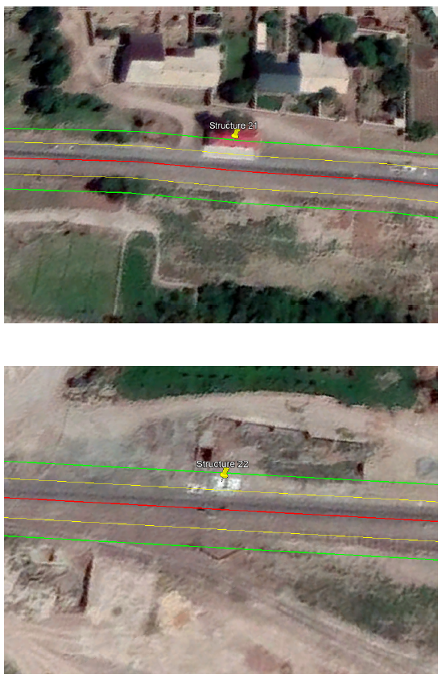
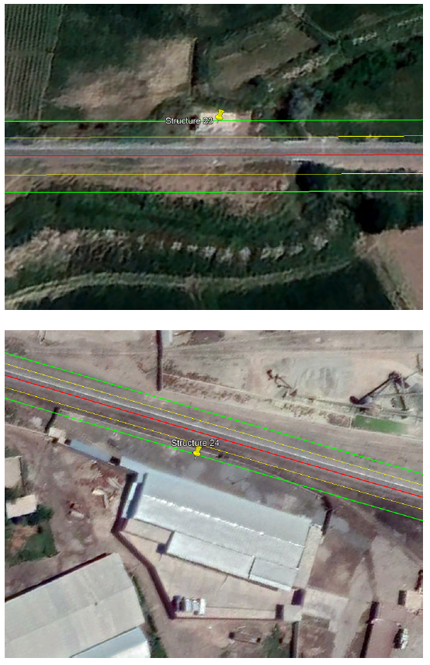
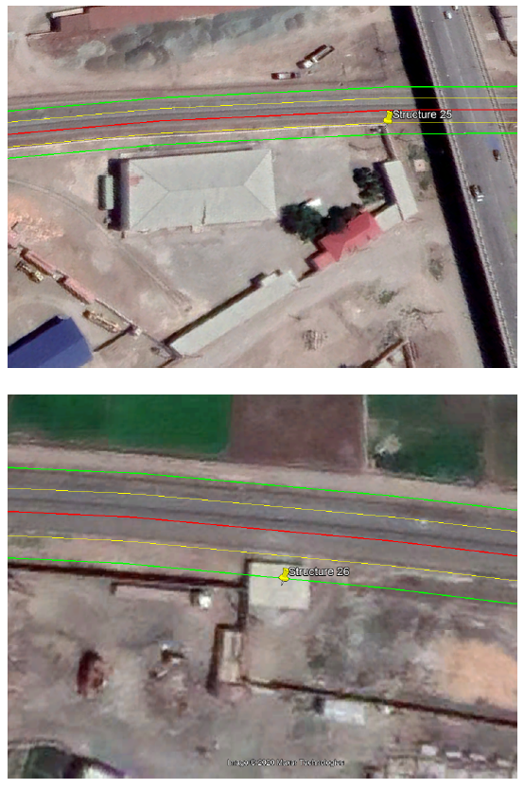

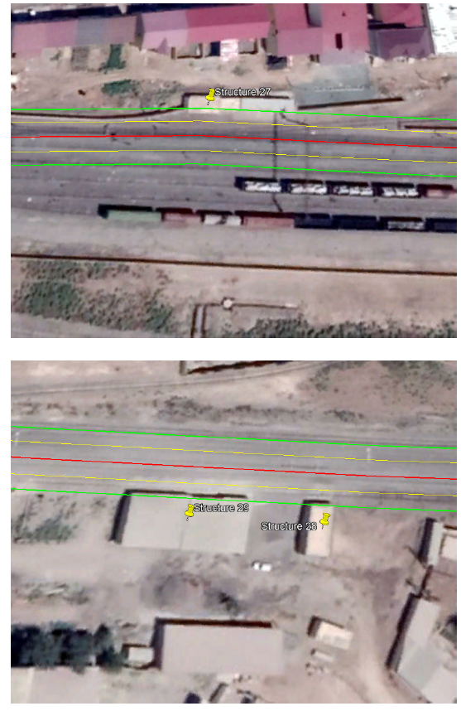
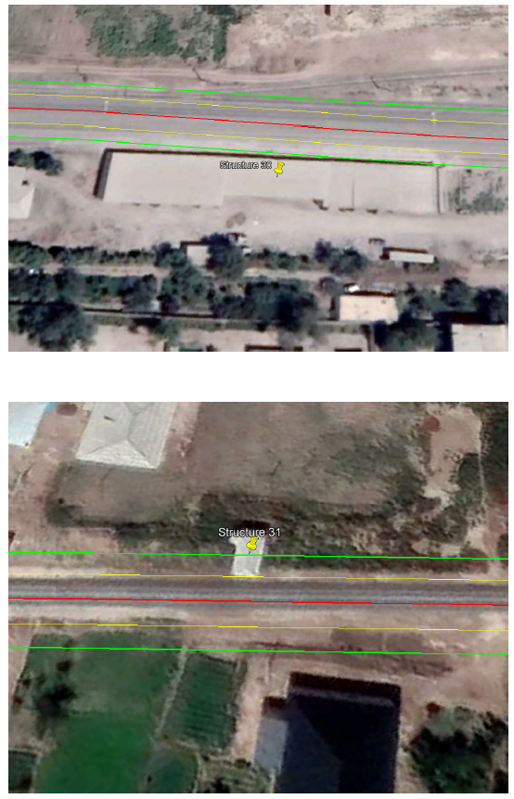
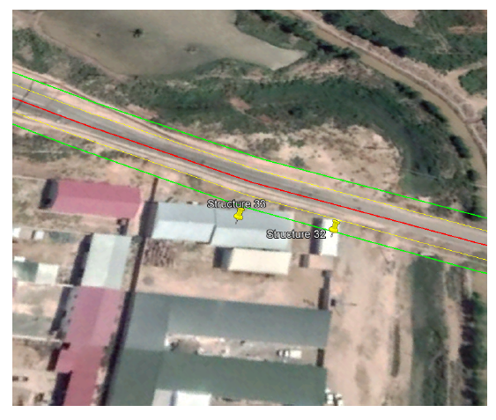

Appendix 5. Copy of Original letter of Design Institute

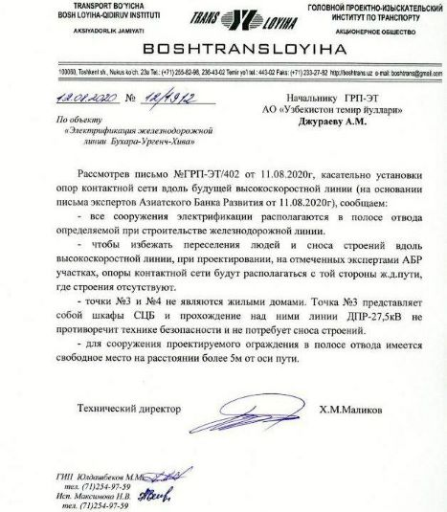

Appendix 6. English translation of Design Institute letter

Translation of the letter No 12/1912 from Design Institute Boshtransloyiha, dated August 8, 2020.
Regarding: Electrification of Bukhara-Urgench-Khiva Project

Having reviewed your letter No GRP-ET/402 dated 11.08.2020 regarding installation of the contact system masts along the future high speed railway line (based on the letter prepared by ADB experts dated 11.08.2020) we inform you of the following:
- All electrification structures are located in the right of way determined during the process of construction of railway line
- In order to avoid resettlement of people and demolishing of structures along the high speed railway line, during development of the design, the contact system masts will be located on the side of track where there are no buildings, at the sections specified by ADB experts.
- Points 3 and 4 are not residential buildings. Point 3 is signaling cabinets and two-wire rail line 27.5kV going above this structure does not interfere safety rules and will not require demolishing of the structure.
- For the purpose of construction of the designed fencing in the right of way there is a free space at the distance of more than 5 meters of the track axis.

Technical director Signed X.M.Malikov

Appendix 7. Public Information Brochure
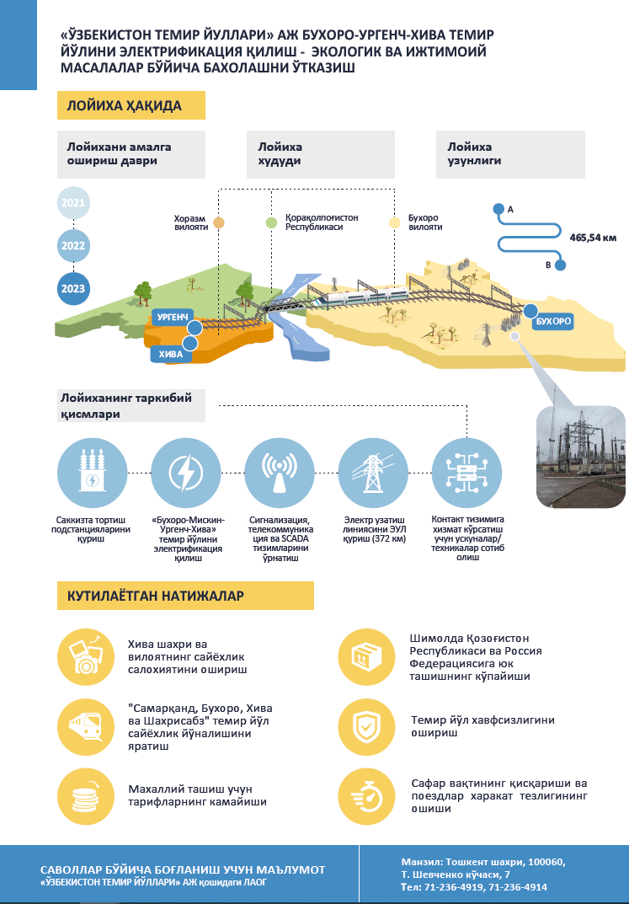
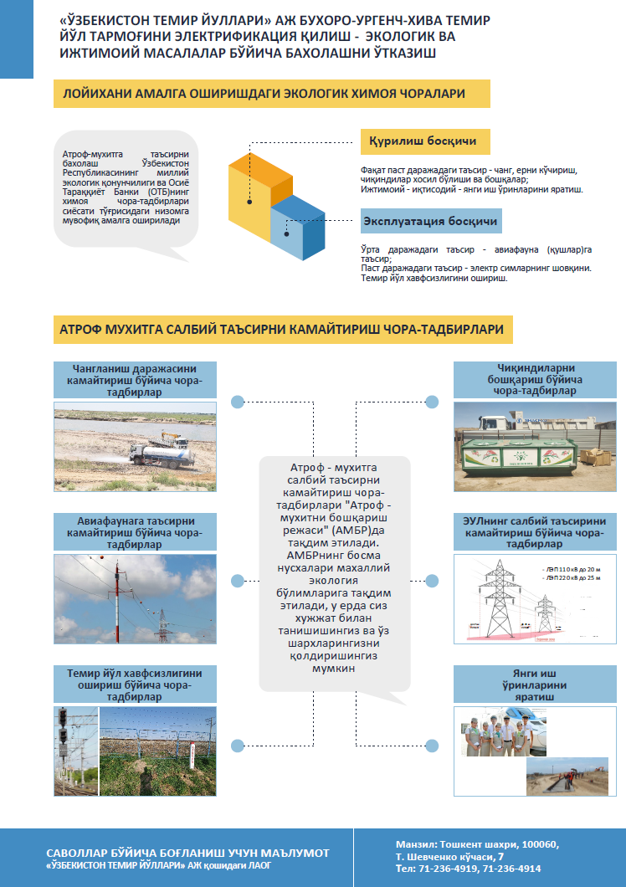
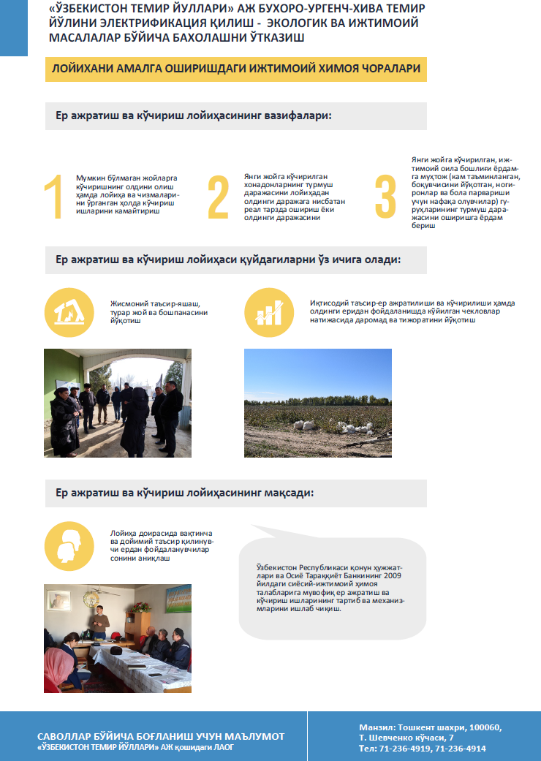
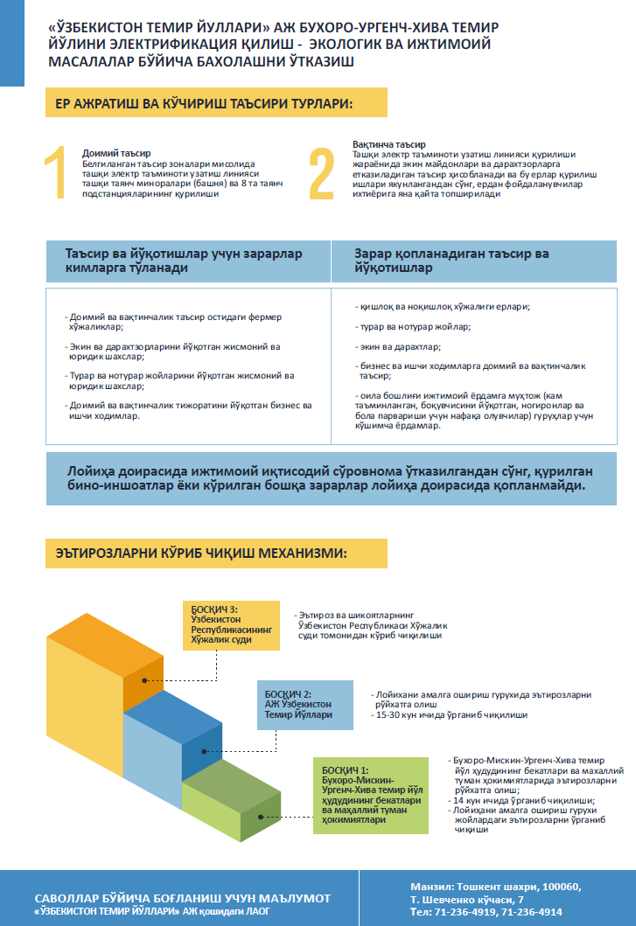

Appendix 8. PIB distribution
Photos of PIB copies being disseminated by PIU Staff and ADB TRTA consultants on 26-27 August 2020
# | Organization | Name | Position | Contact information | Photo
Khiva, August 26, 2020
1 | Railway Station “Khiva” | Doston Matyakubov | Acting Manager of the train station | +99897-526-2829 | 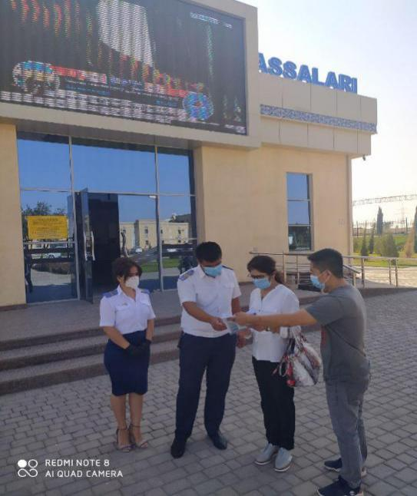
2 | Khokimiyat of Khiva City | Sabir Jumaniyazov | Khokim of City | +99899-331-5556 | 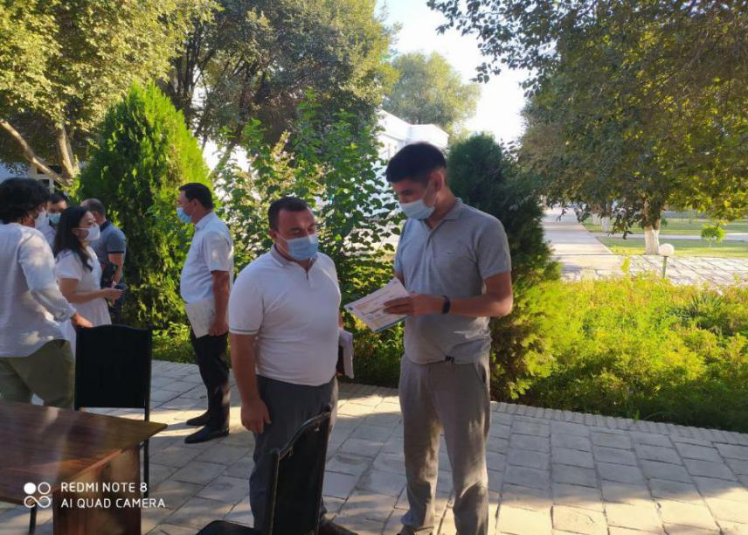

Urgench August 26, 2020

3 | Railway Depot Urganch | Zinat Abdulaev | Head of Engineer | +99897-220-6600 | 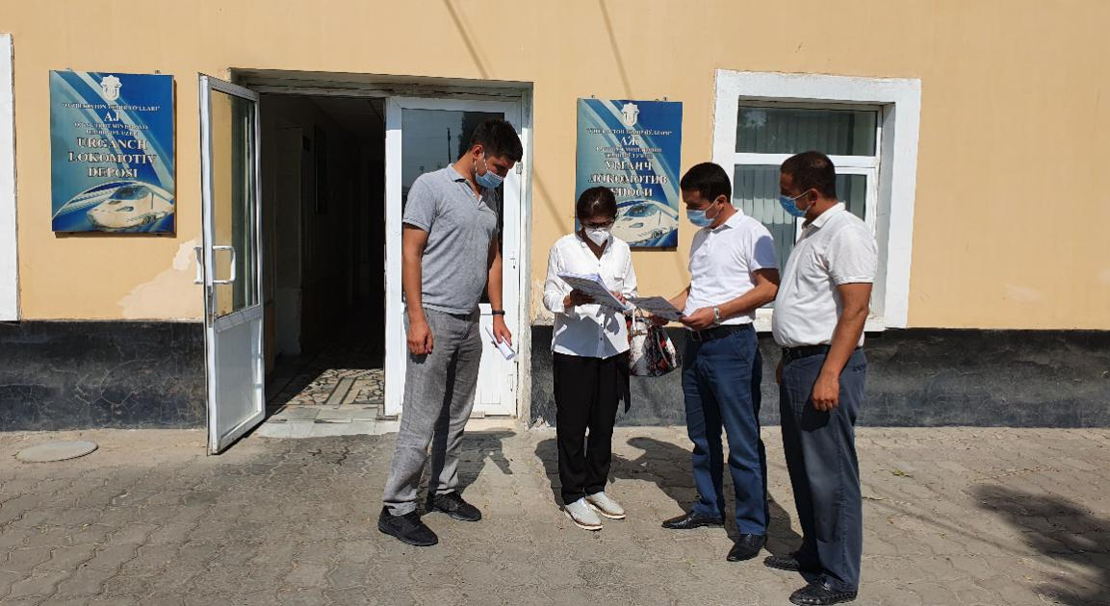
4 | “Uzdaverloyiha” Branch of Khorezm Province | Munis Hamraev | Head of Branch | +99897-516-1767 | 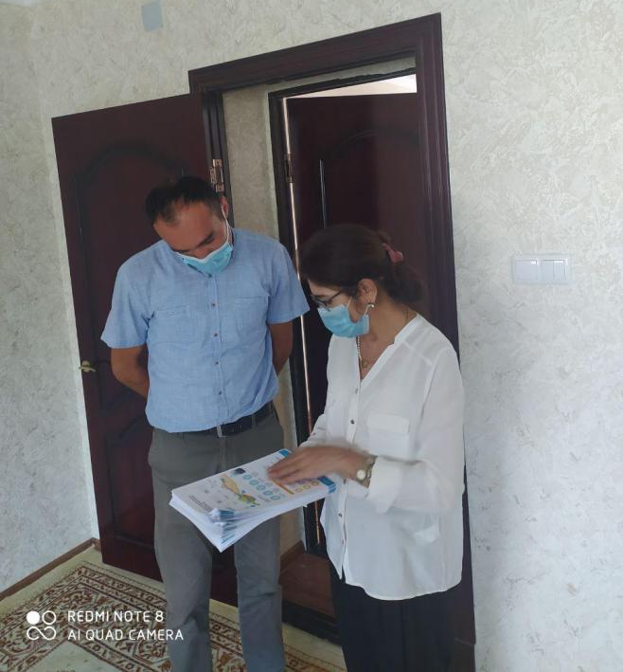
5 | Railway Station “Urgench” | Hushnud Ibragimov | Head of Ticket Office | +99894-904-0001 | 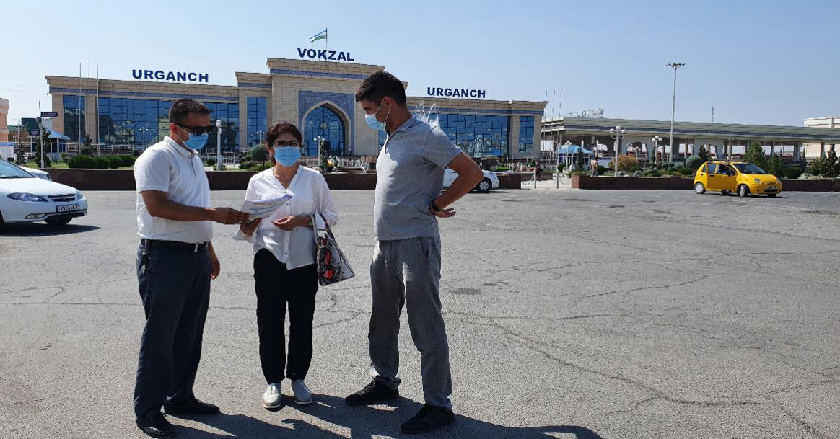
 |  | Bobur Ismailov | Engineer | +99899-508-1717
6 | Khokimiyat of Khorezm Province | Amirbek Masharipov | Specialist | +99899-962-2250
7 | State Committee on Ecology and Environmental Protection (SCEEP) Branch of Khorezm Province | Hamdam MAhmudov | Deputy of Chairman | +99893-741-0100 | 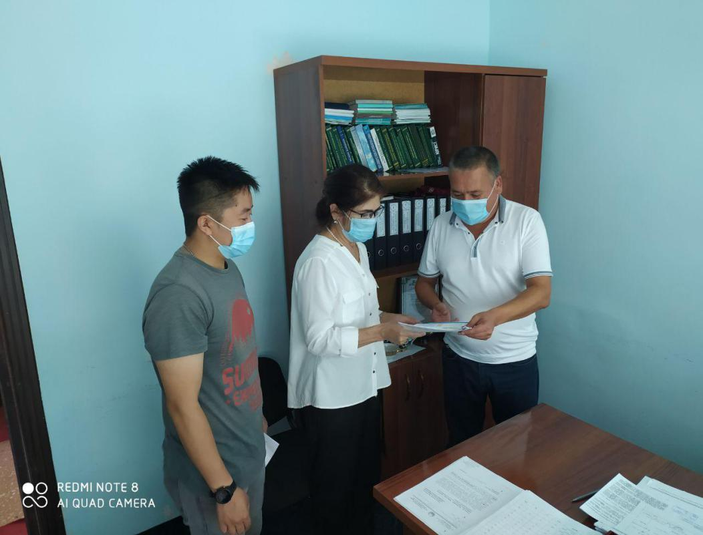

Miskin August 26, 2020
8 | Railway Station “Miskin” | Doniyor Reimov | Manager of the train station | +99897-500-6474 | 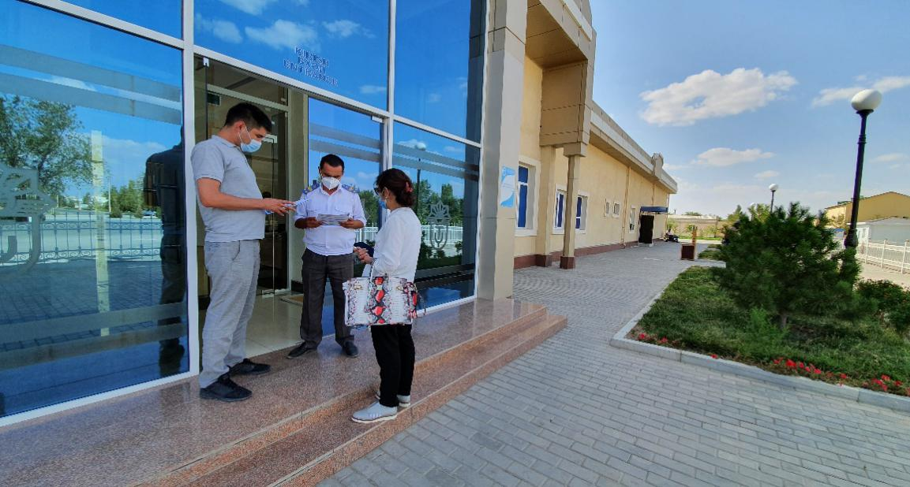

Bukhara 27, 2020
9 | “Uzdaverloyiha” Branch of Bukhara Province | Ruslan Bobochev | Manager | +99894-540-5779 | 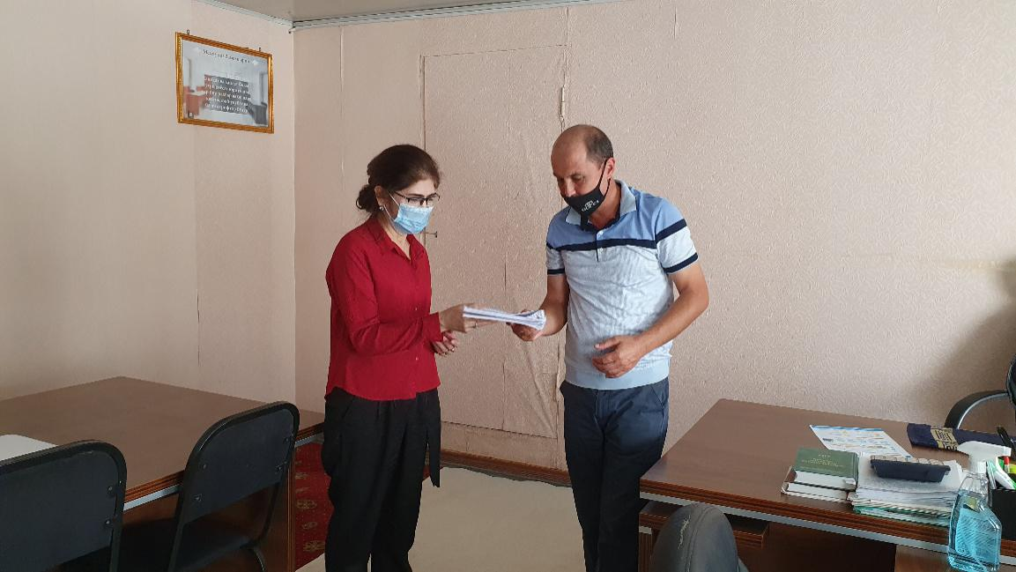
10 | SCEEP Branch of Bukhara Province | Mirholib Mahmudov | Chairman | - | 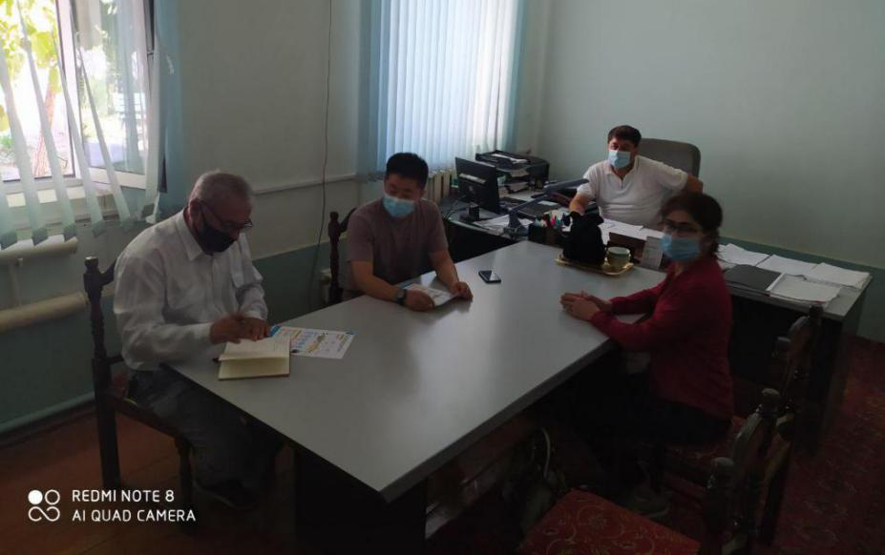
 |  | Mahmud Gulyamov | Head of Department (Expertise) | +99898-774-5636  +99893-959-5636

11 | Railway Station “Bukhara” | Ilhom Zadiev | Head of Engineer | +99893-383-3055 | 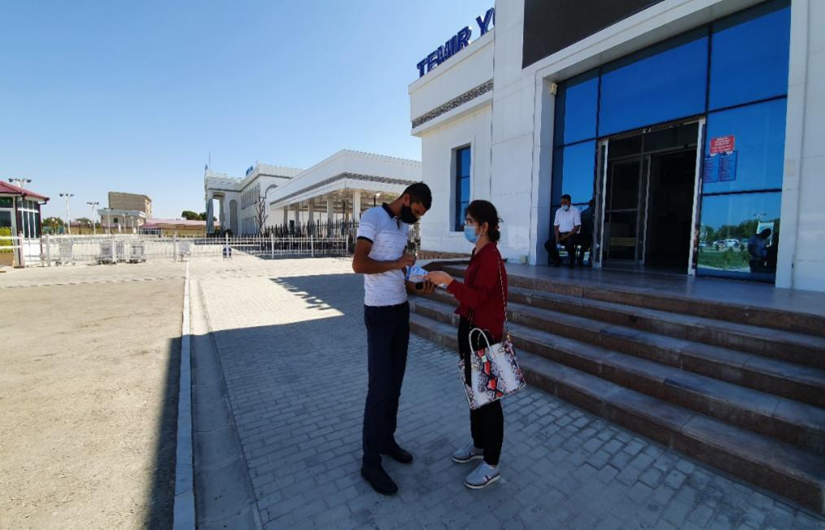
 |  | Fozil Shirinov | Specialist | +99894-540-1994
12 | Railway Depot Bukhara | Jalol Holmurodov | Head of Engineer | +99893-383-3055 | 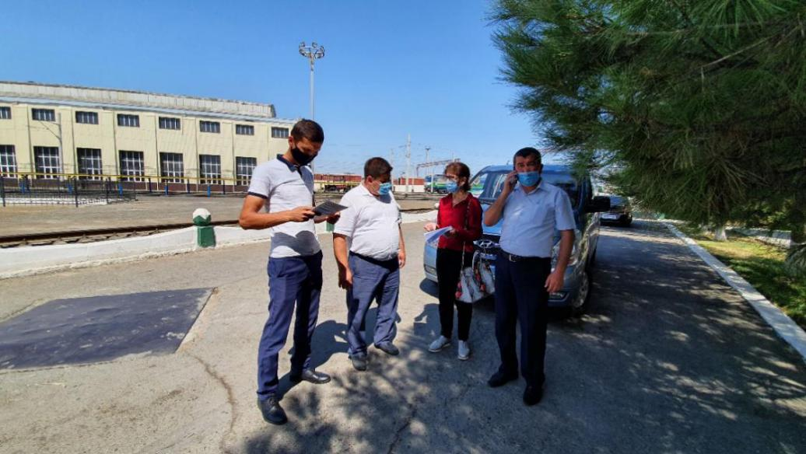
13 | Khokimiyat of Bukhara Province | Abbos Gaybulayev | Specialist | +99891-440-5424  buxoro@exat.uz | 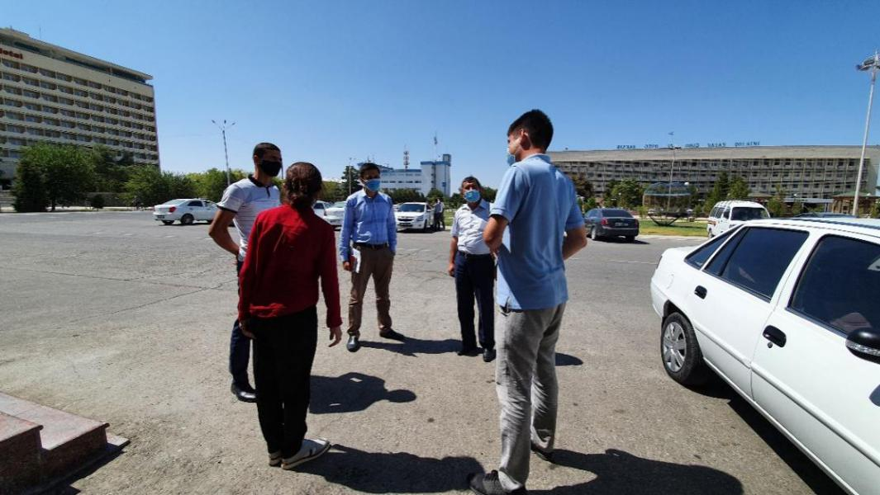

Appendix 9. Information on Traction Substations and Sectioning Posts subject to replacement of transformers

No: 1
Name of substation: Salar
Type: Section Post
Province: Tashkent
District: Tashkent city
Land allocation: Yes
Area: 0,47ha
Reconstruction work: Replacement for 3 new feeders
Social/LAR Impact: None

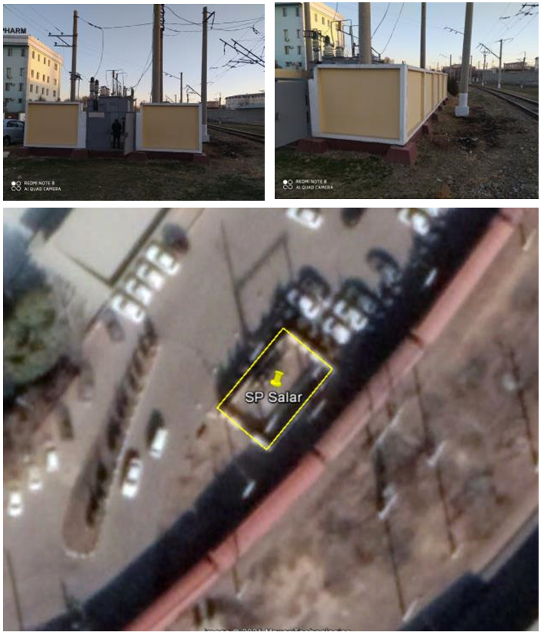

No 2
Name of substation: S.Rahimov
Type: Section Post
Province: Tashkent
District: Tashkent city
Land allocation: Yes
Area, (ha): 0,012ha
Reconstruction work: Replacement for 4 new feeders
Social/LAR Impact: None

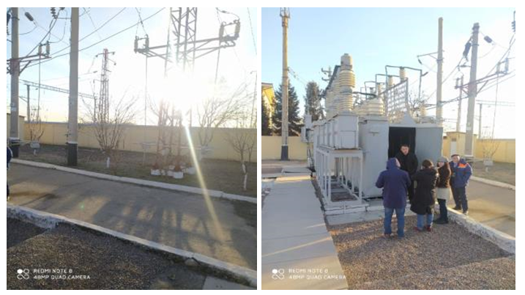

No 3.
Name of substation: Chinaz
Type: Section Post
Province: Tashkent
District: Chinaz
Land allocation: No, however the preliminary selected land with 10*10meter has not any impact to AHs and it locates inside the existing traction substation area.
Area, (ha): Not built
Reconstruction work: Construction of 4 new feeders
Social/LAR Impact: None
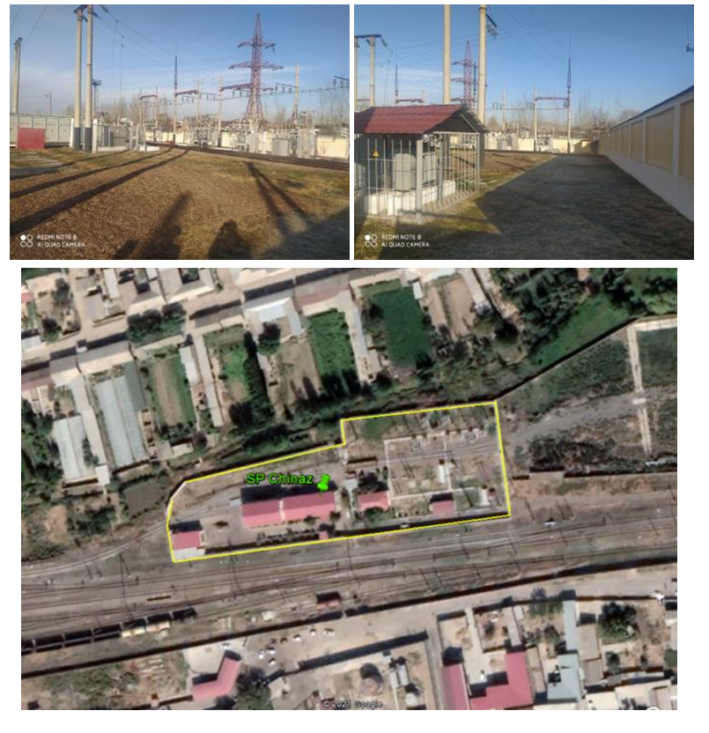
No 4
Name of substation: Syrdarya
Type: Section Post
Province: Syrdarya
District: Syrdarya
Land allocation: Yes
Area, (ha): 0,0025ha
Reconstruction work: Replacement for 4 new feeders
Social/LAR Impact: None
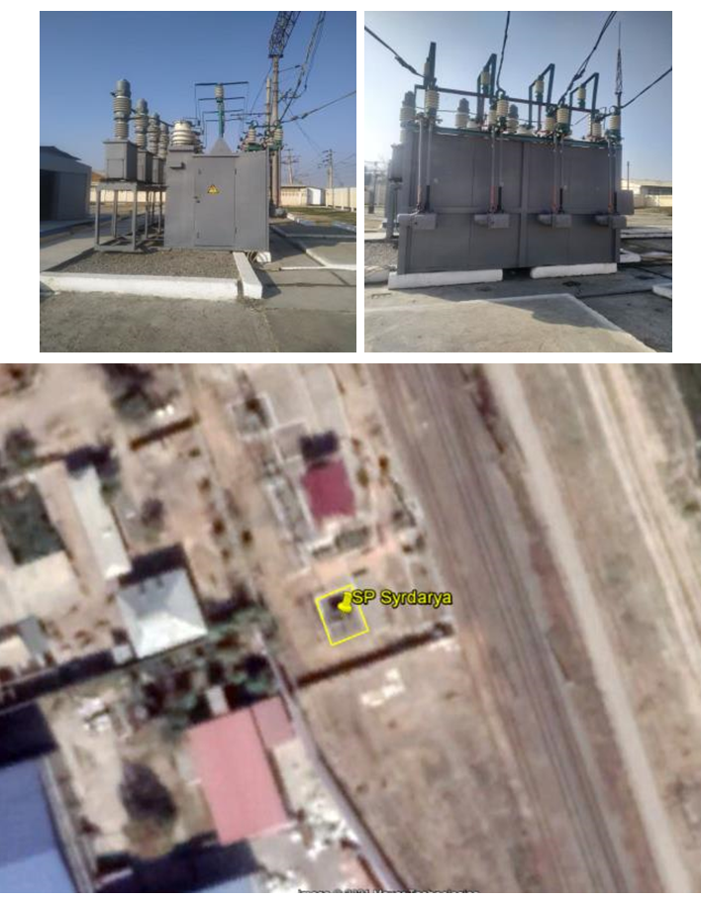
No 5
Name of substation: Bayaut
Type: Section Post
Province: Syrdarya
District: Bayaut
Land allocation: Yes
Area, (ha): 0,008ha
Reconstruction work: Replacement for 4 new feeders
Social/LAR Impact: None
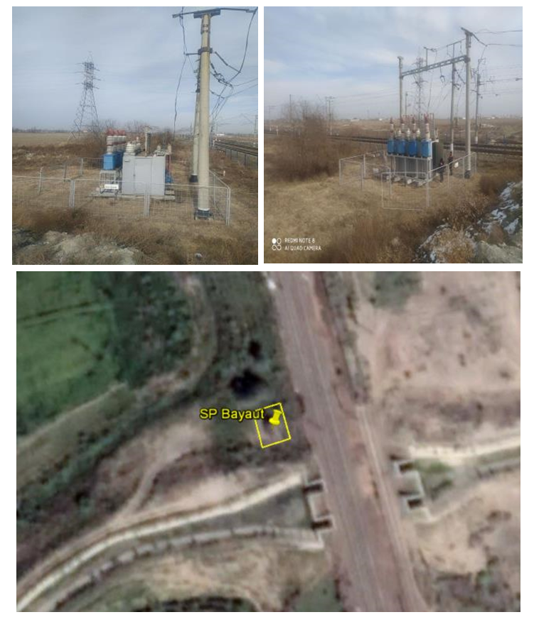
No 6
Name of substation: Dashtabad
Type: Section Post
Province: Jizzakh
District: Dashtabad
Land allocation: No, however the preliminary selected land with 10*10meter has not any impact to AHs.
Area, (ha): Not built
Reconstruction work: Construction of 4 new feeders
Social/LAR Impact: None
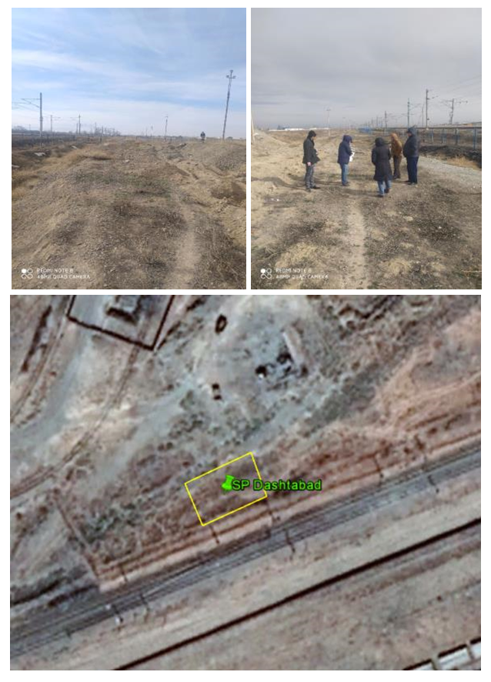

No 7
Name of substation: Gallaaral
Type: Section Post
Province: Jizzakh
District: Gallaaral
Land allocation: Yes
Area, (ha): 0,025ha
Reconstruction work: Replacement for 4 new feeders
Social/LAR Impact: None
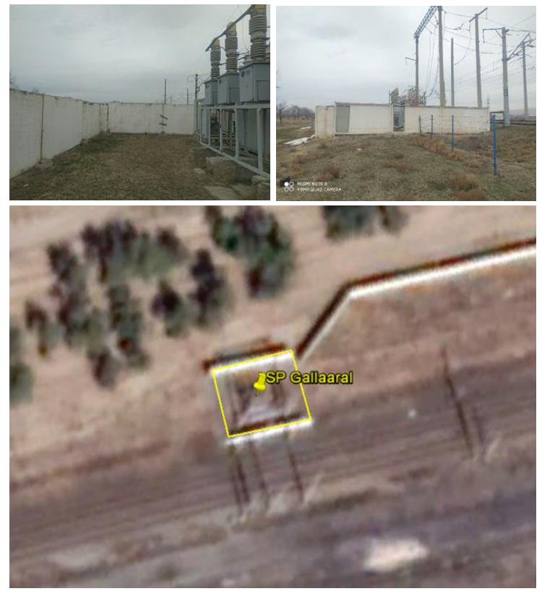
No 8
Name of substation: Bulungur
Type: Section Post
Province: Samarkand
District: Bulungur
Land allocation: Yes
Area, (ha): 0,026ha
Reconstruction work: Replacement for 4 new feeders
Social /LAR Impact: None
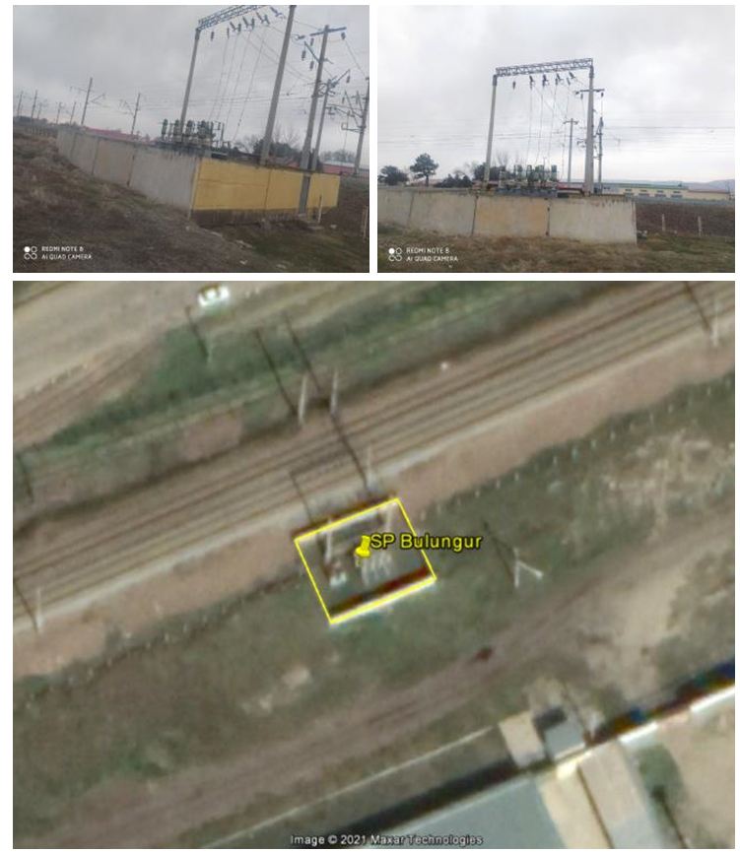

No 9
Name of substation: Marokand
Type: Traction SubStation
Province: Samarkand
District: Pastargon
Land allocation: Yes
Area, (ha): 0,78ha
Reconstruction work: Replacement of 40 MVA transformers with replacements of the below supplied equipment for: TT VVV and SV 27.5 kV for 1600 A; SV and VV circuit breaker 27.5 kV for 1600 A; TT feeders of the overhead line for 1500 A; TT- 110 kV by calculation; Disconnector of input 27.5 kV for 2000 A.
Social /LAR Impact: None
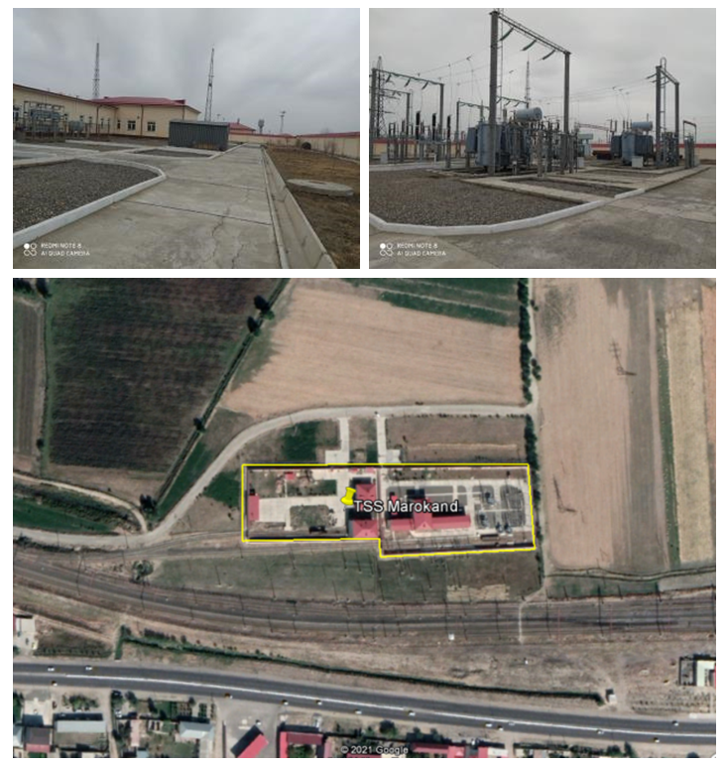
No 10
Name of substation: Juma
Type: Section Post
Province: Samarkand
District: Kattakurgan
Land allocation: Yes
Area, (ha): 0,025ha
Reconstruction work: Replacement for 4 new feeders
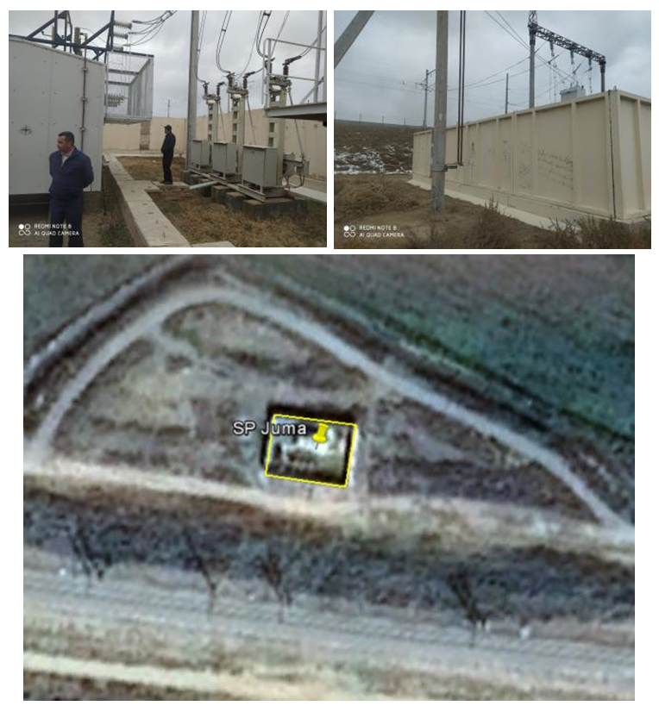
Social /LAR Impact: None
No 11
Name of substation: Kattakurgan
Type: Traction SubStation
Province: Samarkand
District: Kattakurgan
Land allocation: Yes
Area, (ha): 0,97ha
Reconstruction work: Replacement of 40 MVA transformers with replacements of the below supplied equipment for: TT-110 kV by calculation; Disconnector of input 27.5 kV for 2000 A; TT VVV and SV 27.5 kV for 1600 A; SV and VV circuit breaker 27.5 kV for 1600 A.
Social /LAR Impact: None
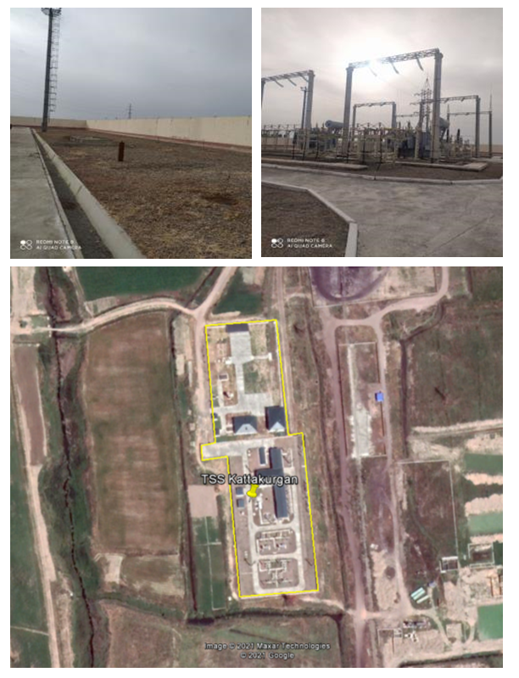
No 12
Name of substation: Zirabulok
Type: Section Post
Province: Samarkand
District: Narpay
Land allocation: Yes
Area, (ha): 0,024ha
Reconstruction work: Replacement for 4 new feeders
Social /LAR Impact: None
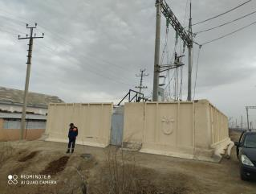
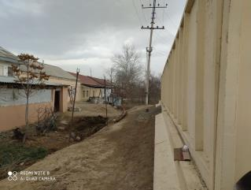
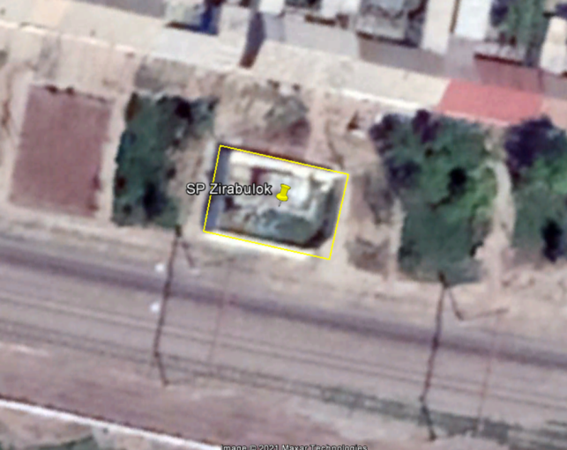
No 13
Name of substation: Ziyadin
Type: Traction SubStation
Province: Samarkand
District: Pakhtachi
Land allocation: Yes
Area, (ha): 0,98ha
Reconstruction work: Replacement of 40 MVA transformers with replacements of the below supplied equipment for: TT-110 kV by calculation; Disconnector of input 27.5 kV for 2000 A; TT VVV and SV 27.5 kV for 1600 A; SV and VV circuit breaker 27.5 kV for 1600 A.
Social /LAR Impact: None
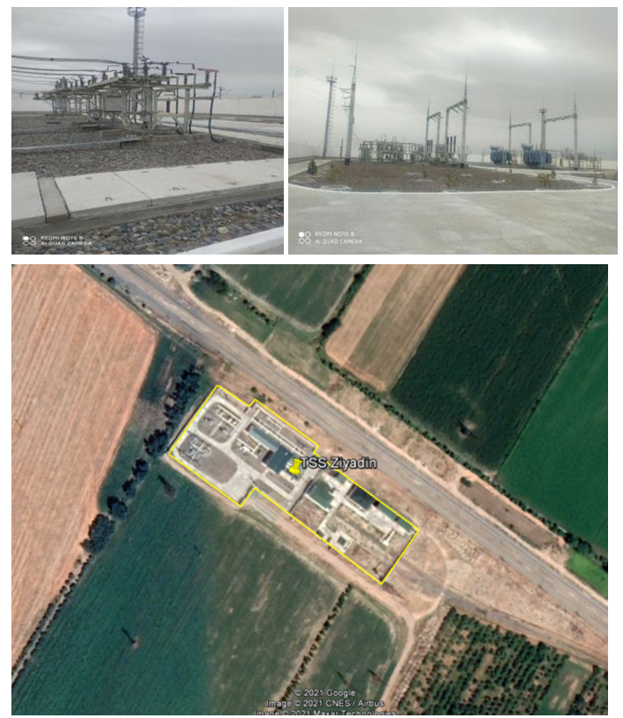
No 14
Name of substation: Binokor
Type: Section Post
Province: Navoi
District: Karmana
Land allocation: Yes
Area, (ha): 0,025ha
Reconstruction work: Replacement for 4 new feeders
Social /LAR Impact: None

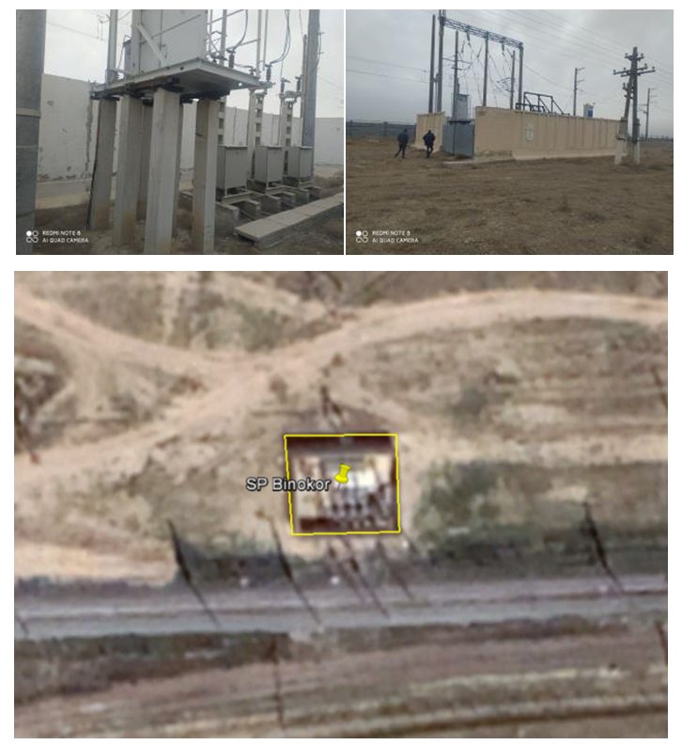
No 15
Name of substation: Kyzyltepa
Type: Traction SubStation
Province: Navoi
District: Kyzyltepa
Land allocation: Yes
Area, (ha): 0,55ha
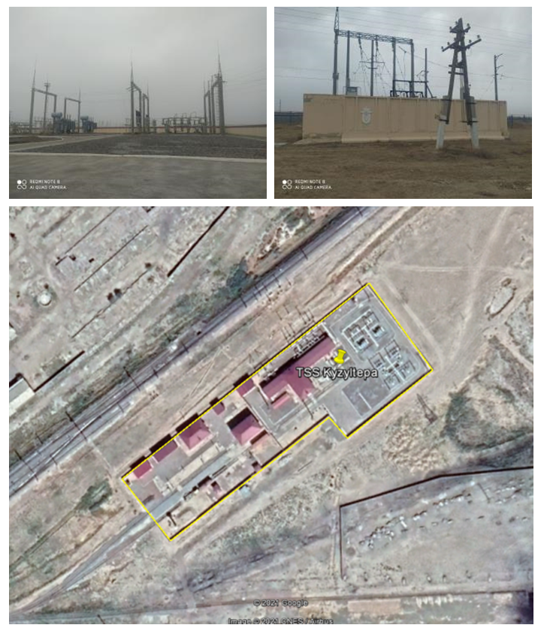
Reconstruction work: Replacement of 40 MVA transformers with replacements of the below supplied equipment for: TT-110 kV by calculation; Disconnector of input 27.5 kV for 2000 A; TT VVV and SV 27.5 kV for 1600 A; SV and VV circuit breaker 27.5 kV for 1600 A
Social /LAR Impact: None

No 16
Name of substation: Ayritam
Type: Traction SubStation
Province: Kashkadarya
District: Chirokchi
Land allocation: Yes
Area, (ha): 0,78ha
Reconstruction work: replacement of traction transformers 25 MVA by 40 MVA
Social /LAR Impact: None
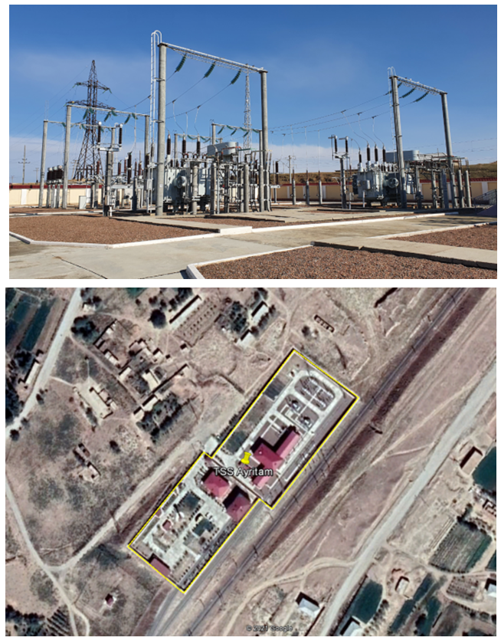

No 17
Name of substation: Kashkadarya
Type: Traction SubStation
Province: Kashkadarya
District: Karshi
Land allocation: Yes
Area, (ha): 0,81ha
Reconstruction work: replacement of traction transformers 25 MVA by 40 MVA
Social /LAR Impact: None

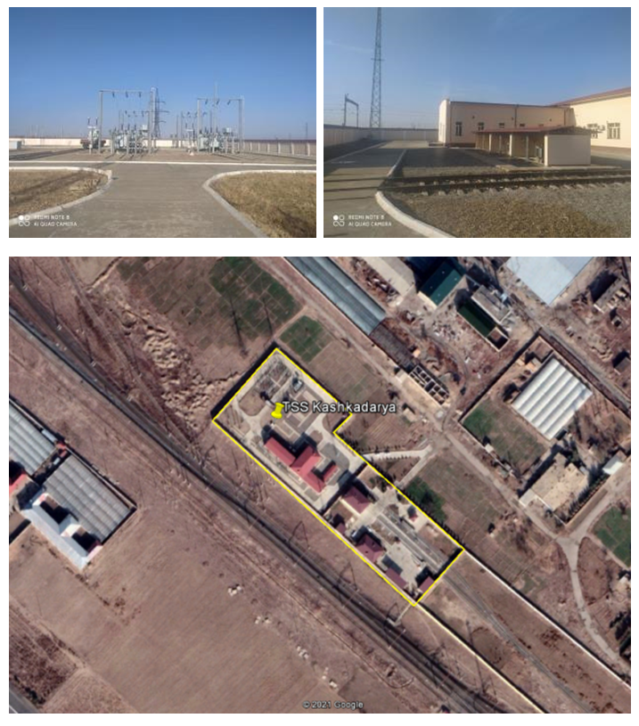
No 18
Name of substation: Tashguzar
Type: Traction SubStation
Province: Kashkadarya
District: Guzor
Land allocation: Yes
Area, (ha): 0,89ha
Reconstruction work: Replacement of 40 MVA transformers with replacements of the below supplied equipment for: TT VVV and SV 27.5 kV for 1600 A; SV and VV circuit breaker 27.5 kV for 1600 A; TT feeders of the overhead line for 1500 A; TT-110 kV by calculation; Disconnector of input 27.5 kV for 2000 A.
Social /LAR Impact: None

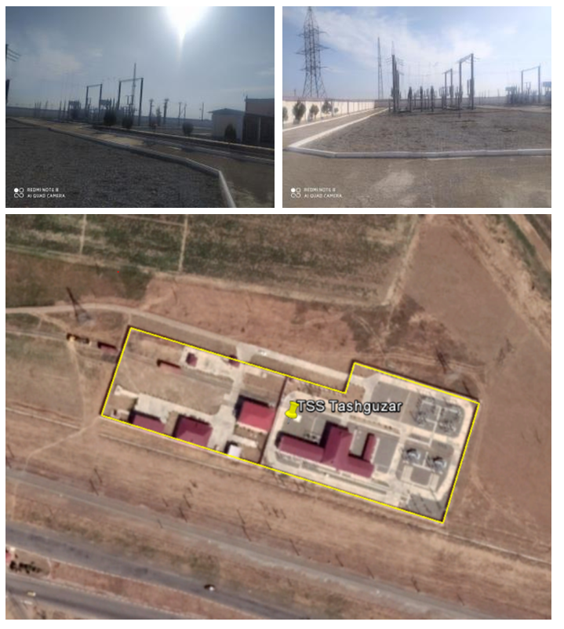

No 19
Name of substation: Dekhkanabad
Type: Traction SubStation
Province: Kashkadarya
District: Dekhkanabad
Land allocation: Yes
Area, (ha): 0,83ha
Reconstruction work: Replacement of 40 MVA transformers with replacements of the below supplied equipment for: TT VVV and SV 27.5 kV for 1600 A; SV and VV circuit breaker 27.5 kV for 1600 A; TT feeders of the overhead line for 1500 A; TT-110 kV by calculation; Disconnector of input 27.5 kV for 2000 A.
Social /LAR Impact: None
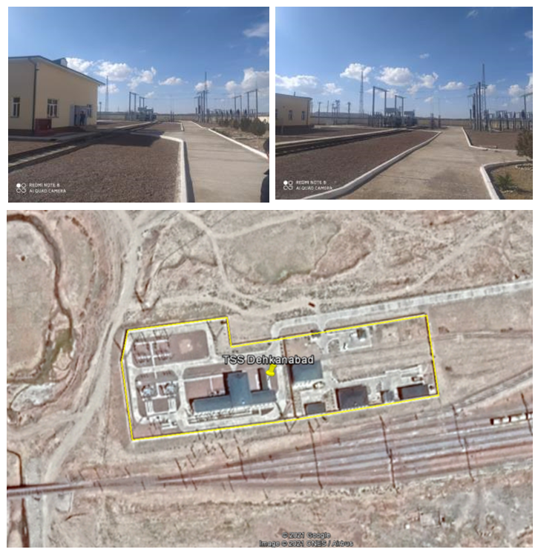

No 20
Name of substation: Akrabat
Type: Traction SubStation
Province: Kashkadarya
District: Dekhkanabad
Land allocation: Yes
Area, (ha): 0,83ha
Reconstruction work: Replacement of 40 MVA transformers with replacements of the below supplied equipment for: TT VVV and SV 27.5 kV for 1600 A; SV and VV circuit breaker 27.5 kV for 1600 A; TT feeders of the overhead line for 1500 A; TT-110 kV by calculation; Disconnector of input 27.5 kV for 2000 A.
Social /LAR Impact: None
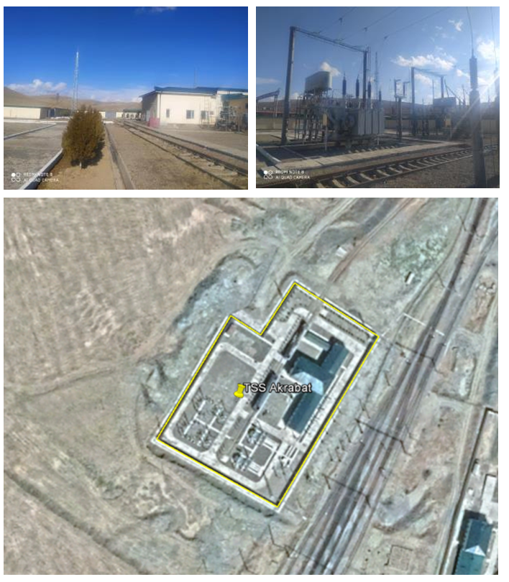

No 21
Name of substation: Boysun
Type: Traction SubStation
Province: Surkhandarya
District: Boysun
Land allocation: Yes
Area, (ha): 0,93ha
Reconstruction work: Replacement of 40 MVA transformers with replacements of the below supplied equipment for: TT VVV and SV 27.5 kV for 1600 A; SV and VV circuit breaker 27.5 kV for 1600 A; TT feeders of the overhead line for 1500 A; TT-110 kV by calculation; Disconnector of input 27.5 kV for 2000 A.
Social /LAR Impact: None
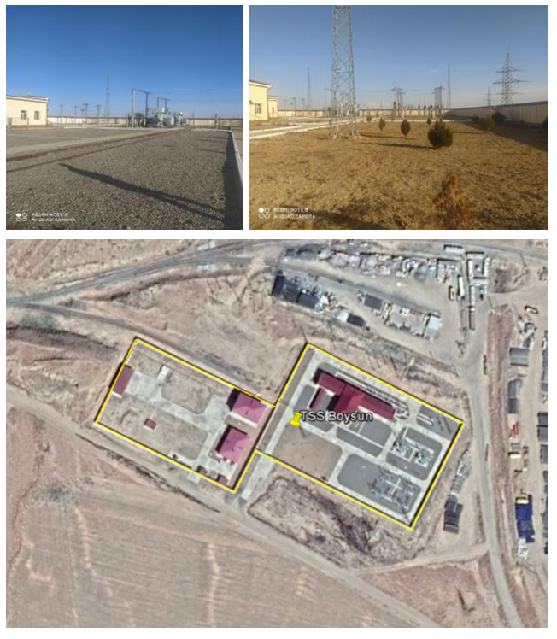
No 22
Name of substation: Kumkurgan
Type: Traction SubStation
Province: Surkhandarya
District: Kumkurgan
Land allocation: Yes
Area, (ha): 0,79ha
Reconstruction work: Replacement of 40 MVA transformers with replacements of the below supplied equipment for: TT VVV and SV 27.5 kV for 1600 A; SV and VV circuit breaker 27.5 kV for 1600 A; TT fiders of the overhead line for 1500 A; TT-110 kV by calculation; Disconnector of input 27.5 kV for 2000 A.
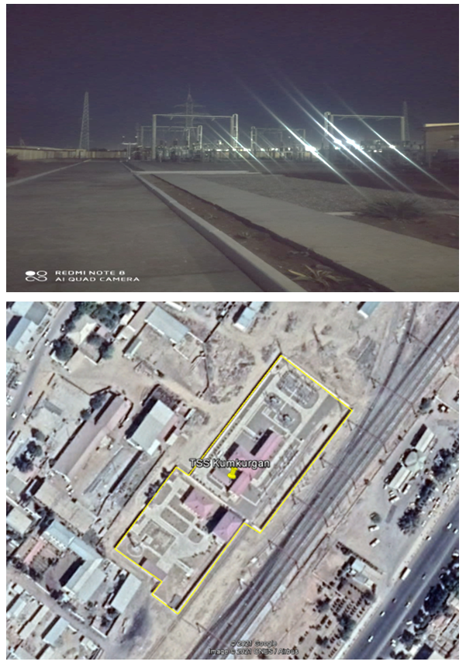

No 23
Name of substation: Razezd 165
Type: Traction SubStation
Province: Surkhandarya
District: Jarkurgan
Land allocation: Yes
Area, (ha): 0,96ha
Reconstruction work: replacement of traction transformers 25 MVA by 40 MVA
Social /LAR Impact: None

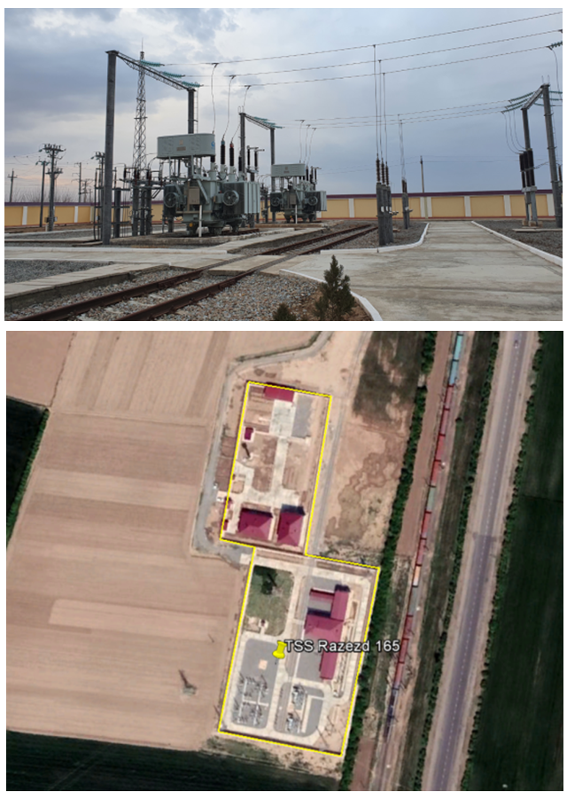

The project components covered under the SDDR are described in detail in Chapter 1, sub-chapter c. Details of Project Components covered by this SDDR.
Facilitating fast passenger train services, the project is expected to have a strong impact on the number of tourists along the corridor Tashkent-Samarkand-Bukhara-Khiva. The project will enable a comfortable travel to Khiva, a city that is currently reached by either long road travels or by air, with the immediate introduction of 4 pairs of high-speed passenger trains a day once the project is completed. Freight traffic (transit/import/export) is expected to increase from 3 to 10 pairs of trains a day, being an important trigger for economic development. Direct and indirect job creation, in particular r in the city of Khiva, will be significant for the western part of the country.
Including double-track section near Bukhara, the total length is 465km.
Para 2.5.112, Regulation on Electrical installation ,”Ugosenergonadzor”, Tashkent 2007
Appendix 3 contains a table with location and UTM coordinates of the 33 pylons and Appendix 4 provides extract from Google map of 33 structures.
Appendix 5 and Appendix 6 provides the original and English translation of Design Institute letter regarding these two locations referred as point # 3 and point # 4.
The preliminarily selected land (10 m X 10 m) is located within the area of existing traction substation and will not have any social /LAR impact to any person or household.
The preliminarily selected land (10 m X 10 m) is located within the area of existing traction substation and will not have any social /LAR impact to any person or household.
Source: Resettlement Action Plan for the Pap-Angren Railway Project, 2014.

