Semi-Annual Environmental Monitoring Report

Semi-Annual Report
Reporting period: January-June and inclusive July, 2023
Project number: 53271
Date: July, 2023

Republic of Uzbekistan: Railway Electrification Project (Bukhara-Urgench-Khiva), passing along the corridor within the framework of the 2nd Central Asian Regional Economic Cooperation

Loan №4170-UZB
(Financed by Asian Development Bank)

Prepared by: Consulting company “’PE DB Engineering & Consulting GmbH’’ (hereinafter referred to as – PE DB E&C) and PIU-ET JSC « O’zbekiston Temir Yo’llari » (UTY) for JSC « O’zbekiston Temir Yo’llari » and Asian Development Bank

This Annual Environmental Monitoring Report is a document of the borrower. The views expressed in this document do not necessarily reflect those of ADB's Board of Directors, management, or staff, and may be preliminary in nature.
In preparing any country program or strategy, financing any project, or in the designation or reference to a particular territory or geographic area in this document, the Asian Development Bank does not intend to make any judgments regarding the legal or other status of any territory or locality.

CURRENCY EQUIVALENTS
(As of 31 December 2022 y.)
Currency unit | – | Uzbekistan Sum (UZS)
UZS 1.00 | "=" | 0,000092 US dollars
$1.00 | "=" | UZS 11582.14

ABBREVIATIONS
ADB | - | Asian Development Bank
CAP | - | Corrective Action Plan
СМ | - | Cabinet of Ministers
PMC |  | Project Management Consultant
EHS | - | Environmental, Health and Safety Guidelines
EMP | - | Environmental Management Plan
EMR | - | Environmental Monitoring Report
GRM | - | Grievance Redress Mechanism
HH | - | Household
IEE | - | Initial Environmental Expertise
IFC | - | International Finance Corporation
PIU-ET | - | Project Implementation Unit for Electrification and Renewal of Rolling Stock
ТS | - | Technical support
UTY  Мinecology  OVOS (EIA)  ZVOS (ESI)  GlavGosExpertisa | -  -  -  -  - | O’zbekiston Temir Yo’llari  Ministry of Ecology, Environmental Protection and Climate Change of the Republic of Uzbekistan  National abbreviation for Environmental Impact Assessment Process  National abbreviation for Environmental Impact Statement  State agency under the Ministry of Ecology responsible for Environmental Impact Assessment
ТSS | - | Traction Substation
SCADA | - | Supervisory Control and Data Acquisition System

NOTE
In this report, "$" refers to US dollars.

TABLE OF CONTENTS
1 INTRODUCTION 6
1.1 Preamble 6
1.2 General information 6
2 DESCRIPTIONS OF THE PROJECT AND EXISTING SITUATION 7
2.1 Description of the project 7
2.2 Project conracts and management 16
2.3 Project activities for the current reporting period 17
2.4 Description of any changes in the design of the project 17
2.5 Description of any changes to agreed construction practices 17
3 ENVIRONMENTAL MEASURES 19
3.1 General description of environmental protection measures 19
3.2 Audit of objects 19
3.3 Tracking issues (based on notifications of non-compliance) 21
3.4 Тrends 21
3.5 Unintended environmental impacts or risks 21
4 COMPLIANCE STATUS 22
5 ENVIRONMENTAL MONITORING RESULTS 26
5.1 Оverview of monitoring carried out during the current period 26
5.2 Air quality monitoring 26
5.3 Noise 26
5.4 Vibration 26
5.5 Water quality monitoring 26
5.6 Topsoil management and soil pollution 26
5.7 Waste generation 26
5.7.1 Non-hazardous waste 26
5.7.2 Hazardous waste 26
5.8 The conditions of the construction camp for workers 26
5.8.1 Storage of construction materials on the site 26
5.8.2 Refuelling station N/A 26
5.9 Health and safety 26
5.9.1 Health and safety of population 26
5.10 Use of material resources 26
5.11 Covid-19 activities 27
5.12 Tracking system and complaints 27
5.13 Trainings 27
5.14 Implementation of the environmental management plan 27
6 FUNCTIONING OF SSEMP 68
6.1 SSEMP Review 68
7 GOOD PRACTICE AND OPPORTUNITY FOR IMPROVEMENT 69
7.1 Good practice 69
7.2 Opportunity for improvement 69
8 SUMMARY AND RECOMMENDATIONS 70
8.1 Summary 70
8.2 Recommendations 70
Appendix 1. CONCLUSION OF THE ENVIRONMENTAL EXPERTISE (EIA) 77

1 INTRODUCTION

1.1 Preamble

This report is the 1st Semi-Annual Environmental Monitoring Report (SEM) for L4170-UZB Central Asia Regional Economic Cooperation Corridor 2 - Railway Electrification Project (Bukhara-Urgench-Khiva) (CAREC Corridor 2). This report has been prepared and covers the period from January to July 2023 inclusive, as the consultants' visit to the project area took place in July. During the reporting period, design was carried out, and there were no construction and repair activities.

General information
- In accordance with ADB Safeguard Policy Statement (2009, SPS), the project belongs to category B, as a project with site-specific impacts, few of which are irreversible, and where in most cases mitigation measures can be designed.

- In accordance with national environmental categorization requirements, the project is classified as a Category 2 – project with moderate impacts on the environment. The identification of the project category was based on the level of impacts from various activities planned under the project: electrification of the existing railway, construction of external power supplies, and construction of the TSSs. Of these project activities, which are the subject of the National Environmental Assessment, the highest impacts are anticipated from the construction of the high-voltage electric lines. Therefore, the category of the project was defined as Category 2.

- The National Design Institute "Boshtransloikha" conducted an environmental impact assessment (EIA) - a Draft Statement of Environmental Impact (ESI) was prepared for the facility: "Construction of external power supply facilities of the project" Electrification of the Bukhara-Urgench-Khiva railway line "VL 110 and 220 kV" and submitted for state environmental expertise to the State Committee for Ecology and Environmental Protection of Uzbekistan in July 2021. Based on the results of consideration of the above Draft EIS, a positive conclusion of the State Ecological Expertise No. 04-01 / 10-08-1478 of 08.30.2021 was received. valid for 3 years with the possibility of extension for another two years if construction work has not started or has not been carried out in the planned volume.

- According to the EIA materials and the conclusion of the state environmental expert review, the planned set of works for the construction of the power transmission line, which will be built in the project area, consists of several construction stages:
  - preparatory work (layout of the centers of supports and the axis of the route of high-voltage lines (VL), reconstruction of engineering structures on the route of VL, delivery of building materials along the route);
  - construction work (pitting, excavation, foundation and grounding devices, assembly, installation, alignment and fixing of supports);
  - installation work (rolling out and connecting wires and cables, lifting them onto supports, stretching and fixing them on supports);
  - commissioning and putting into operation of the overhead line.

- All construction materials for the construction of the contact network and the TSS will be delivered by the existing railway. For the modernization of the depot "Bukhara" - "Urgench", the railway and existing roads will be used as access roads, the construction of new roads is not required.

- At the stage of preparation for construction, it is important to obtain the necessary permits and approvals from authorized government agencies. At the construction stage, the main impact is associated with the generation of construction and other waste, air pollution, increased noise levels, vibration, construction camp area, soil disturbance, health and safety of the population, etc. During the operation stage, noise levels generated by the railway and affecting buildings and premises. But all these impacts can be mitigated by fulfilling the requirements of the Environmental Management Plan (EMP).

2 DESCRIPTIONS OF THE PROJECT AND EXISTING SITUATION

Description of the project
- The project will electrify and modernize the 465 km Bukhara-Urgench-Khiva railway line, which was put into operation in December 2017 and is currently used for low-speed diesel-powered trains (Picture 1). The main parameters of the railway line (Bukhara - Urgench - Khiva) are presented in Table 1.
- The line has an estimated speed of 250 km/h and connects to the existing electrified high-speed railway line Tashkent-Samarkand-Bukhara. Basically, the route passes through the desert regions of Bukhara and Khorezm regions and the Republic of Karakalpakstan, and about 30% passes through agricultural land and settlements. Between the cities of Bukhara and Khiva there are ten railway stations, most of which have already been built or reconstructed. The route also has five junctions. Signalling, communications and SCADA systems will also be installed at all stations and junctions
- The project will radically change the economic geography of the Khorezm region, reduce the time distance to other urbanized regions of Uzbekistan. High-speed trains will reduce the travel time between Bukhara and Khiva to 3.0 hours compared to the current 8.0 hours. The total travel time from Tashkent to Khiva will be approximately 7.0 hours. The annual passenger traffic on the Bukhara-Khiva line is expected to increase from the current 149,500 passengers per year in 2021 to 1,410,000 passengers in 2026.

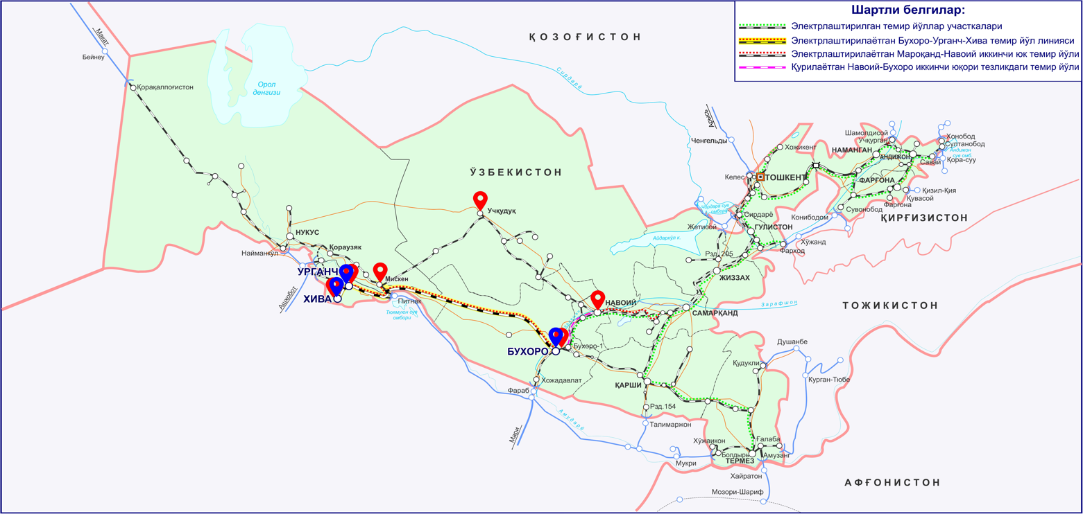

Picture 1. Project location and route
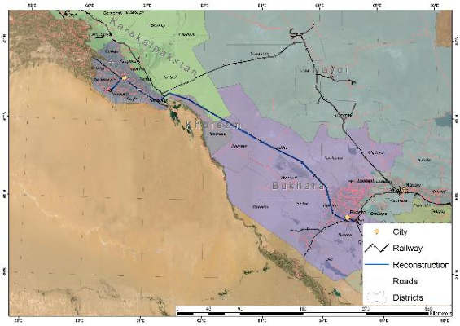
Picture 2. Scheme of the Project railway section.

- Result 1: modernization of the railway infrastructure along and adjacent to the Bukhara-Urgench-Khiva line. This includes (i) construction of 8 TSS, (ii) construction of 8 sectioning posts, (iii) supply and installation of contact network systems, (iv) supply and installation of signaling, communication, and supervisory control and data acquisition (SCADA) systems, (v) construction of external power supply, (vi) purchase of equipment and machinery for maintenance, and (vii) purchase of specialized wires for contact network, (viii) 44 level crossings with road blocking devices (RBD) (Picture 2). In addition, minor upgrades will be made to the electrification infrastructure on the adjacent lines from Bukhara to Tashkent and from Samarkand to the border with Afghanistan. These upgrades, while minor in scope and cost, will allow UTY's electrified network to continue to operate reliably and prepare the network for the expected growth in traffic. The infrastructure incorporates the latest technological advances to ensure efficiency and reliability.
Result 2: Development of the tourist corridor Bukhara-Urgench-Khiva. The railway line will connect the main tourist destinations of Uzbekistan through the services of a high-speed train (up to 250 km / h), which will allow traveling between Bukhara and Khiva in 2-2.5 hours, compared to a car trip, which will take about 6 hours). The project will provide travelers with the opportunity to visit the main tourist attractions of Uzbekistan comfortably in a short time, avoiding the need to make short flights. Passenger traffic will open the country, expanding the corridor of economic development in western Uzbekistan. To support the development of such an economic corridor, the project provides support for the following activities:
• Railway marketing coupled with Uzbekistan's broader tourist attraction efforts.
• Support for municipalities along the railway corridor with the development of transit-oriented developments around stations.
• Support to municipalities along the railway corridor with a sustainable tourism development plan; special attention will be paid to promoting the sustainability of new tourist sites and ecotourism,
• Implementation of an (online) ticketing system to make it easier for tourists and internal passengers to book tickets. A unified "Uzbekistan Rail Pass" could be introduced that would allow visitors to take advantage of unlimited train travel for a fixed fee to visit Tashkent, Samarkand, Bukhara and Khiva.
• Support for increased participation of women in new tourism-related economic activities.
- TSS will be connected to existing electrical substations (SS) through newly constructed high voltage lines (VL) 110 and 220 kV. The total length of the overhead line under construction is about 482.9 km, which will be confirmed at the detailed design stage.

- Planned to build the following TSS:

1. ТSS 110 / 27,5 / 10kV at st. Bukhara. Coordinates - 39 ° 42.385'NС 64 °31.528'EВ
2. ТSS 110 / 27,5 / kV at the Navbakhor (Mashak) Junction Coordinates - 40 ° 5.148'NС 64 ° 5.719'EВ.
3. ТSS 110 / 27,5 / 10kV at the Parvoz Junction Coordinates - 40 ° 30.447'NС 63 ° 37.906'EВ
4. ТSS 110 / 27,5 / 10kV at Kiyikli Junction (Alabuga) Coordinates - 40 ° 47.748'NС 62 ° 53.260'EВ
5. ТSS 220 / 27,5 / 10kV at the Dzhaihun Junction ( Dzhaksay) Coordinates - 41 ° 4.631'NС 62 ° 13.940'EВ
6. ТSS 220 / 27,5 / 10kV at the Turon (Akchuka) Junction Coordinates - 41 ° 20.317'NС 61 ° 31.756'EВ
7. TSS 110 / 27,5 / 10kV at Khazarasp Station Coordinates - 41 ° 18.387'NС 61 ° 2.816'EВ
8. ТSS 110 / 27,5 / 10kV at st. Urgench Coordinates - 41 ° 31.268'NС 60 ° 40.376'EВ

Name of indicator | Unit | Section Bukhara-Urgench-Miskin-Khiva
 |  | Station Bukhara-km 355+916 | km355+916-km372+240/km341+167 (station Istiklol) | Station Istiklol-station Urgench | Station Urgench-station Khiva | Total
Operational length | km | 347.60 | 15.50 | 55.35 | 33.3 | 451.75
Construction length | km | 11,41 |  |  | 1,6 | 13,01
Total length | km |  |  |  |  | 465
Type of traction power |  | Electric locomotives
Width of subgrade (earth embankment) at the open line sections | m | 7.6 | 7.6 | 7.6 | 7.6
Railroad intersection with local roads
- guarded level crossings with the crossing obstruction devices (COD) existing) | unit | 14 | 2 | 1 | 11 | 41
- reconstruction of non-guarded level crossings into the guarded level crossings with installation of COD | unit | - | 3 | 10 | - | 13
Тable 1. Railway line parameters

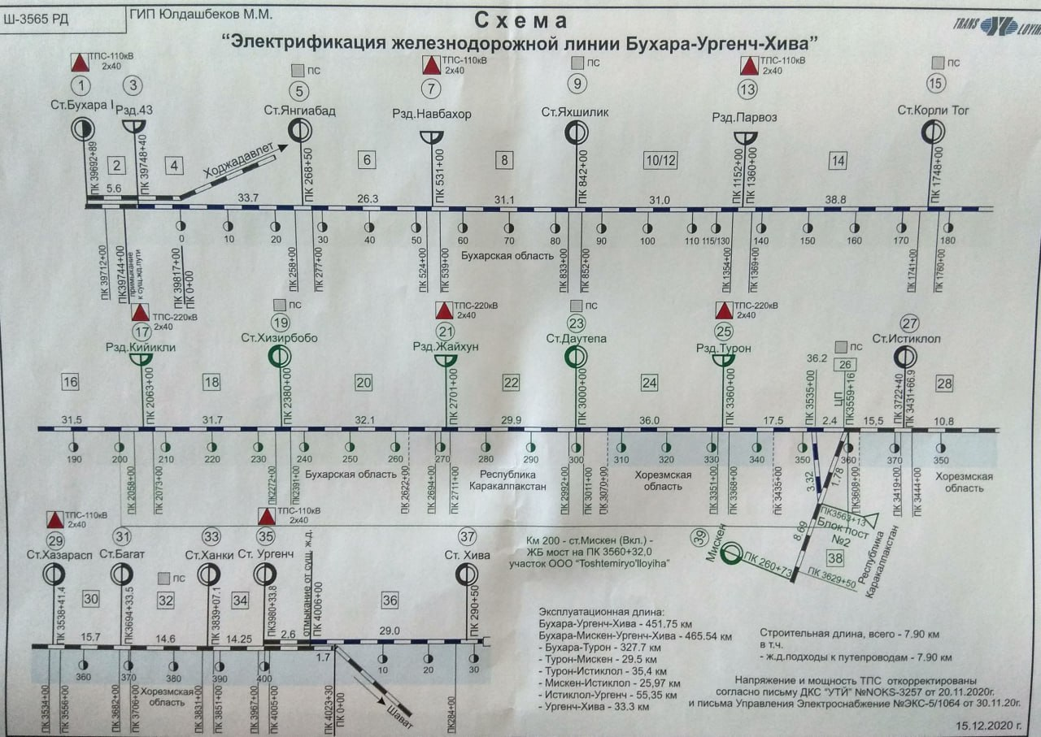
Picture 3. Layout of the main facilities (8 TSS) project of electrification of the railway line Bukhara-Urgench-Khiva
- Improving the connections between these main tourist destinations (the cities of Bukhara, Urgench, Khiva) will greatly enhance the attractiveness of Uzbekistan as a unique tourist destination. The project will stimulate the growth of this important economic corridor by supporting sustainable tourism and transit-oriented development, thereby supporting the recovery of the tourism industry from the effects of the coronavirus (COVID-19) pandemic and increasing women's opportunities to actively participate in rail transport and tourism. Thus, the project supports both the overall strategy of the government to diversify the economy and the development of the tourism sector in Khorezm (Figures 4 and 5).
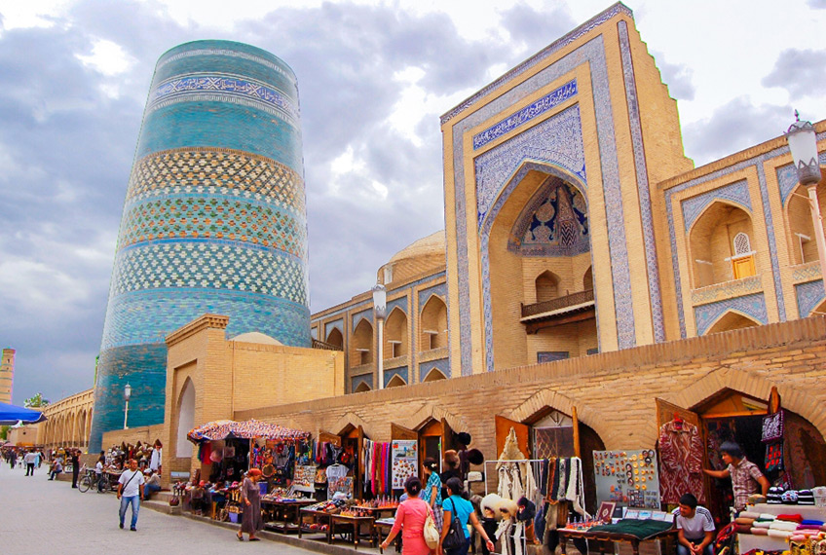
Picture 4. Improving tourism potential

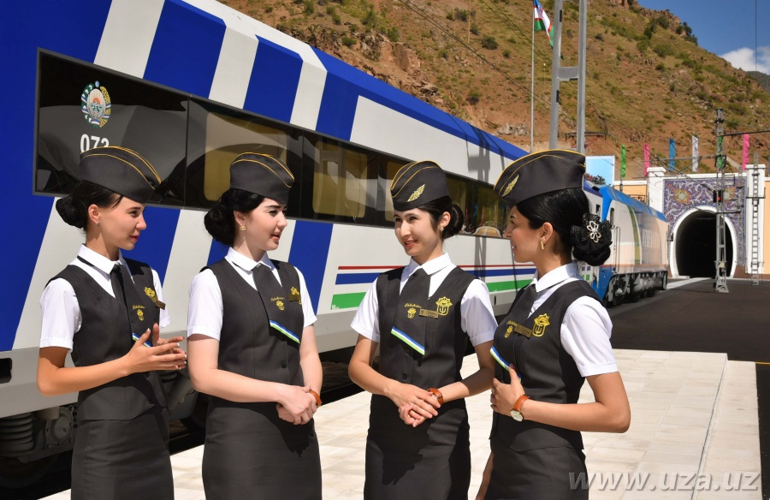
Рicture 5. Role of women in railway transport

- The project is being implemented on the basis of the following resolutions:
• Decree of the President of the Republic of Uzbekistan dated March 6, 2015 No. PP-2313 “On the Program for the Development and Modernization of Engineering, Communications and Road Transport Infrastructure for 2015-2019”;
• Decree of the President of the Republic of Uzbekistan No. PP-72 of December 30, 2021. "On approval of the Investment Program of the Republic of Uzbekistan for 2022-2026 and the introduction of new approaches and mechanisms for managing investment projects";
• Decree of the President of the Republic of Uzbekistan No. PP-2827 dated March 13, 2017 “On measures for the construction of the Bukhara-Miskin railway line”;
• Decree of the President of the Republic of Uzbekistan No. 5 dated 16.01.2023. "On measures to implement the Bukhara-Urgench-Khiva and Miskin-Nukus Railway Electrification Project together with ADB and AIIB banks."

- Institutional scheme. UTY, the executing agency (EA), has adequate staff, a track record of successful implementation of similar projects, and operation and maintenance of both electrified and non-electrified lines. The implementation mechanisms are based on the successful experience of implementing ADB railway projects in the country. On May 1, 2011, the Department for the Implementation of Electrification Projects (PIU-E) was established at UTY, which began to function in full in accordance with UTY's internal order No. 163 dated March 16, 2012. On December 6, 2018, based on the order of the First Deputy Chairman of the Board of UTY No. 2188-N, PIU-E merged with another PIU that had previously implemented projects for the purchase of rolling stock. PIU-E was renamed into Project Implementation Unit for Electrification and Renewal of Rolling Stock (PIU-ET).
- Project Implementation Unit for Electrification and Renewal of Rolling Stock (ERP-ET), established by UTY, has experience with ADB procedures and policies and will be responsible for project implementation. UTY's technical departments will also assist the PIU during project implementation. UTY will work in collaboration with National Electric Networks of Uzbekistan JSC (NENUz) and Regional Electric Networks (REN), which are energy companies responsible for supplying electricity from generating sources to consumers.
- Generating sources to consumers. The PIU-ET consists of 23 employees, including the head, two deputy heads, senior legal adviser, administrator, head of the technical department, three signalling and telecommunications specialists, three electrical supply specialists, one locomotive specialist, one environmental protection specialist, head of the finance department, one accountant, one economist, one head of the monitoring and procurement department and two procurement specialists. PIU-ET employees have experience in implementing projects financed by international financial institutions, including those financed by ADB. International and national experts are involved as consultants on engineering and construction supervision. The terms of the contract include design and construction work, so the role of engineering and construction supervision consultants is to manage contracts with PIU-ET and provide hands-on training in procurement, project management and supervision, operation and maintenance, and reporting.
- International and national experts are involved as consultants on engineering and construction supervision. The terms of the contract include design and construction work; therefore, the role of engineering and construction supervision consultants is to manage contracts with PIU-ET and provide hands-on training in procurement, project management and supervision, operation and maintenance, and reporting.
- The institutional schedule of the PIU-ET and IA is shown in Pictures 6 and 7 below:

ADB
Ministry of Finance
UTY
(
Executing Agency)
Project Implementation Unit for Electrification and
Renewal of Rolling Stock
Engineering and
Construction Supervision
Consultants for Current
Project
G
oods contractors for
external power supply,
OCS, and maintenance
machinery.
Plant contractors for
signaling and
telecommunications,
traction substations and
SCADA

Project
Agreements
Memorandum of
Understanding
Uzbekenergo,
subsequently JSC
“National Electric
Networks of Uzbekistan”

PIU
-
ET

Team

•
Head (1)
•
Deputy heads (2)
•
Senior legal counsel (1)
•
Administrator (1)
•
Head of Technical Department (1)
•
Signaling and telecommunications
specialists (3)
•
Power supply specialists (2)
•
Head of locomotive procurement (1)
•
Locomotive lead specialists (2)
•
Locomotive specialist (1)
•
Environmental protection specialist (1)
•
Head of financial department (1)
•
Accountant (1)
•
Economist (1)
•
Head of monitoring and procurement
department (1)
•
Procurement specialists (3)

Loan Agreements
Relending Agreements
Engineering and
Construction Supervision
Consultants for Additional
Financing

Goods contractors for
maintenance machinery.
Plant contractors for
signaling and
telecommunications,
traction substations,
video surveillance
system, and CTC
upgrade

Picture 6. Institutional scheme

Picture 7: Organizational structure of PIU-ET

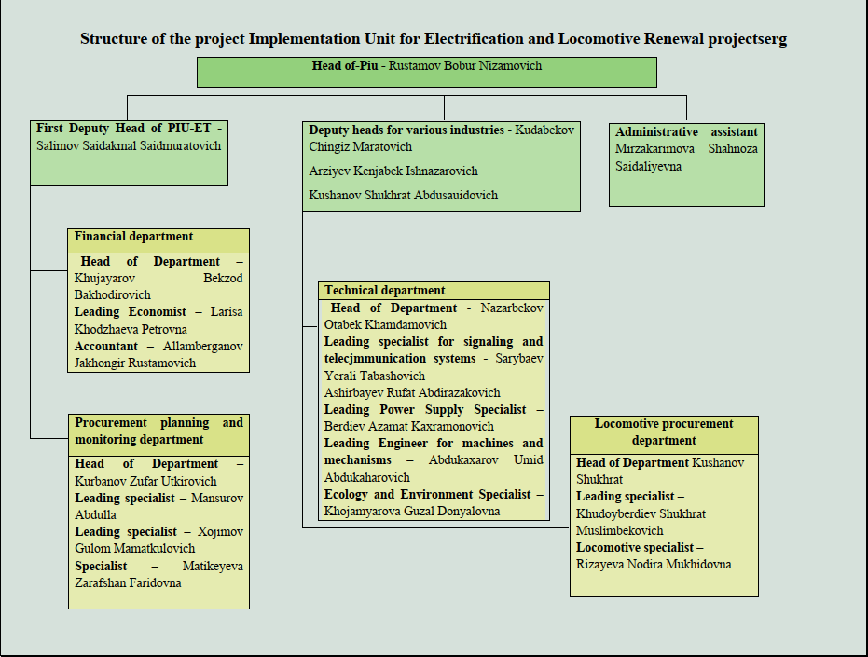

Project contracts and management
- The consulting company DB Engineering & Consulting GmbH (hereinafter referred to as PE DB E&C) has been hired to provide project supervision consulting (PSC).
- The task of the services is to provide support to UTY at several stages of project implementation: development of tender documentation; support during the bidding process; viewing drawings developed by UTY and/or contractors; supervision and control of construction works, technical, commercial, and timely implementation of projects; interface management; supervision of construction; claims management.
- In addition, the Consulting Company conducts training for UTY personnel after the implementation of the upgraded train control and management system.
- During the procurement stage, the Consulting Company will support the preparation of technical specifications and bidding documents in accordance with the Open Competitive Bidding (OCB) procedures, in accordance with the ADB Procurement Policy and Procurement Standards and taking into account the package of contracts based on the Procurement Plan approved by ADB. In the course of this task, the Consulting Company provides continuous assistance to the PIU in the overall procurement process by attending all meetings with contractors and contract negotiations.
- During construction supervision, the Consulting Company will supervise the execution of works by checking the work of the Contractors to ensure compliance with the project schedule, budget, quality and safety requirements, including environmental requirements.
- The National Environmental Expert will carry out the tasks assigned by the Team Leader and assist the PIU, especially its Environmental Specialist. The Environmental Specialist shall (i) monitor Contractors’ compliance with the mitigation measures in accordance with the EMP for Contractors for both ADB and UTY financed activities throughout the activity and report the results to the consultant team leader, PIU-ET, staff and to ADB in writing; (ii) advise and approve Contractors Site-Specific EMPs prior to submission to the PIU for approval prior to commencement of physical works; (iii) prepare an Environment, Health and Safety (EHS) section in the monthly and quarterly project progress reports; (iv) assist PIU-ET in updating the IEE/EMP as needed; (v) assist PIU-ET in the preparation of semi-annual environmental monitoring reports in accordance with ADB requirements; and (vi) conduct a brief training program on environmental protection for the PIU's labor protection staff and contractors' environmental specialists.
- The main organizations involved in the project and the key specialists in these organizations who are responsible for monitoring the implementation of environmental protection measures are presented in Table 2 below.

Тable 2. Personnel associated with the implementation of environmental protection measures
Type of project participant | Agency/company name | Position | Name | Email
Executive agency | JSC «UTY» | Project Manager |  | utypiu@gmail.com
 |  | Environment Specialist | Xodjamyarova Guzal | +998 99 877 22 10  guzal7123@gmail.com
Project supervision consultant | PE DB E&C | International Environment Specialist | Said Muhammad Latif
 |  | Environment Expert | Bekmirzaeva Karina | +998 90 1689997  bekmirzaeva_k@mail.ru
Contractor At the stage of concluding a contract | JSC “Uzelektroapparat-Electroshit” (expected) | Manager | Хashimov Kudrat | +998 93 380 99 60  Kudrat.KHoshimov@uzea.uz
Contractor At the stage of concluding a contract | LLP  "Temirzhol Zhondeu” (expected) | Manager | Shitikov Timur | +998 90 983 65 85  timur.shitikov@gmail.com

Project activities for the current reporting period

Since no construction work was carried out during the reporting period, environmental control over construction performance was not carried out.

Description of any changes in the design of the project

There were no changes for CAREC Corridor 2 during the reporting period. Preparatory work has been carried out by UTY on the transfer of land plots to the Contractor for the construction of traction substations in accordance with the requirements of the ADB. Construction work has not started.

Description of any changes to agreed construction practices

Since the construction work has not yet started, no changes have been made to the agreed construction method.
Тable 3. Summary of upcoming civil works contracts and progress
Package | Scope | Contractor | Contract signing planned | Date of approval |  |  | Name of personnel |  | Construction works |  |  | Progress as of (%)
 |  |  |  | SSEMP | HSMP | ERP | Environmental Officer | Health and Safety Officer | Start | End | DLP | 31 January 2023 y. | 31 December 2023 y.
 | Planned construction of facilities: | JSC “Uzelektroapparat-Electroshit” (expected) | September 2023 y. | At the design stage | At the design stage | At the design stage | - | - | - | - | - | 0 | -
 | Planned design, supply, installation: alarm systems, communications and installation of SCADA systems | LLP "Temirzhol Zhondeu”  (expected) | September 2023 y. | At the design stage | At the design stage | At the design stage | - | -. | - | - | - | 0 | -
Note:
SSEMP = site-specific environmental management plan,
HSMP = health and safety management plan,
ERP = emergency response plan,
DLP = defect liability period.

3 Environmental measures

3.1 General description of environmental protection measures

CAREC Corridor 2 is at the design stage.
- Under this project, one national environmental specialist for the PIU and one international environmental specialist was selected. The activities carried out by the national environmental consultant during the monitoring period are presented in Table 4.
Тable 4. Environmental protection measures taken during the reporting period (January-July 2023y.)
Measures for environmental protection
- January - June and inclusive July 2023. A general environmental audit of the state of the project area was carried out by visiting and visual inspection (audit) of the sites Bukhara - Urgench - Khiva.

3.2 Аudit of objects

Since no planning and construction work was carried out within the framework of this project during the reporting period, a general audit (inspection) of the environmental monitoring facilities of Tables 4 and 5 was carried out during the reporting period.
Тable 5. Object audit
Date of visit | Auditor | Purpose of the audit | Summary of any significant findings | Letters issued after the audit
18.07.2023 -  21.07.2023 | K. Bekmirzayeva, national consultant of the PE DB E&C | Inspection of objects, collection of photographic materials | Landscaping of adjacent territories was revealed at two stations | Not needed at this stage

- Information on the conclusions based on the results of the on-site environmental audit at the work sites includes data on any identified circumstances. Below is information about the results.
- During the environmental audit, it was found that the existing single-track railway line Bukhara-Urgench-Khiva was put into operation in 2017 within the framework of the project "Construction of the Urgench-Khiva Railway Line" according to the parameters of category I of environmental impact. The subgrade is mainly composed of sandy clays and loess-like loams.
- Between the cities of Bukhara and Khiva there are ten railway stations: Bukhara, Yangiabad, Yakhshilik, Korlitog, Khizirbobo, Istiklol, Khazarasp, Dautepa, Bagat, Khanka, Urgench and Khiva. Most of the stations had already been built or rehabilitated before the start of the Project. There are also five junctions on the highway: Navbakhor, Parvoz, Kiyikli, Jayhun and Turon. As part of the Project, signaling, communication and SCADA systems will be installed at all stations and crossings.
- 27. More than two thirds of the alignment passes through desert and moderately populated areas. Although the railway line does not pass through any designated protected areas or buffer zones, about two-thirds of the line nevertheless passes through the Kyzylkum desert. The route also passes through settlements near Bukhara, the cities of Urgench and Khiva in the Khorezm region.
- Previously, the IEE has undertaken a Biodiversity Assessment (BA) and a Critical Habitat Assessment (CHA). According to the IEE, there are 6 key biodiversity areas and 3 protected areas within 10 km of the project site. One of the protected areas is the natural monument of Vardantsi (IUCN category III - natural monument or feature). It is located 2 km from the project site and no impact is expected. The assessment results also indicated the presence of several Important Bird Areas (IBAs) in the wider vicinity of the Bukhara-Miskin railway section. They are: (i) Khorezm fishery and adjacent lakes, located about 2.5 km west of the railway line, (ii) Karakyr lakes, located about 3 km to the south, (iii) Ayakagytma lake, located about 50 km to the southeast and the surrounding desert, and (iv) the Tudakul and Kuyumazar reservoirs, located about 21 km to the southeast. These wetlands are elements of the international IBA network, key habitats for many rare and common bird species. Accordingly, they have a significant impact on the species composition of the desert avifauna of the project area, supplementing it with wetland species. Since 2007, on the territory of more than 400 hectares, south of Lake Karakyr, there has been a breeding center for the beauty bustard "Emirati Breeding Center birds." The Center regularly releases bred birds into the wild. Since 2012, more than 10,000 Gubars have been released into the gypsum desert in the vast areas of the center, including 2382 birds in March 2019. Some of them are registered as nesting in the project area. Segments of the Kuldzhuktau lowland are located 7 km northeast of the Yakhshilik and Kiyikli railway stations. This is a nesting site for large birds of prey, which can be observed in the project area in search of food, as well as during migrations and movements. As noted in the IEE, the concentration of the bustard in the project area is mainly due to the existence of an artificial breeding center (Emirati Conservation Bird Centre), which will not be adversely affected by the project after mitigation measures are taken.
- Five of the eight TSSs will be in desert and semi-desert areas: Turon, Djakasai, Kiyikli, Parvoz and Navbakhor. Two TSSs will be in the settlements: Khazarasp and Urgench. The Bukhara TSS will be located on agricultural land.
- As part of the audit, it was found that in 2022-2023, work was carried out to improve the adjacent territories of existing stations to protect the atmospheric air. Examples are shown in Picture 8.
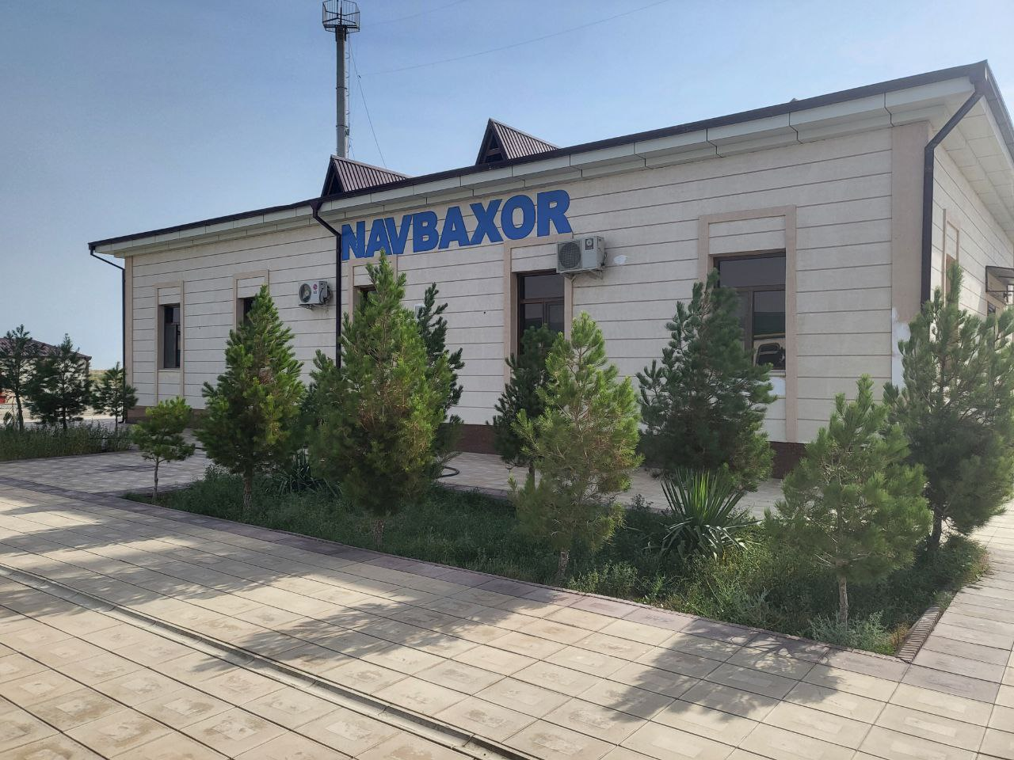 | 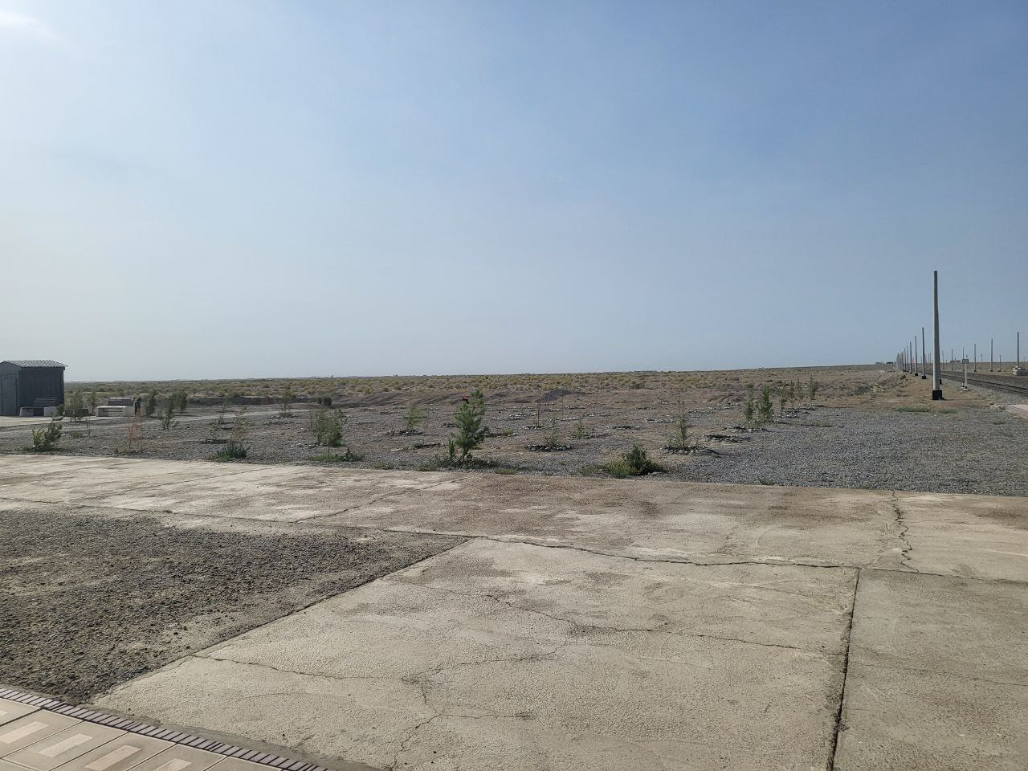 | 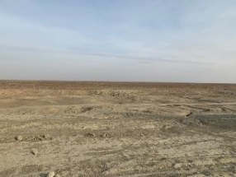
Navbahar Junction, July 2023 y. | Improvement of the adjacent territory, July 2023 y. | Planned site for the construction of TSS Navbakhor, July 2023 y.

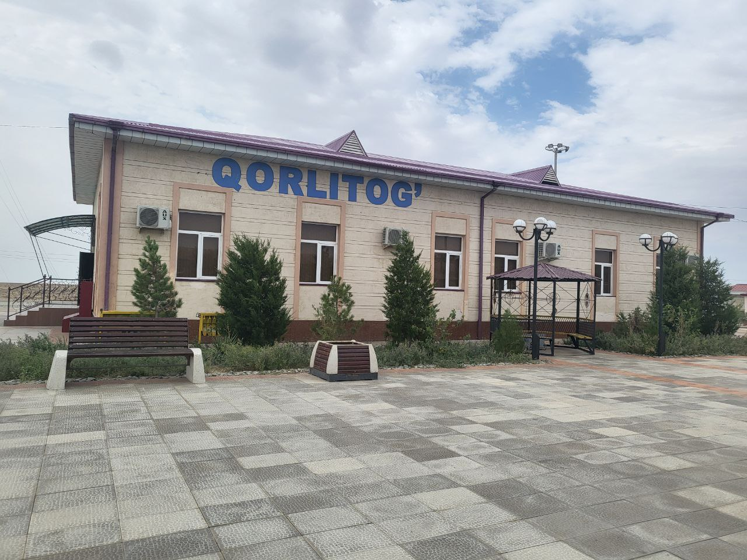 | 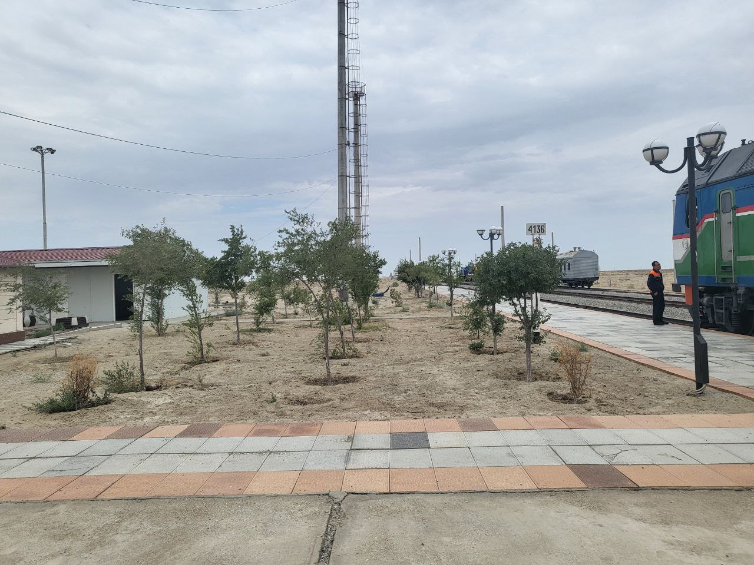 | 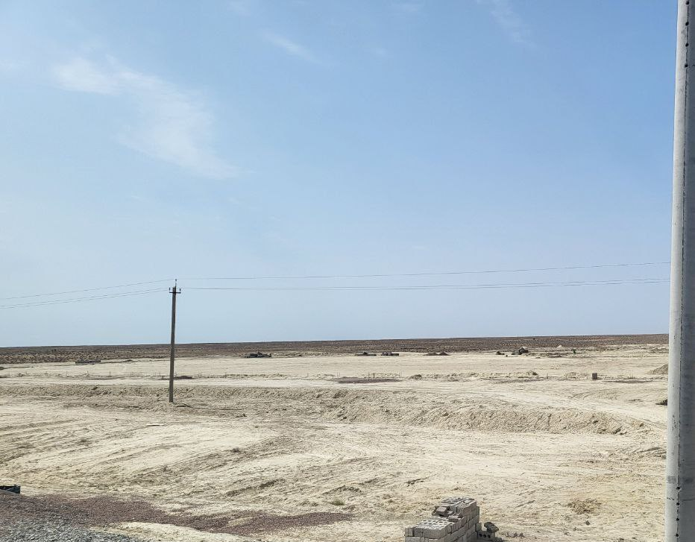
Korlitog Station, July 2023 y. | Improvement of the adjacent territory, July 2023 y. | Planned site for the construction of TSS Korlitog, July 2023 y.

Picture 8. Examples of improvement of the adjacent territory of existing stations.

3.3 Tracking issues (based on notifications of non-compliance)

- During the reporting period, planning and construction work was not carried out; therefore, no significant problems in the field of ecology and environmental protection were identified in the project areas.
Тable 6. Summary of issue tracking activities for the current period
Тable of results | Qty
The total number of questions on the project | 0
Number of open questions | 0
Number of closed questions | 0
Close percentage | 0%
Questions opened in this Reporting Period | 0
Questions closed in this reporting period | 0

3.4 Тrends
- This is the first SAEMR and environmental trends have not been systematically tracked for this project before.

3.5 Unintended environmental impacts or risks
- Unforeseen environmental impacts are not currently identified. Environmental measures are planned according to the EMP.

4 COMPLIANCE STATUS
- The status of compliance with environmental conditions in the Project Loan Agreement signed between the Republic of Uzbekistan and ADB on 6 August 2021 is summarized in Table 7.
Тable 7. Compliance status of the loan agreement
Schedule | Paragraph | Requirements | Compliance Status
4 | 3 | Terms of the contract  The Borrower shall ensure or instruct UTY to ensure that no contracts for performance of works involving environmental impacts are entered into until:  (a) the relevant environmental authority of the Borrower has given final approval to the IEE; And  (b) UTY has included relevant provisions of the EMP in the work contract. | At the conclusion of contracts, the conditions shall be met.
4 | 4 | Environment  The Borrower shall ensure or instruct UTY to ensure that the preparation, design, construction, implementation, operation and decommissioning of the Project and all Project facilities comply with (a) all applicable environmental, health and safety laws and regulations of the Borrower; (b) environmental safeguards – implementation of the EMP; and (c) all measures and requirements set out in the IEE (including, but not limited to, corrective action plans for Associated Facilities and Existing Facilities) and the EMP, as well as any corrective or preventive actions set out in the Safeguards Monitoring Report. | At this stage (design), compliance is ensured.  In accordance with national legislation, the project cannot be launched unless the feasibility study is approved by all government agencies associated with the project, including the Ministry of Justice, the Ministry of Construction, the Ministry of Health, the Ministry of Employment and Labor Relations, and the Ministry of Ecology, etc. All these bodies check the compliance of the project with all relevant regulatory documents and approve the feasibility study or issue their comments / observations before issuing a Presidential Decree on the implementation of the project. All measures and requirements set out in the IEE and EMP, as well as all corrective or preventive actions.
4 | 8 | Human and financial resources to meet safeguards requirements.  The Borrower shall provide or cause UTY to provide the necessary financial and human resources for the full implementation of the EMP; Social due diligence report, including the corrective actions set out in such report. | Complied.  The PIU hired one environmental and social specialist from UTY. The Environmental Specialist is responsible for the EMP portion of all UTY projects implementing ADB-financed projects. The supervisory consultant hired by the PIU includes national and international environmental consultants responsible for compliance with environmental, health and safety requirements.
4 | 9 | Guarantees - relevant provisions in contracts for bidding. Documents and contracts for the performance of work.  The Borrower shall ensure or instruct UTY to ensure that all bidding documents and works contracts contain provisions requiring contractors to:  (a) comply with the contractor related measures set out in the IEE, EMP and Social Due Diligence Report (to the extent they relate to the impact on the population affected during construction) and any corrective or preventive actions set out in ass Monitoring Report;  (b) provide a budget for all such environmental and social measures;  (c) provide the Borrower with written notice of any unanticipated environmental, resettlement, or Indigenous people-related risks or impacts that arise during the construction, implementation, or operation of the Project or Associated Facilities or Existing Facilities that have not been accounted for in the IEE, EMP, and Social Security Report. complex check;  (a) properly record the condition of roads, agricultural land and other infrastructure prior to the commencement of material transportation and construction; And  (b) upon completion of construction, put the paths and other local infrastructure in order at least to the pre-design condition, and carry out the reclamation of agricultural land. | Complied.  (a) The IEE and EMP are an integral part of all tender documents and work contracts and are included as appendices to contracts. Accordingly, contractors must unconditionally comply with the requirements of the IEE and EMP. All corrective or preventive actions are presented in the semi-annual environmental monitoring reports.  (b) Contractors' budgets partially include the required IEE and preventive measures. Despite this, contractors must comply with the requirements in accordance with national legislation.  (c) The Borrower will be informed of any unforeseen impacts. Since the continuation of the project is impossible without the decision of the Borrower  (d) Prior to commencement of work, the Contractor shall obtain permits from the State Railways under the Ministry of Transport with a preliminary selection of road inspectors. With regard to agricultural land and other infrastructure, governor of districts / cities make decisions with the permission of land users or land owners.  (e) All permits are issued only subject to restoration upon completion of work.
4 | 10 | Safeguard monitoring and reporting.  The Borrower shall do the following or instruct UTY to do the following:  (a) submit semi-annual safeguard monitoring reports to ADB and disclose relevant information from such reports to affected persons promptly upon submission;  (b) if any unforeseen environmental and/or social risks and impacts arise during the construction, implementation or operation of the Project, Associated Facilities or Existing Facilities that have not been considered in the IEE, EMP and Social Comprehensive Report, immediately inform ADB of the occurrence such risks or impacts, with a detailed description of the event and a proposed corrective action plan; And  (c) report any actual or potential violation of compliance with the measures and requirements set out in the IEE; EMR; Social due diligence report, including the corrective actions set out in such report, promptly after becoming aware of the violation. | In progress.  The Loan Agreement requires the submission of Safeguard Monitoring Reports in accordance with the IEE. The PIU submits semi-annual reports, as also agreed during the ADB safeguard missions.  - After the publication of the EMR on the ADB website, the reports are translated into Russian and then published on the website of the Executing Agency. The annual report for 2022 has been submitted.  Соmplied.  b) Between January and June 2023, there were no environmental risks and impacts due to the lack of construction activities.  c) Complied with - about all actual or potential violations of compliance with the measures and requirements set out in the IEE; EMP will be reported immediately; Social due diligence report, including the corrective actions set out in such report, promptly after becoming aware of the violation.
4 | 11 | Forbidden list of investments.  The Borrower shall ensure and oblige UTY to ensure that no proceeds from the Loan are used to finance any activity included in the list of prohibited investment activities set out in Appendix 5 of the SPS. | Completed.  The proceeds of the loan are not used to finance any activity included in the list of prohibited investment activities in accordance with Appendix 5, SPS.
4 | 12 | Labor standards, labor protection and safety.  The Borrower shall ensure and oblige UTY to ensure that basic labor standards and applicable laws and regulations of the Borrower are observed during the implementation of the Project. The Borrower shall ensure that UTY's bidding documents and contracts financed by ADB under the Project include specific provisions requiring contractors to, among other things: (a) comply with applicable labor laws and the Borrower's regulations and include applicable workplace health and safety regulations; b) not use child labor; (c) not discriminate against workers in respect of employment and occupation; (d) not use forced labor; (e) allow freedom of association and effectively recognize the right to collective bargaining; and (f) disseminate or engage appropriate service providers to disseminate information about the risks of sexually transmitted diseases, including HIV/AIDS, to contractors employed by the Project and to members of local communities surrounding the Project area, in particular women. | Соmplied.  The project is implemented in accordance with basic labor standards and applicable laws and regulations. Relevant provisions are included in the tender documentation and contracts for the performance of work with contractors.
4 | 13 | The Borrower shall strictly enforce the requirements set out in paragraph 12 above and provide regular reports to ADB. | Сomplied.

5 ENVIRONMENTAL MONITORING RESULTS

5.1 Overview of monitoring carried out during the current period
- The project activity is currently in the preparation phase. Thus, monitoring of environmental indicators has not yet been carried out. At the same time, a general audit of the project area was conducted.
5.2 Air quality monitoring
- N/D

5.3 Noise
- N/D

5.4 Vibration
- N/D

5.5 Water quality monitoring
- N/D

5.6 Topsoil management and soil pollution
- N/D

5.7 Waste generation
- N/D

5.7.1 Non-hazardous waste
- N/D

5.7.2 Hazardous waste
- N/D

5.8 The conditions of the construction camp for workers
- N/D

5.8.1 Storage of construction materials on the site
- N/D

5.8.2 Refuelling station N/A
- N/D

5.9 Health and safety
- N/D

5.9.1 Health and safety of population
- N/D

5.10 Use of material recources
- N/D

5.11 Covid-19 activities
- N/D

5.12 Tracking system and complaints
- N/D

5.13 Тrainings
- N/D

5.14 Implementation of the environmental management plan
- For this report, two Environmental Management Plans (EMPs) have been developed in accordance with the IEE, as two different construction work packages will be used for this project:
- (i) for railway electrification and construction of traction substations, and (ii) for construction of external power supply lines. Thus, two different EMPs will be included in the tender documents for contractors.
- The status of compliance with the environmental management plan (EMP) approved under the project IEE for June 2023 is presented in Table 8 below.
1. EMP for railway electrification and construction of traction substations

Таble 8: Environmental management plan for contact network, traction substations, signaling, communication and SCADA systems
№ | Impact | Mitigation measure | Responsibility | Сost
Pre-construction stage
1 | Collection of various potential environmental impacts as a result of changes in project documentation, schematic plans. | 1. Update or Prepare  new IEE document,  which shall be completely comply with the Statement ADB on Safeguard Policy  measures (2009). | Specialist ecologist PIU-ET  with the assistance of the Consultant PE DB E&C | Included in the budget of the Consultant PE DB E&C and PIU-ET
2 | Lack of relevant environmental requirements | 2. Ensure that environmental measures along with the EMP are included in bidding documents and contracts for contractors;  3. When evaluating proposals, consideration shall be given to: the ability of bidders to comply with the EMP requirements, to propose adequate budgets for the effective implementation of the EMP, and the existence of best practices in environmental performance with other similar projects;  4. Within 30 days of contract award and prior to commencement of any physical work, Contractors will develop Site Specific Environmental Management Plans (SSEMPs) under the guidance of the Consultant, and once approved by the Consultant, submitted to PIU-ET; | Specialist ecologist PIU-ET  with the assistance of the Consultant PE DB E&C | Included in the budget of the Consultant PE DB E&C and PIU-ET
3 | Use of unauthorized quarries | 5. Selected contractors need to locate the nearest licensed pits and enter into agreements for the supply of inert materials in the prescribed manner (Ministry of Mining and Geology, Ministry of Natural Resources); | Contractors provide documents to the Consultant of the PE DB E&C, the Consultant checks for permits | Included in contractor's budget
4 | Non-compliance of purchased machines with national regulations for equipment and machines | • Ensure purchased vehicles and fuels comply with the Euro 4 emission standard; | Consultant PE DB E&C, PIU-ET | Included in contractor's budget
5 | Non-compliance of Goods Procurement Procedures with ADB Safeguard Policy Statement (2009) | • Ensure that the procurement of goods under the project shall be carried out in accordance with the Prohibited List  investment activities of ADB set out in Appendix 5 of the Security Policy Statement (2009). | Consultant PE DB E&C, PIU-ET | Included in the PE DB E&C Consultant budget and in the PIU-ET budget
6 | Improper development of the EMP and EMP for a specific work site | • The final design decisions for the Khazarasp TSS shall be agreed with the Khazarasp District Water Resources Management to avoid negative impacts on surrounding buildings and crops; | Contractors prepare documentation, PE DB E&C consultant checks, PIU-ET approves
7 | Improper preparation of the Environmental Management Plan for the construction site by the contractor | Development of specific guidelines for implementation as part of the SSEMPs such as; (i) spill response plan; (ii) dust management and control plan; (iii) noise management plan; (iv) Waste and Spoil Management Plan including Hazardous Waste/Materials Management Plan; (v) worker’s camp site management plan; (vi) traffic management plan; (vii) prevention and control measures for biodiversity management, (viii) safety management during stringing; (ix) chance find procedure, (v) COVID-19 health and safety management plan and emergency response plan; etc. depending on the scopes and anticipated impacts. | Consultant PE DB E&C | Included in the PE DB E&C Consultant budget and in the PIU-ET budget
Construction stage
1 | Impact on air quality | - Apply watering of TSSs’ construction sites and other construction sites located close to settlements during windy weather and in the dry season;  - During building/facility renovations and signaling and telecom system installations, apply watering to construction sites during windy weather and in the dry season;  - Ensure that all vehicles and equipment comply with national standards on gas emissions (“O’z DSt 1057:2004 Vehicles. Safety requirements for technical conditions” and “O’z DSt 1058:2004 Vehicles. Technical inspection. Method of control”);  - Cover all piles of soil, sand and gravel that will not be used within the next 24 hours to prevent dust generation;  - Cover transported bulk materials;  - In case of the need to demolish the roof during the installation of signaling and telecom systems at the Hazarasp station, conduct works in accordance with an AMMP;  - Vehicle speeds will be restricted on construction sites and access roads;  - All construction machinery and equipment will be maintained in good working order and not left running when not in use;  - A Project OHS Management Plan will be implemented to ensure that project workers are protected from dust and emission impacts, for example by wearing dust masks when working in or near dust generating activities;  - No burning of any material anywhere on or near construction sites | Realized by contractors.  PIU-ET and Consultant PE DB E&C monitor the implementation | Included in the Contractors budget
2 | Noise and vibration | - Inform populations of settlements close to construction sites in advance about construction works;  - The operation of heavy equipment will be conducted between 7 am and 7 pm only and be undertaken intermittently not continuously;  - In case of receiving any complaints from population, additional noise measurements will be conducted, and in case of exceeding established standards, additional mitigation actions for decreasing noise levels need to be undertaken (such as establishing temporary sound absorbing barriers, installing special equipment on noisy machinery and others);  - Schedule construction so as to minimize the simultaneous use of the noisier equipment near sensitive receivers;  - Considering fact that TSS detail final design will be ready later and actual work area of techniques generating noise exceeding standards may change, and as consequences noise level may decrease, it is proposed to conduct baseline noise measurements before construction and in the beginning construction in front of living houses. In case of exceeding norms for daytime (55 dB), establishment of additional acoustic barrier will be required (with heigh of 4 meters). It is anticipated that installation of acoustic barrier will be needed only in Hazarasp TSS;  - Conduct noise measurements in front of residential houses in Urgench depots before and during construction. In case of exceeding standards, it will be necessary to install acoustic barrier.  - Use of Personal Protective Equipment (PPE) by workers involved in construction works in conditions of increased acceptable noise level (for situation when equivalent sound level over 8 hours reaches 85 dB(A), the peak sound levels reach 140 dB(C), or the average maximum sound level reaches 110dB(A), workers should use hearing protection equipment. | Realized by contractors.  PIU-ET and Consultant PE DB E&C monitor the implementation | Included in the Contractors budget
3 | Pollution of surface and ground water | - Ensure that location of Hazarasp TSS will not impact on the local drainage system. It will be achieved through correction of location TSS or re-allocation of existing drainage canal (on 30-50 meters);  - Construction and labor camps, including the storage places for lubricants, fuel and other oils will be located 100 m away from water bodies;  - If the washing of vehicles and equipment is planned at the labor/construction camp sites, appropriate wastewater treatment facilities will be organized on the camp and in specially designated areas. The maintenance area should be provided with oil and grease traps to prevent oil from being washed into offsite drainage canals.  - Activities relating to refueling, oil replacement or repair works will be prohibited within 100 m of surface water courses;  - Sanitary water and solid waste will not be released directly into surface water streams or other water resources. Adequate on-site sanitation facilities with septic tanks should be provided in order to prevent untreated sewage from being channeled into the drainage canals, irrigation canals, and rivers and other water resources.  - Topsoil stripped material will not be stored within 100m of water bodies or in areas where natural drainage will be disrupted;  - In case the drilling of wells is necessary for technical or drinking purpose use, relevant drilling and water use permissions will be received from relevant authorities - State Committee on Geology and Mineral Resources and State Committee on Ecology and Environment Protection.  - Management and storage of fuel, waste oil, hazardous waste will be planned in accordance with the IFC EHS General Guidelines on Hazardous Materials Management. This includes the use of appropriate secondary containment structures capable of containing the larger of 110 percent of the largest tank or 25% percent of the combined tank volumes in areas with above-ground tanks with a total storage volume equal or greater than 1,000 liters.  - Remove topsoil (about 30 cm depth) and store separately during the excavation works, and afterwards, use soil for filling trenches and foundations excavations;  - Use surplus soil generated during the construction of TSSs at the same substations for the creation earth bed for equipment or landscaping adjusted areas;  - Use only authorized carriers with getting all necessary permissions from respective national agencies (SCEEP, khokimiyats);  - In case of necessity to open new carrier for construction materials, obtain all necessary permissions and certificates. Ensure their proper restoration after completion project works;  - Storage and handling of hazardous materials, chemicals, fuels and oils in specially equipped places;  - Provide spill prevention and control kids on each construction site;  - Ensure regular maintenance of vehicles and machinery. | Realized by contractors.  PIU-ET and Consultant PE DB E&C monitor the implementation | Included in the Contractors budget
4 | Impact on biological resources | Impact on flora  - In case of conduction construction works during spring time, examine project area on presence of the plants included into the Red Book, reallocate or pay compensation in accordance with Resolution # 299 of the Cabinet of Ministers of the Republic of Uzbekistan dated 27 October, 2014 “On regulating biological resources use and realization of licenses procedures for use of flora and fauna sites”;  - Landscaping and revegetation of territories of the traction substations will be implemented in fully compliance with project technical specifications;  - Do not apply chemicals for removing vegetation from the sites;  - Ensure that all construction works will be implemented within the territory of stations and allocated traction substations.  - Worker awareness and training sessions in relation to the protection of local flora  - Conduct land leveling of areas where soil was extracted for construction purposes in order to avoid attracting migrating birds and other rare species of animals and cause their death at railway facilities;  - Install markers on catenary system’s wires if required (based on findings of baseline monitoring of birds);  - Conduct regular trainings for construction workers and maintenance personnel of the railway line:  - On the protection of the Central Asian tortoise, grey monitor lizard, boa constrictors, houbara bustard and long-tailed hedgehog;  - on danger of desert rodents  - On the benefits of snakes and rules of behavior when encountering them.  - Complete all construction outside the breeding bird season (April-June) and/or complete a nesting bird check (including ground nesting birds) prior to any ground disturbance. This measure is mostly related to the construction of Yoshlik and Parvoz TSSs;  - The construction of the temporary access roads and the distribution lines close to the breeding center should be completed outside the nesting period.  - Implement Good International Industry Practice (GIIP) during construction, including a ban on hunting and live capture by construction workers and awareness training. | Realized by contractors.  PIU-ET and Consultant PE DB E&C monitor the implementation | Included in the Contractors budget
5 | Impact on land use | - All construction works will be implemented within allocated lands;  - Prohibit the use of unauthorized carriers for construction materials. | Realized by contractors.  PIU-ET and Consultant PE DB E&C monitor the implementation | No expenses
6 | Waste generation | Non-hazardous wastes  - Segregate wastes into recyclable and non-recyclable wastes;  - Conclude agreements with relevant agencies (Hokimiyat, Vodokanal and etc.) on solid and liquid wastes disposal;  - Provide hydro-isolated septic tanks for the collection of wastewater at the camp sites, and bio-toilets for workers at construction sites, and ensure the timely disposal of wastewater into local wastewater municipal systems.  - Sell or donate recyclable wastes to relevant organizations and ensure timely disposal (each 3 days) of non-recyclable wastes;  - Prohibit the burning of waste on any construction site.  Hazardous wastes  - Prior to the commencement of rehabilitation works on demolishing existing buildings, PIU-ET EPS with the contractor’s manager, EMO and HSO will conduct observations of old buildings and facilities regarding the presence of asbestos materials;  - In case of the presence such materials, Attachment 2. Asbestos-Containing Materials Management Plan will be implemented by the respective contractor;  - Conduct vehicle refueling, oil replacement and other similar activities in specially designated and properly equipped places. Emergency facilities and procedures will be in place for the reduction of accidents and oil spills. | Realized by contractors.  PIU-ET and Consultant PE DB E&C monitor the implementation | Included in the Contractors budget
7 | Impact on Socio-economic resources | Increase public awareness among the population on the project area through communication and informing the public in advance about project works;  Involve local workers in the project works where specific qualifications are not required. | Realized by contractors  PIU-ET and Consultants (Social and Safety Specialist) PE DB E&C monitor implementation | Included in the PE DB E&C Consultant budget
8 | Health and safety risks | Community Heath and Safety  - Contractor and PE DB E&C Consultant will inform the population about anticipated works in each settlement in advance;  - Contractors will be required to develop traffic management plans, with clear indications of routes for vehicle movements, the placement of special signs, speeding restrictions inside of the settlements (30 km/h), and a schedule of transportation activities to assist to mitigate peak traffic periods;  - Clear signs will be placed at construction sites in view of the public, warning people of potential dangers such as moving vehicles, excavations etc. and raising awareness on safety issues.  - All construction sites, trenches and ditches will be properly lightened and fenced;  - Site Specific Plans for campsites will be developed by Contractors;  - Carry out regular awareness campaigns among work staff, including specific hazards associated with the spread of HIV/AIDS.  - To avoid cases of gender-based violence and sexual exploitation and abuse, each Contractor will have to develop and implement a Code of Conducts | Realized by contractors  PIU-ET and Consultants (Social and Safety Specialist) PE DB E&C monitor implementation | Included in the Contractors budget
9 |  | Occupational Health and Safety  General  Contractors will develop an Occupational Safety and Health Plan (OSHP) based on EHS General Guidelines (footnote 7);  Contractors will conduct training for workers on EHS and SSEMP implementation;  Contractors will ensure proper implementation of OSHP and SSEMP by all workers.  Fiber cable laying works  All employees performing any splicing or termination activities should always wear safety glasses with side shields. Any other employees or site managers entering the work area will wear safety glasses with side shields also;  Unless an employee is absolutely sure there is not a light source at the other end, they should never look directly into the end of the cable. A power meter will be used to make certain the fiber is dark;  While working with fiber optics, the worker needs a well-ventilated and well-lit work area;  All food and beverages will be kept out of the work area. Workers can wear disposable aprons to keep fiber particles off their clothing. Before leaving the work area, an employee will always check their clothing for pieces of stray fiber, and if any are found, they can remove it with double-sided tape;  A worker will wash their hands thoroughly before touching their eyes, and contact lens wearers should wash their hands before touching their lenses. Workers should also read all instructional material before handling chemicals;  A disposable container that will be tightly closed must be used for fiber scraps. When finished with a fiber optic job, all cut fiber pieces will be disposed of properly along with any used chemicals and containers. The work area will be thoroughly cleaned when job is completed. | Realized by contractors  PIU-ET and Consultants (Social and Safety Specialist) PE DB E&C monitor implementation | Included in the Contractors budget
10 |  | COVID-19 risks  Appropriate sanitary precautions will be taken if cases are identified, such as masks, additional ventilation, social distancing. | Realized by contractors  (if necessary) | Included in the Contractors budget
11 | Establishment and operation of Construction camps. | Develop worker’s camp site management plan in reference to World Bank Group’s Workers' Accommodation: Processes and Standards, as part of the SSEMP, and implement;  select location of the camp sites to ensure least possible conflict with local population - e.g., at a distance from where population density is high;  ensure that construction camps are located 50 m away from irrigation canals;  Inform the closest local community (if any) in advance about planning activities. | Realized by contractors
12 | Impact on Physical Cultural Resources | Excavation and other works will be suspended immediately;  Area with possible heritage will be fenced with fencing tape;  A designated focal point from a local administration (khokimiyat) will to be informed and invited to assess potential heritage and undertaken necessary actions;  Civil works at the finding place will be recommenced after obtaining permission from the focal point (deputy governor of relevant district). | Realized by contractors  PIU-ET and Consultant PE DB E&C monitor the implementation  The representative of the khokimiyat assists in the assessment and takes the necessary actions | Included in the Contractors budget
13 | Construction sites and areas used for construction camps without proper cleaning and reinstatement works | After completion of the main construction, the Contractor will provide full reinstatement of the construction and camp sites by bringing them to their primary condition;  All rubbish, or temporary structures (such as buildings, shelters, and latrines) which are no longer required will be removed;  All hardened surfaces within the construction camp areas will be ripped, all imported materials removed;  PE DB E&C Consultant will conduct a post-construction audit during defect liability periods to ensure that construction sites and camps are properly cleaned and restored to pre-project conditions before the acceptance of works and hand-over to the Kokand Regional Departments of UTY, which will be responsible for the operation and maintenance of the electrified railway.  After completion of works, all roads will be rehabilitated at least up to condition of pre-construction stage. | Realized by contractors | Included in the Contractors budget
Operation phase
1 | Noise and vibration | Conduct noise modeling if daily frequency of trains exceed the number used in the model for this IEE (30 trains per day).  In case of a significant increase of the number of trains in the project zone, additional instrumental measurements near sensitive receptors will be necessary, and if the noise levels exceed the current level by 3 dB or more, additional mitigation measures must be developed and implemented as recommended in Chapter V.C.1: (i) use special seals for rails, (ii) improvement of embankment through using coarse fraction of crushed stone, (iii) rails and wheel turning will be implemented 5.3.4.1.  If the number of trains traveling across the project zone increases, the train traffic schedule is desirable to develop in the way as to limit their traffic across the project zone to day time hours. | NOKS with assistance of the National Design Institute “Boshtransloyiha” who developed national Feasibility Study  In case of exceeding of noise level, NOKS will undertake additional measures | Included in BRD/KRD budget
2 | Impact on water resources | Conclude agreements with local Suvoqova regarding the disposal of domestic wastewater from stations and TSSs;  Verify that UTY, as the maintenance company ensures that wastewater is not discharged into water bodies without treatment;  Washing equipment will be prohibited on the territory of the traction substations;  Rail car maintenance will be allowed only in specially equipped depots (Bukhara and Khiva). | BRD and KRD | Included in BRD/KRD budget
3 | Soil pollution | Ensure that only authorized carriers are used in the supply of construction materials from borrow pits;  All types of wastes from TSSs will be disposed of in a timely manner in accordance with procedures approved by national agencies. No wastes will be buried;  Ensure that the maintenance of vehicles and machinery, the use, storage and handling of chemicals, and the management of wastes, are implemented only in designated and specially equipped areas. | BRD and KRD | Included in BRD/KRD budget
4 | Impact on Biological resources | Impact on flora  Implement integrated vegetation management (IVM). From the edge of the track area to the boundary of the right-of-way, vegetation will be structured with smaller plants near the line and larger trees further away from the line, to provide habitats for a wide variety of plants and animals;  Native species will be planted, and invasive plant species removed;  Maintenance clearing in riparian areas will be avoided or minimized.  Impact on fauna  Suspension insulators of power supply of the electric train throughout the whole length and horizontal structures on traction substations must be equipped with bird protection devices (BPD).  If for railway maintenance opening of new borrow pits for extraction of soil will be required, all opened borrow pits have to properly cultivated in order to prevent the formation of permanent or seasonal reservoirs, which will attract migrating birds and other rare species of animals and cause their death at railway facilities;  It is recommended to install CCTVs to monitor the movement and safety of wild animals at crossings under the railway line;  It is recommended to conduct regular extermination of rodents in the vicinity of the Bukhara-Misken railway. The measures to reduce the number of rodents is effectively carried out by the road anti-plague station (RAPS), which is part of the medical service of UTY. These measures will contribute to the epidemiological safety of the population and significantly reduce the risk of bio-injuries. The absence or low number of rodents along the railway line will also significantly reduce the risk of death of predatory birds on power lines.  It is necessary to conduct regular trainings for construction workers and maintenance personnel of the railway line:  On the protection of the Central Asian tortoise, grey monitor lizard, boa constrictors, houbara bustard and long-tailed hedgehog;  On the benefits of snakes and rules of behavior when encountering them;  In order to perform the abovementioned actions efficiently, a qualified EWS-NBS who will conduct monitoring of birds’ migration and will work with PIU-ET will be hired; | BRD and KRD | Included in BRD/KRD budget
5 |  | Involve the road anti-plague station (RAPS), which is part of the medical service of UTY to implement measures to reduce the number of rodents. | BRD and KRD  and media agencies | Included in BRD/KRD budget
6 | Waste generation | Non-hazardous  It recommended to introduce a waste recycling program, including the placement of waste-labeled containers in each station and each train for improved segregation and further disposal;  The UTY will ensure that waste collection and its disposal from passenger trains is being implemented properly, and that liquid wastes are not discharged during train stops;  Agreements on waste collection and disposal will be concluded between local khokimiyats, waste management entities and railway stations and track substations; | BRD and KRD | Included in BRD/KRD budget
7 |  | Hazardous  To avoid soil pollution, all oil replacement works will be conducted in compliance with the JSC ‘Uzbekenergo’ instruction “RH 34-301-941: 2007 Individual consumption rates of transformer oil for the repair and maintenance needs for equipment of power facilities”;  Spare oil has to be storage in properly organized places with concrete floors and covers;  Oil used in transformers will be free from oil. | BRD and KRD | Included in BRD/KRD budget
8 | Health and safety risks | Occupational Health and Safety  UTY will ensure compliance with all safety requirements indicated in all relevant documents indicated in previous paragraphs;  Mitigation measures relating to the repair or replacement of fiber cable are indicated in #75- #80 of this table.  All measures related with COVID-19 has to applied in accordance with relevant national regulations.  General rail operation safety  Conduct awareness program on a regular base, which will include among others such topics as: impact of electromagnetic fields, electrocution, and risks related to fast moving trains;  Prepare spill prevention and control, and emergency preparedness and response plans, based on an analysis of hazards, including the nature, consequence, and probability of accidents;  Install automatic gates at all level crossings, and regular inspection/maintenance to ensure proper operation;  Fulfill occupational and community health and safety requirements as indicated in national and international standards documents;  It is recommended to consider the density of population in the project area during safety assessments and the necessity of additional passages. | UTY, BRD, KRD and media agencies | Partly included in PE DB E&C Consultant contract

2. EMP for external energy supply

Table 9: ENVIRONMENTAL MANAGEMENT PLAN FOR CONSTRUCTION EXTERNAL POWER SUPPLY
№ | Impact | Mitigation measure | Responsibility | Cost
Pre-construction stage
1 | Impact on biological resources | 1. Carry out pre-construction monitoring during the migration season (late April, May and September-October) to identify additional sites for marker installation. | EWS-NBS | Included in EWS Consultant budget
2 |  | - move the alignment of the external power supply line away from the Asian Houbara breeding center westward, to ensure a 4km distance between them. [Note: this action was agreed in consultation with the Asian Houbara breeding center staff, who confirmed that this will minimize possibility of released birds from hitting the line]  - Move the alignment of the external power supply lines so that they are sufficiently outside of IBAs  - Bundle the new external power supply lines with existing ones to make both easier to see from birds.  - Design in bird protection markers on external power supply line at key locations (i.e. near IBA)  - Design in anti-electrocution insulators on catenary system at key locations (i.e. near IBA) | UTY, PIU-ET and Contractors | Included in Contractor budget
3 | Generation of unanticipated environmental impacts due to changes in design, layout | - Ensure that environmental provisions along with EMP are included in the bidding documents and contracts for Contractors  - Update IEE to be prepared with full compliance of ADB SPS;  - Update LARP for 110kV and 220 kV as per detail design. All activities related to land acquisition and compensation payment will be completed prior commencement of construction works. | PIU-ET EPS assisted by EWS Consultant | Included in EWS Consultant and PIU-ET budgets
4 | Cutting down trees without permission | - Upon completion of Project Detail conduct survey of route of construction of 110 kV and 220 kV HV lines for identification type and number of trees for cutting;  - Obtain official permission for cutting trees from the SCEEP and conduct payment of defined compensation | Contractor together with representatives of SCEEP | Survey expenses are included in PIU-ET and Contractor budgets
5 | Use of illegal quarries | 11. Determine the location of the nearest licensed quarries and conclude contracts for the supply of inert materials in the prescribed manner. | Contractors | Included in contractor's budget
6 | Non-compliance of goods procurement procedure with ADB SPS | 12. Ensure that goods procured for project implementation will be done in compliance with ADB Prohibited Investment Activities List set forth at Appendix 5 of ADB SPS. | EWS Consultant, PIU-ET | Included in EWS Consultant and PIU-ET budgets
7 | Contractor’s inadequate preparation for construction works. Absence of Topic Specific EMPs | 13. Development of specific guidelines for implementation as part of the SSEMPs such as; (i) spill response plan; (ii) dust management and control plan; (iii) noise management plan; (iv) Waste and Spoil Management Plan including Hazardous Waste/Materials Management Plan; (v) worker’s camp site management plan; (vi) traffic management plan; (vii) prevention and control measures for biodiversity management, (viii) safety management during stringing; (ix) chance find procedure, (v) COVID-19 health and safety management plan and emergency response plan; etc. depending on the scopes and anticipated impacts. | EWS Consultants | Included in EWS Consultant and PIU-ET budgets
Construction stage
1 | Impact on air quality | 14.Stockpiling of soil and earthen material will be minimized by proper coordination of earthworks and excavation activities (excavation, grading, compacting, etc.);  15. When there is visible dust being generated by vehicles and other activities, apply water sprinkling measures to reduce dust;  16.Reduce speeds on unpaved roads and take other measures as needed to reduce emissions if intensive fugitive dust emission occurs, until water sprinkling or other mitigation measures are put in place;  17.Vehicle speeds will be restricted on construction sites and access roads, especially inside or close to settlements;  - All construction machinery and equipment will be maintained in good working order and not left running when not in use;  - No burning of any material anywhere on or near to construction sites;  - Vehicles carrying aggregate material and workings will be sheeted at all times;  - Observe dust levels and amount of dust settling on properties near (200 m) construction sites and take action to reduce dust generation if there is excessive dust on surfaces.  - A Project OHS Management Plan will ensure that Project workers are protected from dust and emission impacts, for example through requirements for the provision of dust masks when working near dust generating activities. | Contractors implement  PIU-ET and EWS Consultant monitor implementation | Included in the Contractors budget
2 | Noise and vibration | - Inform the populations of settlements located close to construction site in advance about the planned works.  - In the areas where construction works will be conducted close to settlements, the operation of heavy equipment shall be conducted between 7 am and 7 pm only, and be undertaken intermittently and not continuously;  - In case of complaints from the population, additional noise measurements will be conducted and where they exceed established standard, additional mitigation actions for decreasing noise levels need to be undertaken (establishing temporary sound absorbing barriers and others);  - Use of Personal Protective Equipment (PPE) by workers involving in construction works in conditions of increased acceptable noise level (for situation when equivalent sound level over 8 hours reaches 85 dB(A), the peak sound levels reach 140 dB(C), or the average maximum sound level reaches 110dB(A), workers should use hearing protection equipment) is mandatory | Contractors implement  PIU-ET and EWS Consultant monitor implementation | Included in the Contractors budget
 | Pollution of surface and ground water | 22. Construction and labor camps, including storage places for lubricant, fuel and other oils will be located 100 m away from water bodies;  - If the washing of equipment and vehicles is planned for the labor/construction camp sites, appropriate wastewater treatment facilities will be organized on the camp in specially designated areas. The maintenance area should be provided with oil and grease traps to prevent oil from being washed into the offsite drainage canals;  - Refueling, oil replacement and other repair works will be prohibited within 100 m from water streams;  - Removal of vegetation will be performed strictly within the acquired land plots. | Contractors implement  PIU-ET and EWS Consultant monitor implementation | Included in the Contractors budget
 |  | Losses of topsoil and soil contamination  - In case of necessity to open new carrier for construction materials, obtain all necessary permissions. After completion of works properly and obtain certificates on closing borrow pits;  - The top layer of fertile soil will be removed during construction works and stored;  - Land re-cultivation and restoration will be carried out after works implementation;  - After completion of construction, all temporary roads and embankments will be reinstated;  - To avoid soil contamination, contractors will implement good working practices in relation to the maintenance of vehicles and machinery, use, storage and handling of chemicals and management of wastes, provision of spill prevention, and control of personnel on each construction site. | Contractors implement  PIU-ET and EWS Consultant monitor implementation | Included in the Contractors budget
 | Impact on biological resources | Impact on flora  - Ensure implementation of appropriate measures for the management of site clearance and excavation activities, and soil and waste management both along the OHL, as well as for associated infrastructure, such as worker camps, access roads etc.;  - Worker awareness and training sessions in relation to the protection of local flora. | Contractors implement  PIU-ET and EWS Consultant monitor implementation | Included in the Contractors budget
Impact on fauna
    - The section of HL 110/35 kV Gazli-Parvoz from the geographical point N 40.213553° E 63.719490° to the point No. 007 (Attachment 7. Biodiversity Impact Assessment), is subjected to be marked or equipped with bird tubing devices.
    - Mark the most dangerous areas of the projected HL 110/35 kV Sarymay-Turon) on the recommended section and based on results of baseline monitoring.
    - Avoid rolling and connection of wires and cables in “virgin" areas with shrubs, to avoid disturbing nests of ground-nesting birds, including the Asian Houbara and White-bellied Grouse. These types of works will therefore have to be conducted in areas without bushes.
    - Conduct all major construction works outside of the breeding season (April-June) and/or complete a nesting bird check (including ground nesting birds) prior to any ground disturbance.
    - The construction of the temporary access roads and the distribution lines close to the breeding center should be completed outside the nesting period.
    - Implement Good International Industry Practice (GIIP) during construction, including a ban on hunting and live capture by construction workers and awareness training
    - To avoid killing animals unwittingly, it is necessary to conduct regular trainings for construction workers and maintenance personnel of the railway line:
    - On the protection of the Central Asian tortoise, grey monitor lizard, boa constrictors, houbara bustard and long-tailed hedgehog;
    - On the benefits of snakes and rules of behavior when encountering them;
    - Hire a national biodiversity specialist as part of EWS Consultancy
    - implement Good International Industry Practice (GIIP) during construction, including a ban on hunting or live capture by construction workers and awareness training

 | Impact on land use | - All construction works will be implemented within for temporary and permanent acquired lands.  - Prior construction works, all compensations will paid in accordance with the LARP;  - Consultation with project affected people (PAPs) to ensure informed participation for all compensations and the Grievance Redress Mechanism (GRM);  - Establish a GRM to receive and address in a timely fashion specific concerns about compensation. | Contractors implement  PIU-ET and EWS Consultant monitor implementation | No cost
 | Waste generation | - Responsible storage and disposal of liquid effluents, such as sewage, from temporary accommodation;  - Segregation, reuse and, where feasible, recycling of wastes by local recycling agencies;  - Collection of solid wastes from the workforce in specially designated areas, and their timely disposal;  - Covering solid waste containers to prevent windblown litter across and outside site;  - Composting of organic wastes.  - Hazardous wastes  - Avoidance of refueling on site to prevent oil spills. If this is not possible, procedures will be developed to avoid accidental spillage, such as the provision of drip trays and bunding for stores of fuel and waste chemicals;  - Appropriate handling and storage of hazardous waste for licensed collection for responsible disposal by a registered operator;  - Any waste fuels, oils or chemicals that may will be temporarily stored on site will be contained within solid impermeable bunding with 110% capacity of storage containers, to avoid contamination of soils and groundwater in the event of spillage / leakage. | Contractors implement  PIU-ET and EWS Consultant monitor implementation | Included in the Contractors budget
 | Impact on Socio-economic resources | - Increase public awareness among the population on the project area through communication and informing the public in advance about project works;  - Involve local workers in the project works where specific qualifications are not required  . | Contractors implement  PIU-ET and EWS Consultant monitor implementation | Included in the Contractors budget
 | Establishment and operation of Construction camps | - Develop construction camp management plan as part of SSEMP in reference to World Bank Group’s Workers' Accommodation: Processes and Standards (or part of general SSEMP) with description of waste collection and disposal procedure, set up of camp facilities (such as a storage place for construction materials and techniques if any, laundry and toilets, access roads).  - If washing equipment and vehicle is planning to be conducted at the labor/construction camp’s site, appropriate wastewater treatment facilities will be organized on the camp and respective permissions on water intake and wastewater disposal need to be received by Contractor from SCEEP  - Provide safe and adequate living conditions for workers, such as dining rooms, toilets, shower rooms etc. | Contractors implement  PIU-ET and EWS Consultant monitor implementation | Included in the Contractors budget
 | Impact on Physical Cultural Resources | - Excavation and other works will be suspended immediately;  - Area with possible heritage will be fenced with fencing tape;  - A designated focal point from a local administration (khokimiyat) needs to be informed and invited for assessment of potential heritage and undertaken necessary actions;  - Civil works at the finding place will be recommenced after obtaining permission from the focal point. | Contractors implement  PIU-ET and EWS Consultant monitor implementation  Representative from Khokimiyat assist in assessment and undertake necessary actions | Included in the Contractors budget
 | Construction sites and areas used for construction camps without proper cleaning and reinstatement works | - Provide full reinstatement of the construction and camp sites by bringing them to its primary condition after completion of the main construction;  - Remove all rubbish, or temporary structures (such as buildings, shelters, and latrines) which are no longer required; and  - Restore all disrupted utilities, rehabilitate/compensate all affected structures;  - Check the area that previously housed the construction camp for spills of substances such as oil, paint, etc. and cleaned up as requested;  - Conduct post-construction audit during defect liability period to make sure that construction sites and camps are properly cleaned and restored to pre-project conditions before acceptance of works before hand-over to Kokand Railway Department | Contractors implement  PIU-ET and EWS Consultant monitor implementation  EWS Consultant will conduct post-construction audit  State Nature Committee accept works | Included in the Contractors budget
Operation phase
 | Soil pollution | - Ensure that the maintenance of vehicles and machinery, the use, storage and handling of chemicals, and the management of wastes, are implemented only in designated and specially equipped areas. | National Electirc Netwrok of Uzbekistan (NENU) | Included in NENU performance
 | Impact on biological resources | - Implement integrated vegetation management (IVM). From the edge of the track area to the boundary of the right-of-way, vegetation should be structured with smaller plants near the line and larger trees further away from the line, to provide habitats for a wide variety of plants and animals;  - Native species should be planted and invasive plant species removed;  - Maintenance clearing in riparian areas should be avoided or minimized.  - Conduct ongoing monitoring of the Asian Houbara population, in consultation with the breeding center.  - Conduct ongoing monitoring of bird mortality and adjust the location of bird protection markers and anti-electrocution insulators as necessary. | UTY | Included in UTY budget
 | Waste generation | - Establish waste management system, considering possibilities for re-use of obsolete conductors and insulators or incorporation into recyclable waste streams of authorized waste contractors.  - Ensure appropriate storage and disposal of surplus paints. | National Electirc Netwrok of Uzbekistan (NENU) | Included in NENU performance
 | Health and Safety Risks | Occupation Health and Safety  - Identification of potential exposure levels in the work area, including surveys of exposure levels and establishment of safety zones;  - Limit access to only appropriately trained workers equipped with suitable PPE when entering safety zones;  - Utilization of personal monitors during work activities in high EMF zones; and  - Posting of safety signals and warning signs.  Community Health and Safety  - Prohibit any construction within the established RoW – 20 meters for 110 kV and 25 meters for 220 kV;  - For farm workers who will be working the land under the OHL, information on EMF should be provided along with recommendations to reduce potential exposure, as well as on safe working practices | National Electirc Netwrok of Uzbekistan (NENU) | Included in NENU performance

Table 10. EMP implementation status
Item | EMP requirements | Compliance achieved (yes/no) |  | Commentary on the reasons for partial or total non-compliance | Necessary actions and timelines to achieve compliance
 |  | JSC «Uzelectroapparat-Electroshield» (assume) | "Temirzhol Zhondeu” (assume)
Stage before construction
Generation of various potential environmental impacts due to changes in design, layout | - An update or new IEE must be prepared in full compliance with ADB's SPS (2009). | Yes | Yes | The design is under development, there is no difference between design and IEE yet. Thus, an update or a new IEE is not required at this time.
Lack of proper environmental requirements | - Ensure that environmental provisions are included along with the EMP in tender documents and contracts with contractors;  - Evaluation of proposals should take into account: the ability of bidders to comply with the requirements of the EMP, the proposal of an adequate budget that is effective for the implementation of the EMP, the availability of best practices in the field of environmental performance in other similar projects;  - Within 30 days of contract award and prior to commencement of any physical works, the Contractors, under the guidance of the PIU, will develop Site Specific Environmental Management Plans (SSEMP), which will be approved by the PIU before being submitted for approval to the PIU-ET. | Yes | Yes | -
Use of illegal quarries | - The selected contractor needs to determine the location of the nearest permitted (licensed) quarries and conclude contracts for the supply of inert building materials with the relevant authorities (subject to permits/licenses from the Regional Department of the Land Cadastre, the State Committee for Geology, the Ministry of Natural Resources, the Sanitary and Epidemiological Supervision Authority of the Ministry of Health). | Yes | Yes | -
Illegal drilling of wells for groundwater | - The selected contractor must have a Groundwater Well Drilling Permit for use in traction substations (Goskomgeologiya) | Yes | Yes
Use of illegal water | - The selected contractor must have permission from the relevant government agency (regional department of the Ministry of Natural Resources and Ecology) before using the wells | Yes | Yes
Non-compliance of the purchased equipment with national requirements for equipment and machinery | - Make sure that the purchased special equipment complies with Euro-3 standards for emissions from special equipment (certificates) | Yes | Yes | -
Inconsistency in Procurement Procedure for Goods ADB’s SPS (2009) | - Ensure that project goods are procured in accordance with ADB's Investment Prohibited List set out in Appendix 5 of the Safeguard Policy Statement (2009). | Yes | Yes | -
Wrong design of SEMP and SSEMP | - Within 30 days of contract award and prior to commencement of any physical work, Special Environmental Management Plans (EMP) will be developed by the Contractors under the guidance of the PMC, which will be approved by the PMC before being submitted to the PMC for approval; In addition to the EMP, Contractors are required to prepare thematic EMPs to be approved by the PMC and approved by the DM for the following activities:  - Traffic management plan for the construction of a distribution network within settlements.  - Waste management plan for facilities where demolition of buildings and structures is planned.  - Hazardous waste management plans are described in the following subsections: Construction Camp Management Plan and Occupational Health and Safety Plan (Occupational Health and Safety Plan); | Under development | Yes | -
Construction period
Implementation is at the design stage.

6 Functioning of SSEMP

6.1 SSEMP review
- At the design stage.

7 Good practice and opportunity for improvement

7.1 Good practice
- At the design stage.

7.2 Opportunity for improvement
- At this stage, the project does not need to be finalized.

8 Summary and recommendations

8.1 Summary
- At the design stage.
- Prior to the start of planning and construction works, environmental control is not required. At the same time, the national environmental consultant monitors changes in the applicable legislation of the Republic of Uzbekistan in the field of environmental protection, protected natural areas, protection of soils, atmospheric air, water resources, waste management, wastewater and regulation of greenhouse gas emissions.
- During the improvement of the territories adjacent to the stations, plan water-saving irrigation of green spaces in order to save water resources.

8.2 Recommendations
- At the design stage.
- It is recommended to monitor compliance with the environmental protection requirements of ADB and the legislation of the Republic of Uzbekistan in accordance with the Laws “On Nature Protection”, “On Environmental Control” and other applicable legislation of the Republic of Uzbekistan in the field of environment and environmental monitoring during the further implementation of the project.
- It is important that the project meets the requirements of international lending institutions. The following international standards, considered during the EIA process, apply to the project:
•ADB Safeguard Policy Statement (June 2009);
•ADB Operational Guidelines for the ADB Safeguard Policy Statement (March 2010);
•GPN ADB (comment 12);
•Guidelines for Estimating Greenhouse Gas Emissions from Asian Development Projects (Supplementary Guidelines for a Transport Project) (2016);
•Transport Emission Estimation Model for Projects developed by Clean Air Asia in collaboration with ITDP, ADB, Cambridge Systematics and UNEP-GEF.

- Contractors will be responsible for implementing mitigation measures. Within 30 days of contract award and prior to commencement of physical works, the contractors, under the guidance of the PMC, will develop site-specific environmental impact management action plans, and these plans will be approved by the PAC prior to submission to the PIU for approval. A site-specific EMP is a document to be prepared by contractors that describes how they plan to implement the EMP at a site and in particular how the mitigation work provided for in the EMP will be organized, the site-specific EMP is required in with respect to serious environmental issues and critical sites where sensitive receptors are located. During the construction period, contractors are required to maintain an environmental specialist who will be tasked with implementing and continually updating site-specific EMPs and reporting on the implementation of mitigation measures throughout the contract period.
- The EMP is part of the tender documentation, to ensure that mitigation actions are carried out in accordance with the requirements of the EMP, monitoring should be carried out as follows:
• Instrumental monitoring of environmental quality such as air, noise, vibration - it must be performed monthly by a certified and accredited laboratory of the Sanitary and Epidemiological Station, which is a subsidiary of UTY. Schedules, parameters, locations are specified in the Project EMP and must be approved by the Supervision Consultant.
- Separate monitoring of migratory birds will be carried out by the national biodiversity expert. The national expert will be hired by PIU-ET on a contractual basis. The purpose of monitoring is to clarify the location of sites where bird protection devices should be installed for external power supply. The first round of monitoring will be carried out during the upcoming migration season at three locations indicated in the biodiversity assessment report. Monitoring will also be carried out during the construction phase - twice a year during the migration period. The monitoring results will be included in the semi-annual environmental monitoring report.
- The Environmental Monitoring Plan developed under the current IEE contains detailed information on required measurements, location of measurement points, frequency and responsibilities associated with each monitoring task (Table 11).
- In addition to the instrumental environmental monitoring indicated in Table 12, the implementation of the EMP will be monitored. For the effective implementation of these activities, it is proposed to carry out several levels of oversight activities: (i) daily inspection by the Contractor's environmental specialist, (ii) monthly inspection by the National Environmental Specialist from the Supervision Consultant's staff, and (iii) periodic inspection (quarterly) by the PIU-ET.
- The results of contractors environmental activities, including monitoring activities, should be properly documented and reported to the PIU and the DB E&C Consultant. As stated in the EMP, the original records of the results of the required instrumental monitoring of the environment (air and water quality), as well as environmental training, should be kept in a separate file for record keeping. Also, each Contractor shall keep a log with information about the conducted occupational safety and health training for workers and another log for recording accidents during construction work.
- It is recommended that the DB E&C Surveillance Consultant develop a site inspection format for Contractors prior to commencement of construction work to optimize the environmental control process. The format could be in the form of a checklist with a list of mitigation measures to be implemented at construction sites, their performance status and some explanation as needed.

Table 11: INSTRUMENTAL ENVIRONMENTAL MONITORING PLAN FOR CONTACT NETWORK AND SUBSTATIONS

Parameter to be monitored | Location | Frequency | Responsibility | Standards | Cost
Pre-construction Stage
Dust level  (PM10)  NO2, SO2,  CO | Residential buildings located near the construction sites of the Khazarasp and Urgench TSS | Basic monitoring immediately before construction work. | Contractor monitors. External certified laboratory performs sampling and analysis | Hygiene standards. List of maximum permissible concentrations (MPC) of pollutants in the atmospheric air of settlements of the Republic of Uzbekistan, including Appendix 1. SanPiN R.Uz. No. 0293-11 | Included in the Contractor's budget
NO2, SO2,  CO | Same as A: Dust level (PM10) higher | Basic monitoring immediately before construction work. | Contractor monitors. External certified laboratory performs sampling and analysis | Hygiene standards. List of maximum permissible concentrations (MPC) of pollutants in the atmospheric air of populated areas of the Republic of Uzbekistan, including SanPiN No. 0293-11 "Hygienic standards for maximum permissible concentrations (MPC) of pollutants in the atmospheric air of populated areas on the territory of Uzbekistan" | Included in the Contractor's budget
Noise level | Same as A: Dust level (PM10) higher | Basic monitoring immediately before construction work.  Weekly and supplement on complaints received from the public during construction work | Contractor monitors and PE DB E&C consultant supervises the work performed | 1. "Sanitary norms for the permissible noise level at construction sites" SanPiN No. 0120-012. SanPiN No. 026709 Sanitary rules and norms for ensuring the permissible noise level in a residential building, public building and on the territory of residential premises. | Included in the Contractor's budget
Water quality (Suspended solids, oil residues, salinity, nitrates and nitrites) | Canals near Khazarasp (4 points) and Urgench (1 point) | Basic monitoring immediately before construction work. | External certified laboratory performs sampling and analysis | 1. SanPin № 0172-  04 | Included in the Contractor's budget
Construction stage
Dust level  (PM10) | Same as A: Dust level (PM10) higher | Weekly and supplement on complaints received from the public during construction work | Same as A: Dust level (PM10) higher | Same as A: Dust level (PM10) higher | Included in the Contractor's budget
NO2,  SO2, CO | Same as  B: NO2, SO2,  CO higher | Quarterly - In addition, according to complaints received from the public during construction work | Same as  B: NO2,  SO2, CO  higher | Same as B: NO2,  SO2, CO higher | Included in the Contractor's budget
Noise level | Same as  C: Noise level higher | Weekly - In addition, according to complaints received from the public during construction work | Same as  C: Noise level higher | Same as C:  Noise level higher | Included in the Contractor's budget
Water quality (Suspended solids, oil residues, salinity, nitrates and nitrites) | Same as  D higher | Monthly - In addition, according to complaints received from the public during construction work | Same as  D higher | Same as  D higher | Included in the Contractor's budget
Operational stage
Noise level | Population of settlements located near the railway | First measurement after the launch of the electrified line biennially  Additional measurements will be taken based on complaints received from people about noise exposure due to the movement of electrified trains. | Regional railway junctions | SanPiN No. 0267-09 Sanitary rules and norms for ensuring the permissible noise level in a residential building, public building and on the territory of residential premises. With the current setting, the noise level Lmax should not exceed 3 dB of the values given in the table. 2 | Expenses will be included in the budget of regional railway junctions
Building integrity | Buildings located at a distance of 50 m from the railway | - Initial conditions - before the commissioning of the electrified railway. - annually - during the operation of the project - upon the complaint of the population | Regional railway junctions | During the first basic monitoring - document the state of integrity of the houses. Without compromising the integrity of the home | Expenses will be included in the budget of regional railway junctions
Vibration | Buildings located at a distance of 50 m from the railway | - Initial conditions - before the commissioning of the electrified railway. - quarterly - during the operation of the project - upon the complaint of the population | Regional railway junctions | SanPiN No. 0267-09 Sanitary rules and norms for ensuring the permissible level of vibration in a residential building, public building and residential premises. | The cost will be included in the BRD and URD budget.  Regional junctions will attract a subsidiary laboratory of UTY.
Number of rodents along the railroad | along the railroad | Twice a year | UTY, BRD, KRD with support of RAPS, which is part of the medical service of UTY | According to internal instructions | Expenses will be included in the budget of regional railway junctions

Table 12: INSTRUMENTAL MONITORING PLAN FOR EXTERNAL POWER SUPPLY
Parameter to monitor | Location | Periodicity | Responsibility | Standarts | Expenses
Stage before construction
Area of concentration of birds during the migration season | Power line as indicated in the biodiversity report (Parvoz, Kiyikli, Turon stations) | Once per migration period (March or September) | PIU-ET will hire a national biodiversity expert to conduct monitoring | Not applicable. The biodiversity expert will identify areas of intensive bird migration for the installation of markers. | Included in the Contractor's budget
Dust level (PM10), NO2,  SO2, CO | Residential buildings located next to construction sites (5 points) | Once before construction | Contractor | Hygiene standards. List of maximum allowable concentrations (MAC) of pollutants in the atmospheric air of settlements of the Republic of Uzbekistan, including Appendix 1.  SanPin R.Uz. №0179-04  (standarts - 0,5 mg / m3) | Included in the Contractor's budget
Noise level | Residential buildings located next to construction sites | Once before construction | Contractor | 1. "Sanitary Norms for Permissible Noise Level at Construction Sites" SanPiN No. 0120-01 2. SanPiN No. 026709 Sanitary rules and norms for ensuring the permissible noise level in a residential building, public building and on the territory of residential premises. | Included in the Contractor's budget
Construction stage
Dust level (PM10)  NO2, SO2,  CO | Residential buildings located next to construction sites | Weekly and additionally based on complaints from the population during construction work | Contractor monitors | Hygiene standards. List of maximum permissible concentrations (MPC) of pollutants in the atmospheric air of settlements of the Republic of Uzbekistan, including Appendix 1. SanPiN R.Uz. No. 0179-04 (norms - 0.5 mg / m3) | Included in the Contractor's budget
Noise level | Residential buildings located next to construction sites | Weekly and surcharge for complaints from the population during construction work | Contractor monitors | 1. "Sanitary standards for the permissible noise level at construction sites" SanPiN No. 0120-01  2. SanPiN No. 026709 Sanitary rules and norms for ensuring the permissible noise level in a residential building, public building and on the territory of residential premises. | Included in the Contractor's budget
Number of accidents during construction work | All construction sites | Weekly | Contractor,  PIU-ET | The target is zero. In the event of an accident, review contractors' plans for labor protection. | Included in the budgets of PIU-ET and Contractors
The area of concentration of birds during the migration period | Power line as indicated in the biodiversity report (Parvoz, Kiyikli, Jakasai, Turon stations) | In each migratory season (spring/autumn for 3 years) | Consultant will hire an EWS NBE specialist to monitor | Not applicable. The NBE EWS Specialist will identify high bird migration areas for marker placement. | Included in the Contractor's budget
Operational stage
Records of accidents involving the death of birds and mammals | Along the power line in the areas specified in the report on biodiversity assessment | Every May and September | National electric networks of Uzbekistan | Target is zero | Will be included in the NENU budget

Appendix 1. CONCLUSION OF THE ENVIRONMENTAL EXPERTISE (EIA)
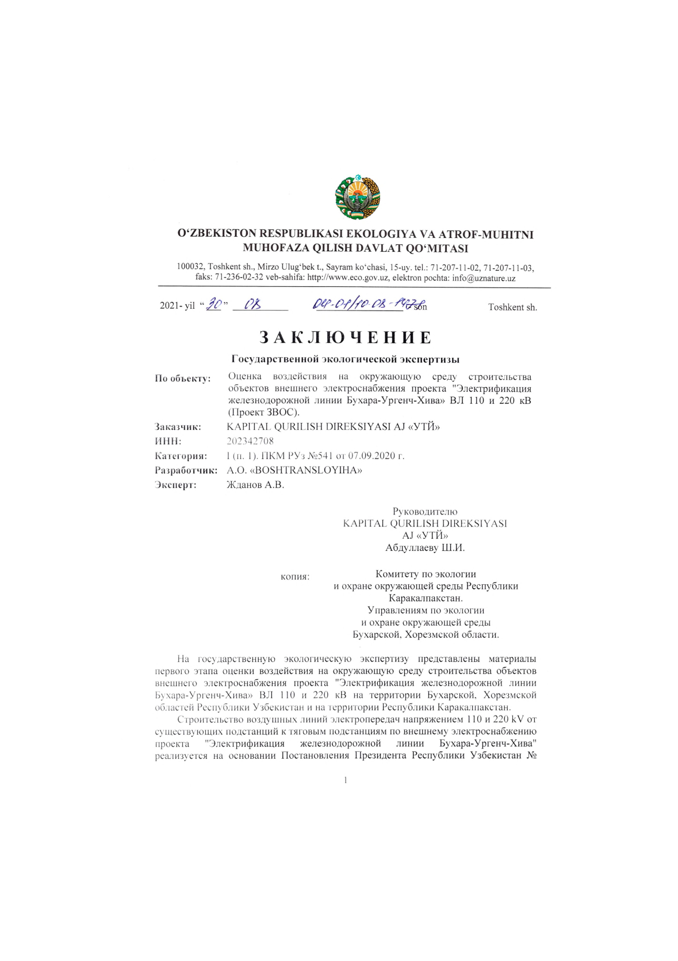
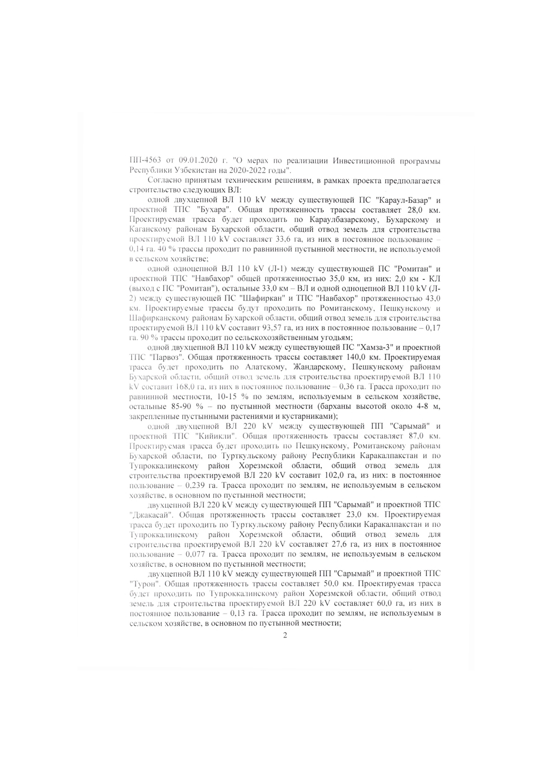
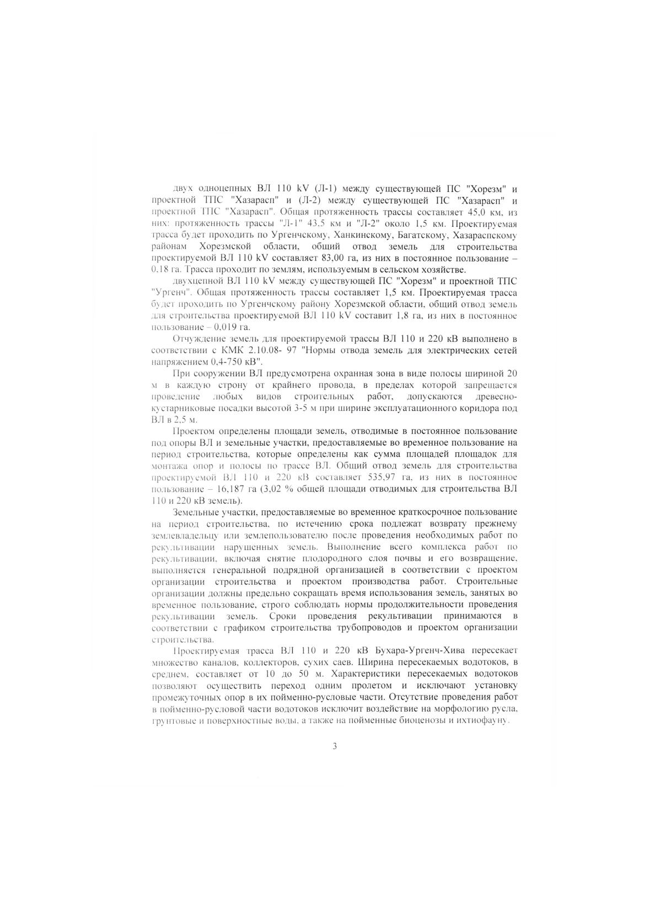
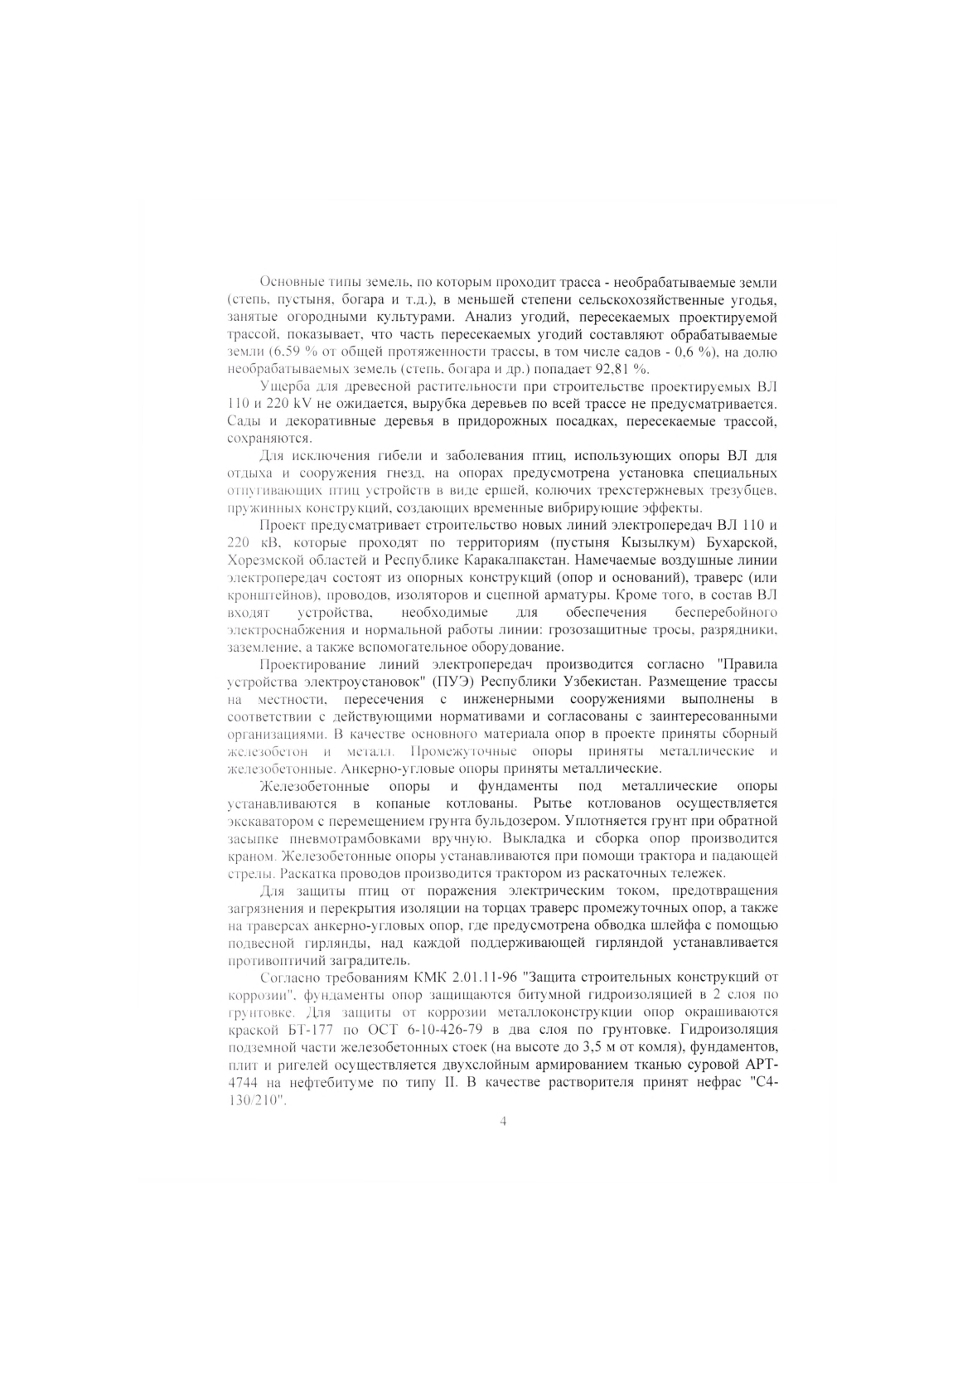
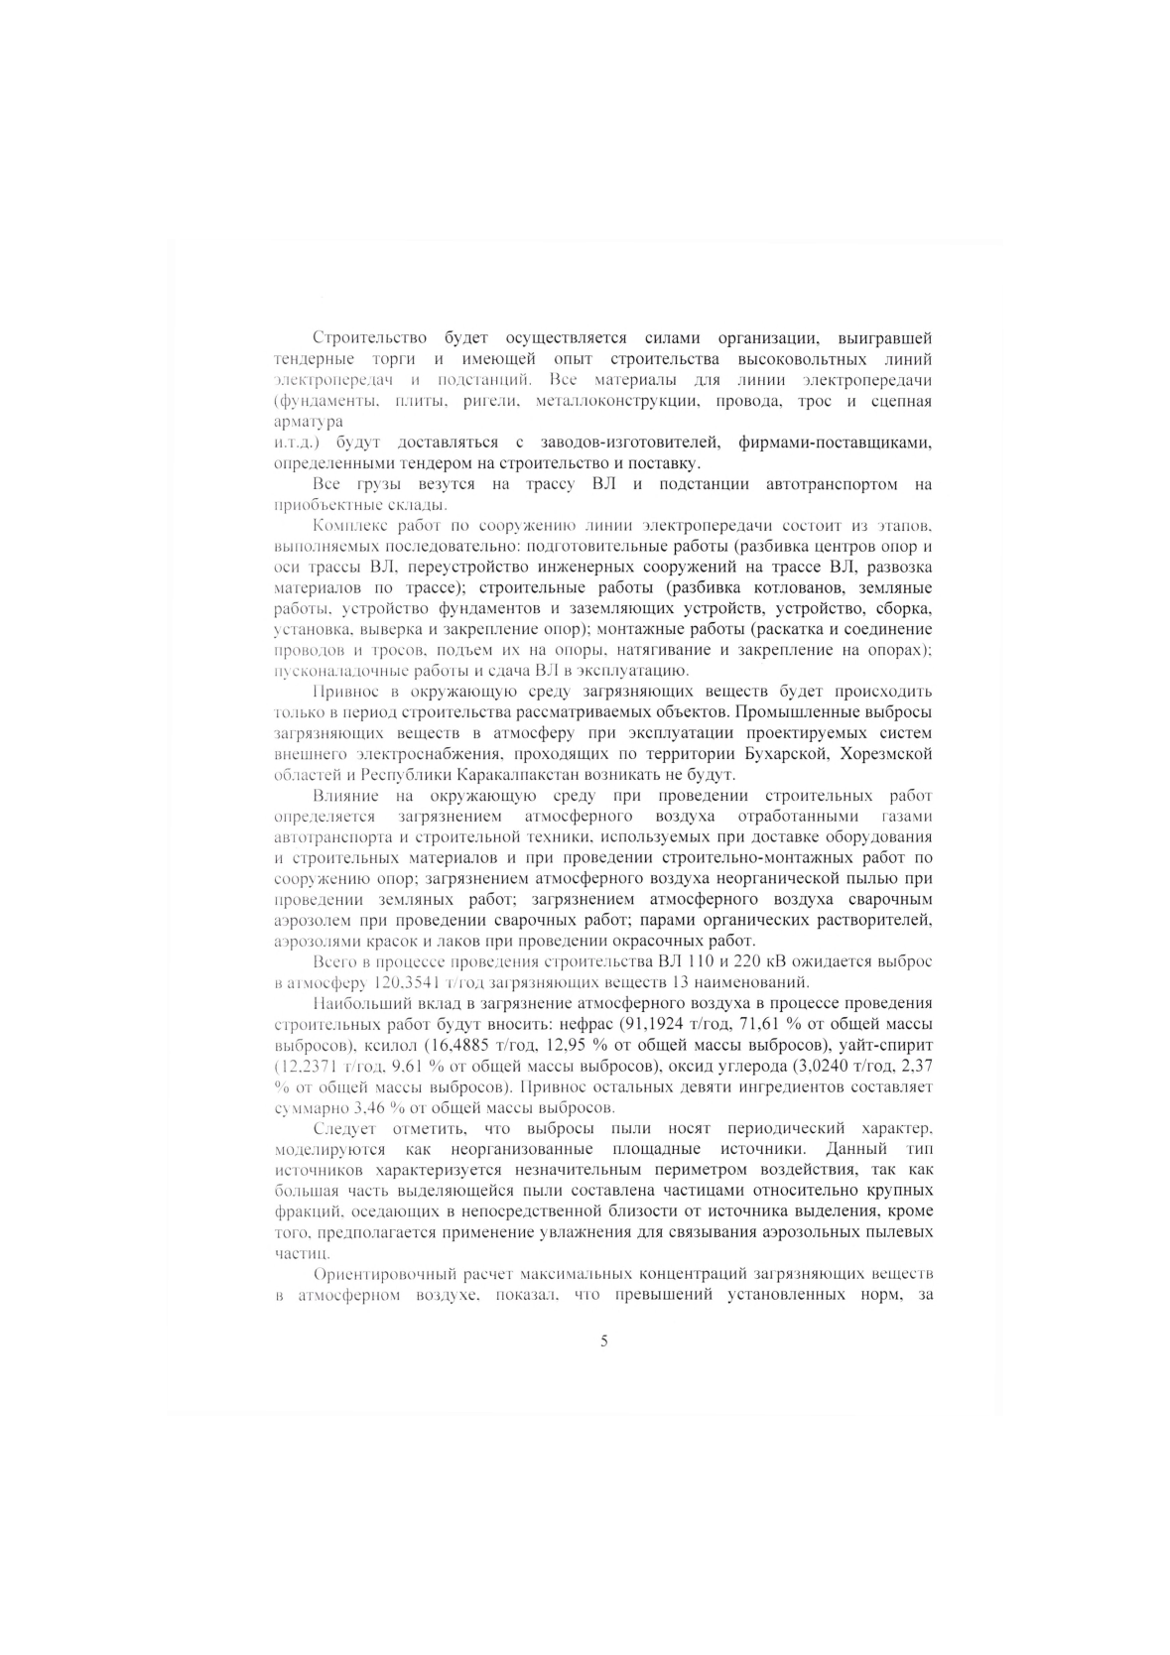
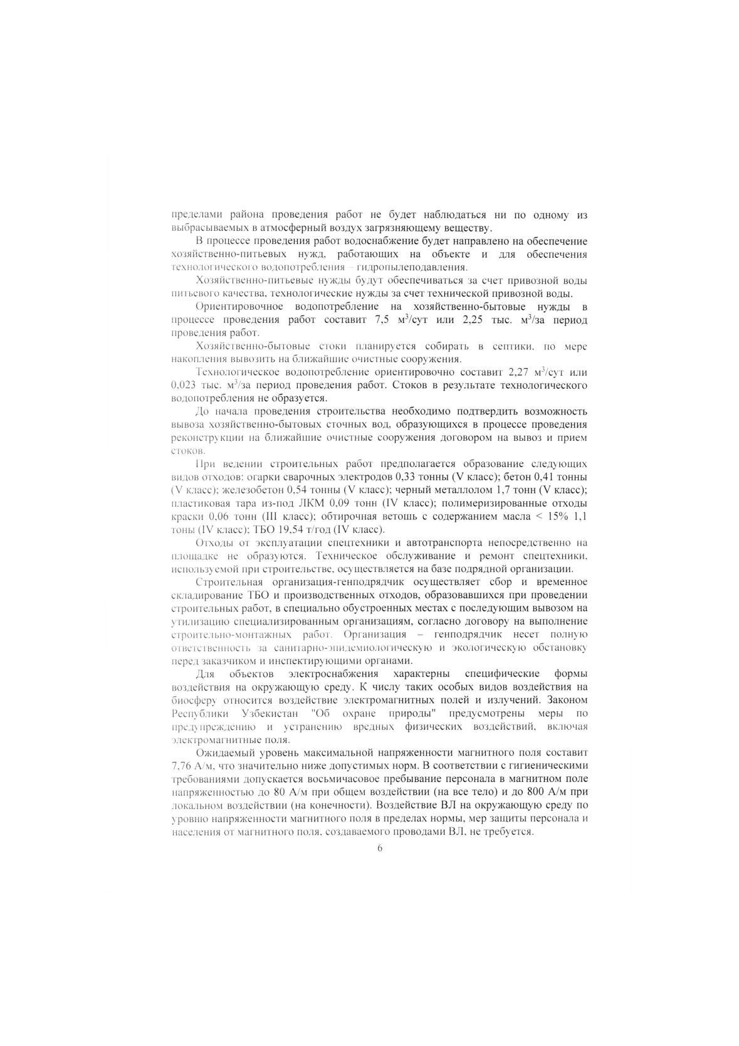
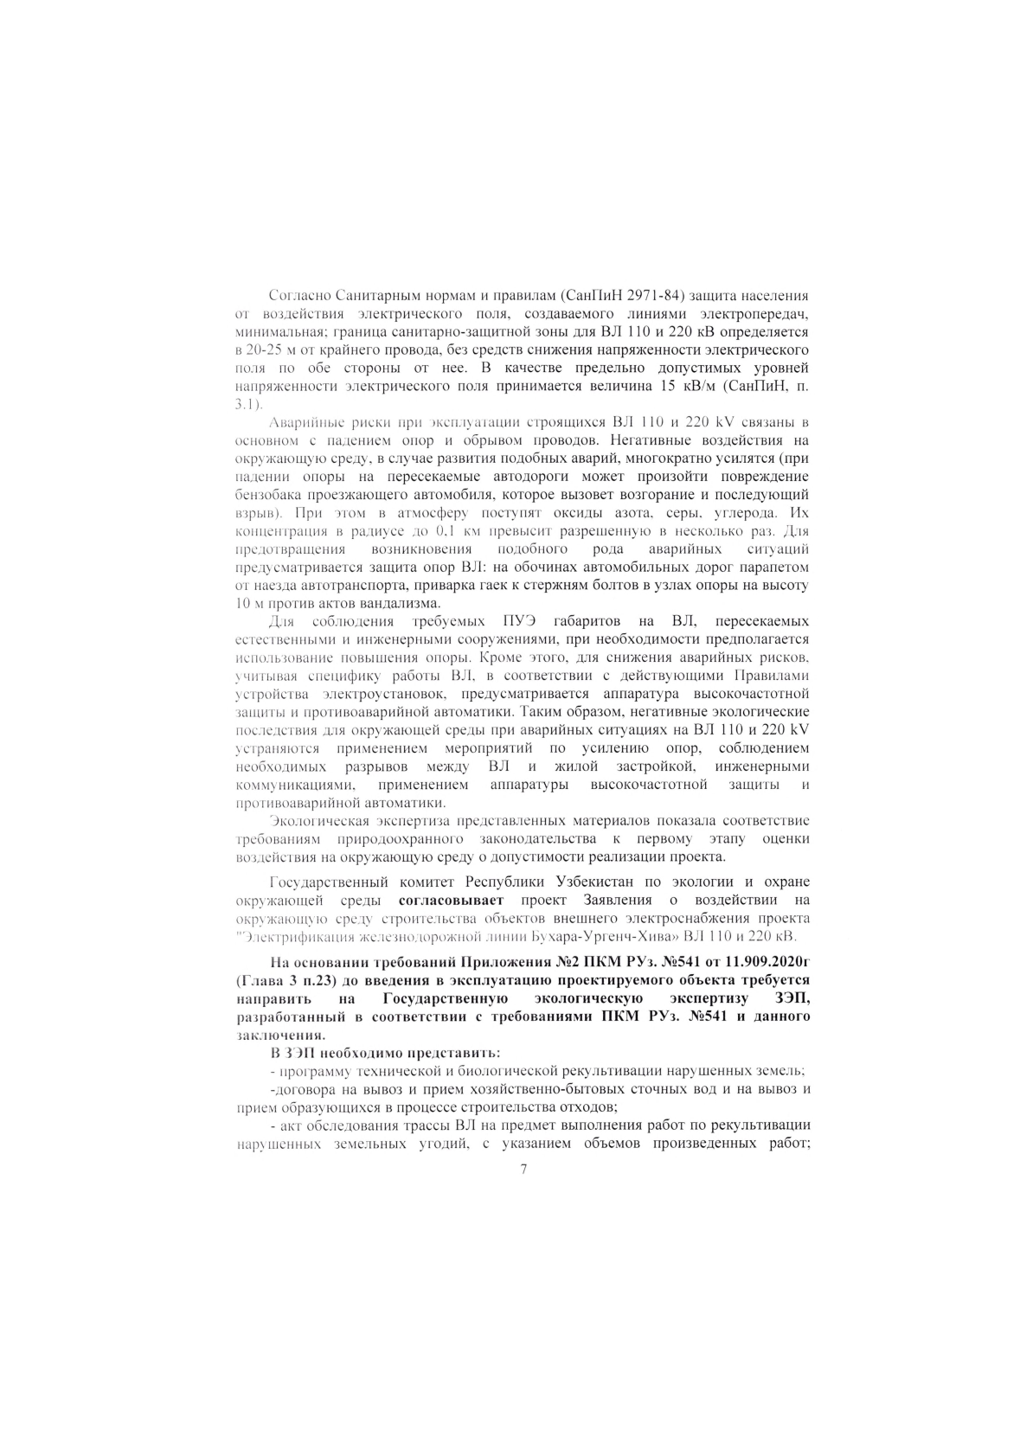
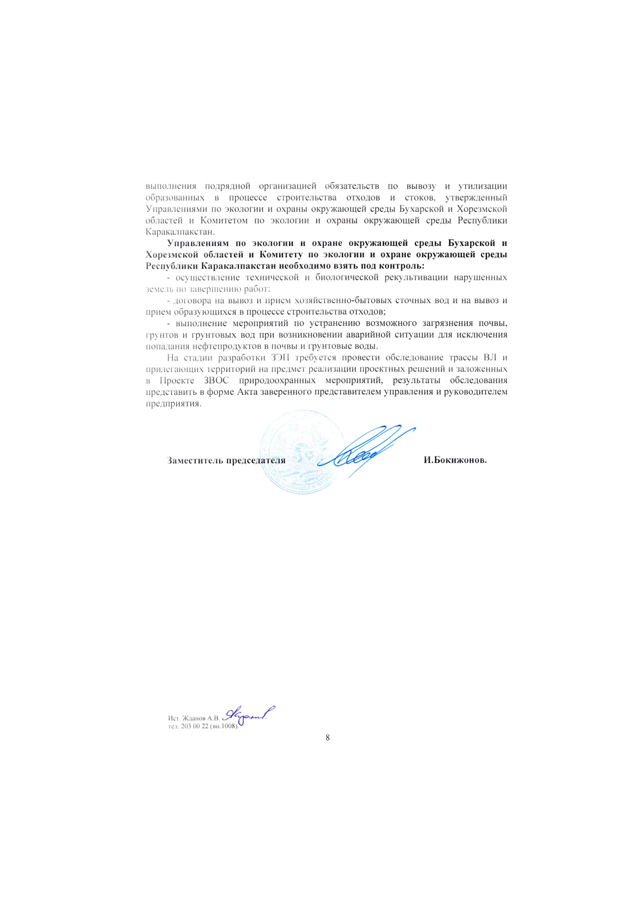

For reference: National environmental impact assessment and state environmental expertise is carried out in accordance with Appendix No. 1 (List of activities for which state environmental expertise is carried out) to RCM No. 541 of the Republic of Uzbekistan dated September 7, 2020.
For reference: Since January 2023, the State Committee for Ecology and Environmental Protection of Uzbekistan has been transformed into the Ministry, currently its name is the Ministry of Ecology and Environmental Protection and Climate Change of the Republic of Uzbekistan.
Admissible noise level into the living area, both inside and outside the buildings (SanR&N No.0267-09)
NOKS – department under UTY which will be responsible for maintenance of railway during operation phase
Including the State Committee on Ecology and Environmental Protection, local municipalities, and the Sanitarian Epidemiological Station.
Attachment 5. Chance finds procedure
Admissible noise level into the living area, both inside and outside the buildings (SanR&N No.0267-09).
A guidance note by IFC and the EBRD Workers' Accommodation: Processes and Standards (ifc.org) (August 2009)
Following requirements of ADB SPS, UTY will apply pollution prevention and control technologies and practices consistent with international good practice as reflected in internationally recognized standards such as EHS Guidelines (footnote 7). When Government regulations differ from these levels and measures, UTY will achieve whichever is more stringent. If less stringent levels or measures are appropriate in view of specific project circumstances, UTY will provide full and detailed justification for any proposed alternatives that are consistent with the requirements presented in ADB SPS.

