Social Safeguards Document

Land Acquisition and Resettlement Plan
(LARP 1 for 8 Traction Substations)

Document Stage: Draft
Project Number: TA-9795 UZB
October 30, 2020

P53271-001 CAREC Corridor 2
(Bukhara-Miskin-Urgench-Khiva)
Railway Electrification Project

Prepared by O’zbekiston Temir Yo’llari (UTY), Republic of Uzbekistan for the Asian Development Bank.

This Land Acquisition and Resettlement Plan is a document of the borrower. The views expressed herein do not necessarily represent those of ADB's Board of Directors, Management, or staff, and may be preliminary in nature.

In preparing any country program or strategy, financing any project, or by making any designation of or reference to a particular territory or geographic area in this document, the Asian Development Bank does not intend to make any judgments as to the legal or other status of any territory or area.
Table of Contents
Abbreviations 6
Currency Equivalent 6
Definition of Terms 7
Executive Summary 10
Project Description 10
Need for LARP preparation 10
Scope of LAR Impact 10
Stakeholder Engagement 13
Grievance Redress Mechanism 13
Legal Regulatory Framework and ADB SPS 2009 13
Compensation Eligibility 13
Institutional Arrangement 13
LARP Implementation, Monitoring and Reporting 14
Project Financing and LARP Budget 14
Chapter 1. Project Description 15
Project Area 15
Figure 1.2: Bukhara-Miskin-Urgench-Khiva Railway Electrification Project 15
Project Rationale 16
Purpose of the LARP 17
Limitations during LARP preparation 18
Conditions for Project Implementation 18
Chapter 2. Scope of Impact 19
Methods for Impact Assessment 19
Affected Land 19
Impact on crops 20
Impact on trees 21
Project affected structures 21
Impact on business and employment 21
Severity of Impact 21
Impact on Vulnerable AHs 22
Public Utilities 22
Summary of Impacts 22
Chapter 3. Socio-economic Profile of project Affected area 25
Introduction 25
Briefly about the project affected area 25
Demography 26
GDP and Economic Sectors 26
Migration 29
Income and Poverty 30
Education 34
Health Care 35
Women in the Local Context 36
Impact on Minorities 36
Chapter 4. Legal Framework 37
Applicable Country Legislation 37
ADB Safeguard Policy Statement (ADB SPS 2009) 41
ADB Policy Principles 42
ADB Policy Principles Adopted for the project 43
Chapter 5. Institutional Arrangement 45
General 45
Executing Agency 45
Other Relevant Government Line Agencies 47
Chapter 6. Grievance redress Mechanism 50
General 50
Objective 50
Grievance Redress Mechanism 50
GRC Records and Documentation 52
ADB Accountability Mechanism 52
Chapter 7. Compensation Entitlem33ents 54
Objectives of Compensation Policy 54
Establishment of the Cut-off Date 54
Eligibility Criteria for Compensation of APs 55
Chapter 8. Public Consultations and LARP Disclosure 61
Objectives of Public Information and Consultation 61
Public Information Booklet 62
Dissemination of Public Information Booklets 62
LARP Disclosure 63
LARP Implementation Process 63
LARP Implementation Schedule 64
Chapter 9. MONITORING AND REPORTING 65
Overview and objective 65
Monitoring 65
Monitoring Indicators 66
Reporting 66
Chapter 10. Estimated LARP Implementation Budget 67
Loss profit (loss of income) from affected land 67
Severe impact allowances 68
Total of Estimated Cash Compensation 69
ANNEXES 70
Annex 1. Description of Eight Traction Substations 70
Annex 2. Public Information Brochure 78
Annex 3. Detailed Calculation of Project Impact Percentage (severe impact assessment) 82
Annex 4. Estimated Detailed Budget 89
Annex 5. PIB distribution 92

List of Tables

Table 1 . Identified LAR impact per each Traction Substation to be constructed 11
Table 2 . Summary of project Impact covered under LARP 1 12
Table 3 . Estimated land take needs 17
Table 4 . List of Affected Provinces, Districts and Massives 19
Table 5 . Affected Land 20
Table 6 . Loss of Annual Crops due to Permanent Land Acquisition 21
Table 7 . Number of Severely Affected AHs 22
Table 8 . Summary of Impacts 22
Table 9 . Demographic indicators in project area 26
Table 10 . GDP of BMUK project area provinces in 2019 27
Table 11 . Labor statistics in Project area in 2018 28
Table 12 . Secondary schools in the Project Area in 2018/2019 34
Table 13 . Secondary-special and Higher Education Institutions in 2018/2019 35
Table 14 . Health-care service indicators in 2018 36
Table 15 . Institutional Roles and Responsibilities 48
Table 16 . Grievance Redress Cycle 51
Table 17 . Entitlements Matrix 55
Table 18 . LARP Implementation Schedule 64
Table 19 . Monitoring Indicators 66
Table 20 . Compensation for loss profit (loss of income) crops grown on the affected land 68
Table 21 . Severely impact allowance 68
Table 22 . Summary of Land Acquisition and Resettlement (LAR) Cost 69

Abbreviations
ADB | - | Asian Development Bank
AD | - | Affected Dehkan
AF | - | Affected Farm Enterprise
AP | - | affected person
AH | - | affected household
CC | - | Civil Code
CSC | - | construction supervision consultant
DMS | - | detailed measurement survey
DLARC | - | district land acquisition and resettlement committee
EA | - | executing agency
EPS |  | external power supply
FGD | - | focused group discussion
GRM | - | grievance redress mechanism
ha | - | hectare
HH | - | household
IA | - | implementing agency
IP | - | indigenous peoples
km |  | kilometer
kV |  | kilovolt
LAR | - | land acquisition and resettlement
LARP | - | land acquisition and resettlement plan
LC | - | Land Code
MOF | - | Ministry of Finance
PC | - | public consultation
PIB | - | Public Information Brochure
PIU | - | project implementation unit
PPTA | - | project preparatory technical assistance
RoW | - | right of way
SCLRGCSC | - | State Committee on Land Resources, Geodesy, Cartography and State Cadastre
SES | - | socioeconomic survey
SS |  | substation (source of external power)
SSMR | - | semi-annual social monitoring report
SPS | - | Safeguard Policy Statement
TC | - | Tax Code
TL | - | transmission line
ToR | - | terms of reference
TSS |  | traction substation
UTY | - | O’zbekiston Temir Yo’llari
UZS | - | Uzbek Som

Currency Equivalent
(as of July 22, 2020)
1 USD= 10,210.39 UZS

Definition of Terms

Affected Persons | Affected persons (APs) are physical and/or legal ,juridical persons who experience full or partial, permanent or temporary physical displacement (relocation, loss of residential land, or loss of shelter) and economic displacement (loss of land, assets, access to assets, income sources, or means of livelihoods) resulting from (i) involuntary acquisition of land, or (ii) involuntary restrictions on land use or on access to legally designated parks and protected areas. APs could be of three types: (i) persons with formal legal rights to land lost in its entirety or in part; (ii) persons who lost the land they occupy in its entirety or in part who have no formal legal rights to such land, but who have claims to such lands that are recognized or recognizable under national laws; and (iii) persons who lost the land they occupy in its entirety or in part who have neither formal legal rights nor recognized or recognizable claims to such land. In the project, affected persons are similar to the economic displaced persons as per ADB's SPS.
Affected Household | A household consists of one or more people who live in the same dwelling and also share at meals or living accommodation and may consist of a single family.
Compensation | Payment for an asset to be acquired or affected by a project at replacement cost.
Cut-off-date | The date after which people will not be considered eligible for compensation i.e. they are not included in the list of AHs as defined by the census. Normally, the cut-off date is the date of the detailed measurement survey which will be based on the detailed and final engineering design.
Dehkan | A dehkan farm is a small-scale family farm (usually not more than 0.33 ha) that produces and sells agricultural products based on the personal labor of family members on a land plot provided to the head of the family for life-long inherited possession.
Displaced Persons (DPs) | In the context of involuntary resettlement, displaced persons are those who are physically displaced (relocation, loss of residential land, or loss of shelter) and/or economically displaced (loss of land, assets, access to assets, income sources, or means of livelihoods) as a result of (i) involuntary acquisition of land, or (ii) involuntary restrictions on land use or on access to legally designated parks and protected areas. In the project, physical displacement is not anticipated.
Economic Displacement | Loss of land, assets, access to assets, income sources, or means of livelihoods as a result of (i) involuntary acquisition of land, or (ii) involuntary restrictions on land use or on access to legally designated parks and protected areas.
Entitlement | The range of measures comprising cost of compensation, relocation cost, income rehabilitation assistance, transfer assistance, income substitution, and relocation which are due to /business restoration which are due to AH, depending on the type and degree nature of their losses, to restore their social and economic base. All entitlements will be given to all affected households as per the entitlement matrix.
Farm Enterprise | A farm is a business entity engaged in the production of agricultural products and other types of activities not prohibited by law, using leased land plots from the government with an average size of 40 ha. A farm is usually registered to an individual farmer. However, there are also few cases of farms that are registered to multiple farmers.
Inventory of Loss | The inventory of assets getting affected by project.
Illegal/Non legalizable/Non recognizable | People that have not registered their business, agriculture, residential and orchard and those who have no recognizable rights or claims to the land that they are occupying and include people using private or state land without permission, permit or grant i.e. those people without legal lease to land and/or structures occupied or used by them. ADB’s SPS explicitly states that such people are entitled to compensation for their non-land assets.
Khokimyiat | Local government authority that interfaces between local communities and the government at the regional and national level. It has ultimate administrative and legal authority over local populations residing within its jurisdiction.
Land acquisition | The process whereby a person is compelled by a public agency to alienate all or part of the land s/he owns or possesses, to the ownership and possession of that agency, for public purposes, in return for fair compensation.
Land Use Rights | According to Land Code (article 17) real persons (can have the land plot under the right of lifelong inheritable possession and land parcel use transferred as descent. This right is given to individual residential housing construction and collective gardening and vineyard (orchards), peasant farms. Legal persons (enterprises, stores, business and farm enterprises) can possess land parcels according to the right to permanent possession, permanent use, temporary use, lease and property. In the above case when person wants to sell the property (land and building), he will sell the building & structure and subsequently land parcel will be sold as an attachment (right is being sold).
Leaseholder | Legal person (including farm enterprise) running agricultural production with the use of land parcels granted to him on a long-term lease. Lease term is limited up to fifty years but not less than for ten years. Leaseholder cannot sell - buy, mortgage, bequeath , giving as a gift and exchange the land.
Low Income | According to the GoU low-income households are classified as households where the monthly per capita income is less than the equivalent of UZS 202,730 (approximately US$ 2.1 per capita per day), which is close to the internationally accepted income poverty line of approximately US$2.0 per capita, per day for developing countries. According to WB (UNDP Human Development Index) poverty data in 2013 the number of people living in poverty in Uzbekistan constitutes 14.1% of the population.
Mahalla | Is a local level community-based organization recognized official by the GoU that serves as the interface between state and community and is responsible for facilitating a range of social support facilities and ensuring the internal social and cultural cohesiveness of its members. Mahalla leaders are elected by their local communities.
Meaningful Consultation | A process that (i) begins early in the project preparation stage and is carried out on an ongoing basis throughout the project cycle; (ii) provides timely disclosure of relevant and adequate information that is understandable and readily accessible to affected people; (iii) is undertaken in an atmosphere free of intimidation or coercion; (iv) is gender inclusive and responsive, and tailored to the needs of disadvantaged and vulnerable groups; and (v) enables the incorporation of all relevant views of affected people and other stakeholders into decision making, such as project design, mitigation measures, the sharing of development benefits and opportunities, and implementation issues.
Replacement cost | Replacement cost is the principle to be complied with in compensating for lost assets. Calculation of which should include: (i) fair market value; (ii) transaction costs; (iii) interest accrued, (iv) transitional and restoration costs; and (v) other applicable payments, if any. Where market conditions are absent or in a formative stage, APs and host populations will be consulted to obtain adequate information about recent land transactions, land value by types, land titles, land use, cropping patterns and crop production, availability of land in the project area and region, and other related information. Baseline data on housing, house types, and construction materials will also be collected. Qualified and experienced experts will undertake the valuation of acquired assets. In applying this method of valuation, depreciation of structures and assets should not be taken into account.
Severely Affected | Severely affected are those who lose 10% or more of their productive asset (income generating productive land) and or physically displaced
Significant impact | Major impacts which are defined as; (i) being physically displaced from housing, or (ii) losing 10% or more of their productive assets (income generating). Projects where 200 or more persons will experience significant impacts are classified as category A for involuntary resettlement.
Vulnerable | Individuals and groups who may be differentially or disproportionately affected by the project because of their disadvantaged or vulnerable status. These may include low-income households, female-headed households, elderly headed households, households headed by physically disabled persons.

Executive Summary

Project Description

- The Asian Development Bank (ADB) and the Asian Infrastructure Investment Bank (AIIB) have both been invited by the Government of Uzbekistan (GoU) and O’zbekiston Temir Yo’llari (UTY) to help co-finance the Central Asia Regional Economic Cooperation (CAREC) Corridor 2 (Bukhara-Miskin-Urgench-Khiva) Railway Electrification Project (hereafter referred to as the Project).

- The Project is being prepared based on (i) the indicative project design (rationale, impacts, outcome, outputs), cost estimates and financing plan, implementation arrangements and implementation schedule, due diligence requirements and processing schedule agreed between UTY and ADB as recorded in the ADB’s Aide Memoire of July 2019, and (ii) agreements between UTY, AIIB and ADB.

- The Project will upgrade the railway infrastructure along the Bukhara-Miskin-Urgench-Khiva line, including (i) construction of 8 traction substations, (ii) construction of 8 section posts, (iii) installation of catenary systems, (iv) installation of signalling, telecoms and SCADA, and (v) construction of external power supply. The Project will also help create a tourism economic corridor by supporting sustainable tourism, transit-oriented development along the railway corridor, and an electronic ticketing system to further enhance the attractiveness of railway transport.
- The Project is strongly aligned with the strategy of the Government to diversify the economy and develop the tourism sector in the Khorezm region. With electrification, the route can be served by high-speed passenger trains already in operation on other parts of the network.
- This will shorten travel times between Bukhara and Khiva from the current 6 hours (on road transport) down to 2 hours. The top tourist destinations of Tashkent, Samarkand, Bukhara and Khiva will all be connected by high-speed rail, significantly improving the attractiveness of Uzbekistan as a tourism destination.

Need for LARP preparation
- Construction of eight (8) new Traction Substations (TSS) along the new railway under the Project will require land acquisition and resettlement.

- To adequately address and ensure project impact is clearly defined, accurately measured and fully compensated and mitigated in compliance with country legislation, ADB SPS 2009 and best practice examples, this draft LARP was prepared and submitted to MOT/UTY and, ADB (and AIIB) for further review and assessment.

- This LARP is prepared specifically for the construction of eight new traction substations and is based on the design drawings provided by the UTY.

Scope of LAR Impact
- The project scope is extended within 3 provinces, 7 districts and 7 massives. The project will require permanent acquisition of agricultural land used by farmers and dehkans and State reserve of desert land area.

Table 1. Identified LAR impact per each Traction Substation to be constructed
# | Name of TSS | kV | TSS location | TSS area  (ha) | EPS source (SS) | Length of EPS | Impact on Agriculture | Impact on Structures | Number of APs
 |  |  |  |  |  |  |  |  | Total | Including
 |  |  |  |  |  |  |  |  |  | Farm Ent. (AF) | Dehkans (AD)
1 | Bukhara | 110 | Bukhara province, Kogan district | 2.44 | Karaulbazar | 28 km | Yes | No | 2 | 2 | -
2 | Navbahor (Mashak) | 110 | Bukhara province, Rumitan district | 3 | Shafirkan and Rumitan | 38 km and 35 km respectively | Yes | No | - | - | -
3 | Parvoz (Azanir) | 110 | Bukhara province, Peshku district | 3 | Gazli | 76 km | No | No | 1 | 1 | -
4 | Kiyikli (Alabuga) | 110 | Bukhara province, Peshku district | 3 | Gazli | 70 km | No | No | 1 | 1 | -
5 | Jakasay (Jayhun) | 220 | Republic of Karakalpakstan, Turtkul district | 3 | Sarimay | 25 km | No | No | - | - | -
6 | Turon (Akchuka) | 220 | Khorezm province, Karaulbazar district | 3 | Sarimay | 50 km | No | No | - | - | -
7 | Hozarasp | 110 | Khorezm province, Hozarasp district | 5.4 | Hozarasp and Khorezm | 3.5 km and 45 km respectively | Yes | No | 38 | - | 38
8 | Urgench | 110 | Khorezm province, Urgench district | 5.25 | Khorezm | 1.5 km | Yes | No | 23 | 1 | 22
Total |  |  |  | 28.09 |  | 370 km | - | - | 65 | 5 | 60

Source: Impact Assessment Survey, April-July 2020

- As shown in Table 1 above, of the eight TSS to be constructed under the Project, the construction of five TSS (Bukhara, Parvoz, Kiyikli, Hozarasp and Urgench) requires permanent land take from private farmers and dehkans farms, while construction of three TSS (Navbahor, Jakasay, and Turon) will impact only State-owned desert land.

- The due diligence including visiting the project construction sites, review of the Google maps of the project area, and data of land cadastral agency identified 65 landusers (5 farmers and 60 private dehkans) of 18.91 ha of agricultural land subject to permanent acquisition for construction works in 5 TSS.

- This draft LARP 1 is developed to adequately address LAR and social impacts identified with regard to the construction of 5 TSS (Bukhara, Parvoz, Kiyikli, Hozarasp and Urgench) requiring permanent acquisition of privately used land from landusers defined during preliminary impact assessment process.

- Although DMS ,census, SES, and on-site inventory of project affected assets was not allowed due to restrictions and COVID-19 pandemic preventive measures, the Consultant managed to collect available official data from the State Land Cadastre and local Khokimiyats necessary to develop this draft LARP 1.

Table 2. Summary of project Impact covered under LARP 1
# | Type of Impact | Permanent impact | Temporary impact | Remarks
1 | Number of provinces | 3 |  | Republic of Karakalpakstan, Khorezm, Bukhara
2 | Number of districts | 7 |  | Kagan, Rumitan, Peshku, Turtkul, Tuprokala, Hozarasp, Urgench
3 | Number of massive | 7 |  | Z.Kobilov, E.Khodjaev, Djongeldi, Kizilkum, Sarimoy, Dustlik, Pakhtakor
4 | Number of Traction Substations | 8 |  | "Bukhara",  "Navbakhor" (Mashak), "Parvoz" (Azanir),  "Kiyikli" (Alabuga), "Djakasay" (Jayhun), "Turon" (Akchuka), "Hozarasp",  "Urgench"
5 | Total Affected Land area (ha) | 28,09 | - | Includes agricultural land and state-owned desert land
6 | Affected agricultural cultivated land area (cotton/wheat and vegetables) (ha) | 18,91 | - | Includes both dekhan land and farmland
7 | Affected orchard/garden land area (ha) | - | -
8 | Ditches, canals, roads, cemetery and other lands | - | -
9 | Reserve land | 9,18 | -
10 | Residential land | - | -
11 | Number of severely affected persons (losing 10% or more of dehkan farm land) | 58
12 | Number of vulnerable AHs | -
13 | Number of affected fruit trees | -
14 | Number of affected wood trees | -
15 | Number of affected bushes | -
16 | Number of affected residential structures | -
17 | Number of affected non-residential structures | -
18 | Number of affected businesses, employees | -
19 | Number of permanently affected APs (landusers) | 65 |  | All APs (landusers) have a permanent impact
20 | Number of temporarily affected Aps | -
Source: Impact Assessment Survey, April-July 2020

Stakeholder Engagement
- During draft LARP preparation no public consultations were allowed and either provided. However, Social Safeguards Team comprising environment and resettlement experts prepared a public information booklet (PIB) that contains all relevant information regarding project scope, objectives, eligibility to compensation, GRM, environment protection HSE instruction, including contact details for GRM focal person at PIU-ET. In August 24-28 2020, 700 copies of the PIB were distributed among all khokimiyats located within the project area and Bukhara, Urgench, Miskin and Khiva Railway stations for further distribution to the APs and solicit comments from them. The Team followed COVID-19 preventative measures on social distancing, face masks, and use of hand sanitizer.
- The Uzbek version of the PIB is provided in Annex 2. The photos of PIB distribution are provided in Annex 5.
- In the final LARP preparation, alternative measures to stakeholders engagement and public consultations will be elaborated to comply with current pandemic restrictions and provide supplementary instruments to reach public affected communities and APs to provide relevant project related information and seek their feedback.

Grievance Redress Mechanism
- The scope and role of the GRM is to address all issues related to involuntary resettlement, social and environmental performance. Local population will be informed about their right to file complaints and queries on any aspect of the Project, including land acquisition, compensation and appeal any decision, practice or activity related to the Project. The UTY will ensure effectiveness and efficiency of GRM on local and national levels monitor that grievances and complaints are addressed in a timely and effective manner.

Legal Regulatory Framework and ADB SPS 2009
- The legal and policy framework of the project is based on national laws and legislation related to land acquisition and compensation policy in Uzbekistan, and ADB’s Safeguard Policy Statement 2009 (SPS). Based on the analysis of applicable laws and policies and ADB’s Policy requirements, project related land acquisition and resettlement (LAR) principles have been adopted and described in this draft LARP.

Compensation Eligibility
- Compensation eligibility is limited by a cut-off- date which is the start of final AP census date during the detailed measurement survey, following the detailed design. The cut-off-date will be published and communicated to APs by the UTY prior the start of final AP census survey during the public consultations. APs who settle in the affected areas after the cut-off date will not be eligible for compensation. They however will be given sufficient advance notice prior to construction. All the compensation will be based on replacement cost.

Institutional Arrangement
- The O’zbekiston Temir Yo’llari (UTY) will be executing agency (EA) responsible for implementation of the project. A project implementation unit (PIU) is created in UTY which will be responsible for the overall land acquisition and resettlement (LAR) activities. The PIU has a designated safeguards specialist who is specialized in safeguards activities and will be responsible for ensuring that all the activities related to land acquisition and involuntary are being followed and implemented in accordance with Uzbekistan's legislation and policies and ADB's SPS. The project management and construction supervision consultant (CSC) will support PIU in monitoring and reporting of safeguards compliance.

LARP Implementation, Monitoring and Reporting
- The time for implementation of LARP will be scheduled as per the overall project implementation schedule. All activities related to the land acquisition and compensation are planned to ensure that compensation is paid prior to displacement and commencement of civil works. Public consultation, monitoring and grievance redress will be undertaken intermittently throughout the project duration. The construction can only start once all the compensation and resettlement measures are completed. The implementation of LARP will be closely monitored, which will be the responsibility of UTY with assistance of CSC. The PIU will provide ADB with an effective basis for assessing LARP implementation results and identifying potential difficulties and problems reported to ADB through the LARP implementation Compliance Report. The safeguards compliance monitoring will be conducted throughout the project implementation period and will be reported to ADB through semi-annual social monitoring reports (SSMR).

Project Financing and LARP Budget
- The procedures for permanent land acquisition issuance of relevant compensation to eligible APs as described in this draft LARP is based on entitlement matrix developed in compliance of country legislation, ADB SPS 2009 and the best practice examples. Total LARP budget is estimated at 200,600,642.00 UZS equivalent to 19,646.72 USD.

Chapter 1. Project Description

Project Area
- The Project area is located in the western part of Uzbekistan, covering Bukhara (Bukhara station), and Khorezm (Urgench and Khiva stations) Province. The total length of the electrified railway between Bukhara and Khiva will be about 452 km, mainly passing through the areas of Bukhara and Khorezm provinces, with 2 short crossing of Turtkul district area of Karakalpakstan closer to the Khorezm province (Figure 1.1).
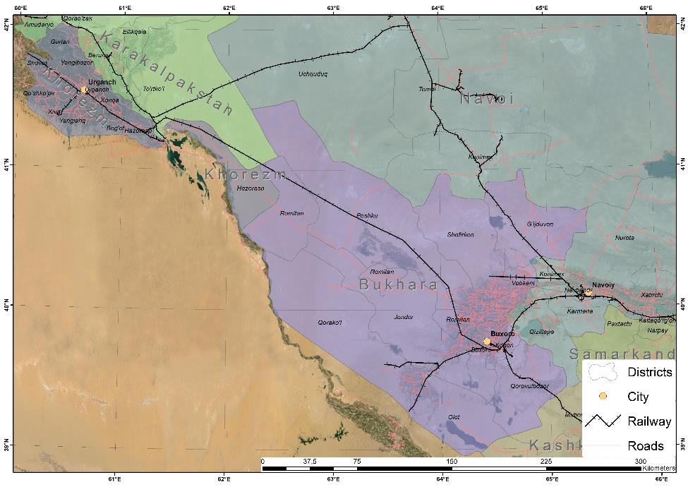

Figure 1.1: Map of the Project Area (Bukhara and Khorezm provinces)

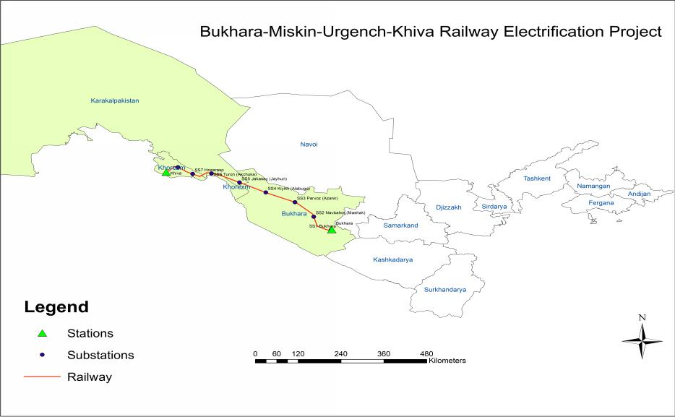

Figure 1.2: Bukhara-Miskin-Urgench-Khiva Railway Electrification Project

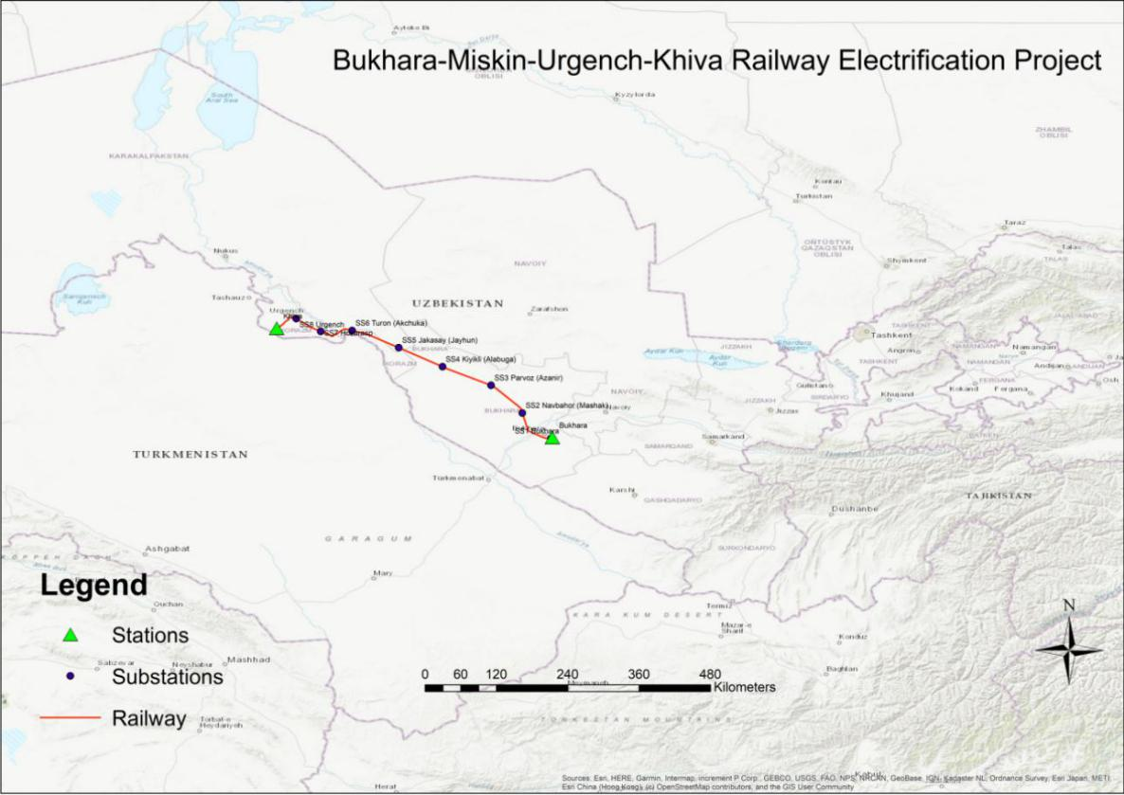

Figure 1.3: Topographic map of the BUMK Railway Section

Project Rationale
- The outcome of the project is improved railway services for freight and passengers, connecting the country’s capital with major cities in the west of the country by rail. The project includes two outputs:
  - Output 1: Railway infrastructure along the Bukhara-Miskin-Urgench–Khiva line upgraded. This includes (i) construction of 8 traction substations, (ii) construction of 8 section posts, (iii) installation of catenary systems, (iv) installation of signalling, telecoms and SCADA, (v) construction of external power supply and (vi) the commissioning of machinery and equipment for railway maintenance, and equipment for depots.
  - Output 2: Tourism corridor Bhukara-Miskin-Urgench-Khiva developed. The railway line will connect the major tourist destinations of Uzbekistan with fast train services (up to 250 km/h), allowing to travel between Bukhara and Khiva will in 2-2.5 hours, compared to travelling by car that will take about 6 hours). It will provide opportunities to travellers to visit Uzbekistan’s tourist highlights comfortably in a short time, avoiding the need for short flights. The passenger service will open up the country the country, developing a corridor for economic development in western Uzbekistan.

Table 3. Estimated land take needs
# | Name of TSS | kV | TSS location | Needed land (in ha) | Total of APs | No of AFs | No of ADs
1 | Bukhara | 110 | Bukhara province, Kogan district | 2.44 | 2 | 2 | -
2 | Navbahor (Mashak) | 110 | Bukhara province, Rumitan district | 3 | - | - | -
3 | Parvoz (Azanir) | 110 | Bukhara province, Peshku district | 3 | 1 | 1 | -
4 | Kiyikli (Alabuga) | 110 | Bukhara province, Peshku district | 3 | 1 | 1 | -
5 | Jakasay (Jayhun) | 220 | Republic of Karakalpakstan, Turtkul district | 3 | - | - | -
6 | Turon (Akchuka) | 220 | Khorezm province, Hozarasp district | 3 | - | - | -
7 | Hozarasp | 110 | Khorezm province, Hozarasp district | 5.40 | 38 | - | 38
8 | Urgench | 110 | Khorezm province, Urgench district | 5.25 | 23 | 1 | 22
Total |  |  |  | 28.09 | 65 | 5 | 60
Source: Impact Assessment Survey, April-July 2020

Purpose of the LARP
- According to the initial assessment of project impact to and assets is exclusively permanent and will affect:
  - Large territories of State-owned agricultural lands leased by large farms through long-term lease agreements
  - Dehkan land parcels, small size land parcels used by local households for agricultural purposes with the right to bequeath
  - State land not used by private persons

- The specificities of permanent impact to land will be defined once the DMS is carried out and actual scope of land take is defined with regard to total land holding of individual landuser versus the area of land to be permanently acquired. According to the currently available information permanent impact to land will cause loss of perennials (fruit trees, and annual crops), but not no structures of residential, commercial of supplementary designation is to be affected.

- The main objective of the LARP is to identify APs subject to permanent land and assets acquisition impact, asses the loss and develop relevant compensation and mitigation measures to assist them if not improved at least to restore their livelihoods to pre-project level. The LARP is based on the requirements of ADB’s Safeguard Policy Statement (SPS) 2009 and complies with the relevant laws of the Republic of Uzbekistan.

- The LARP has been prepared to:
  - address and mitigate impacts caused by the project
  - ensure compliance with ADB’s SPS (2009) requirements, and
  - determine compensation, resettlement and rehabilitation assistance for the affected households.
- LARP is prepared by the UTY/MOT with technical support provided by National and International Social Safeguards and Resettlement Specialists of the Engineer (and design Institute)

- LARP will be updated into a final and implementation-ready LARP following the detailed design and implemented by the PIU of UTY and Social Safeguards Specialists engaged by the supervision consultant. The LARP implementation activities will commence following the official ‘no objection’ being granted to the final LARP.

Limitations during LARP preparation
- Due to the restrictions and COVID-19 pandemic preventive measures the consultants could not carry out the following activities: (I) on site DMS (census, SES, on-site inventory of project affected assets; and (ii) identification of vulnerable APs. These activities will be conducted in the preparation of the final LARP following the detailed design.
- Project estimated budget is based on data obtained from official records on yield capacity of affected arable land, average market price of crops grown in the area and the approach for determination compensation unit rates for affected assets and income exercised during preparation of other similar LARPs recently approved by ADB and UTY/MOT.

Conditions for Project Implementation
- Based on the ADB policy/practice, the approval of the project implementation is based on the following conditions:
- Signing of Contract Award: Conditional to the approval of the implementation-ready LARP for the proposed sub-project by ADB and Government. Implementation-ready LARP reflects final impacts, final AP lists and compensation rates at replacement cost approved by PIU/MOT.

- Notice to Proceed to Contractors: Conditional to the full implementation of LARP (full delivery of compensation and rehabilitation allowances) and confirmed by LARP implementation Compliance Report prepared by PIU and approved by ADB.

Chapter 2. Scope of Impact
- Activities described below are undertaken to determine project affected assets, their users and determine relevant compensation entitlements and rehabilitation allowances to restore income source and livelihoods of all APs at minimum to pre-project levels.

Methods for Impact Assessment
- The impact assessment survey for this LARP was carried out based on the draft design for construction of eight (8) new TSS. The impacts on land acquisition and involuntary resettlement for this component are categorized only into permanent impacts in terms of land acquisition.

- The due diligence includes visiting the project construction sites, review of the Google maps of the project area, and collecting data from the Land Cadastral Agency to identify the plots, land use and improvements and registered users.
- The final LARP will be added with more specific information on the cultivated crops, the level of productivity of the affected land, including the level of productivity of dehkan farms and degree of dependence of the land-users to the crops for their livelihood based on secondary sources. The DMS surveys will allow to identify and differentiate the ways of land cultivation exercised by dehkan farms and large agricultural farm enterprises. Important findings will be assessed and considered in the final LARP to ensure all APs, if not improved at least manage to maintain their livelihood to pre-project levels.

Affected Land
- The scope of impact to land was determined based on impact assessment survey data analyses. Table 4 shows the provinces (Republic of Karakalpakstan, Khorezm, and Bukhara provinces) districts (Turtkul, Tuproqkala, Hazarasp, Urgench, Kagan, Rumitan, Peshku) and massives that are affected by the TSS construction component.

- Affected land includes both lands owned/used by APs for agricultural purposes as well as khokimiyats reserve lands. The total affected cultivation area is 18.91 ha. The total affected of khokimiyats reserve lands is 9,18 hectares. All land impacts are permanent. No garden or orchard is affected. Table 5 provides details on the land impact from the TSS construction. The affected land users due to loss of permanent land acquisition include 5 farm enterprises and 60 private dehkans. Annex 3 provides the list of affected landusers.

Table 4. List of Affected Provinces, Districts and Massives
# | Name of the Province | Name of the District | Name of the Massive | Number of TSS
1 | Bukhara | Kagan | Z.Kobilov | 4
 |  | Rumitan | E.Khodjaev
 |  | Peshku | Djongeldi
2 | Rep. of Karakalpakstan | Turtkul | Kizilkum | 1
3 | Kharezm | Tuprokala | Sarimoy | 3
 |  | Hozarasp | Dustlik
 |  | Urgench | Pakhtakor
Total: | 3 | 7 | 8
Source: Impact Assessment Survey, April-July 2020

Table 5. Affected Land
# | Name of the Province | Name of the District | Name of the Massive | Type of impact | Total Affected Land (ha)
 |  |  |  |  | Total Affected Land (ha) | Including
 |  |  |  |  |  | Agriculture land |  | Ditches, canals and other lands | Affected Land users (AF/AD)
 |  |  |  |  |  | Arable/Crop Cultivation | Garden/
 |  |  |  |  |  |  | Orchards
1 | Bukhara | Kagan | Z.Kobilov | Permanent | 2,44 | 2,44 | - | - | 2 AF
 |  |  |  | Temporary | - | - | - | - | -
 |  |  |  | Total | 2,44 | 2,44 | - | - | 2 AF
 |  | Rumitan | E.Khodjaev | Permanent | 3 | - | - | 3 | 0
 |  |  |  | Temporary | - | - | - | - | -
 |  |  |  | Total | 3 | - | - | 3 | 0
 |  | Peshku | Djongeldi | Permanent | 6 | 6 | - |  | 2 AF
 |  |  |  | Temporary | - | - | - | - | -
 |  |  |  | Total | 2,44 | 6 | - | - | 2 AF
2 | Republic of Karakalpakstan | Turtkul | Kizilkum | Permanent | 3 | - | - | 3 | 0
 |  |  |  | Temporary | - | - | - | - | -
 |  |  |  | Total | 3 | - | - | 3 | 0
3 | Kharezm | Tuprokala | Sarimoy | Permanent | 3 | - | - | 3 | 38 AD
 |  |  |  | Temporary | - | - | - | - | -
 |  |  |  | Total | 3 | - | - | 3 | 0
 |  | Hozarasp | Dustlik | Permanent | 5,4 | 5,22 | - | 0.18 | 38 AD
 |  |  |  | Temporary | - | - | - | - | -
 |  |  |  | Total | 5,4 | 5,22 | - | 0.18 | -
 |  | Urgench | Pakhtakor | Permanent | 5,25 | 5,25 | - | - | 22 AD + 1 AF
 |  |  |  | Temporary | - | - | - | - | -
 |  |  |  | Total | 5,25 | 5,25 | - | - | 23
Total permanent land, ha |  |  |  |  | 28,09 | 18,91 | - | 9,18 | -
Total temporary land, ha |  |  |  |  | - | - | - | - | -
Total: |  |  |  |  | 28,09 | 18,91 | - | 9,18 | 65 (5 AF and 60 AD)
Source: Impact Assessment Survey, April-July 2020

Impact on crops
- The results of impact assessment survey confirmed project impact on annual crops, mainly on five types. According to locally established practice, people grow cotton and wheat mixed on the same land parcel. Similarly, rice and alfalfa is also mixed cultivated.

- However this initial information will be added with more detailed data on crops cultivated by 65 APs once the DMS will be carried out including inventory of all project affected assets.

- The detailed information on area of land used for growing annual crops disaggregated according to districts and massives is given in the Appendices.

Table 6. Loss of Annual Crops due to Permanent Land Acquisition
# | Name of the province | Name of the District | Name of the Massive | Total affected agricultural land area. ha | Type of main cultivated crops
1 | Bukhara | Kagan | Z.Kobilov | 2,44 | Cotton/Wheat/ Vegetables/Alfalfa/Rice  (Usually, 2 types of crops (Cotton/Wheat) are mixed cultivated on the same land. Vegetables/Alfalfa/ Rice are also mixed cultivated)
 |  | Rumitan | E.Khodjaev | -
 |  | Peshku | Djongeldi | 6
2 | Republic of Karakalpakstan | Turtkul | Kizilkum | -
3 | Khorezm | Tuprokala | Sarimoy | 3
 |  | Hozarasp | Dustlik | 5,22
 |  | Urgench | Pakhtakor | 5,25
Total: |  | 7 | 7 | 18,91
Source: Impact Assessment Survey, April-July 2020

Impact on trees
- According to the impact assessment survey, there are no perennials (fruit bearing or timber trees) affected as a result of land acquisition for the construction of eight TSS.

Project affected structures
- No structures of residential or commercial designation is affected by the TSS construction. Therefore, no physical displacement of households or relocation of business is expected. The Project will not entail loss of income through stoppage of business or employment.

Impact on business and employment
- According to the impact assessment, there are no businesses affected. The 5 farm enterprises will lose about 1.12 % of their leased land. Remaining portion will allow these farm enterprises to continue with their operations and agricultural laborers will be able to keep on working.

- Therefore, it is confirmed that the project will not affect the employment of those agricultural labourers and they will be able to continue working on the remaining parts of the farmlands.

Severity of Impact
- Severe impact occurs when an AP loses 10% or more of the total productive asset. Data on the total agricultural landholding size of the affected households have been collected and accordingly, the severity of impact has been calculated. Appendix 3 shows that 58 of the 60 dehkan farm-holders will lose 100% of their land plots. Two (2) farm-holder households lose less than 10% of their land parcel. Thus, there are 58 severely affected dehkan farm-holders/landusers under the project.

- Table 7 provides number of severely affected AHs distinguished according to the TSS. For detailed information about severity impact per each AHs please see the Annex 3.

Table 7. Number of Severely Affected AHs
# | Name of TSS | kV | TSS location | No of Severely affected AHs
1 | Bukhara | 110 | Bukhara province, Kogan district | 0
2 | Navbahor (Mashak) | 110 | Bukhara province, Rumitan district | 0
3 | Parvoz (Azanir) | 110 | Bukhara province, Peshku district | 0
4 | Kiyikli (Alabuga) | 110 | Bukhara province, Peshku district | 0
5 | Jakasay (Jayhun) | 220 | Republic of Karakalpakstan, Turtkul district | 0
6 | Turon (Akchuka) | 220 | Khorezm province, Hozarasp district | 0
7 | Hozarasp | 110 | Khorezm province, Hozarasp district | 36
8 | Urgench | 110 | Khorezm province, Urgench district | 22
Total |  |  |  | 58
Source: Impact Assessment Survey, April-July 2020

Impact on Vulnerable AHs
- The information on vulnerable AHs cannot be identified due to the COVID-19 restrictions. However, the LARP includes vulnerability allowances and procedures to identify vulnerable AHs once the restrictions are released and SES is carried out.

- The last resort will be additional efforts during LARP implementation. The PIU of UTY will collect data on vulnerable AHs and ensure all eligible AHs receive vulnerability allowance as described in the Entitlement Matrix of the approved LARP.

Public Utilities
- According to the project design and impact assessment survey, no impacts will be caused to any public utility/common use property by the project. However, in case any impacts occur they will be fully repaired by the contractor.

Summary of Impacts
- Summary Impact per project components is shown in table 11 below. As per the detailed breakdown of impacts per AHs and massives is given in Annex 3.
Table 8. Summary of Impacts
# | Type of Impact | Permanent impact | Temporary impact | Remarks
1 | Number of provinces | 3 |  | Republic of Karakalpakstan, Khorezm, Bukhara
2 | Number of districts | 7 |  | Kagan, Rumitan, Peshku, Turtkul, Tuprokala, Hozarasp, Urgench
3 | Number of massive | 7 |  | Z.Kobilov, E.Khodjaev, Djongeldi, Kizilkum, Sarimoy, Dustlik, Pakhtakor
4 | Number of Traction Substations | 8 |  | "Bukhara",  "Navbakhor" (Mashak), "Parvoz" (Azanir),  "Kiyikli" (Alabuga), "Djakasay" (Jayhun), "Turon" (Akchuka), "Hozarasp",  "Urgench"
5 | Total Affected Land area (ha) | 28,09 | - | 69 AHs (including 60 Dehkan,5 Farm, and 4 reserve lands)
6 | Affected agricultural cultivated land area (cotton/wheat and vegetables) (ha) | 18,91 | - | 65 landusers including 60 dehkan farmholders and 5 farm enterprises
7 | Affected Orchard/ Garden land area (ha) | - | -
8 | Ditches, canals, roads, cemetery and other lands | - | -
9 | Reserve land (ha) | 9,18 | -
10 | Residential land | - | -
11 | Number of severely AHs (losing 10% or more of their productive land) | 58
12 | Number of vulnerable AHs | - |  | To be confirmed during census and coordination with mahalla during final LARP preparation
13 | Number of affected fruit trees | -
14 | Number of affected wood trees | -
15 | Number of affected bushes | -
16 | Number of affected residential structures | -
17 | Number of affected non-residential structures | -
18 | Number of affected businesses, employees | -
19 | Number of permanent affected AHs/APs | 65
20 | Number of temporary affected AHs/APs | -
21 | Number of total AHs | 65 |  | Without double counting
22 | Number of total APs | - |  | Due to the COVID-19 pandemic situation, public consultations and meetings postponed having during the Final LARP update
Source: Impact Assessment Survey, April-July 2020

Chapter 3. Socio-economic Profile of project Affected area

- During the LARP preparation the Consultants had to follow COVID-19 preventive measures imposed by the GoU therefore DMS could not be carried out. The socio-economic profile was developed based on the Poverty and Social Assessment Report Analyses carried out for the BUMK project at earlier phase of the project by Social and Gender Specialist.

Introduction
- The main source of information for this section is the data obtained from the State Statistics Committee of Uzbekistan. In order to avoid seasonal changes impact and make all data in line with the latest information the Consultant used available annual data as of 1 January 2020, based on the results of year 2019. In case some data was not released yet at the moment of report preparation, data was used as of January 1, 2019, based on the results of the year 2018.

Briefly about the project affected area
- Bukhara province is located in the central and south-western part of Uzbekistan, it borders on Kashkadarya and Navoi provinces of Uzbekistan and the Republic of Turkmenistan. The total area is 40.22 thousand km². The territory of the region is a wavy plain, with separate elevations, a significant part of the territory is occupied by the sands of Kyzylkum, only in the south, in the lower reaches of Zarafshan there are small irrigated oases - Gijduvan, Bukhara, and Karakul.
- Bukhara province was founded on January 15, 1938. Bukhara province is divided into 11 administrative districts, these are: Alat, Bukhara, Gijduvan, Jondor, Kagan, Karakul, Karavulbazar, Peshku, Ramitan, Shafirkon, Vobkent. The largest City is Bukhara (pop. 277,800), which is the administrative center of the province, other largest cities are Kagan (pop. 60,700), and Gijduvan (pop. 46,100).
- The main sectors of agriculture are cotton and wheat production, vegetable growing, sheep breeding. The main industries are fuel, (oil and gas), chemical and petrochemical, building materials, light (cotton gin) and the food industry.
- Khorezm province is located in the north-west of Uzbekistan in the lower reaches of the Amudarya river. The total area is 6.05 thousand km² and occupies 1,4 percent of the territory of Uzbekistan. In the north, the Khorezm province borders with the Republic of Karakalpakstan, in the south - with Turkmenistan, in the north-east - with the Bukhara province of Uzbekistan.
- Khorezm province was founded on January 15, 1938. Khorezm province is divided into 10 administrative districts: Bogot, Gurlen, Khiva, Koshkopir, Shovot, Urganch, Khonqa, Hazorasp, Yaniariq, and Yangibozor. The largest City is Urgench (pop. 141,700), which is the administrative center of the province, other largest city is Khiva (pop. 90,700).
- The main sectors of agriculture in Khorezm province: cotton, melon-growing, rice-growing, meat and dairy farming, sericulture. Main industries: vehicle production, electric power industry, machine building and metalworking, building materials, light, food, flour and cereal industry.

Demography
- Bukhara province occupies 9% of the total area of Uzbekistan, it is the third largest region after Karakalpakstan and Navoi provinces, and population of Bukhara province is 5.7% of the total population of Uzbekistan, density here is below national average 47.8 people per sq.km. Khorezm province occupies 1,3% of the total area of Uzbekistan, it is the third smallest province of Uzbekistan, after Syrdarya and Andijan provinces. Population of Khorezm province is 5.5% of the total population of Uzbekistan. Share of urban population is about 35% and rural 65% in the project area. Details of the demographic indicators are presented in Table 9.
Table 9. Demographic indicators in project area
Province | Population  (in ‘000) |  | Population density  per km² | Gender  (% Share) |  | Population growth, profile | Average age of population
 | Jan 2019 | Jan 2020 |  | Male | Female
Bukhara | 1,894.8 | 1,924.2 | 47.8 | 50.0 | 50.0 | 21.6 | 29.9
Khorezm | 1,835.7 | 1,866.7 | 308.5 | 50.0 | 50.0 | 22.2 | 28.3
Uzbekistan | 33,255.5 | 33,905.8 | 74.1 | 50.2 | 49.8 | 24.3 | 28.7
- About 60% of the total population in the project area are in working age, and 30% are young people under 16, the remaining 10% are residents of retirement age. The proportion of men and women is the same 50.0% men and 50.0% women. Average household size is 5 persons. In Khorezm province 97% of the population are Uzbeks, and the rest are Russians, Turkmens and etc. In Bukhara province about 83% are Uzbeks, 6% - Russians, 5% - Tajiks, 3% - Tatars, 1% - Koreans and 2% - others. Main language spoken is here Uzbek, however some people here speak Russian and Tajik too.

GDP and Economic Sectors
- In terms of Gross Domestic Product, Uzbekistan has the second largest economy in Central Asia only after that of Kazakhstan. Although its economy is growing at a rapid pace in recent years, Uzbekistan is still classified as a lower-middle-income economy. External trade is commodity-driven. Major export items are oil/gas and energy products, cotton, and foodstuff while major import items are machinery, chemical products, and foodstuff. Major trade partners are Russian Federation, Kazakhstan, and China for export and Russian Federation, Korea, and China for import.
- According to the preliminary data, the GDP of Uzbekistan in 2019 amounted to 511,838.1 billion UZS, or $57,907 million and increased by 5.6% compared to 2018. GDP deflator index is 119.2% compared to 2018.
- Agriculture is leading sector in forming of Gross Regional Product in Project area, it’s share amount to 42-45%, followed by the Services sector with 27-30% as shown in Figure 3.1. Bukhara (5.2%) and Khorezm (3.7%) provinces in total contribute 8,9% to the GDP of Uzbekistan in 2019. Details of the GDP structure in the project area provinces are provided in table 10.

Figure 3.1: Gross Regional Product of Project Area by Sectors in 2017-2019
Table 10. GDP of BMUK project area provinces in 2019
Sectors | Bukhara |  | Khorezm
 | (bln. UZS) | (mln.USD) | (bln. UZS) | (mln.USD)
Agriculture, forestry and fishery | 11,262.0 | 1,274.1 | 8,728.3 | 987.5
Industrial Production | 4304.6 | 487.00 | 2715 | 307.2
Construction | 1921.5 | 217.4 | 1170.9 | 132.5
Services | 7001.3 | 792.1 | 5,680.4 | 642.7
Taxes | 2205.6 | 249.5 | 841.9 | 95.3
TOTAL | 26,695.0 | 3,020.1 | 19,136.5 | 2,165.0
Share in total Country GDP | 5.2% |  | 3.7%

Labor and Employment
- The total number of labor force in Uzbekistan as of January 1, 2019 was 18,829.6 thousand people, or 56.6% of the total population. These are people at the age from 16 to 60 years old (55 for women).
- The economically active population, which is the sum of employed and unemployed people seeking jobs, was 14,641.7 thousand people (77.7% of the total labor force). The economically active population of the Bukhara province was 887.7 thousand people, and in Khorezm province 786.0 thousand people.
- The number of unemployed, determined by the method of calculating the unemployed population in need of employment, approved by government decree of May 24, 2007 No. 106, averaged to 9.3% of the economically active population. Unemployment rate in the country decreased to 9.0% (decrease by 0.3%) in 2019 according to the latest publication of the Ministry of Employment and Labor Relations.
- In Khorezm province unemployment rate is higher than average in the Republic - 9,5%, in Bukhara province it is lower than average in the Republic – 8.7% (table 14). The average age of the working people is 36,4 for women and 37,9 for men, which indicates the higher rate of unemployment among young people in the project area.
Table 11. Labor statistics in Project area in 2018
Province | Number of Workforce | Number of economic active population | Number of employed people | Unemployment  rate (%)
Bukhara | 1,077.8 | 887.7 | 810.1 | 8.7%
Khorezm | 1,013.4 | 786.0 | 711.8 | 9.5%
Uzbekistan | 18,829.6 | 14,641.7 | 13,273.1 | 9.3%

Figure 3.2: Employed people by Economic Sectors (in %)

- About 1/3 of the employed people in the project area are working in Agricultural Sector. Construction, Industry, trade, and education sectors are next highest employment sources for the residents of the project area, as shown in Figure 3.2. Share of people working in the Transportation and Storage sectors are twice higher in Bukhara province 5,7% than in Khorezm province 2.8%. And share of people working in the service sector of Hotels, Restaurants and Catering (HoReCa) is about 2%. It is expected that number of people working in service sector will increase after the project implementation, especially in Khorezm province with the increase of tourists coming to the area.
- From February 2020, the minimum wage payment for a full-time position, cannot be less than 679,330 UZS (or $71,2), increase by 7% since 2019. The average monthly wage in project area vary from $200 to $300.

Migration

- About 2.6 million citizens of Uzbekistan are currently working abroad according to the information revealed by the Ministry of Employment and Labor relations of Uzbekistan in 2019. The share of remittances sent by migrant workers in overall household income varies from 4.8% to 24.4% in Uzbekistan provinces. Share of remittances from abroad in the total income of population is highest in Khorezm province in Uzbekistan, and it increased by 1.2% compared to 2018 and reached 24.4% in 2019, in Bukhara province it is also above average in Uzbekistan (Figure 3.3).
- In 2018 according to the Central Bank of Uzbekistan about 5 bln. US dollars were sent by migrant workers to their families in Uzbekistan, 77.5% from Russia, 6.3% from Kazakhstan, 4,0% from Turkey, 3,7% from USA, 2,1% from South Korea and other countries.

Figure 3.3: The share of remittances from abroad to the total income of the population, %

- According to recent publication based on the country household survey “Listening to the Citizens of Uzbekistan”, initiated by World Bank and conducted in July 2018: “Both in terms of absolute numbers and in terms of percentages, most Uzbek labor migrants are from poorer and more rural areas. More than 26% of the poorest quintile of households in Uzbekistan include at least one member who is an international migrant compared to about 14% in the richest quintile. The poorest households are also most reliant on the remittances that they receive from abroad: remittances account for 11% of household income in the poorest quintile households, and about 8 percent in the richest quintile. The two most important uses of remittance income are for food and to buy or improve housing (combined, these account for about 82% of the primary use of remittance income). Expenditure on food is substantially more common among poorer households. It is important to note however that as remittance income tends to relax household budgets in general (the income is “fungible”) this is a rather subjective measure of the welfare impact of remittance income”.
- The Russian Federation is by far the largest destination country for international migrants from Uzbekistan. Before 2015, regional cooperation agreements permitting visa-free entry and waiving certain registration requirements facilitated this migration (Ajwad et. al., 2014). However, changes in migration law in Russia beginning in 2015 has significantly reduced the ease with which migrants from outside of the Eurasian Union are able to legally migrate to Russia. Nonetheless, the country remains the dominant destination, accounting for more than 75% of current migrants abroad, followed by Kazakhstan at nearly 14% and Turkey at nearly 5%. In comparison to other Central Asian countries, this is a relatively diversified set of destination countries. This diversity is in part related to linguistic and cultural ties: Uzbek is a Turkic language, to an extent lowering the adjustment required to migrate to Turkey, and there is a large Korean community in Uzbekistan.

Income and Poverty
- Total aggregate income of the project provinces per capita is above the average in Uzbekistan as shown in Figure 3.4. In US dollars total annual per capita income in 2019 in Bukhara is $1,440 and in Khorezm - $1,224 and average in Uzbekistan- $1,165. The average annual rate in 2019 according to Statistics Committee of Uzbekistan: $1 = 8,839 UZS.

Figure 3.4: GDP per capita in 2017-2019 (in mln. UZS)

- The structure of comprehensive income of population is presented in Figure 3.5. In Bukhara 70% and in Khorezm 62% of income comes from employment, Income from employment consists of the income of employees and the self-employed population. The share of income from self-employment in total income by region varies from 15.5% (in the city of Tashkent) to 60.2% (in the Jizzakh region), in Bukhara it is 50% and in Khorezm – 43.2%.
- Transfers which includes social transfers and remittances sent from abroad 26.7% in Bukhara province and in Khorezm 32.9%. And income from own production, usually production of agriculture (cropping and livestock breeding) at the small adjacent land plots to the house makes 3-5% of the total income of population.
- The impact of income from property on changes in the total income of the population is insignificant. In the past period, these revenues contributed to an increase in total income in the order of 1.2 %. Two-thirds of the volume of property income received in January-December 2019 fell to the share of Tashkent city - 66.5%. The next regions with significant weight are Tashkent (5.5%), Samarkand (4.4%) and Ferghana (4.0%) regions. In Bukhara it is 3.3 and in Khorezm 3.2%.

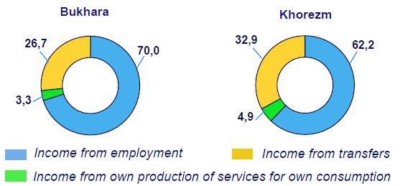
Figure 3.5: Structure of comprehensive income of population in 2019

- Household expenditures are divided in consumption and non-consumption expenses. Consumer spending include all private purchases of durable goods, non-durable goods, and services and non-consumption expenses include payment of taxes, loans, insurance and etc. In 2018 HH consumption expenses made 84.6% of total HH expenses and non-consumption expenses – 15.4%.
- In 2018 on average each HH member spent 572,300 UZS ($68) for consumption, in Bukhara province households spent on average 608,000 UZS ($73), and in Khorezm 669,800 UZS ($80.5) as shown in Figure 3.6.

Figure 3.6: Average household monthly consumption expenses in 2018 per capita
- About 45% of consumption expenses are spent for purchase of food products and eating out, 31.5% is spent to buy clothes, shoes, kitchen and home appliances, furniture and other non-food products. For transportation HH spend 3,4% of total consumption expenses, which is about $10 monthly expense per HH in the project area (Figure 3.7).

Figure 3.7: Structure of HH consumption expenses in 2018
- In the last decade, Uzbekistan has achieved significant progress in reducing low income rates and tackling malnutrition. Official statistics indicate that the national poverty rate has decreased from 19.5% in 2001 to 11.4% in 2018. Social cohesion has been maintained through more equitable income distribution, the creation of employment opportunities with a specific focus on rural areas, and attention given to vulnerable populations (Figure 3.8).

Figure 3.8: Share of Uzbekistan Population below the National Poverty Line

- This poverty calculation is based on 2,100 kilo-calories per day on the recommendation of the World Bank as said on the official website of the Statistics Committee of Uzbekistan.
- However, World Bank according to the most recent revision in 2011, estimated new line set at $1.90 a-day using the national poverty lines of the poorest countries. But in addition to the international “low income” poverty line, the World Bank also uses income class poverty lines which facilitate comparisons between countries at similar stages of development. The income class poverty lines are defined for the lower middle-income and upper middle-income countries and are based on the national poverty lines of the countries in each group. As such, they provide a more appropriate threshold to measure poverty for countries in each income class. The lines are defined at $3.2 (for lower middle-income countries) and $5.5 (for upper middle-income countries). The welfare measures of income or consumption used are the same as those used for the international poverty line.
- Until recently, Uzbekistan did not regularly provide the international community with the official data needed to estimate internationally comparable poverty rates. Consequently, the latest official and internationally comparable estimates date from the early 2000s. However, in 2018 a new study was launched by the World Bank in consultation with the National Statistical Agency of Uzbekistan and other partners called Listening to the Citizens of Uzbekistan. This study included a comprehensive baseline survey that can be used to estimate comparable poverty rates. These estimates suggest that in 2018 the poverty rate in Uzbekistan measured at the $3.2/day line stood at 9.6 percent of the population, and 36.6 percent at the $5.5-a day line.
- Poverty rates by provinces are presented in Figure 3.9. According to it, poverty rates in Bukhara province is lower than average, however it is higher than average in Khorezm province.

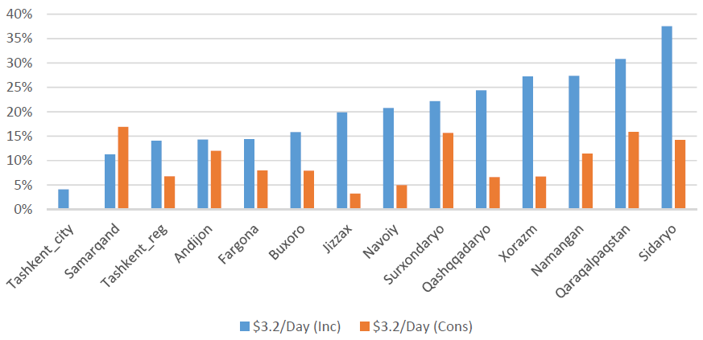
Figure 3.9: Poverty Rates by Provinces of Uzbekistan (2018)
Source: “The Listening to the Citizens of Uzbekistan” Survey, World Bank

- The poverty reduction program will be developed for the first time in Uzbekistan in conjunction with the World Bank, UNDP and other international institutions. This was announced by the President of Uzbekistan, in his address to the parliament on 24 January 2020. He was pledging $700 million toward combating the problem, but that the situation could not be resolved through handouts alone.

Education
- The education system in Uzbekistan is currently managed by three ministries: Ministry of Preschool Education, Ministry of Public Education and Ministry of Higher and Secondary Specialized Education. Educational system in Uzbekistan includes:
          - Preschool training (pre primary from 3 to 6 years old)
          - General secondary education (from 6 to 15 years old)
          - Secondary vocational education (from 15 to 18 years old)
          - Higher education (undergraduate and graduate-from 18 years old).

- Girls and boys are legally considered equal and study in the same classes and schools. Schools are open to all ethnic groups, and minorities in schools are rarely an issue. According to UNESCO Uzbekistan has an adult literacy rate of 99.99%, while the male literacy rate is 99.99%, for females is 99.98%.
- General secondary education in Uzbekistan is free (implying no tuition fees) and compulsory in the country, and this has resulted in a near-universal enrolments in the sub-sector. At the beginning of the 2018/2019 school year, the total number of general education institutions was 9,774, including 9,648 general secondary schools, 37 primary, 89 other institutions. This includes 6,044 schools (62%) located in rural areas, and 3,730 schools (38%) in urban areas. Number of schools in Bukhara and Khorezm provinces and number of students enrolled in the year 2018/2019 are presented in Table 12.
Table 12. Secondary schools in the Project Area in 2018/2019
Province | Number of schools | Number of students enrolled at schools  (in thousands) | Number of teachers working at schools  (in thousands) | Average number of students per teacher
Bukhara | 539 | 313.6 | 27.0 | 11.6
Khorezm | 526 | 341.3 | 29.1 | 11.7
Uzbekistan | 9,774 | 5,850.9 | 457.8 | 12.8

- According to the State Statistics Committee, in total 123 lyceums and 1,414 professional colleges are functioning in Uzbekistan currently, where 728,100 students are studying. Since the beginning of 2018/2019 school year, 360.2 thousand students are receiving education in higher educational institutions, and 22.1% students are studying on a state grant basis, 77.9% on a paid contract basis in Uzbekistan. In project area in total 8 higher educational institutions are operating now, where 34.3 thousand students are studying (Table 13). It should be noted that about nearly half of the higher educational institutions are located in Tashkent City (42 out of 98) and there are many students from Bukhara and Khorezm provinces studying in universities and institutes in Tashkent.
Table 13. Secondary-special and Higher Education Institutions in 2018/2019
Province | Academic Lyceums | Students at Lyceums (‘000) | Professional Colleges | Students at Colleges (‘000) | Higher Education Institutes | Students at Higher Education Institutes (‘000)
Bukhara | 6 | 3.7 | 81 | 38.6 | 5 | 20.9
Khorezm | 5 | 3.9 | 86 | 39.0 | 3 | 13.4
Uzbekistan | 123 | 71,8 | 1,414 | 656,3 | 98 | 360,2

- An analysis of the share of women in educational institutions in Uzbekistan shows interesting picture: While the gender parity is nearly achieved in preschools up till vocational colleges, thereafter, the share of women declines drastically. In academic lyceums, there are only 78 women for every 100 men enrolled, and only 61 women for 100 men in higher education institutions and finally, in research positions, for every 100 men, only 53 women are enrolled.
- The Ministry of Public Education recently adopted the second Education Sector Plan (2019-2023). The plan was developed with the participation of the different divisions of the Ministries of Education, and other line ministries (Finances, Economy, Health, and Employment and Labor Relations), as well as the State Inspection for the Quality of Education, State Statistics Committee and international development partners.
- The 2019-2023 Education Sector Plan has an overall vision that reflects the recent reforms introduced by the Government of Uzbekistan and is consistent with the it’s national development strategy 2017-2021. It presents the long-term strategic direction for accomplishing key policy priorities for the national education system.
- The Education Sector Plan responds to many developmental priorities as outlined in the country's national as well as global priorities.

Health Care
- According to the WHO country profile, as in most other countries, cardiovascular diseases (CVD) are the leading cause of death, both in people up to 65 years and in older age groups. The share of under-65 mortality attributable to CVD, diseases of the respiratory and digestive systems, and infectious and parasitic diseases is higher than the European average, whereas that due to cancer is lower. These differences are even more marked when compared with the averages for western European countries alone.
- Cancer mortality in Uzbekistan, one of the lowest in the Region, has fallen steadily since 1986. Mortality due to cancer of the trachea/ bronchus/lung is also substantially lower than the average for the newly independent states (NIS) and EU, and it remains one of the lowest in the European Region.Basic health-care service indicators are presented in the table 14. In total 123 hospitals, with beds for 15.2 thousand people available in project area. In addition, 789 clinics with the total capacity of medical observation of 41.9 thousand people per shift are operating here.
Table 14. Health-care service indicators in 2018
Province | Number of hospitals | Total number of beds in hospitals (in thousand) | Number of clinics | Total number of visits per day | No of diseases registered first time per 100,000 population
Bukhara | 81 | 8.3 | 486 | 21.4 | 32,352.1
Khorezm | 42 | 6.9 | 303 | 20.5 | 51,601.9
Uzbekistan | 1,165 | 153,6 | 5,631 | 440,9 | 47,853.8

Women in the Local Context
- Women are mainly involved in household activities. Women participate in household decision-making processes and organizing family matters. During census and socio-economic survey, most families suggested male household members to be the respondents, though females heading the affected household were active and willing interviewees. Women are actively involved in decision making process in family care, children’s education, household issues, and sharing social responsibilities.

Impact on Minorities
- The project is ethnically neutral, since different ethnicities share equal rights, as well as equal access to public and social facilities. No group of local residents showed any specific or unique features that could be identified as a distinct minority group. No impact on Indigenous People is expected from the Project.
- The country in general, as well as the investment project area does not include communities that may be defined as indigenous peoples under ADB's Safeguard Policy Statement (2009). Consequently, the indigenous peoples' impact classification for the proposed project is Category C and no further action is required.

- The project at the construction phase will include appropriate measures to mitigate the potential risk of HIV/AIDS and other sexually transmitted diseases, as well as drugs, human trafficking, child labor and labor trafficking. These measures include raising public awareness and shall be undertaken by Construction Contractor and/or Supervision Consultant as requested according to the identified needs.

Chapter 4. Legal Framework
- The legal and policy framework of the project is based on national laws and legislation related to land acquisition and compensation policy in Uzbekistan and the ADB Safeguard Policy Statement 2009 (SPS). Based on the analysis of applicable laws, regulations, and ADB’s Policy requirement, project related LAR principles have been adopted.

Applicable Country Legislation
- Constitution of Uzbekistan (December 8, 1992) guarantees ownership rights, freedom of economic activities and legal protection of all forms of ownership. The property owners can possess, use, and dispose their assets at their own will without harming the environment and infringing the rights and interests of others protected by law (Articles 36, 53 and 54). The land, its minerals, waters, fauna and flora, and other natural resources are the national wealth. The state shall protect and ensure their rational use (Article 55).
- Land Code (30 April 1998) regulates land administration, allocation and transfer of land plots and land use rights. Among other norms it defines (i) responsibilities of authorities (Cabinet of Ministers and regional, districts, and cities authorities) in management of land resources, (ii) rights and obligations of land users, (iii) categories of lands, and (iv) conditions for termination of land use rights including acquisition of lands for the state and public needs based on the creed of the authorities (districts, cities, regional Hokimiyats) or the Cabinet of Ministers and in agreement with the land users. In case of dispute, the Court will decide (article 37). The natural and legal persons can appeal the decree to the Court (article 36). The legal land users shall receive full compensation for all losses including lost profits and land plots of equal value (articles 39 and 41).
- Land Code further specifies the provisions for compensations including for lost profits (Article 86) in case of (i) acquisition, redemption or temporary occupation of lands, (ii) restrictions to the land use in connection with establishment of water protection zones, coastal strips, sanitary protection zones of water bodies, zones of formation of surface and underground waters, resort areas, public areas of biosphere reserves, protected zones around national parks, game reserves, national nature monuments, cultural heritage, discharges, roads, pipelines, communication and power lines.
- Civil Code (29 August 1996) among the other norms, (i) defines the legal status of all participants of civil relations, (ii) contractual obligations, (iii) procedure of enforcement of property rights including for intellectual property and personal non-property relations, and (iii) provides general rules of termination of property rights and compensation. As such, it envisages full compensation of all damages for affected persons, unless the law or the agreements provide otherwise. As per article 14, the person who loses property rights has right for compensation of all lost items and lost profit:
  - Costs of the AHs have incurred or shall incur to restore the property rights;
  - Loss of or damage to property (real damage); and
  - Incomes the AHs would have received under normal conditions of civil turnover if his/her property rights have not been affected (lost profits).

- According to the Civil Code, if the international treaty or agreement signed by Uzbekistan stipulates other rules than those stipulated by civil legislation, rules of the international treaty or agreement shall prevail (article 7). As per Article 8, Clause 3, the rights to the property which are subject to state registration arises upon the state registration of such rights, unless otherwise provided by law. Article 84, Clause 1 provides that the ownership rights to the immovable properties are subject to state registration. This means that without undergoing state registration, the land users can not establish property rights. It is important to understand and apply this requirement in the land acquisition and resettlement process including in the demolition of buildings.
- Tax Code (25 December 2007) along with other tax issues, envisages tax reduction and exemption for property, income, and taxable incomes for vulnerable people.

- Labor Code (21 December 1995) regulates labor relations of all forms of employment relations and mandatory for all employers and employees including the Uzbekistan nationals, foreign nationals, stateless persons and employees of the foreign international organizations and legal entities. Among other norms, the Code has provisions about (i) protection of the interests and occupational health and safety of employees, and (ii) indemnity compensation for the loss of employment to paid by the employers. In involuntary resettlement cases, the project proponents pay compensations. This does not guarantee compensation to informal employees and therefore does not guarantee that all APs lose jobs receive compensation.
- Law About Valuation Activities (2009 as amended to date). The Law envisages that valuation is a licensed activity and the valuators should be licensed and independent (article 4). It envisages the events when valuation is mandatory including in case of acquisition of assets (article 11). The law does not provide detail methodologies for valuation activities but refers to valuation standards and other regulations related to different industries. In case of dispute if necessary, to verify the reliability of the evaluation report, an examination of the conducted valuation report can be conducted by another valuator (article 181).
- Decree of the President of the Republic of Uzbekistan # 5495 (1 August 2018) “On measures on cardinal improvement of the investment climate in the Republic of Uzbekistan" provides acquisition of lands for state and public needs shall take place through discussions with the APs and assessment of costs and benefits. Land acquisition and demolition of immovable properties (residential, industrial, and other forms of structures) can take place after full compensation of owners and users at the market value of the lost property and other relevant costs. The Decree provides that land acquisition may take place by the approval of the Republican Centralized Fund (RCF), discussed below.
- Resolution of the Cabinet of Ministers # 1047 (26 December 2018) “On the procedure for the formation and use of centralized funds for the compensation to affected individuals and legal entities due to land acquisition for the state or public needs”. It defines sources of compensation payments based on the type of projects. The Supervisory Board of RCF decides on the allocation of funds for compensation.
- Resolution of the Cabinet of Ministers # 3857 (16 July 2018). The resolution “On measures to improve the effectiveness of training and realizing projects with participation of international financial institutions and foreign government financial organizations” specifies about payment of compensation for the land acquisition, demolition of houses/structures and trees for the projects financed by International Financial Institutions (IFIs) if such covenants are specified thereto, and will be carried out by authorized bodies as per the requirements of IFIs or Foreign Governmental Finance Organizations (FGFOs).
- Resolution of Cabinet of Ministers № 911 (16 November 2019). The resolution envisages procedures for acquisition of lands for state and public needs that belong to individuals (individual entrepreneur, citizen of the Republic of Uzbekistan, foreign citizen and stateless persons) and legal entities (business entities, non- governmental organizations) on the basis of ownership, permanent use or temporary use, as well as in the framework of investment projects and compensation for property owners including for the properties located on impacted lands.
- According to the Chapter 3 (General procedure for providing compensation to owners due to demolition of properties), Article 11 of the resolution, compensations are paid as follows:
  - Market value of real estate located on the seized land, and the market value of the right to the seized land;
  - Expenses associated with the temporary acquisition of properties, including relocation;
  - Loss of profits of individuals and legal entities, and other expenses and losses stipulated by law or agreement.
  - The cost of self-constructed housing, industrial and other buildings and structures should also be covered.

- Types of compensation provided:
  - Cash;
  - Provision of land plot or another property for the acquired land and property;
  - Other form of compensation as per agreement of parties.

- By agreement of the parties, the owner may be provided with several types of compensation, considering the estimated value of the property. The term for the provision of a new property instead of demolished property should not exceed 24 months from the date of provision of another property for temporary use. If a new property is not issued within the indicated period, the entrepreneur pays the owner a fine of 0.01 percent for each day of delay. In this case, the size of the fine should not exceed 50 percent of the value of the violated property. An agreement providing for the provision of property as compensation is subject to state registration in cases provided for by law.
- In case of acquiring the land for state and public needs, compensation shall be paid by the Council of Ministers of the Republic of Karakalpakstan, Hokimiyats of the city of Tashkent, regions, or district (city) from the funds of the corresponding centralized fund and other sources not prohibited by law.
- In case of acquiring the land for investment projects, the investor pays compensation and compensation can also be paid from other sources not prohibited by law, through:
  - Transferring funds to the appropriate bank (deposit) account of the affected owner;
  - In case of acquiring an apartment building the affected owner shall be given apartment for ownership in the same area or another area based on the agreement of parties;
  - A new apartment can be given from an apartment building (or houses) which are being built on the acquired land plot, as wished by the affected owner. In this case, the owner will be provided with temporary housing for rent paid by the investor, until he/she receives a new apartment in the housing buildings which is being built;
  - In case of acquiring lands occupied by a non-residential building, as agreed by parties, the affected owner shall be given a non-residential building within the same district (city) and not less than the total area of the acquired non-residential building;
  - If a non-residential building to be given as compensation from the buildings being built at the acquired land, the affected owner shall be given a temporary non-residential building for rent at the expense of the investor until she/he will receive the compensated non-residential building;
  - In case of acquiring a land, plot occupied by an individual residential premise (including construction in progress, but registered) - by an agreement of the parties, the owner shall be compensated with an individual residential premise within the district (city);
  - In case of acquiring a land plot the affected owner shall be given another land plot, the type and area of which is equal to the previous one.

- If the market value of the right to the seized land exceeds the market value of the right to the land plot provided as compensation, the difference shall be compensated to the right holder of the land plot.
- If the market value of the right to the affected land is lower than the market value of the right to the land granted as compensation, the affected land holder will not be required not pay the difference.
- By agreement of the parties, the size, and types of the land plot unit for compensation may be reduced by providing additional land plot as compensation.
- In case of acquiring the land plot for housing construction, the investor provides the affected owner and his/her family with temporary rent housing until the completion of construction and transferring the housing unit to the affected owner. In this case, the construction period should not exceed two years from the date of conclusion of the agreement.
- Resolution of the Cabinet of Ministers # 146 (25 May 2011) provides (i) procedures for allocating lands for urban development and other non-agricultural purposes considering architectural planning of towns and efficient use of lands based on the norms of the Land Code and the City Planning Code; and (ii) methodology for valuation and compensation for loss of lands, plants, agricultural and forestry products, incomes, as well land development costs.
- The Resolution provides that in case of land acquisition the valuation for compensation of lost plants, agricultural and forestry production shall be carried out following the methodology and formulas described in the Annex 4 of this Resolution. The “Uzdaverloyiha” State Scientific-Design Institute and its territorial divisions, branches of state-owned land management enterprises and real estate cadaster of the respective districts, will define amount of compensation with involvement of valuation companies. The valuation and defined compensation will be reviewed by commissions under respective districts Hokimiyats and approved by the Hokimiyats. In the case of dispute of AHs, the Court has own procedure for engaging a valuation commission to the value of losses for compensation. The Resolution envisage compensations for all losses (e.g. lands, costs of land development, structures, utilities, crops, trees, and fruits, and the lost income) to AHs with formal rights, but no compensation to AHs with no legal rights.
- Compensation in form of replacement land shall be made with lands of equal value, productivity, and irrigation services in a comparable location. If such land is not available, another land plot shall be given plus land development cost to improve the land quality and productivity, and irrigation supply; plus, transitional allowance for loss of income from crops based on the tax reported average annual net income for the last three years multiplied by four (four years during which the land will be selected and developed, or the irrigation system of the existing lands will be improved). UTY/Local Khokimiyats will pay all transaction costs and registration fees for the replacement land. UTY/Local Khokimiyats will pay the land development costs to the local authorities to use for land development. If the remained part of the affected land become nonviable, the whole land plot shall be acquired and compensated.
- Resolution of the Cabinet of Ministers # 44 (15 February 2013) envisages allowances to families (i) with children under the age of 14 years and/or disabled children, (ii) widows raising two or more children under the age 14, (iii) low income, (iv) single parents bringing up children, (v) one or both parents are unemployed and have been registered employment and social protection centers as job-seekers, (vi) single retired persons, and also childcare until the age of two years. UTY will verify the vulnerability status of AHs with the Mahallas.

ADB Safeguard Policy Statement (ADB SPS 2009)
- The ADB Safeguard Policy Statement (ABD SPS 2009) for infrastructure project related to Involuntary Resettlement defines the following:
- Objectives: To avoid involuntary resettlement wherever possible; to minimize involuntary resettlement by exploring project and design alternatives; to enhance, or at least restore, the livelihoods of all displaced persons in real terms relative to pre-project levels; and to improve the standards of living of the displaced poor and other vulnerable groups.
- Scope and Triggers: The involuntary resettlement safeguards covers physical displacement (relocation, loss of residential land, or loss of shelter) and economic displacement (loss of land, assets, access to assets, income sources, or means of livelihoods) as a result of (i) involuntary acquisition of land, or (ii) involuntary restrictions on land use or on access to legally designated parks and protected areas. It covers them whether such losses and involuntary restrictions are full or partial, permanent, or temporary.

ADB Policy Principles

- Resettlement planning is an integral part of project design for any ADB operation requiring involuntary resettlement, to be dealt with from the earliest stages of the project cycle, considering the following policy principles:

- Screen the project early on to identify past, present, and future involuntary resettlement impacts and risks. Determine the scope of resettlement planning through a survey and/or census of displaced persons, including a gender analysis, specifically related to resettlement impacts and risks.
- Carry out meaningful consultations with affected persons, host communities, and concerned non-government organizations. Inform all displaced persons of their entitlements and resettlement options. Ensure their participation in planning, implementation, and monitoring and evaluation of resettlement programs. Pay particular attention to the needs of vulnerable groups, especially those below the poverty line, the landless, the elderly, women and children, and Indigenous Peoples, and those without legal title to land, and ensure their participation in consultations. Establish a grievance redress mechanism to receive and facilitate resolution of the affected persons’ concerns. Support the social and cultural institutions of displaced persons and their host population. Where involuntary resettlement impacts and risks are highly complex and sensitive, compensation and resettlement decisions should be preceded by a social preparation phase.
- Improve, or at least restore, the livelihoods of all displaced persons through (i) land-based resettlement strategies when affected livelihoods are land based where possible or cash compensation at replacement value for land when the loss of land does not undermine livelihoods, (ii) prompt replacement of assets with access to assets of equal or higher value, (iii) prompt compensation at full replacement cost for assets that cannot be restored, and (iv) additional revenues and services through benefit sharing schemes where possible.
- Provide physically and economically displaced persons with needed assistance, including the following: (i) if there is relocation, secured tenure to relocation land, better housing at resettlement sites with comparable access to employment and production opportunities, integration of resettled persons economically and socially into their host communities, and extension of project benefits to host communities; (ii) transitional support and development assistance, such as land development, credit facilities, training, or employment opportunities; and (iii) civic infrastructure and community services, as required.
- Improve the standards of living of the displaced poor and other vulnerable groups, including women, to at least national minimum standards. In rural areas provide them with legal and affordable access to land and resources, and in urban areas provide them with appropriate income sources and legal and affordable access to adequate housing.
- Develop procedures in a transparent, consistent, and equitable manner if land acquisition is through negotiated settlement to ensure that those people who enter into negotiated settlements will maintain the same or better income and livelihood status.
- Ensure that displaced persons without titles to land or any recognizable legal rights to land are eligible for resettlement assistance and compensation for loss of non-land assets.
- Prepare a resettlement plan elaborating on displaced persons’ entitlements, the income and livelihood restoration strategy, institutional arrangements, monitoring and reporting framework, budget, and time-bound implementation schedule.
- Disclose a draft resettlement plan, including documentation of the consultation process in a timely manner, before project appraisal, in an accessible place and a form and language(s) understandable to affected persons and other stakeholders. Disclose the final resettlement plan and its updates to affected persons and other stakeholders.
- Conceive and execute involuntary resettlement as part of a development project or program. Include the full costs of resettlement in the presentation of project’s costs and benefits. For a project with significant involuntary resettlement impacts, consider implementing the involuntary resettlement component of the project as a stand-alone operation.
- Pay compensation and provide other resettlement entitlements before physical or economic displacement. Implement the resettlement plan under close supervision throughout project implementation.
- Monitor and assess resettlement outcomes, their impacts on the standards of living of displaced persons, and whether the objectives of the resettlement plan have been achieved by taking into account the baseline conditions and the results of resettlement monitoring. Disclose monitoring reports.

ADB Policy Principles Adopted for the project

- Based on the above, the core involuntary resettlement principles are proposed as follows:
  - Land acquisition, and other involuntary resettlement impacts will be avoided or minimized through all viable alternative project designs;
  - Construction schedule shall be matched with off-the agricultural season so that loss of crops can be avoided;
  - Land for land compensation will be opted, where possible, for permanent land acquisition;
  - Consultation with APs on compensation, disclosure of resettlement information to APs, and participation of APs in planning and implementing sub-projects will be ensured;
  - Vulnerable and severely affected APs will be provided special assistance;
  - Non-titled APs (e.g., informal dwellers or squatters, or APs without registration details) will receive applicable rehabilitation allowances defined by Entitlement matrix in lieu of land compensation and will be fully compensated for losses other than land;
  - Relevant information from the LARP will be disclosed to the APs in the local language;
  - Payment of compensation, resettlement assistance and rehabilitation measures will be fully provided prior to the contractor taking physical acquisition of the land and prior to the commencement of any construction activities on a particular package;
  - All compensation will be paid and other resettlement entitlements will be provided before physical or economic displacement;
  - Appropriate grievance redresses mechanisms will be established to resolve APs’ grievances, if they occur.
  - The temporarily affected land needs (if any) to be restored to previous use and the farmers shall be allowed to continue their cultivation after the completion of civil works;
  - People moving in the project area after the cut-off date will not be entitled to any assistance;

- All common property resources (CPR) lost due to the project will be replaced or compensated by the project and UTY will ensure that replacement of all utilities and CPRs are also undertaken consistent with ADB SPS, 2009.

Chapter 5. Institutional Arrangement

General
- The O’zbekiston Temir Yo’llari (UTY) will be executing agency (EA) responsible for implementation of the project. A project implementation unit (PIU) is created in UTY which will be responsible for the overall land acquisition and resettlement (LAR) activities. The PIU has a designated safeguards specialist who is specialized also in safeguards activities and will be responsible for ensuring that all the activities related to land acquisition and involuntary are being followed and implemented in accordance with Uzbekistan's legislation and policies and ADB's SPS. The safeguards specialist in the PIU, will ensure the final LARP is implemented prior to start of the civil works. There will be several other government agencies that will also be responsible for the LAR activities such as (i) Provincial/District Governments (Khokimyiat) and (ii) Goskomzemgeodezcadastre (State Committee on Land Resources, Geodesy, Cartography and State Cadaster (SCLRGCSC) at district level. The UTY (PIU) will perform systematic coordination with local authorities and other stakeholders in terms of LARP implementation and monitoring.

Executing Agency
UTY and its Project Implementation Unit
- UTY as the EA has established a PIU with required staff, including a safeguards specialist within the PIU. UTY is also responsible for selection of Construction Supervision Consultant (CSC). UTY through its Department of Capital Construction (“НОКС”) and its PIU will be responsible for approval of adequate budgetary support for LARP implementation and will facilitate coordination with the concerned government line agencies on LAR activities. UTY and its PIU will be responsible for getting the government’s endorsement of LARP, approval of the LARP from ADB and will ensure compliance in terms of complete payment of compensation to APs prior to the start of civil construction with close coordination with khokimiyats.

Safeguards Specialist in PIU
- The safeguards specialist of the PIU will ensure that the LARP and the social monitoring plan are followed and will provide technical support to the PIU. The specialist will coordinate with relevant government agencies on social matters, will prepare social monitoring reports to be submitted to ADB, and draft any updates/revision to the LARP and corrective action plan in case of unanticipated social and involuntary resettlement impacts resulting from change in design, location, etc. The safeguards specialist should have up-to-date knowledge of various social safeguards policies of Government of Uzbekistan and ADB with specific importance to land acquisition and resettlement. Specific tasks and responsibilities of the safeguards specialist of the PIU will include the following:
  - Responsible for overall planning, co-ordination and implementation of social safeguards and resettlement activities including land acquisition.
  - Overall coordination in all social issues in the PIU and ensuring that the project components comply with Government and ADB social safeguard policy.
  - Ensure comments from ADB are integrated in finalized documents.
  - Endorsement of LARP and obtaining the approval from ADB.
  - Disclosure of LARP and information dissemination on LARP to the Affected Persons through adequate consultations.
  - Ensure the implementation of LARP is consistent with Government and ADB policies.
  - Coordinate with line agencies such as local administration (Khokimyiat), SCLRGCSC at province and district level, valuation by the valuation committees and independent valuation firm and finalization of compensation packages.
  - Filing of application on land acquisitions with SCLRCGCSC
  - Coordination with Hokimiyats administration on facilitating the transfer of funds for payment of compensation to APs in accordance with LARP.
  - Coordination with contractor to ensure that the land is brought to pre project condition in case of temporary loss and land acquisition
  - Help UTY to make the necessary budgetary arrangements available in advance for the updating and implementation of LARPs.
  - Responsible for addressing the grievance in a timely manner and keeping the records of each grievance.
  - Monitoring of LARP implementation including the proper reporting to ADB.
  - Seeking permission from ADB to go ahead with the civil construction where the compensation and assistance are provided to APs, upon submission of a LARP implementation compliance report (section-wise, as necessary).
  - Submission of semi-annual monitoring reports to ADB.

- Under the guidance and close consultation with the PIU, conduct a daily monitoring of the LARP implementation for each project component in accordance with LARP defined monitoring indicators and further preparation of LARP implementation Compliance Reports.

- Assist the PIU in monitoring project associated facilities and related social safeguard issues and recommend corrective measures/actions as needed.

Project Management and Supervision Consultant (CSC)

- An international consulting firm once engaged by the PIU as a Project Management and Supervision Consultant (CSC) to assist UTY in managing and implementing the project and ensuring compliance with the project implementation plan, the loan agreement, and the project agreement(s), including the supervision of the implementation and monitoring of the compliances with social and environmental safeguards, and social/gender development aspects.

- The scope of CSC services is extended with involvement of international and national resettlement specialists (IRS and NRS) who will provide overall assistance to PIU in managing and implementing the project and ensuring safeguards compliance with the project implementation plan, the loan agreement, and the project agreement(s) in terms of social safeguards and resettlement, particularly in implementation and monitoring of LARPs, including the preparation of LARP implementation compliance reports and other required progress reports under the Project. During the implementation of the assignment, the IRS and NRS shall closely cooperate with each other, as well as with the PIU’s safeguards specialist, particularly they will:
  - Assist the PIU in implementation of LARPs, in particular- payment for compensation and other practical arrangements to affected people as per the final compensation and income restoration measures stated in LARPs prior to construction commencement;
  - Under the guidance and close consultation with the PIU, conduct a daily monitoring of the LARP implementation for each project component in accordance with LARP-defined monitoring indicators and further preparation of LARP implementation compliance reports;
  - Under the guidance and close consultation with the PIU, update the LARPs (and/or prepare corrective action plans (CAP) as required by ADB) for each project component in case of changes in project designs;
  - Assist the PIU in monitoring of SDDRs for project associated facilities and related social safeguards issues and recommend corrective measures/actions for PIU’s actions as needed.
  - Under the guidance and close consultation with the PIU, prepare semi-annual social monitoring reports throughout the project implementation period with indication of all social safeguards/resettlement related progress and issues for each Project component, including the associated facilities.

Other Relevant Government Line Agencies
Regional and District State Committee on Land Resources, Geodesy, Cartography and State Cadastre (SCLRGCSC)
- This is a permanent committee at Provincial and District levels. However it plays an enhanced role throughout implementation. It is responsible for:
  - identifying land losses incurred by land users plus agricultural output losses;
  - determining the degree and area of land restitution, including removal and temporary storage of productive soil layer;
  - determining the need for protective sanitary and water protection zones around constructions;
  - preparing proposals on allocation of land plots of equal value under land for land;
  - investigating alternatives to acquiring currently used land through developing unused land;
  - approving the Implementation Act and the attached plan.
District (Khokimyiat) (local government)
- District (Khokimyiat) will be closely involved in the LARP review and implementation which forms the Commission on Land Acquisition and District Evaluation Commissions. These will form district land acquisition and resettlement committee (DLARC) which will undertake the following:
  - Outline locations of constructions and structures affected by the project;
  - Select land for construction sites;
  - Approves the decree for the right to use of the land plot;
  - Compensation payment for AHs.
  - Farmer’s and Dehkan Councils and Mahalla authorities will be involved in resettlement activities to ensure the rights and interests of affected households.

- Implementation of LARP will require close coordination with the local Mahalla and farmer associations. This coordination will help UTY in the following:
  - Dissemination of information related to LARP;
  - Checking timely disbursement of compensation to affected households defined by LARP;
  - Obtaining early warnings on the grievances of APs;
  - Obtaining information regarding any unexpected impacts, if any, being incurred by the affected households.

Independent Valuation Firms
- Independent valuation firm will be involved in valuation of project affected assets once deployed by PIU and provided with detailed TOR.

Table 15. Institutional Roles and Responsibilities

Activity |  | Responsible Agency
A. Detailed Design and LARP finalization/update
Conducting discussions/meetings/consultation with APs and other stakeholders | UTY (PIU), National and International Resettlement Consultants hired by ADB, district Khokimyiat, Farmer’s and Dehkan Councils and Mahalla authorities
Disclosure of final entitlements and rehabilitation packages | UTY (PIU), District Khokimiyats
Approval of Final LARP | UTY, ADB
B. LARP Implementation Stage
Disbursement of compensation and assistance | District Khokimiyats, UTY (PIU)
Taking possession of land | UTY through the assistance of district Khokimyiat
Implementation of proposed rehabilitation measures | UTY (PIU)
Grievances redress | UTY (PIU) through the Safeguards Specialist, CSC, District Khokimiyats
Monitoring and Reporting | UTY (PIU) through the Safeguards Specialist, CSC
C. Completion Stage
Rest oration of land by the contractor along the Right of way and other construction sites | UTY/CSC will ensure that contractor follows the norms as mentioned
Restoration of approach roads and access if disturbed during construction | UTY/CSC will ensure that contractor follows the norms as mentioned
Consultation with local people regarding any further grievance | UTY (PIU), CSC

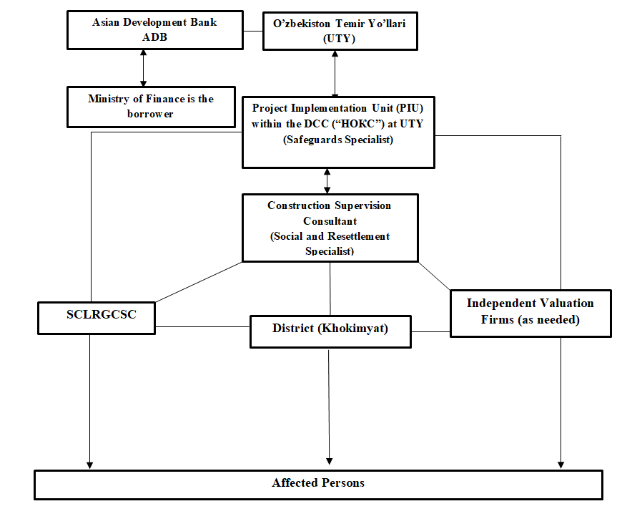
Figure 5.1: Scheme of Institutional Arrangements

Chapter 6. Grievance redress Mechanism

General
- A grievance mechanism is designated to allow an AP appealing any decision on which they disagree, practice or activity arising from land or other assets compensation. APs will be fully informed of their rights and of the procedures for addressing complaints whether verbally or in writing during consultation, survey, and time of compensation. Care will always be taken to prevent grievances rather than going through a redress process. This can be obtained through careful LAR design and implementation, by ensuring full participation and consultation with the APs, and by establishing extensive communication and coordination between the affected communities, UTY, and local governments in general. Complaint & grievances will be addressed through the process described below.

Objective
- In accordance with ADB SPS (2009), a grievance redress mechanism (GRM) is established to provide project effectiveness. The main goals of GRM are ensuring the receipt and timely redress of grievances and concerns submitted by aggrieved project affected persons, and to resolve complaints at the project level and prevent escalation to the national courts or to the ADB Accountability Mechanism. A grievance mechanism established to allow affected persons a mechanism for appealing any disagreeable decision, practice, or activity arising from land or other assets disorientation or compensation issue. APs are fully informed of their rights and of the procedures for addressing complaints whether verbally or in writing during consultation, survey, and/or time of compensation.
- The grievance mechanism does not impede access to the country’s judicial or administrative remedies. Affected persons can approach a court of law at any time and independent of the project level grievance redress process.
- Along with the ADB requirements on development and approval of grievance redress mechanism by implementation of investment projects, grievance redress procedure in Uzbekistan is also regulated by the national legislation of the Republic of Uzbekistan, in particular by the “Law on the order of submission of appeals of physical and legal entities” (#378, 03 December 2014).
- According to this Law, the application or complaint shall be considered within fifteen days from the date of receipt in the state authority, which is obliged to resolve the issue on its merits, as well as requiring additional study (research) and/or checking (investigation), a request for additional documents is valid for one month. The submission procedure for grievances and citizens’ applications was discussed during the public consultations in the project districts.

Grievance Redress Mechanism
- The GRM for the current project takes into account the national legislation, the specificity of the project sites, and results of public consultations. According to Resolution 97 (29 May 2006), the khokimiyats of the respective crayons (cities) are obliged to notify owners of residential, production and other buildings, constructions and plantings on the effective decision in writing for signature not later than six (6) months prior to demolition, while attaching to the notice, copies of the relevant decisions of local government units on the basis of the decision of the Cabinet of Ministers of the Republic of Uzbekistan on any land acquisition, demolition of residential, production and other buildings, constructions, and plantings located on the land.
- The APs will have the right to file complaints and query any aspect of land acquisition compensation and resettlement. PIU (UTY) acts as the GRM secretary to make sure that the GRM is operational to effectively handle environmental and social concerns of project affected persons. The proposed GRM was discussed PIU’s manager and safeguard specialist and it was presented during the public consultations. PIU will ensure that grievances and complaints on any aspect of the land acquisition, compensation, and resettlement are addressed in a timely and satisfactory manner. All possible avenues are made available to the APs to resolve their grievances at the project level. Under the established project level grievance mechanism, affected households may appeal any decision, practice or activity connected with the assessment or valuation of land or other assets, acquisition and compensation. APs were informed of the procedures they can follow to seek redress, including, if necessary resort to the courts through the Government’s grievance mechanism. The project grievance mechanism has been disseminated via the PC during the final LARP preparation stage, as well as will be reminded though the LARP information leaflet that will be distributed to affected households through the Mahalla or village assembly of citizens or farmers councils during the LARP disclosure and implementation stages.
- In addition, the GRM was discussed and updated into the format applicable for both aspects – environmental and social in terms of environmental impact and mitigation measures. After discussion with all parties, the following multi-level GRM is proposed for the project and is described below in Table 16.
Table 16. Grievance Redress Cycle
Level/Steps | Process
Level 1- any station of railway BUMK or khokimiyat | The aggrieved person applies to any station of railway BUMK. Head of station or designated officer will be in charge for receiving and registration complaints. PIU representatives at the construction site will collect information about received complaints from supervising stations on daily base. The alternative entry point for complaints will be also khokimiyats due to their obligations defined by national legislation: (i) khokimiyats of the respective crayons (cities) are obliged to notify owners of residential, production and other buildings, constructions and plantings on the made decision in writing for signature not later than six months prior to demolition, (ii) there is a 1st deputy of khokim responsible for industry, capital construction communications and utilities, who is usually responsible for any issues/complaints regarding the construction and land allocation; he works closely with the head of stations, and in case of complaints they will inform each other.  After registration of received complaints, PIU representatives will review nature/specificity of the complaint and will forward it to relevant party for resolving. In parallel, PIU representative will inform PIU in Tashkent about received complaint and further actions undertaken for its solution. Depending on nature of complaint it may go to Contractor, Land Cadastre, Mahala or district branch of Nature Protection Committee. For example, complaints related to resettlement issues may be forwarded to Land Cadastre, Khokimyiat and Mahallas. In case of environmental issue, compliant will be forwarded to Contractor or District Nature Protection Committee. PIU representatives will be assisted by CSC and PIU’s Environmental Specialist in GRM implementation. At this level complaint should be resolved during 2 weeks.
Level 2 - UTY’s secretariat in Tashkent | In case the grievance was not redressed on the first stage or applicant is not satisfied with the decision made/solution, s/he can submit the grievance directly to UTY’s secretariat in Tashkent. In accordance with established procedure, the secretariat will review the compliant and will forward complaints to respective department to made decision on its redress. In case the grievance is not related directly to the project, the further instance will be recommended to the applicant where s/he should apply for the decision making.  In case, if the compliant is required more time and resources for resolution, the UTY may establish complaint handling team with following members such as representatives from UTY area representative office, district Khokimyiat: cadastral department and Mahalla or village assembly of Citizens or/and farmer’s councils, or/and women association. All complaints will be resolved in 15 days, and in case additional details are required, a maximum of 30 days will be used to resolve and close the complaint with prior notification of complainant.

GRC Records and Documentation
- Most grievances on land acquisition and resettlement issues are redressed at Levels 1-2. All grievances received from the public will be registered in a logbook which will be available at all levels: at the site office of Contractor, each station of railway BUMK. Further, there are also logbooks in the khokimiyats where the grievances from the public are normally registered. All information received with respect to Contractor grievances and applications from aggregated persons, and any measures undertaken should be submitted to the representatives of PIU on the project site for updating records and accounting of all grievances. Otherwise, all received information on grievances will be collected at the PIU. Meantime, the UTY, with the assistance of construction supervision engineer, will maintain a consolidated electronic complaint register (database). This will include a record of all complaints received from all GRM entry points and levels for regular the monitoring of grievances.
- The Contractor and Supervision Consultant should include the information on grievances in monthly progress reports submitted to the PIU, who in their turn will include aggregated information to the semi-annual social monitoring reports (SSMR) to be submitted to the ADB.

- The UTY PIU will maintain the complaint register (I.e. Grievance Log) to record all complaints for regular monitoring of grievances and results of services performed by the GRCs for periodic review by the ADB.

ADB Accountability Mechanism
- Aggrieved persons may also use the ADB Accountability Mechanism (AM) through the direct citizens’ application to the Headquarters in Manila, particularly to the Complaints Receiving Officer, Accountability Mechanism, Asian Development Bank Headquarters 6 ADB Avenue, Mandalay City 1550, Philippines Email: amcro@adb.org , Fax +63-2-636-2086.
- AM is the last resort and ADB has its availability as a recourse in case other mechanisms for dealing with harmful project effects are unsuccessful. GRM is required by SPS and the use of project level GRM should be encouraged as a first recourse.
Figure 6.1: Grievance Redress Process

3
Any Station of Bukhara-Miskin-Urgench-Khiva or khokimiyat
Grievance is Addressed
Affected Person
UTY’s secretariat in Tashkent
Grievance is Addressed
Complaint handling team within UTY
Grievance is Addressed

LEVEL-1

LEVEL-2 Not addressed within 2 weeks

LEVEL-3 Not addressed within 15 days

Chapter 7. Compensation Entitlem33ents

- To adequately address land acquisition and related economic and social impacts, compensation entitlements elaborated in the LARP will be prepared in compliance with the applicable laws of Georgia and ADB SPS 2009 on Involuntary Resettlement.

Objectives of Compensation Policy

- The implementation of resettlement activities is linked to the implementation of the investment component of the project to ensure that land acquisition, economic displacement displacement, physical re-settlements or restriction of access does not occur before the necessary measures for resettlement are in place.
- All project related impacts identified during the relevant studies should be addressed accordingly, meaning that all project affected persons will be provided with relevant compensation and other assistance as required for their relocation. Prior to the displacement, preparation and provision of resettlement sites with adequate facilities, will be arranged where and as required. Acquisition of land and related assets may take place only after compensation has been paid and, where applicable, resettlement sites and re-location allowance s have been provided to the displaced persons.

Establishment of the Cut-off Date
- Compensation eligibility is limited to APs by a cut-off date that will be determined and clarified in the implementation ready LARP, the date of completion of DMS once the official limitations are officially released by the GoU.
- The APs will be informed about the essence and meaning of the cut-off date and advised that this is the completion date for the census, demarcation, land surveys, socioeconomic survey of project affected households, and inventory of project affected assets.
- Any person who settles in the affected areas, or erects any fixed assets, such as fences, auxiliary structures, buildings of residential and/or commercial designation, perennials (decorative and/or fruit bearing trees), and woodlots or other fixed or movable assets (except annual crops), after the cut-off date will not be eligible for any compensation.

- However, they will be given sufficient advance notice by a request to vacate premises and dismantle affected structures prior to project implementation. Their dismantled structures will not be confiscated, nor will they pay any fine or sanction. Forced eviction will only be considered following exhaustion of all other supporting efforts assisting re-location having been provided.

Eligibility Criteria for Compensation of APs
- The criteria for eligibility of compensation are based on APs belonging to one of three groups:
  - those who have certified and/or formal rights to the use of occupied land;
  - those who do not have formal legal rights to land at the time of completion of DMS
  - or census, but have legitimate right to claim such land or assets—provided that
  - such claims are recognized under the laws of Uzbekistan, and
  - those who have no legitimate possession or are not eligible to claim recognizable legal right to the land they occupy (including informal settlers) will be issued one
  - time financial aid to for all affected assets rather than land.
- The Entitlement Matrix presented in this document is the initial draft and as referenced above may experience due alterations to reflect the nuances detected during DMS, census, socioeconomic surveys, land surveys, inventory of project affected assets, and through the in-depth title search undertaken during the preparation of implementation-ready LARP.

Table 17. Entitlements Matrix
TYPE | SPECIFICATIONS | ENTITLED PERSONS | ENTITLEMENT
A. IMPACT ON LAND (PERMANENT LAND ACQUISITION)
A.1. Agriculture land/Orchard Land | All land losses independent of impact severity (due to construction of substation and towers of TLs, and any other primary structures, if any) | Concerned Government Agency responsible for land development | - Land development cost to be paid to develop new lands or through irrigation and agro-irrigation activities to raise the productivity of existing lands in accordance with the unit rate set by Cabinet of Minister Resolution # 146 and in case of absence such value category of agricultural land such as pasture, reserve land and others will be calculated by application of special unit rate set by this Resolution.  - The period for rehabilitation of under-received products shall be considered as being equal to four years, during which the land plot shall be selected for development of new lands or for irrigation improvement of existing irrigated lands.
 |  | Leaseholders/Land user having user permit (dehkan farm-holders) | - Land for land compensation with plots of equal value/productivity class, comparable location and agricultural support services (or compensation to provide such services);  - Compensation for loss of land in terms of loss of income equivalent to 4 years of net average income of the affected crops from the affected agricultural land.  - Unaffected portions of an affected arable plot will also be compensated, if the same becomes nonviable after impact.  - Transaction cost, registration fee, related to new plot allotted, to be will be borne by UTY.
 | Additional provision in case of severe impacts (10% or more loss of productive assets) | Leaseholders with lease agreement and dehkan plot holder | - Severe impact allowance equal to the net income from annual crop production (inclusive of winter and summer crop in addition to standing crop compensation) will be paid in addition to the compensation for land loss.
A.2. Residential land/ Commercial land | Land loss | APs who has right on lifelong  inheritable  possession/  permanent  possession | - Land for land compensation through provision of a plot comparable in value/location to the plot lost including services (or compensation to provide such services) to plots lost  - OR  - Cash Compensation at market replacement cost to be determined by the Independent Valuator.  - Transaction cost, registration fee, related to new plot allotted, to be will be borne by UTY  - Unaffected portions of an affected arable plot will also be compensated, if the same becomes nonviable after impact.
A3. Unregistered agricultural land | Land loss | Unregistered lessee who initiated to pay unpaid land taxes and become a leaseholder. | - All entitlements for agricultural land losses as stated above for lease holder, however, they will be entitled for compensation for non land assets regardless of tax payments and registration.  - Assistance in acquiring required legal documents for registration at no cost for APs.
A4. Unregistered agricultural land | Land loss | Non titled or non-legalizable affected household | - Non legalizable affected households will be entitled for compensation for non land assets only.
B. IMPACT ON LAND (TEMPORARY LAND ACQUISITION)
B.1. Agriculture land/Orchard Land | All land losses independent of impact severity (due to construction of Transmission Lines along the Right of Way) | Concerned Government Agency responsible for land development (in case there is damage to associated services such as irrigation facilities and other existing services) | - Land development cost for restoring the existing facilities and providing required services.
C. IMPACT ON STRUCTURES
Residential/ Commercial Structures | Full or partial loss of structures if to be displaced | All affected households irrespective of legal title and irrespective of nature of impact whether permanent land acquisition or temporary acquisition | - Compensation at full replacement cost for affected structure/fixed assets free of depreciation and transaction cost  - APs must have right to salvage materials with no deduction from the compensation.  - Household losing structures/buildings who need to relocate will each be provided with a relocation allowance (equal to 3 months of minimum salary) while the new house or building is being erected.  - In case of partial impacts on structures (structure wall, fences etc), cash compensation at replacement rates to restore the remaining structure.  - Household losing structures/buildings who need to relocate will each be provided with a temporary housing on the conditions of lease agreement or rental allowance in cash for the period of land plot utilization for up to two years while the new house or building is being erected.  - Household losing structures/buildings who need to relocate will each be provided with shifting allowances to hire vehicle for transportation of the family members, goods and chattels to temporary and permanent relocation sites.  - The access to similar or better levels of infrastructure will be provided to displaced households (water, gas and electricity connections, access to social infrastructure etc.”
 | Loss of place to  Rent | Tenant | - New lease by landlord or 3 months cash equivalent of existing lease to allow for a new lease to be found and signed.  - Compensation for lost rent paid in advance. The time is to be established by the independent valuer.  - Tenant who has lost the rent and need to relocate will each be provided with shifting allowances to hire vehicle for transportation of the family members, goods and chattels to new lease sites.  - Tenant without formal notarized lease to show proof or evidence in order to claim compensation.
 | Additional provision of severe impact allowance in case of physical displacement | All physically displaced households | - Household losing structures/buildings who need to physically relocate will each be provided with a severe impacts allowance (equal to 3 months of minimum salary).
D. IMPACT ON CROPS AND TREES
Agriculture land/ orchard land | Loss of crops for permanent land acquisition | All affected Households | - Compensation at full replacement cost for primary (and secondary crops if any) on affected land based on 1 year of production costs (inputs) plus an allowance equivalent to 1 year average net income based on the average income over the past 3 years.  - Advance notice to harvest the crops  - Schedule of construction to avoid crop season
 | Loss of standing crops along the right of way of transmission line (temporary land acquisition) | All affected Households | - Compensation at full replacement cost for primary (and secondary crops if any) on affected land based on 1 year of production costs (inputs) plus an allowance equivalent to 1 year average net income based on the average income over the past 3 years.  - Advance notice to harvest the crops  - Schedule of construction to avoid crop season  - Restoration of land to previous use and farmers will be allowed to continue their cultivation post the construction  - Duration of construction shall not exceed more than one crop season at that particular stretch.
 | Loss of fruit Trees (permanent and temporary land acquisition) | All Affected Households (including non leased land owner) | - Compensation for fruit trees will be based on the average annual income for past 3 years (UZS/kg/tree) multiplied by 4 (years) to reflect the duration from planting to reach the productive stage (including the cost of saplings).  - Felled fruit trees will be kept by the AHs with no deduction from the compensation.
 | Loss of timber trees (permanent and temporary land acquisition) | All Affected Households | - Compensation for timber trees will be compensated based on market value of dry wood volume.  - Felled trees will be kept by the AHs with no deduction from the compensation.
E. IMPACT ON INCOME AND LIVELIHOOD
E1. Employment from affected agricultural land | Loss of employment from affected agricultural land | Agricultural workers losing their contract | - Compensation corresponding to their salary (in monetary terms or in kind) for the remaining part of the agricultural year/or contractual period whichever is higher in monetary value  - In case of informal agricultural workers those work without any agreement will be paid an allowance equivalent to 3 months of minimum wage.
E2. Business and involved workers | Loss of business and employment (permanent or temporary interruption of business and employment) | Affected household losing business and involved workers | - Affected household losing business will be compensated for the period of business interruption up to 6 months, or 6 months cash compensation in case of permanent closure of business based on the estimated average monthly income in the past 3 years multiplied by the number of months of business interruption.  - Workers from the affected businesses will be paid for lost wages for the duration of business interruption up to 6 months.  - In case of informal workers working without any agreement will be paid an allowance equivalent to 3 months of minimum wage.
 |  | Affected household losing non-titled (unregistered) business and involved workers | - Affected household losing non-titled business will be paid a rehabilitation allowance equivalent to 3 months of minimum wage.  - Workers from the affected non-titled businesses will be paid an allowance equivalent to 3 months of minimum wage.
 | Additional provision of severe impact allowance in case of physical displacement | All physically displaced households | - Household losing structures/buildings who need to physically relocate will each be provided with a severe impacts allowance (equal to one year profit loss).
E3. Livelihood/employment due to physical relocation | Loss of livelihood/employment due to physical relocation | Affected household losing livelihood/employment due to physical displacement | - Affected household losing livelihood/ employment due to physical displacement will get a rehabilitation allowance equivalent to 3 months of average monthly income in case of provision of relevant grounds of such loss.
F. VULNERABLE HOUSEHOLDS
Vulnerable Affected Households | All Impacts | Women headed household, Low Income household, household headed by elderly with no support and household headed by physically disabled people | - Rehabilitation allowance equivalent to 3 months of minimum wage.  - Priority for employment in project-related jobs, training opportunities, self-employment and wage employment assistance.
G. IMPACT ON COMMUNITY STRUCTURES AND ASSETS
Community structures and assets | Loss or damage to public infrastructure and utility | Community owned Assets | - Rehabilitation/replacement of affected structures/utilities (i.e. roads, pavements, pipelines) to pre-Project level.
H. TEMPORARY IMPACTS DURING CONSTRUCTION
Temporary impact on private or public Land, assets and/or Income | Due to construction | All affected households and assets | - UTY will ensure that any kind of temporary impact on private and public assets during project implementation for civil work purposes will be compensated by contractor based on replacement value for structures, rentals for land use, replacement value for crop and tree loss as stated above in the entitlement matrix.
I. ANY UNANTICIPATED IMPACTS
Any unanticipated impacts identified during Project implementation will be compensated in full at replacement cost and the entitlement matrix shall be revised if required in case major unanticipated impacts occur during detailed and final design.

Chapter 8. Public Consultations and LARP Disclosure
- Project stakeholders, such as AP, National and local government agencies involved in the LARP preparation and implementation process and NGOs will be kept well-informed about the project and encouraged to remain actively engaged in the LARP development process.

Objectives of Public Information and Consultation
- Information dissemination to APs and involved agencies is an important part of LARP preparation and implementation. Consultation with APs ensuring their active participation will reduce the potential for conflicts and minimize the risk of project delays. To ensure that local authorities, as well as representatives of APs, have been included in the planning and decision-making processes, UTY-PIU and Consultant will maintain a dialogue with district and Khokimyiat authorities and NGOs, as relevant, during the entire project implementation process to ensure:
  - Fully sharing information with APs about the proposed project and LARP preparation activities, including the disclosure of design options, as needed
  - Obtaining information about the needs and priorities of APs, as well as receiving information about their reactions to proposed policies and activities
  - That APs are fully informed about the decisions that will directly affect their incomes and living standards; and that they will have the opportunity to participate in activities and decision-making about issues that will directly affect them, including the announcement of cut-off date;
  - APs are given contact information of project responsible persons from local authorities/RD to provide timely and sufficient feedback to their inquiries
  - Obtaining the cooperation and participation of the APs and communities in activities necessary for the resettlement planning and implementation, and transparency in all activities related to land acquisition and compensation procedures.

- Due to COVID-19 pandemic restrictions public consultation meetings were kept on hold, but will be carried out as soon as restrictions are released. Public consultation meetings will be open to a large spectrum of project stakeholders and ensure that local authorities and permanently and temporally affected persons are well-informed on pending project objectives, related impacts, and mitigation measures.
- The public meetings attendees including APs, representatives of local government and civil society will be provided with information on pending project activities, rights and responsibilities, advised on GRM procedures, raised awareness and importance of APs’ participation in project planning, and made aware of pending surveys to attain a high accuracy and fair approach in the determination of APs’ eligibility for compensation.
- Further, attendees will be introduced to the essence of the cut-off date and related limitations, general compensation principles, other additional rehabilitation measures and one-time allowances considered for severely affected and vulnerable groups as stipulated in the ADB guidelines on Involuntary Resettlement and National legislation. The Minutes of Public Consultation Meetings, list of attendees and photos will be provided in the final LARP.

Public Information Booklet
- The Public Information Booklet (PIB), i.e., the reduced version of the draft LARP in Uzbek language and easy-read format for APs will be prepared based on the draft of implementation ready LARP. The document will summarize the importance of the cut-off date, compensation eligibility criteria, brief review of valuation methodology and compensation entitlements, project schedules and implementation features, procedures for land acquisition and conditions for expropriation procedures, the rights and responsibilities of APs and other project stakeholders, opportunities of grievance redress mechanism and monitoring programs.
- The minutes of the meetings supplemented with an overview of the question-answer session, photo materials, and gender disaggregated list of meetings attendees showing their full names, contact phone details, and signatures will be presented in the Final Draft LARP.

Dissemination of Public Information Booklets
- Social Safeguards Team comprising environment and resettlement experts prepared a Public Information Booklet (PIB) that contains all relevant information regarding project scope, objectives, eligibility to compensation, GRM, environment protection HSE instruction, including contact details for GRM focal person at PIU-ET.
- In August 24-28 2020 700 copies of the Public Information Brochure were distributed among all Khokimiyats located within project area and Bukhara, Urgench, Miskin and Khiva Railway stations. The Team followed COVID-19 preventative measures on social distancing, facial masks, and use of hand sanitization. The Uzbek version of the Public Information Brochure is provided in Annex 2. The photos of PIB distribution are provided at Annex 5.
- The team provided 700 copies of PIB to the project affected Khokimyats. The UTY district offices are in coordination with the Khokimyiats and provide needed technical assistance to ensure copies of PIB are distributed to village/massive levels and delivered to head of local makhalla offices.
- Head of makhalla offices ensure that PIBs are displayed on the Information Boards placed in the lobby of makhalla offices. In addition, every head of local makhalla offices were instructed by khokimiyats to provide copy of PIB to the local shops to be displayed at the entrance (wall, glass window) of the shop visited by local people almost on a daily basis.
- At this phase of project preparation local shops, head of local makhalla office provided with sufficient number of PIBs are the best channel to disseminate PIBs and ensure local population is well-informed regarding the pending project.
- Once the COVID-19 restrictions are released and field surveys for Implementation Ready LARP are allowed more PIBs will be individually provided to each affected household and farm enterprise during census, SES, inventory of project affected assets that requires face-to-face communication with every interviewed person and users of project affected land and assets.
- Face-to-face communication during field surveys is the best communication channel to provide all APs project related information, allowing APs to ask questions and receive sufficient and satisfying information form the Project Team. Feedback of APs obtained through such communication allows project Team to improve Implementation Ready LARP by addressing all possible socio and economic impacts of the pending project; and ensure livelihood of individual APs and in general project affected community if not improved is at maintained to pre-project level.
- Once the field surveys are completed and draft Implementation Ready LARP prepared the UTY-PIU will organize additional Public Consultation meetings prior to commencement of LARP implementation and civil works.

LARP Disclosure
- The draft LARP in Russian and English will be disclosed on the MOT/UTY and ADB websites. Hard copies of LARP will be provided to all project affected khokimiyats and village Mahallas.
- Once the draft LARP is approved and ADB and GoU the English version will be disclosed on ADB website, while Russian and English versions will be uploaded to MOT/UTY website. The draft LARP will be updated and finalized into an implementation-ready LARP following the detailed design. The final and implementation-ready LARP will also be disclosed on ADB and MOT/UTY websites.
- In cased pandemic restrictions are prolonged the UTY-PIU may exercise alternative method to keep APs well informed and using State Post service mail sufficient number of copies of Public Information Booklet in Uzbek language to all project affected villages to Raisi Mahallas, so that APs could then obtain a copy of PIB and get familiar with all land acquisition and compensation procedures prior to commencement of LARP implementation activities.

LARP Implementation Process
- The time for implementation of LARP will be scheduled as per the overall project implementation schedule. All activities related to the land acquisition and resettlement will be planned to ensure that compensation is paid prior to taking possession of land and commencement of civil works. Public consultation, monitoring and grievance redress will be undertaken intermittently throughout the project duration. Draft LARP implementation may start after the approval of draft LARP by UTY and ADB. The completion of LARP implementation will be documented through the draft LARP implementation compliance report (s) prepared by TPIO and approved by ADB.

- Upon the approval of draft LARP, all the arrangements for fixing the compensation and the disbursement needs to be done which includes issuance of identity cards (IDs), payment of all eligible compensation and assistance; initiation of land development process; site preparation for delivering the site to contractors for construction and finally commencement of the civil work.
- Payment of compensation and allowances under the draft LARP will commence after a number of preparatory tasks have been completed. These tasks are:
    - Disclosure and consultation
    - Issuance of IDs and bank account for AHs
    - Disbursement of compensation and assistance
    - Grievance resolution
    - Compliance review and reporting
    - Notice to proceed for Civil works construction
    - Restoration of land (temporary impacts)
    - Monitoring and reporting

- Supervision consultant/PIU specialists should work close with all AHs in weekly base and all AHs (who are entitled for compensation) should write the official statement with indication of bank account details to UTY/Khokimiyat, consultant bring it to UTY for the payment procedure start through the accountancy.

LARP Implementation Schedule

- The tentative schedule for the draft LARP implementation of the project is provided in table below.

Table 18. LARP Implementation Schedule
LAR Activities | Timing
- Draft LARP approval and disclosure | By November 2020
- Land allocation document and evaluation report | By November 2020
- Final LARP preparation and disclosure | Dec -20 -Jan 21
- Final LARP Implementation | By April-May 2021
Issuance of IDs to APs | By April-May 2021
Payment of compensation to APs | By April-May 2021
Payment of all eligible assistance | By April-May 2021
Consultation and GRM | Continual
Internal Monitoring by UTY
LARP Compliance Report (s) to be submitted upon completion of LARP implementation | June-July 201
SSMR to be submitted to ADB | On semi-annual basis

Chapter 9. MONITORING AND REPORTING

Overview and objective

- Monitoring will be the responsibility of UTY, with the assistance of the social and resettlement specialist, CSC will systematically monitor and measure the progress of implementation of the LARP. The objective of the monitoring is to assess the progress of implementation of LARP in terms of its process, targets, problems, mitigation measures, and corrective action etc., so that the physical activity and implementation of the project progresses undisturbed. The extent of monitoring activities will be commensurate with the project’s risks and impacts. The implantation of LARP will be monitored by UTY (PIU). In addition to recording the progress in compensation payments and other resettlement activities, UTY will prepare monitoring reports ensuring that the implementation of LARP continues producing the desired outcomes. The PIU will provide ADB with an effective basis for assessing land acquisition and resettlement progress and identifying potential difficulties and any emerging problems.

Monitoring
- The monitoring will involve (i) administrative monitoring to ensure that implementation is on schedule and problems are dealt with on a timely basis and (ii) overall monitoring to assess status of affected persons in terms of compensation and assistance and alternate land allocation with land development etc. UTY is required to implement safeguard measures as provided in the LARP. UTY through its PIU will:
  - monitor the progress of implementation of LARP,
  - verify the compliance with safeguard measures and their progress toward intended outcomes,
  - document and disclose monitoring results and identify necessary corrective and preventive actions in the periodic monitoring reports,
  - effect these actions ensuring steady progress toward desired outcomes, and
  - submit LARP implementation compliance reports, and semi-annual social monitoring reports (SSMR) as required to ADB.

- Monitoring will include daily planning, implementation, troubleshooting, and feedback, individual affected person file maintenance, community relationships, dates for consultations, number of appeals placed and progress reports. UTY through its PIU will be responsible for managing and maintaining affected person databases, documenting the results of the affected person census. With assistance from CSC, monitoring reports documenting progress of LARP implementation and a Completion Report will be prepared by UTY through its PIU to be submitted to ADB for review and consideration. The monitoring report will contain: (i) accomplishments to-date, (ii) proof of compensation and land allocation, (iii) problems encountered, grievances received and addressed, consultations accomplished during the reporting period, if any, and (iv) suggested options for further corrective measures.

Monitoring Indicators
- Fulfilment of the LARP policy and targets in the implementation process will be monitored through the establishment of indicators. The vital indicators to be monitored will include the contents of the activities and entitlement matrix. The LARP contains indicators for achievement of the objectives under the resettlement program. The indicators for achieving the proposed objectives during the implementation of the LARP are of two types: (i) Process Indicators (indicating project inputs, expenditure, staff deployment, etc.), and (ii) Output Indicators (indicating results in terms of numbers of DPs/APs compensated, and assistance provided. Indicative monitoring indicators are presented in Table 19.

Table 19. Monitoring Indicators
Type | Indicators
Process Indicator | Number of consultation and participation events held with various stakeholders  Grievance mitigation Procedure  Placement of Project staff at the project level  Placement of funds for land acquisition  Procedure of allocation of new land plots (if applicable)  Disbursement of compensation to APs  Disclosure and consultation events  Grievance redress procedures in-place and functioning  Monitoring reports submission
Output Indicator | Number of households compensated:  Compensation paid for loss profit from affected land  Compensation paid for loss of harvest from trees  Compensation paid for affected trees  Land development cost paid to gov. special account

Reporting
- UTY through its PIU will be responsible for managing and maintaining AP's database documenting the final results of the affected person census based on final design. Monitoring reports documenting progress on land acquisition and resettlement will be provided by UTY through its PIU to ADB. A LARP implementation compliance report will be prepared upon completion of the disbursement of compensation and allowances and allocation of replacement plots to APs. ADB approval of the LARP implementation compliance report is a condition for commencing civil works in the TSS with LAR impacts. UTY will also monitor any LAR-related issues, complaints and actions during project implementation through semi-annual social monitoring reports (SSMR). The LARP implementation compliance report and SSMRs will be posted on the ADB website upon acceptance of the report by ADB.

Chapter 10. Estimated LARP Implementation Budget
- This chapter describes the methodology adopted for the determination of cost of LAR and compensation that will be paid to APs for permanent and temporary resettlement impacts caused by the Project. The compensation entitlements of different categories of impacts presented in this chapter have been defined according to the ADB SPS 2009 requirements and the applicable laws of the Uzbekistan. The land development cost, compensation for lost profit from crops and trees was calculated on the basis of previous LARPs as example as currently no land allocation document is ready at this stage. Compensation in the project will include compensation for affected properties, applicable crops, trees and other associated assets if any.

- The draft LARP compensation package contains the following:
  - Compensation for income loss (lost profit) from crop due to permanent and temporary land acquisition which will be evaluated by agricultural department of local khokimiyats.
  - Compensation for permanent loss of land use rights
  - One-time allowance for severe impact
  - One-time allowance for vulnerable AHs (once identified under the final LARP)
  - One-time allowance for loss of employment (wages for agricultural labourers if identified under the final LARP)

- The preliminary data on compensation per type of impact is given below in separate tables. The detailed breakdown of APs (affected farms and/or dehkans) is described in Annex 4.

Loss profit (loss of income) from affected land
- This compensation amount will be paid to the affected households for permanent land acquisition in terms of loss of income equivalent to 4 years of net income based on last 3 years of average annual profit (this amount will be multiplied to the area of permanently affected land).

- For this draft LARP, the annual net profit from one hectare is taken as 539,040,000 UZS. The main criteria and methodology of lost profit cost are area and usage type of affected land (cultivated), average net profit per hectare of land.

- The loss profit from affected land will be calculated by Uzdaverloyikha Institute together with Agricultural Department of project-affected districts based on the provisions of entitlement matrix and totally amounts to 40,766,733 UZS compensation for loss profit from affected land will be paid by UTY/Local Khokimiyats to AH’s bank accounts. The details on compensation per massives are given in table 20 below and the detailed calculation is attached in Annex 4.
Table 20. Compensation for loss profit (loss of income) crops grown on the affected land
# | Affected district | Affected Massive | Affected cultivatedarea (ha) | Loss of profit from affected land (UZS)
1 | Kagan | Z.Kobilov | 2,44 | 5,261,030
2 | Rumitan | E.Khodjaev | - | --
3 | Peshku | Djongeldi | 6 | 12,936,960
4 | Turtkul | Kizilkum | - | -
5 | Tuprokala | Sarimoy | - | -
6 | Hozarasp | Dustlik | 5,22 | 11,255,155
7 | Urgench | Pakhtakor | 5,25 | 11,313,587
Total: |  |  | 18,91 | 40,766,733
Source: Impact Assessment Survey, April-July 2020.

Severe impact allowances
- There are the total of 58 AHs losing more than 10% of productive land. Each of these 58 AHs will receive onetime allowance for severe impact calculated according to the area of project affected cultivated land multiplied to average annual net profit unit rate 539,040.00 UZS per ha.

- This unit rate is based on the information obtained from Agricultural Department of Khorezm and Bukhara provinces. One year profit loss (539,040.00 UZS /ha) is multiplied to the affected area of severely affected AHs. The details on compensation per massives are given in table 21 below and the detailed calculation is attached in Annex 4.

- As shown in table 21 below severely affected AHs are located only in Dustlik (of Hozarasp district) and Pakhtakor (of Urgench district).

Table 21. Severely impact allowance
# | Affected district | Affected Massive | Affected cultivated area (ha) | Severely impact allowance (UZS)
1 | Kagan | Z.Kobilov | 2,44 | N/A
2 | Rumitan | E.Khodjaev | -
3 | Peshku | Djongeldi | 6 | N/A
4 | Turtkul | Kizilkum | - | -
5 | Tuprokala | Sarimoy | - | -
6 | Hozarasp | Dustlik | 5,18 | 2,797,618
7 | Urgench | Pakhtakor | 5,25 | 1,642,509
Total: |  |  | 18,91 | 4,440,126
Source: Impact Assessment Survey, April-July 2020.

Total of Estimated Cash Compensation
- The total cost for land acquisition and resettlement is 200,600,642.00 UZS equivalent to 19,646.72 USD. Summary cost estimate for land acquisition and involuntary resettlement is shown in Table 22 below. The detailed breakdown of compensation cost per each AH and per types of loss is provided in Annex 4.

Table 22. Summary of Land Acquisition and Resettlement (LAR) Cost
Particulars | Total Cost, UZS
A. LAR cost category
Loss profit from affected land | 40,766,733
Sub-total of loss profit from affected land | 40,766,733
Topographic survey | 30,000,000
Severe impact allowance (58 dehkan landholders) | 4,440,126
Preparation of land allocation document (zemelniy otvod) | 84,000,000
TOTAL A | 153,206,859
B. Administrative cost (5% of the total cost) | 7,960,343
TOTAL A and B | 167,167,202
C. Contingency (20% of the total cost) | 33,433,440
TOTAL ABC (UZB) | 200,600,642
Total (USD) | 19,646.72

ANNEXES

Annex 1. Description of Eight Traction Substations
Name of the Traction substation: Bukhara
Location: Bukhara province, Kagan district
GPS: 39°42'24.56"N and 64°31'36.68"E
Voltage: 110kV
Total area: 2.44 ha
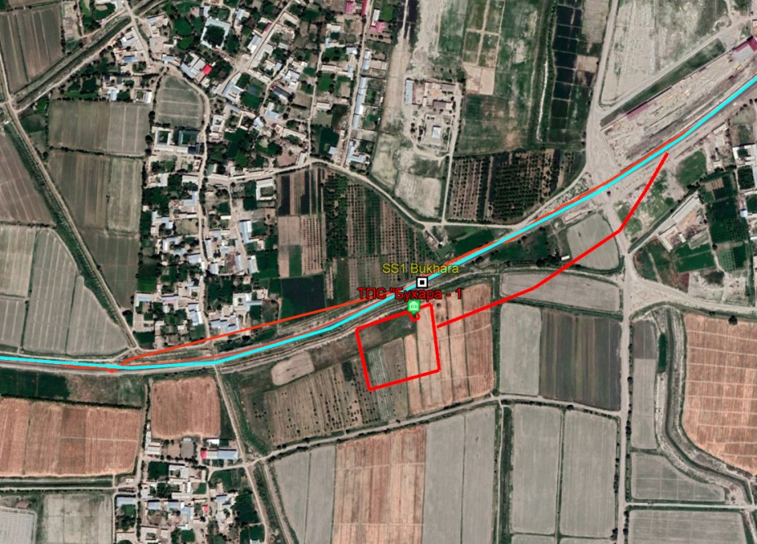
Number of APs: 2 (2 farm enterprises)
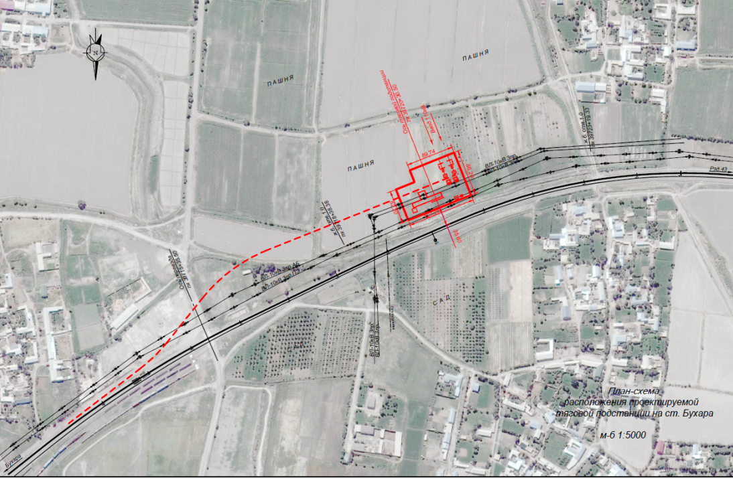

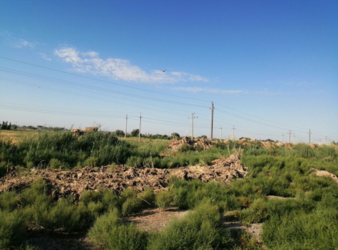

Name of the Traction substation: Navbahor (Mashak)
Location: Bukhara province, Rumitan district
GPS: 40° 5'27.10"N and 64° 5'33.90"E
Voltage: 110kV
Total area: 3 ha
Number of APs: 0

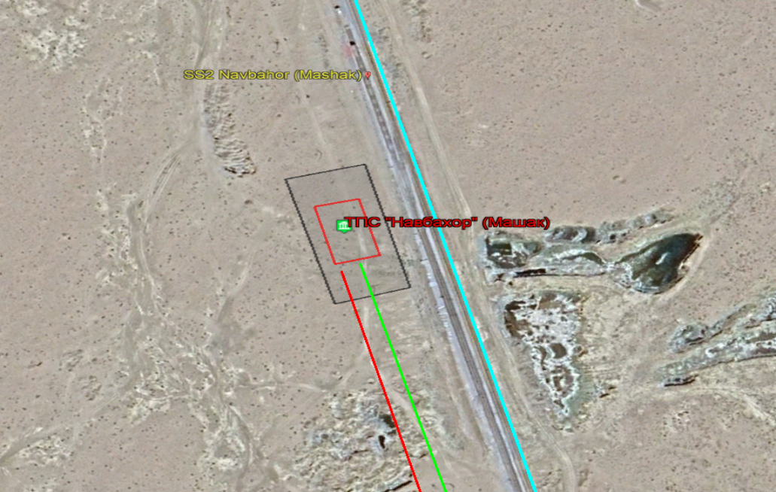
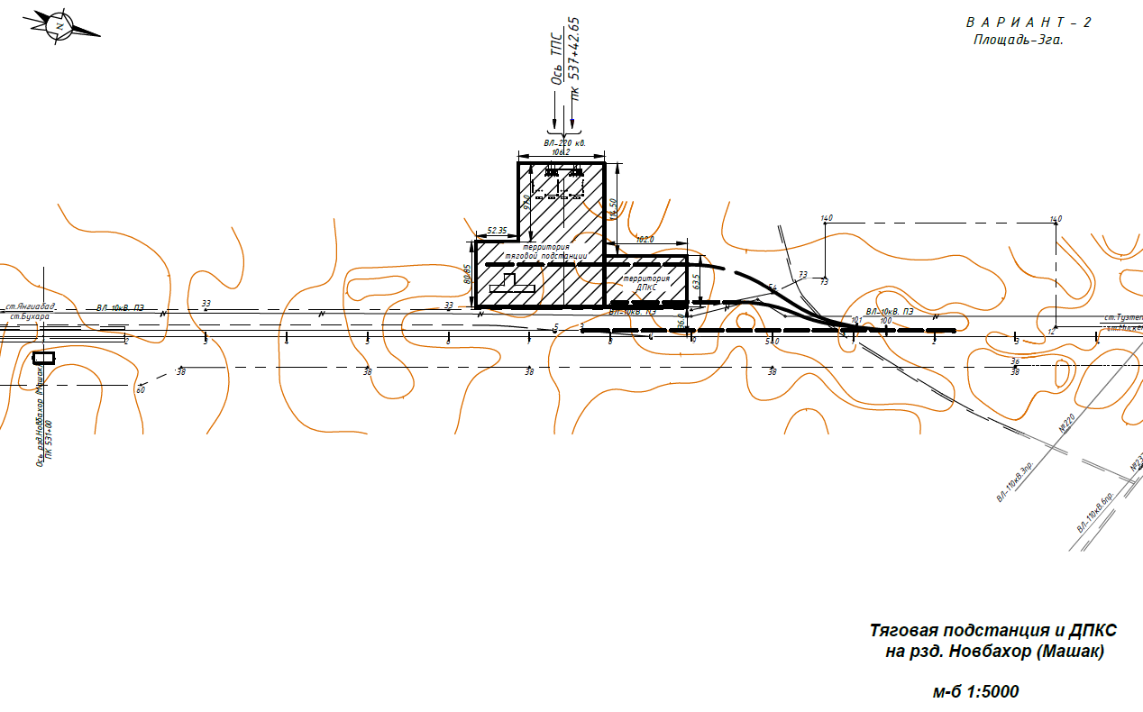
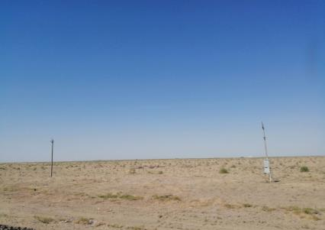

Name of the Traction substation: Parvoz (Azanir)
Location: Bukhara province, Peshku district
GPS: 40°30'31.98"N and 63°37'24.15"E
Voltage: 110kV
Total area: 3 ha
Number of APs: 1 (1 farm enterprise)

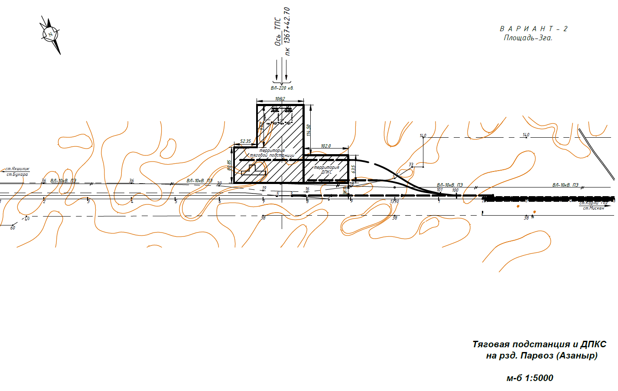 | 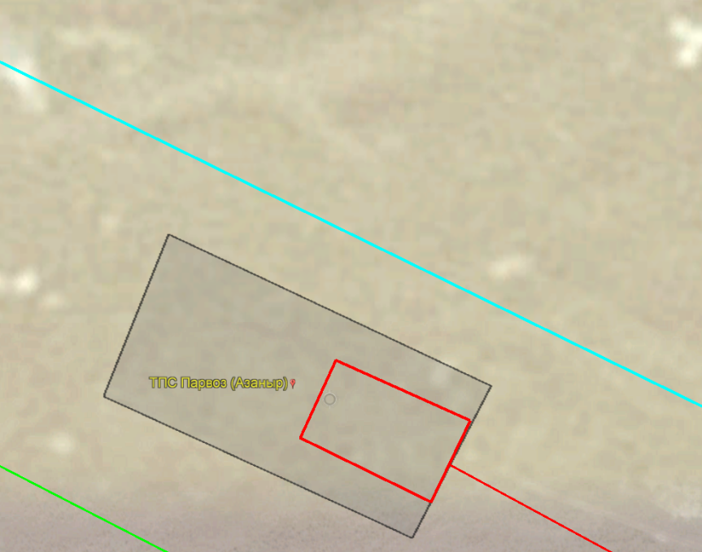

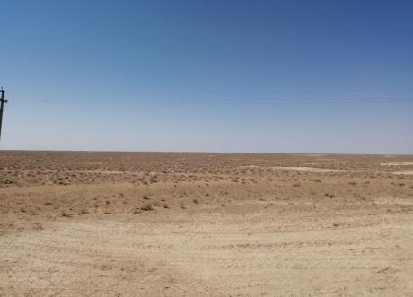
Name of the Traction substation: Kiyikli (Alabuga)
Location: Bukhara province, Peshku district
GPS: 40°47'44.89"N and 62°53'15.72"E
Voltage: 110kV
Total area: 3 ha
Number of APs: 1 (farm enterprise)

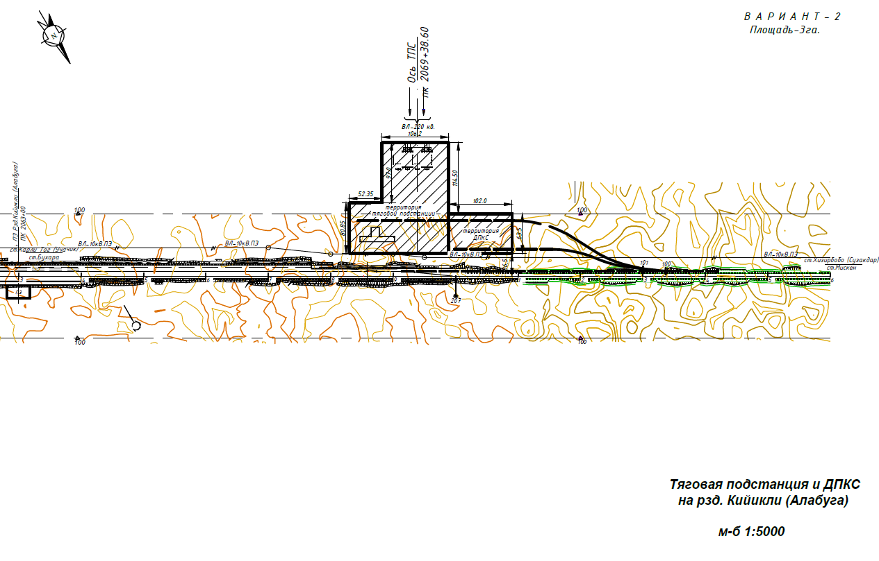 | 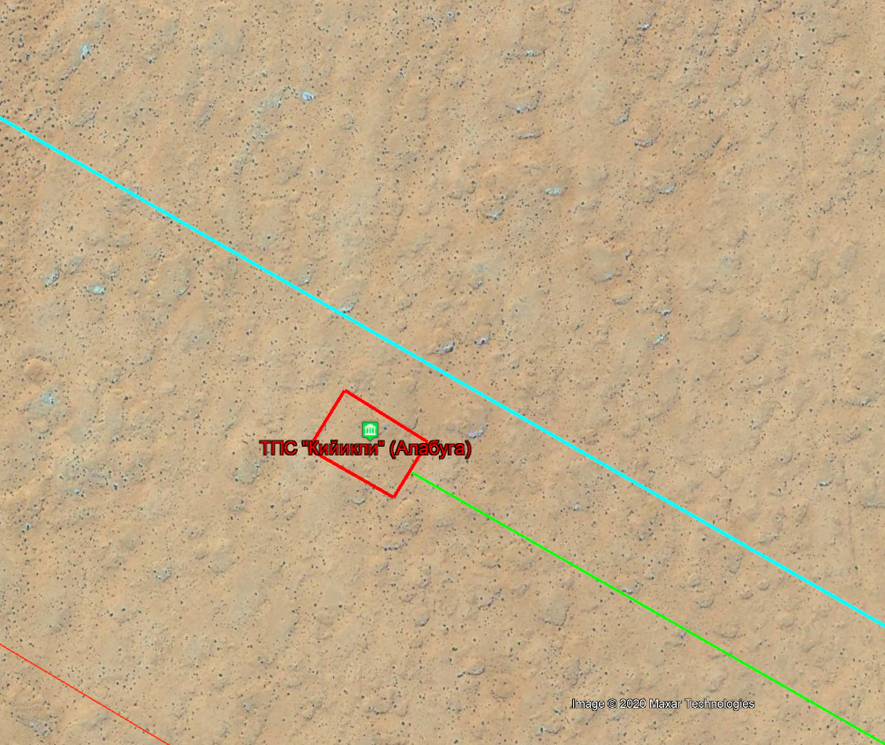

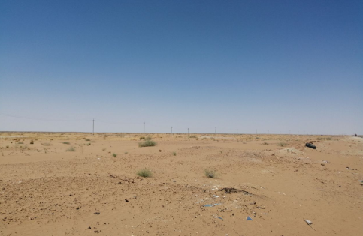

Name of the Traction substation: Jakasay (Jayhun)
Location: Republic of Karakalpakstan, Turtkul district
GPS: 41° 4'25.85"N and 62°14'16.96"E
Voltage: 220kV
Total area: 3 ha
Number of APs: 0

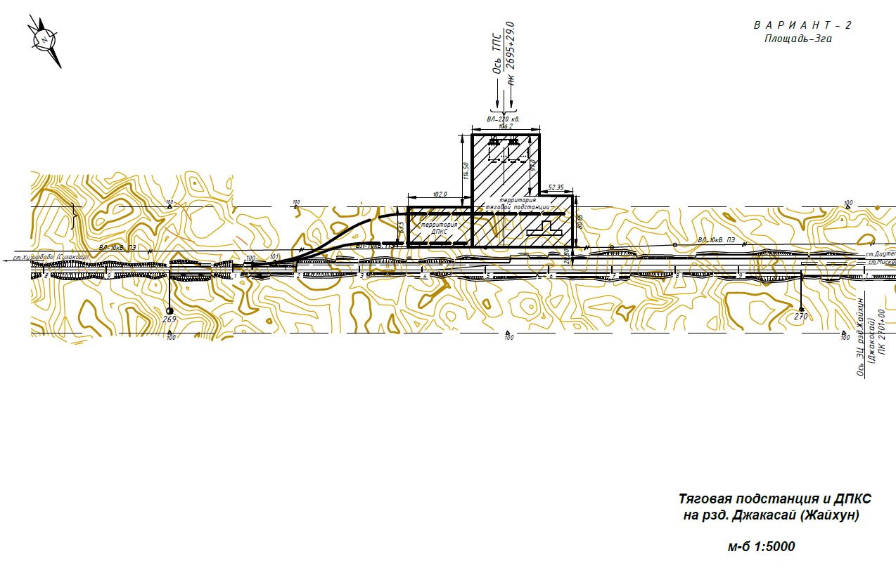 | 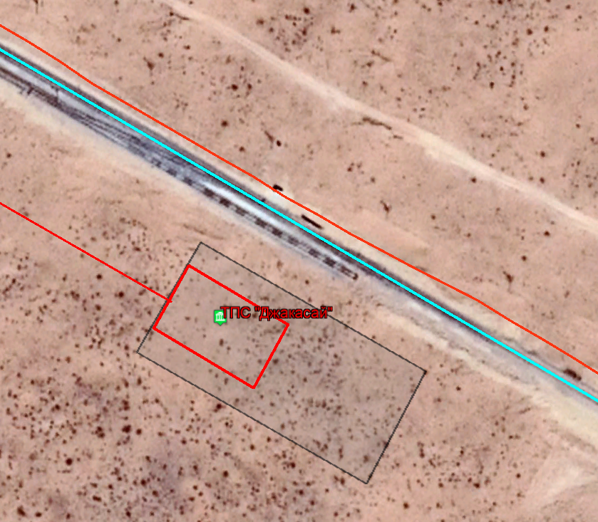

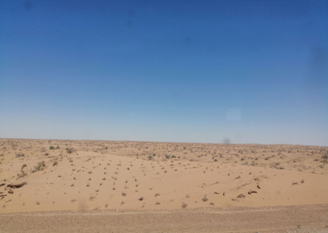

Name of the Traction substation: Turon (Akchuka)
Location: Khorezm province, Tuprokala district
GPS: 41°20'20.11"N and 61°31'23.34"E
Voltage: 220kV
Total area: 3 ha
Number of APs: 0

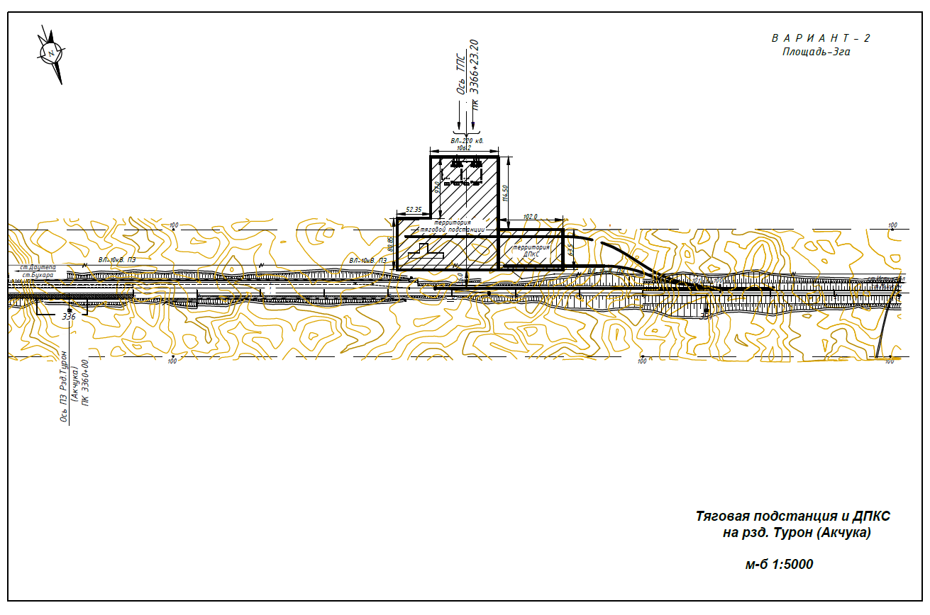 | 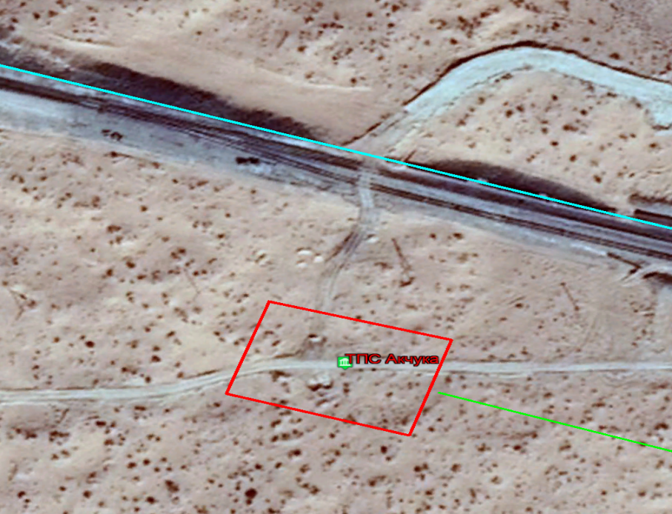

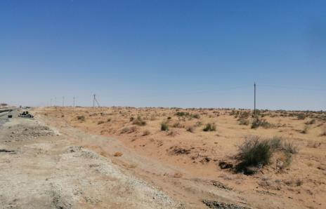

Name of the Traction substation: Hozarasp
Location: Khorezm province, Hozarasp district
GPS: 41°19'39.12"N and 61° 2'45.24"E
Voltage: 110kV
Total area: 5.4 ha
Number of APs: 38 (38 dehkan holders)

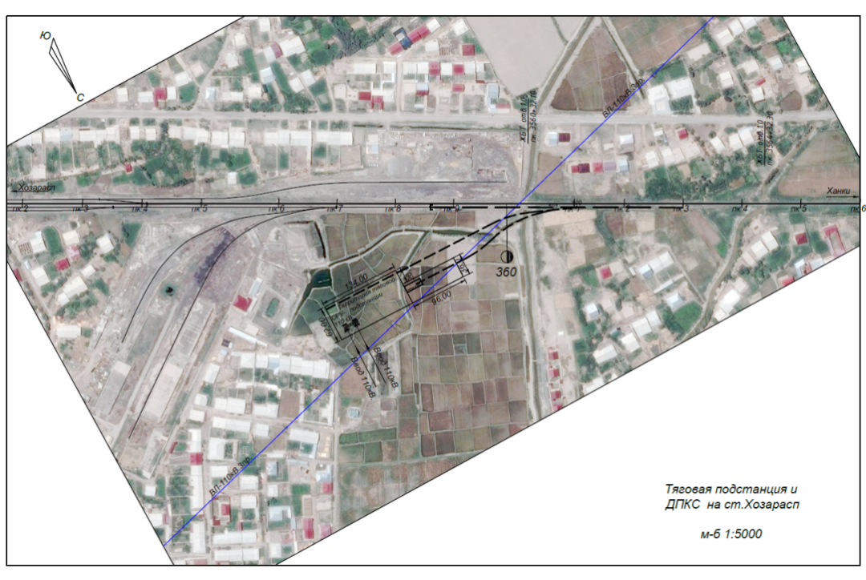 | 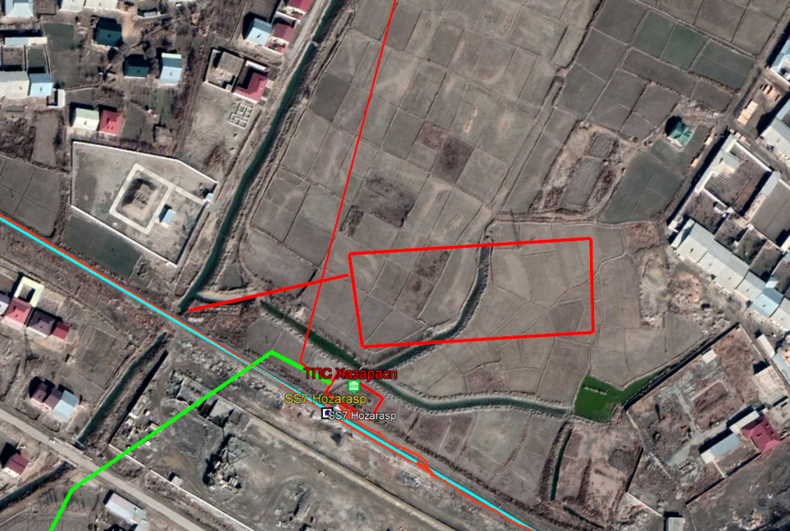

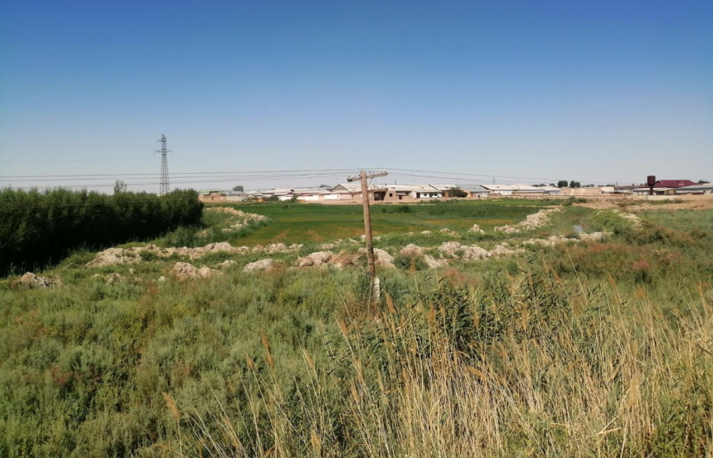

Name of the Traction substation: Urgench
Location: Khorezm province, Urgench district
GPS: 41°31'16.07"N and 60°40'22.71"E
Voltage: 110kV
Total area: 5.25 ha
Number of APs: 23 (22 dehkan holders and 1 farm enterprise)

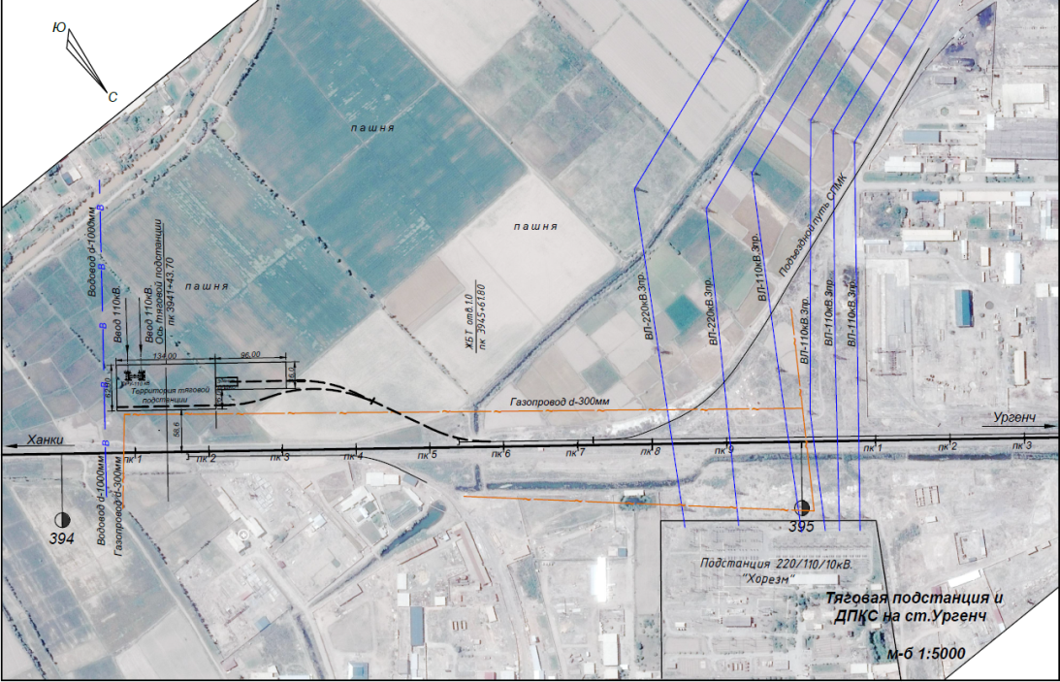 | 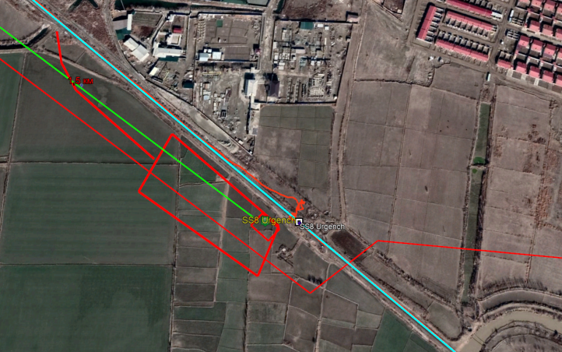

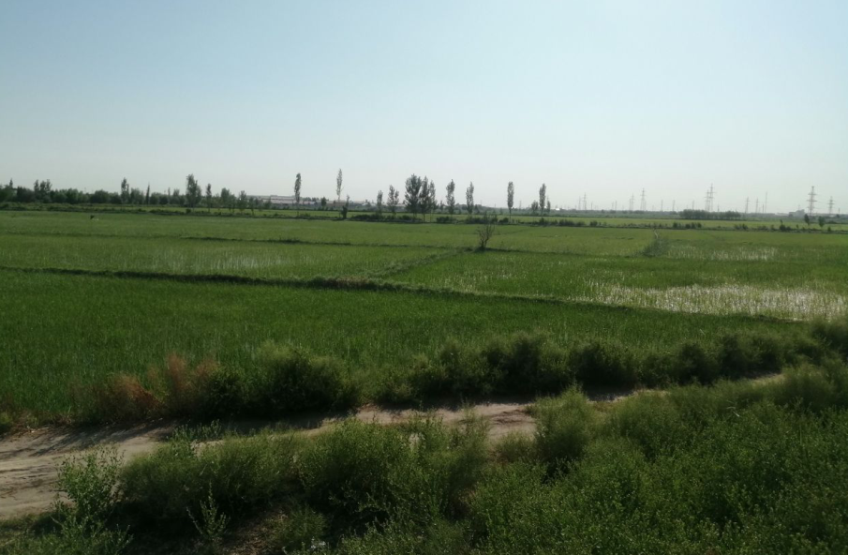

Annex 2. Public Information Brochure
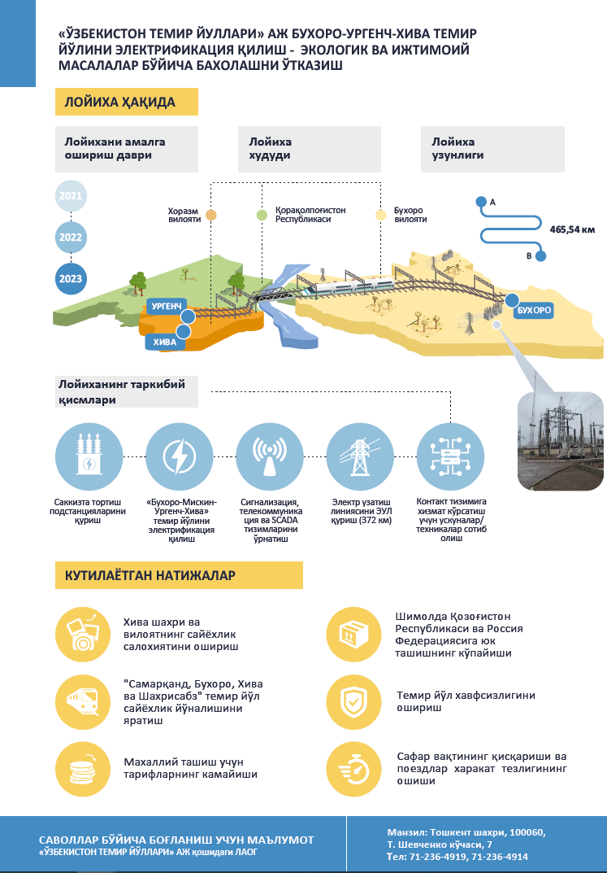

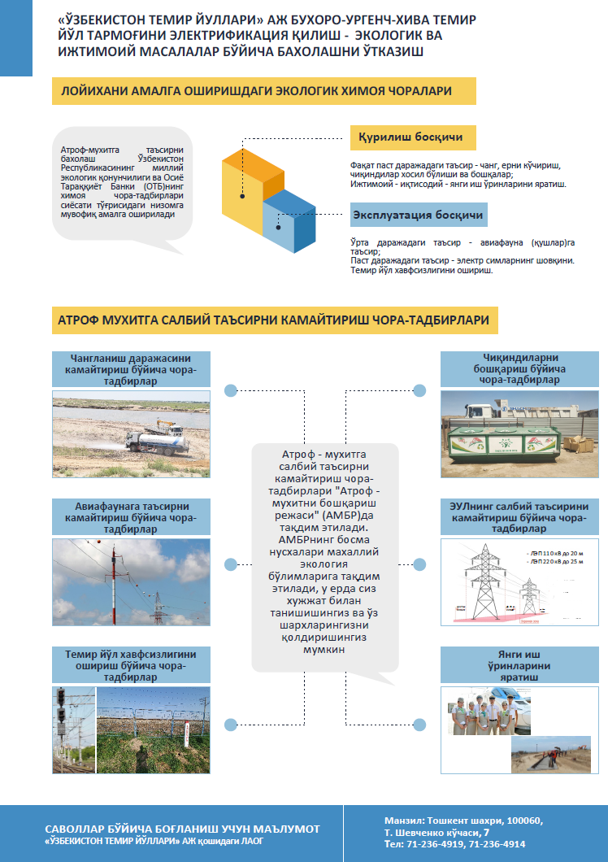

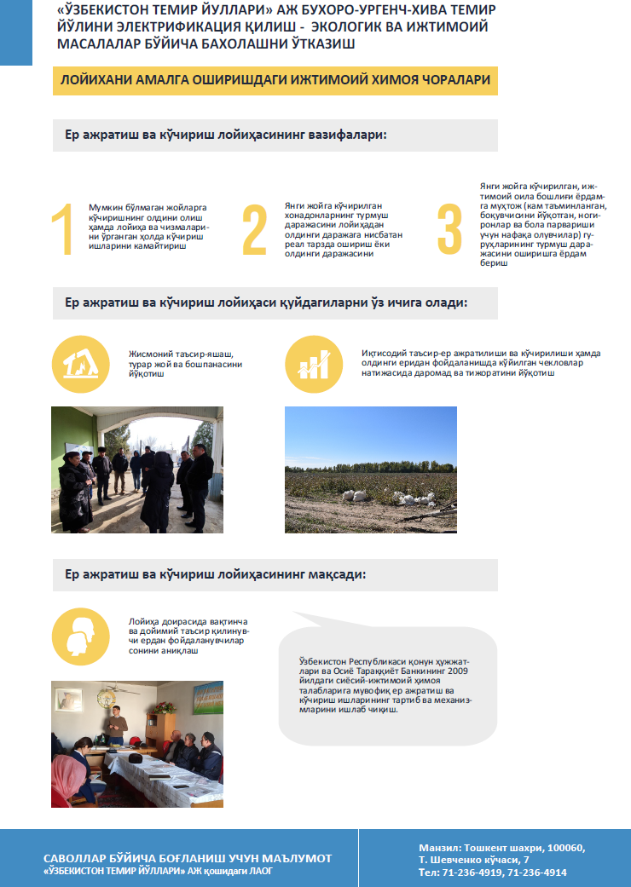

33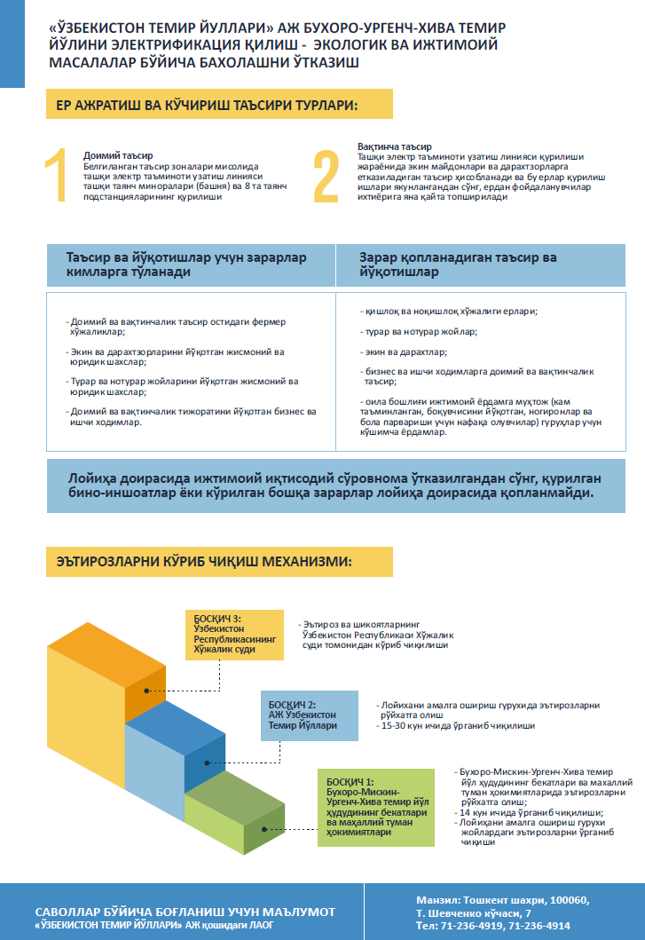

Annex 3. Detailed Calculation of Project Impact Percentage (severe impact assessment)
# | ID | Total land holding area (ha) | Type of impact | Total Affected Land (ha)
 |  |  |  | Total Affected Land (ha) | Including
 |  |  |  |  | Agriculture land |  | Ditches, canals and other lands | Residential | Severity of impact in %
 |  |  |  |  | Arable/Crop Cultivation | Garden/
 |  |  |  |  |  | Orchards
Kagan district Z.Kobilov Massive
1 | B-K-F-1 | 55,3 | Permanent | 1,76 | 1,76 | - | - | - | 3,18
 |  |  | Temporary | - | - | - | - | - | -
2 | B-K-F-2 | 8,7 | Permanent | 0,68 | 0,68 | - | - | - | 7,82
 |  |  | Temporary | - | - | - | - | - | -
Total affected for massive |  | 64 | Permanent | 2,44 | 2,44 | - | - | - | -
 |  |  | Temporary | - | - | - | - | - | -
Total |  |  |  | 2,44 | 2,44 | - | - | - | -
Rumitan district E.Khodjaev Massive
1 | Reserve land (Desert) | - | Permanent | 3 | - | - | 3 | - | -
 |  |  | Temporary | - | - | - | - | - | -
Total affected for massive |  | - | Permanent | 3 | - | - | 3 | - | -
 |  |  | Temporary | - | - | - | - | - | -
Total |  |  |  | 3 | - | - | 3 | - | -
Peshku district Djongeldi Massive
1 | B-P-F-1 | 2855,46 | Permanent | 3 | 3 | - | - | - | 0,11
 |  |  | Temporary | - | - | - | - | - | -
2 | B-P-F-2 | 7018,89 | Permanent | 3 | 3 | - | - | - | 0,04
 |  |  | Temporary | - | - | - | - | - | -
Total affected for massive |  | 9874,35 | Permanent | 6 | 6 | - | - | - | -
 |  |  | Temporary | - | - | - | - | - | -
Total |  |  |  | 6 | - | - | 6 | - | -
Turtkul district Kizilkum Massive
1 | Reserve land (Desert) | - | Permanent | 3 | - | - | 3 | - | -
 |  |  | Temporary | - | - | - | - | - | -
Total affected for massive |  | - | Permanent | 3 | - | - | 3 | - | -
 |  |  | Temporary | - | - | - | - | - | -
Total |  |  |  | 3 | - | - | 3 | - | -
Tuprokala district Sarimoy Massive
1 | Reserve land (Desert) | - | Permanent | 3 | - | - | 3 | - | -
 |  |  | Temporary | - | - | - | - | - | -
Total affected for massive |  | - | Permanent | 3 | - | - | 3 | - | -
 |  |  | Temporary | - | - | - | - | - | -
Total |  |  |  | 3 | - | - | 3 | - | -
Hozarasp district Dustlik Massive
1 | K-H-D-1 | 0,19 | Permanent | 0,11 | 0,11 | - | - | - | 58
 |  |  | Temporary | - | - | - | - | - | -
2 | K-H-D-2 | 0,19 | Permanent | 0,03 | 0,03 | - | - | - | 16
 |  |  | Temporary | - | - | - | - | - | -
3 | K-H-D-3 | 0,67 | Permanent | 0,01 | 0,01 | - | - | - | 1
 |  |  | Temporary | - | - | - | - | - | -
4 | K-H-D-4 | 0,5 | Permanent | 0,37 | 0,37 | - | - | - | 74
 |  |  | Temporary | - | - | - | - | - | -
5 | K-H-D-5 | 0,64 | Permanent | 0,38 | 0,38 | - | - | - | 59
 |  |  | Temporary | - | - | - | - | - | -
6 | K-H-D-6 | 0,333 | Permanent | 0,02 | 0,02 | - | - | - | 6
 |  |  | Temporary | - | - | - | - | - | -
7 | K-H-D-7 | 0,15 | Permanent | 0,03 | 0,03 | - | - | - | 20
 |  |  | Temporary | - | - | - | - | - | -
8 | K-H-D-8 | 0,46 | Permanent | 0,35 | 0,35 | - | - | - | 76
 |  |  | Temporary | - | - | - | - | - | -
9 | K-H-D-9 | 0,1 | Permanent | 0,08 | 0,08 | - | - | - | 80
 |  |  | Temporary | - | - | - | - | - | -
10 | K-H-D-10 | 0,224 | Permanent | 0,06 | 0,06 | - | - | - | 27
 |  |  | Temporary | - | - | - | - | - | -
11 | K-H-D-11 | 0,32 | Permanent | 0,16 | 0,16 | - | - | - | 50
 |  |  | Temporary | - | - | - | - | - | -
12 | K-H-D-12 | 0,281 | Permanent | 0,16 | 0,16 | - | - | - | 57
 |  |  | Temporary | - | - | - | - | - | -
13 | K-H-D-13 | 0,37 | Permanent | 0,22 | 0,22 | - | - | - | 59
 |  |  | Temporary | - | - | - | - | - | -
14 | K-H-D-14 | 0,27 | Permanent | 0,12 | 0,12 | - | - | - | 44
 |  |  | Temporary | - | - | - | - | - | -
15 | K-H-D-15 | 0,21 | Permanent | 0,1 | 0,1 | - | - | - | 48
 |  |  | Temporary | - | - | - | - | - | -
16 | K-H-D-16 | 0,419 | Permanent | 0,25 | 0,25 | - | - | - | 60
 |  |  | Temporary | - | - | - | - | - | -
17 | K-H-D-17 | 0,153 | Permanent | 0,03 | 0,03 | - | - | - | 20
 |  |  | Temporary | - | - | - | - | - | -
18 | K-H-D-18 | 0,285 | Permanent | 0,1 | 0,1 | - | - | - | 35
 |  |  | Temporary | - | - | - | - | - | -
19 | K-H-D-19 | 0,14 | Permanent | 0,06 | 0,06 | - | - | - | 43
 |  |  | Temporary | - | - | - | - | - | -
20 | K-H-D-20 | 0,305 | Permanent | 0,16 | 0,16 | - | - | - | 52
 |  |  | Temporary | - | - | - | - | - | -
21 | K-H-D-21 | 0,37 | Permanent | 0,29 | 0,29 | - | - | - | 78
 |  |  | Temporary | - | - | - | - | - | -
22 | K-H-D-22 | 0,32 | Permanent | 0,2 | 0,2 | - | - | - | 63
 |  |  | Temporary | - | - | - | - | - | -
23 | K-H-D-23 | 0,3 | Permanent | 0,11 | 0,11 | - | - | - | 37
 |  |  | Temporary | - | - | - | - | - | -
24 | K-H-D-24 | 0,237 | Permanent | 0,05 | 0,05 | - | - | - | 21
 |  |  | Temporary | - | - | - | - | - | -
25 | K-H-D-25 | 0,18 | Permanent | 0,07 | 0,07 | - | - | - | 39
 |  |  | Temporary | - | - | - | - | - | -
26 | K-H-D-26 | 0,2 | Permanent | 0,09 | 0,09 | - | - | - | 45
 |  |  | Temporary | - | - | - | - | - | -
27 | K-H-D-27 | 0,35 | Permanent | 0,08 | 0,08 | - | - | - | 23
 |  |  | Temporary | - | - | - | - | - | -
28 | K-H-D-28 | 0,07 | Permanent | 0,07 | 0,07 | - | - | - | 100
 |  |  | Temporary | - | - | - | - | - | -
29 | K-H-D-29 | 0,29 | Permanent | 0,12 | 0,12 | - | - | - | 41
 |  |  | Temporary | - | - | - | - | - | -
30 | K-H-D-30 | 0,19 | Permanent | 0,12 | 0,12 | - | - | - | 63
 |  |  | Temporary | - | - | - | - | - | -
31 | K-H-D-31 | 0,213 | Permanent | 0,08 | 0,08 | - | - | - | 38
 |  |  | Temporary | - | - | - | - | - | -
32 | K-H-D-32 | 0,276 | Permanent | 0,14 | 0,14 | - | - | - | 51
 |  |  | Temporary | - | - | - | - | - | -
33 | K-H-D-33 | 0,232 | Permanent | 0,09 | 0,09 | - | - | - | 39
 |  |  | Temporary | - | - | - | - | - | -
34 | K-H-D-34 | 0,34 | Permanent | 0,14 | 0,14 | - | - | - | 41
 |  |  | Temporary | - | - | - | - | - | -
35 | K-H-D-35 | 0,25 | Permanent | 0,19 | 0,19 | - | - | - | 76
 |  |  | Temporary | - | - | - | - | - | -
36 | K-H-D-36 | 0,24 | Permanent | 0,18 | 0,18 | - | - | - | 75
 |  |  | Temporary | - | - | - | - | - | -
37 | K-H-D-37 | 0,25 | Permanent | 0,13 | 0,13 | - | - | - | 52
 |  |  | Temporary | - | - | - | - | - | -
38 | K-H-D-38 | 0,38 | Permanent | 0,27 | 0,27 | - | - | - | 71
 |  |  | Temporary | - | - | - | - | - | -
39 | Reserve land (Desert) | - | Permanent | 0,18 | - | - | 0,18 | - | -
 |  |  | Temporary | - | - | - | - | - | -
Total affected for massive |  | 10,895 | Permanent | 5,4 | 5,22 | - | 0,18 | - | -
 |  |  | Temporary | - | - | - | - | - | -
Total |  |  |  | 5,4 | 5,22 | - | 0,18 | - | -
Urgench district Pakhtakor Massive
1 | K-U-D-1 | 0,25 | Permanent | 0,047 | 0,0471 | - | - | - | 19
 |  |  | Temporary | - | - | - | - | - | -
2 | K-U-D-2 | 0,22 | Permanent | 0,150 | 0,1496 | - | - | - | 67
 |  |  | Temporary | - | - | - | - | - | -
3 | K-U-D-3 | 0,31 | Permanent | 0,17 | 0,17 | - | - | - | 54
 |  |  | Temporary | - | - | - | - | - | -
4 | K-U-D-4 | 0,32 | Permanent | 0,186 | 0,186 | - | - | - | 58
 |  |  | Temporary | - | - | - | - | - | -
5 | K-U-D-5 | 0,32 | Permanent | 0,200 | 0,200 | - | - | - | 62
 |  |  | Temporary | - | - | - | - | - | -
6 | K-U-D-6 | 0,20 | Permanent | 0,071 | 0,071 | - | - | - | 35
 |  |  | Temporary | - | - | - | - | - | -
7 | K-U-D-7 | 0,21 | Permanent | 0,079 | 0,079 | - | - | - | 38
 |  |  | Temporary | - | - | - | - | - | -
8 | K-U-D-8 | 0,23 | Permanent | 0,098 | 0,098 | - | - | - | 43
 |  |  | Temporary | - | - | - | - | - | -
9 | K-U-D-9 | 0,33 | Permanent | 0,115 | 0,115 | - | - | - | 35
 |  |  | Temporary | - | - | - | - | - | -
10 | K-U-D-10 | 0,24 | Permanent | 0,105 | 0,105 | - | - | - | 45
 |  |  | Temporary | - | - | - | - | - | -
11 | K-U-D-11 | 0,25 | Permanent | 0,074 | 0,074 | - | - | - | 29
 |  |  | Temporary | - | - | - | - | - | -
12 | K-U-D-12 | 0,25 | Permanent | 0,122 | 0,122 | - | - | - | 48
 |  |  | Temporary | - | - | - | - | - | -
13 | K-U-D-13 | 0,31 | Permanent | 0,17 | 0,17 | - | - | - | 55
 |  |  | Temporary | - | - | - | - | - | -
14 | K-U-D-14 | 0,39 | Permanent | 0,255 | 0,255 | - | - | - | 66
 |  |  | Temporary | - | - | - | - | - | -
15 | K-U-D-15 | 0,34 | Permanent | 0,117 | 0,117 | - | - | - | 34
 |  |  | Temporary | - | - | - | - | - | -
16 | K-U-D-16 | 0,45 | Permanent | 0,136 | 0,136 | - | - | - | 31
 |  |  | Temporary | - | - | - | - | - | -
17 | K-U-D-17 | 0,36 | Permanent | 0,044 | 0,044 | - | - | - | 12
 |  |  | Temporary | - | - | - | - | - | -
18 | K-U-D-18 | 0,23 | Permanent | 0,097 | 0,097 | - | - | - | 43
 |  |  | Temporary | - | - | - | - | - | -
19 | K-U-D-19 | 0,33 | Permanent | 0,201 | 0,201 | - | - | - | 61
 |  |  | Temporary | - | - | - | - | - | -
20 | K-U-D-20 | 0,36 | Permanent | 0,230 | 0,230 | - | - | - | 64
 |  |  | Temporary | - | - | - | - | - | -
21 | K-U-D-21 | 0,32 | Permanent | 0,2 | 0,2 | - | - | - | 63
 |  |  | Temporary | - | - | - | - | - | -
22 | K-U-D-22 | 0,44 | Permanent | 0,18 | 0,18 | - | - | - | 41
 |  |  | Temporary | - | - | - | - | - | -
23 | K-U-F-1 | 352,1 | Permanent | 2,2 | 2,2 | - | - | - | 0.6
 |  |  | Temporary | - | - | - | - | - | -
Total affected for massive |  | 358,8 | Permanent | 5,25 | 5,25 | - | - | - | -
 |  |  | Temporary | - | - | - | - | - | -
Total |  |  |  | 5,25 | 5,25 | - | - | - | -
Total |  | 10308,05 | Permanent | 28,09 | 18,91 | - | 9,18 | - | -
 |  |  | Temporary | - | - | - | - | - | -

Annex 4. Estimated Detailed Budget
Below is provided cash compensation package per each Affected Farm and/or Dehkan eligible to cash compensation under the proposed project.
# | ID of the land user | Loss profit from affected land | Severe impact allowance | Total UZS | Total USD
Bukhara province
Kagan district Z.Kobilov massive
1 | B-K-F-1 | 3794841,6 | - | 3 794 842 | 371,66
2 | B-K-F-2 | 1466188,8 | - | 1466188,8 | 143,60
Total affected for massive |  | 5261030,4 | - | 5 261 030 | 515
Rumitan district E.Khodjaev Massive
1 | Reserve land (Desert) | - | - | - | -
Total affected for massive |  | 0 | - | 0 | 0
Peshku district Djongeldi Massive
1 | B-P-F-1 | 6468480 | - | 6 468 480 | 633,52
2 | B-P-F-2 | 6468480 | - | 6 468 480 | 633,52
Total affected for massive |  | 12936960 | - | 12 936 960 | 1 267
Total affected for province |  | 18 197 990 | - | 18 197 990 | 1 782
Republic of Karakalpakstan
Turtkul district Kizilkum Massive
1 | Reserve land (Desert) |  | - | 0 | 0,00
Total affected for massive |  | 0 | - | 0 | 0,00
Total affected for province |  | 0 | - | 0 | 0,00
Kharezm province
Tuproqkala district Sarimoy Massive
1 | Reserve land (Desert) |  | - | 0 | 0,00
Total affected for massive |  | 0 | - | 0 | 0,00
Hozarasp district Dustlik Massive
1 | K-H-D-1 | 237177,6 | 59294,4 | 296 472 | 29,04
2 | K-H-D-2 | 64684,8 | 16171,2 | 80 856 | 7,92
3 | K-H-D-3 | 21561,6 |  | 21 562 | 2,11
4 | K-H-D-4 | 797779,2 | 199444,8 | 997 224 | 97,67
5 | K-H-D-5 | 819340,8 | 204835,2 | 1 024 176 | 100,31
6 | K-H-D-6 | 43123,2 |  | 43 123 | 4,22
7 | K-H-D-7 | 64684,8 | 16171,2 | 80 856 | 7,92
8 | K-H-D-8 | 754656 | 188664 | 943 320 | 92,39
9 | K-H-D-9 | 172492,8 | 43123,2 | 215 616 | 21,12
10 | K-H-D-10 | 129369,6 | 32342,4 | 161 712 | 15,84
11 | K-H-D-11 | 344985,6 | 86246,4 | 431 232 | 42,23
12 | K-H-D-12 | 344985,6 | 86246,4 | 431 232 | 42,23
13 | K-H-D-13 | 474355,2 | 118588,8 | 592 944 | 58,07
14 | K-H-D-14 | 258739,2 | 64684,8 | 323 424 | 31,68
15 | K-H-D-15 | 215616 | 53904 | 269 520 | 26,40
16 | K-H-D-16 | 539040 | 134760 | 673 800 | 65,99
17 | K-H-D-17 | 64684,8 | 16171,2 | 80 856 | 7,92
18 | K-H-D-18 | 215616 | 53904 | 269 520 | 26,40
19 | K-H-D-19 | 129369,6 | 32342,4 | 161 712 | 15,84
20 | K-H-D-20 | 344985,6 | 86246,4 | 431 232 | 42,23
21 | K-H-D-21 | 625286,4 | 156321,6 | 781 608 | 76,55
22 | K-H-D-22 | 431232 | 107808 | 539 040 | 52,79
23 | K-H-D-23 | 237177,6 | 59294,4 | 296 472 | 29,04
24 | K-H-D-24 | 107808 | 26952 | 134 760 | 13,20
25 | K-H-D-25 | 150931,2 | 37732,8 | 188 664 | 18,48
26 | K-H-D-26 | 194054,4 | 48513,6 | 242 568 | 23,76
27 | K-H-D-27 | 172492,8 | 43123,2 | 215 616 | 21,12
28 | K-H-D-28 | 150931,2 | 37732,8 | 188 664 | 18,48
29 | K-H-D-29 | 258739,2 | 64684,8 | 323 424 | 31,68
30 | K-H-D-30 | 258739,2 | 64684,8 | 323 424 | 31,68
31 | K-H-D-31 | 172492,8 | 43123,2 | 215 616 | 21,12
32 | K-H-D-32 | 301862,4 | 75465,6 | 377 328 | 36,96
33 | K-H-D-33 | 194054,4 | 48513,6 | 242 568 | 23,76
34 | K-H-D-34 | 301862,4 | 75465,6 | 377 328 | 36,96
35 | K-H-D-35 | 409670,4 | 102417,6 | 512 088 | 50,15
36 | K-H-D-36 | 388108,8 | 97027,2 | 485 136 | 47,51
37 | K-H-D-37 | 280300,8 | 70075,2 | 350 376 | 34,32
38 | K-H-D-38 | 582163,2 | 145540,8 | 727 704 | 71,27
39 | Reserve land (Desert) | - | - | - | -
Total affected for massive |  | 11255155,2 | 2797617,6 | 14 052 773 | 1 376,32
Urgench district Pakhtakor Massive
1 | K-U-D-1 | 101555,14 | 25388,78 | 126 943,92 | 12,43
2 | K-U-D-2 | 322561,54 | 80640,38 | 322561,54 | 31,59
3 | K-U-D-3 | 366547,2 | 91636,80 | 366547,20 | 35,90
4 | K-U-D-4 | 400830,14 | 100207,54 | 400830,14 | 39,26
5 | K-U-D-5 | 430585,15 | 107646,29 | 430585,15 | 42,17
6 | K-U-D-6 | 152440,51 | 38110,13 | 152440,51 | 14,93
7 | K-U-D-7 | 169689,79 | 42422,45 | 169689,79 | 16,62
8 | K-U-D-8 | 211088,06 | 52772,02 | 211088,06 | 20,67
9 | K-U-D-9 | 248389,63 | 62097,41 | 248389,63 | 24,33
10 | K-U-D-10 | 227259,26 | 56814,82 | 227259,26 | 22,26
11 | K-U-D-11 | 159771,46 | 39942,86 | 159771,46 | 15,65
12 | K-U-D-12 | 263051,52 | 65762,88 | 263051,52 | 25,76
13 | K-U-D-13 | 366547,2 | 91636,80 | 366547,20 | 35,90
14 | K-U-D-14 | 550683,26 | 137670,82 | 550683,26 | 53,93
15 | K-U-D-15 | 252486,34 | 63121,58 | 252486,34 | 24,73
16 | K-U-D-16 | 293237,76 | 73309,44 | 293237,76 | 28,72
17 | K-U-D-17 | 94655,42 | 23663,86 | 94655,42 | 9,27
18 | K-U-D-18 | 208931,90 | 52232,98 | 208931,90 | 20,46
19 | K-U-D-19 | 433819,39 | 108454,85 | 433819,39 | 42,49
20 | K-U-D-20 | 496563,65 | 124140,91 | 496563,65 | 48,63
21 | K-U-D-21 | 431232 | 107808,00 | 431232 | 42,23
22 | K-U-D-22 | 388108,8 | 97027,20 | 388108,80 | 38,01
23 | K-U-F-1 | 4743552 |  | 4743552 | 464,58
Total affected for massive |  | 11 313 587 | 1 642 509 | 12 956 096 | 1 268,91
Total affected for province |  | 22 568 742 | 4 440 126 | 27 008 869 | 2 645,23
Total |  | 40 766 733 | 4 440 126 | 45 206 859 | 4 427,54

Annex 5. PIB distribution
Photos of PIB copies being disseminated by PIU Staff and ADB TRTA consultants on August 26-27, 2020
# | Organization | Name | Position | Contact information | Photo
Khiva, August 26, 2020
1 | Railway Station “Khiva” | Doston Matyakubov | Acting Manager of the train station | +99897-526-2829 | 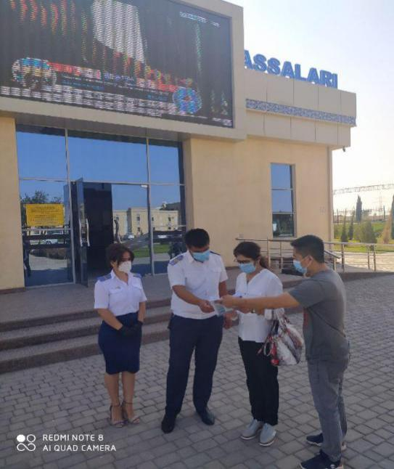
2 | Khokimiyat of Khiva City | Sabir Jumaniyazov | Khokim of City | +99899-331-5556 | 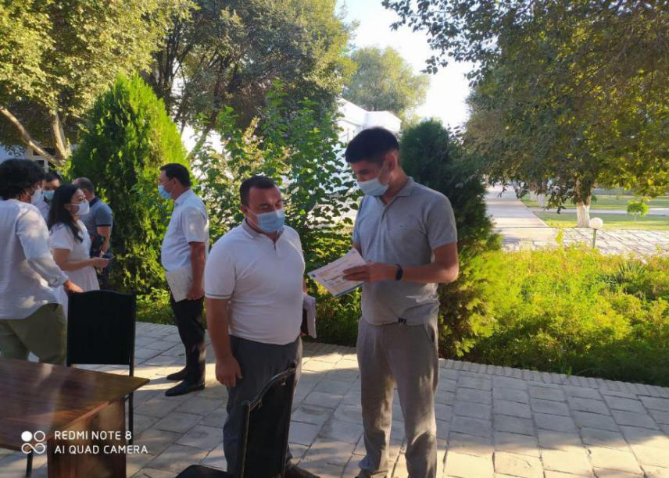
Urgench August 26, 2020

3 | Railway Depot Urganch | Zinat Abdulaev | Head of Engineer | +99897-220-6600 | 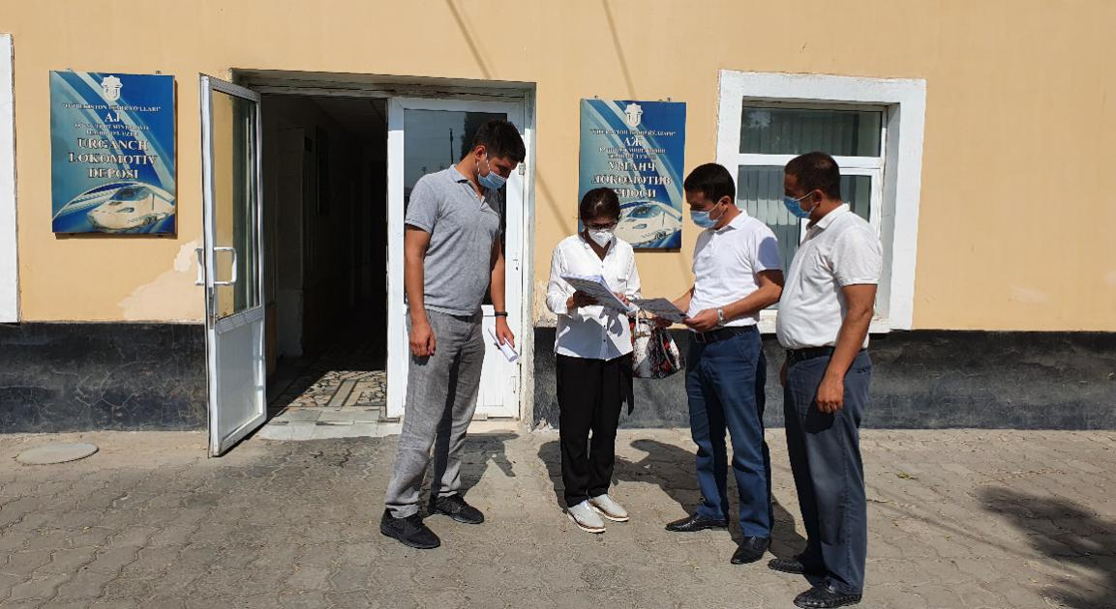
4 | “Uzdaverloyiha” Branch of Khorezm Province | Munis Hamraev | Head of Branch | +99897-516-1767 | 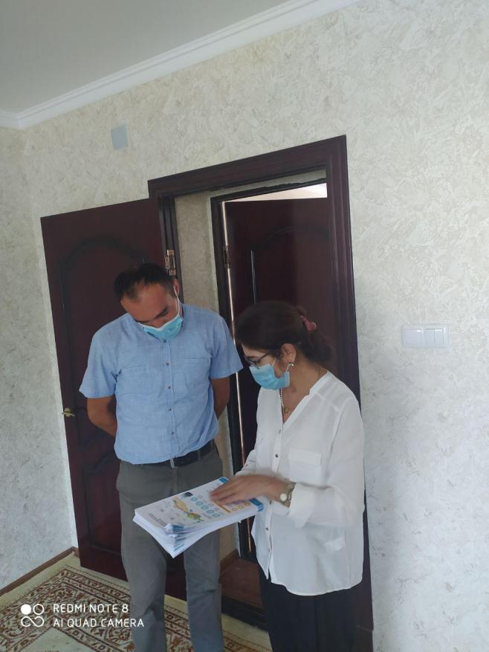
5 | Railway Station “Urgench” | Hushnud Ibragimov | Head of Ticket Office | +99894-904-0001 | 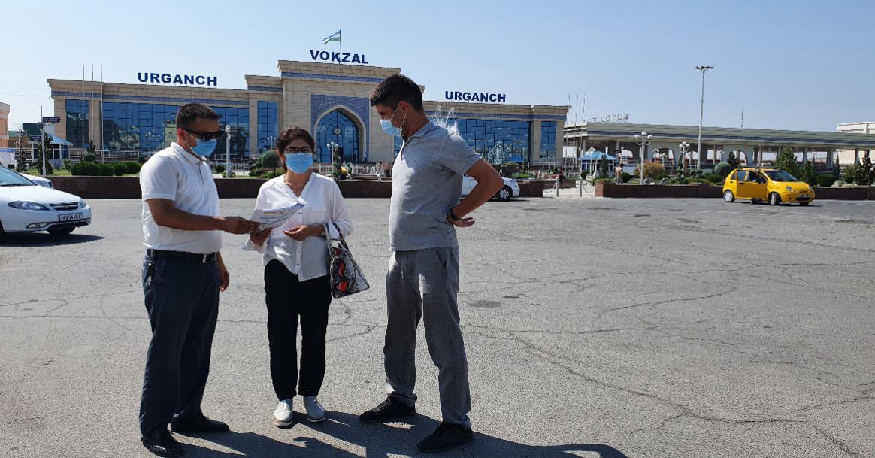
 |  | Bobur Ismailov | Engineer | +99899-508-1717
6 | Khokimiyat of Khorezm Province | Amirbek Masharipov | Specialist | +99899-962-2250
7 | State Committee on Ecology and Environmental Protection (SCEEP) Branch of Khorezm Province | Hamdam MAhmudov | Deputy of Chairman | +99893-741-0100 | 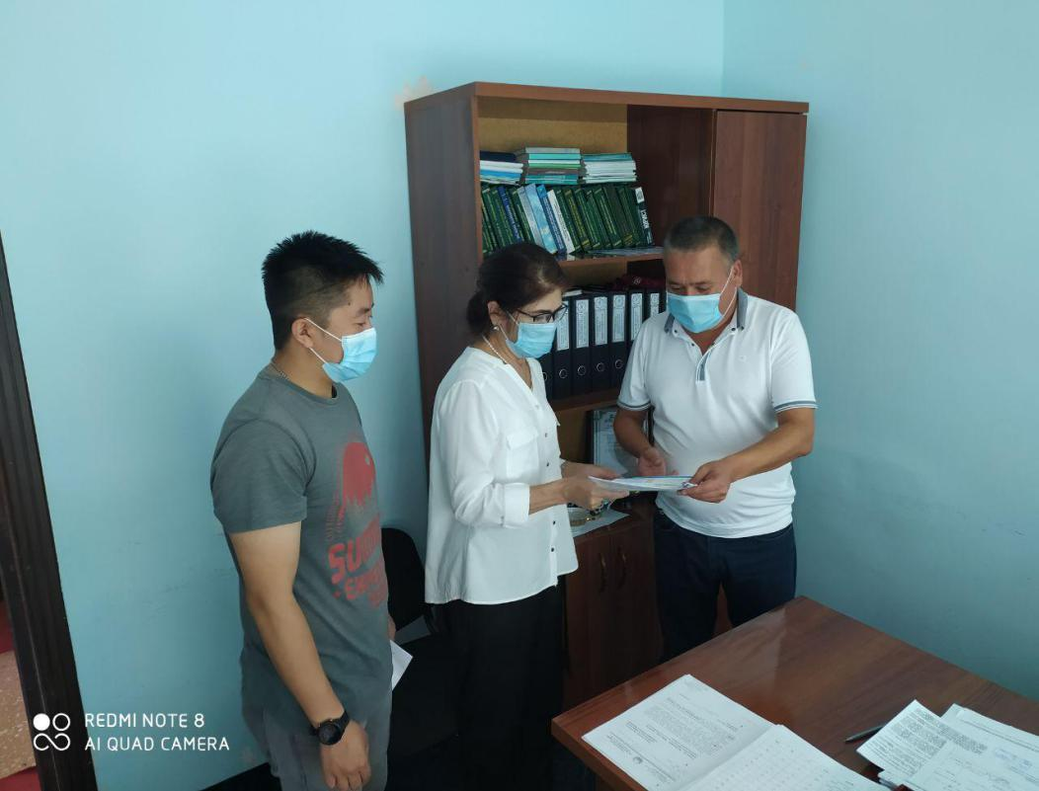
Miskin August 26, 2020
8 | Railway Station “Miskin” | Doniyor Reimov | Manager of the train station | +99897-500-6474 | 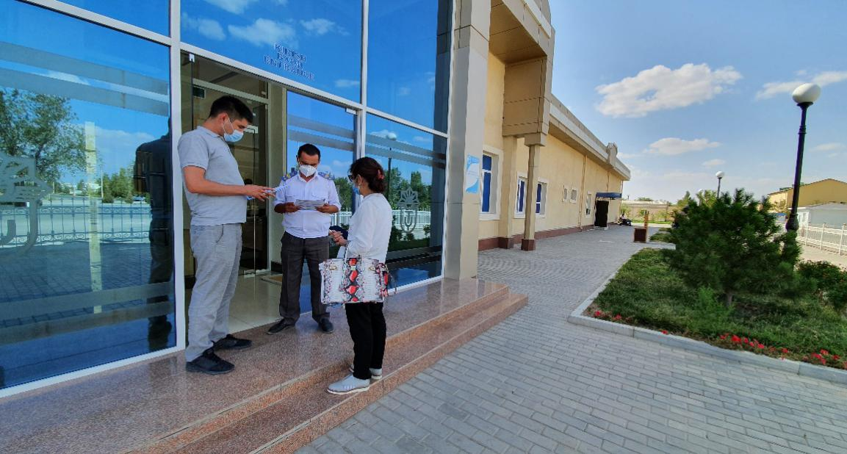
Bukhara 27, 2020
9 | “Uzdaverloyiha” Branch of Bukhara Province | Ruslan Bobochev | Manager | +99894-540-5779 | 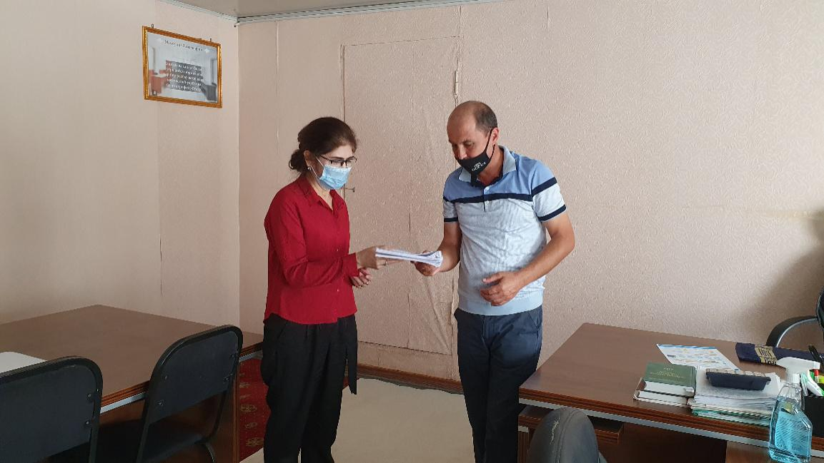
10 | SCEEP Branch of Bukhara Province | Mirholib Mahmudov | Chairman | -
 |  | Mahmud Gulyamov | Head of Department (Expertise) | +99898-774-5636  +99893-959-5636 | 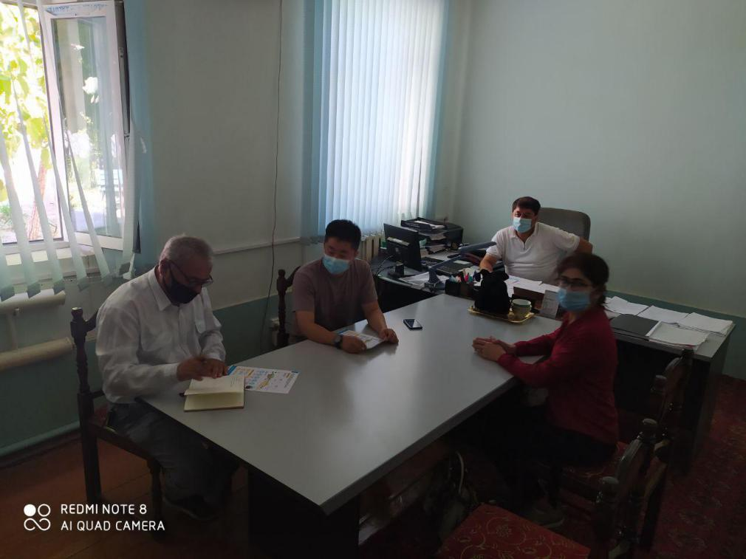
11 | Railway Station “Bukhara” | Ilhom Zadiev | Head of Engineer | +99893-383-3055 | 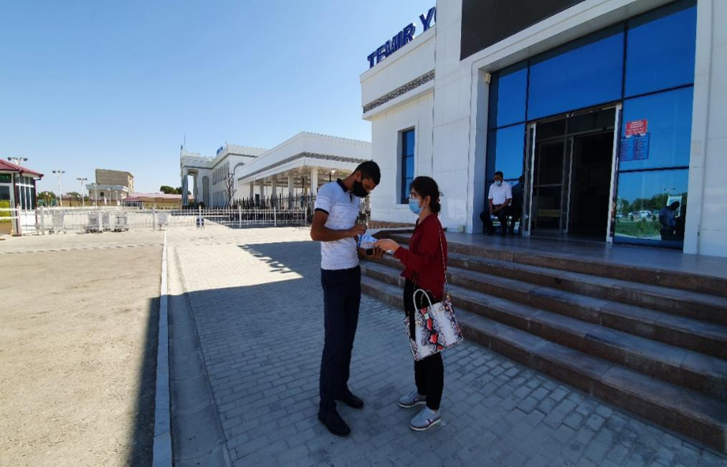
 |  | Fozil Shirinov | Specialist | +99894-540-1994
12 | Railway Depot Bukhara | Jalol Holmurodov | Head of Engineer | +99893-383-3055 | 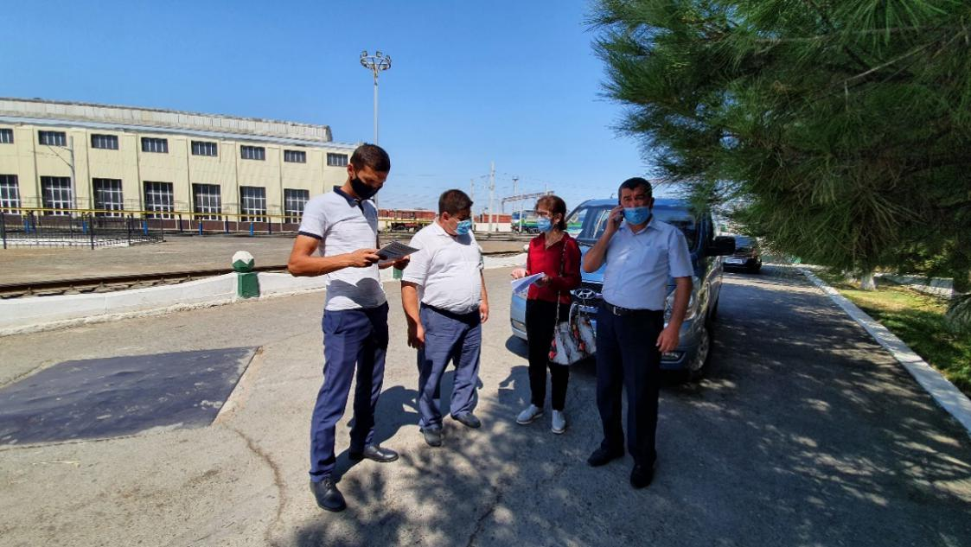
13 | Khokimiyat of Bukhara Province | Abbos Gaybulayev | Specialist | +99891-440-5424  buxoro@exat.uz | 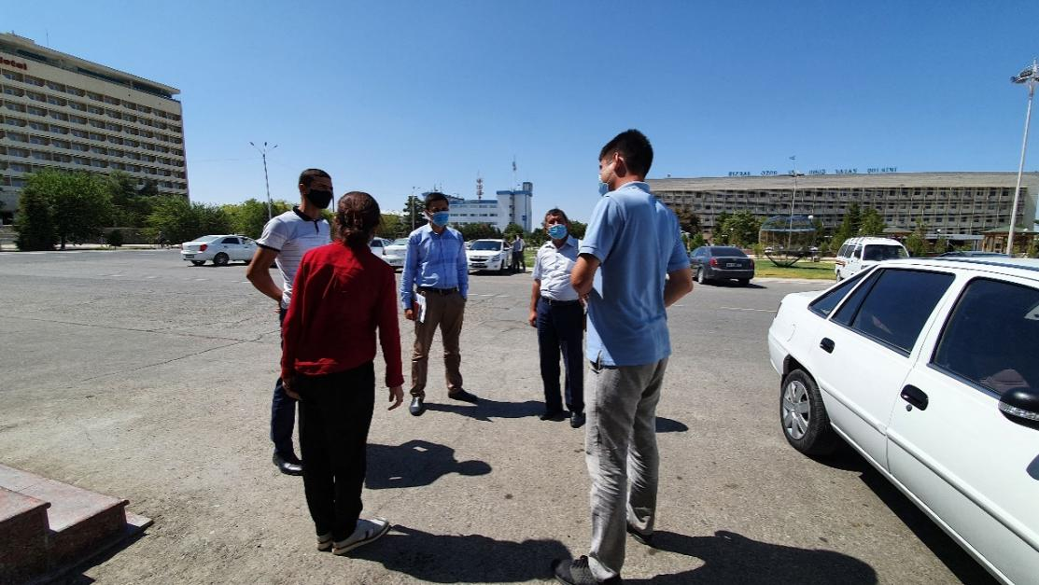

Enterprises, including farm enterprises leasing land for agricultural purposes.
Transfer property to another person by a will.
As per the minutes of video-conferences dated as of 18 October 2019, 8 November 2019, and 22 November 2019.
Kharezm, Republic of Karakalpakstan and Bukhara.
These districts are : Kagan, Rumitan, Peshku, Turtkul, Tuprokala, Hozarasp, Urgench
Such as Z.Kobilov, E.Khodjaev, Djongeldi, Kizilkum, Sarimoy, Dustlik, Pakhtakor.
Preventive measures including curfew introduced by GoU considered travel restrictions and public gatherings.
Facilitating fast passenger train services, the project is expected to have a strong impact on the number of tourists along the corridor Tashkent-Samarkand-Bukhara-Khiva. The project will enable a comfortable travel to Khiva, a city that is currently reached by either long road travels or by air, with the immediate introduction of 4 pairs of high-speed passenger trains a day once the project is completed. Freight traffic (transit/import/export) is expected to increase from 3 to 10 pairs of trains a day, being an important trigger for economic development. Direct and indirect job creation, in particular in the city of Khiva, will be significant for the western part of the country.
The location of 8 TSS is provided in Annex 1.
It is a local level community-based agricultural unit of farmers.
These crops are as follows: cotton, wheat, vegetables, alfalfa and rice.
Prepared within the framework of the P53271-001 CAREC Corridor 2 Bukhara-Miskin-Urgench-Khiva) Railway Electrification Project by Social Development and Gender Specialist, Mr. Isroiljon Hakimjonov.
https://stat.uz/en/about-committee/overview
Sta tistics Committee of Uzbekistan, as of Jan 1, 2019
The average annual rate in 2019 according to Statistics Committee of Uzbekistan: $1 = 8,839 UZS
https://mehnat.uz/uz/news/2019-yilda-uzbekistonning-ishsizlik-darazhasi-qancha#
President’s Decree #4555 from 30.12.2019 https://lex.uz/ru/docs/4673469
“International Migration and Household Well-Being. Evidence from Uzbekistan” William Seitz, World Bank
http://l2cu.strategy.uz/
http://documents.worldbank.org/curated/en/210801569934716898/pdf/Where-They-Live-District-Level-Measures-of-Poverty-Average-Consumption-and-the-Middle-Class-in-Central-Asia.pdf
https://www.gazeta.uz/ru/2020/01/24/poverty/
https://www.globalpartnership.org/content/education-sector-plan-2019-2023-uzbekistan
WHO Uzbekistan: profile http://www.euro.who.int/__data/assets/pdf_file/0017/130364/E71959.pdf
The Labor Code (1996, last amended on 2015) envisage in loss of employment compensation for 2 months average salary plus a severance pay of a maximum of 1-month average salary subject to the employment period.
APs will not be restricted to keep using project affected agricultural land parcels to grow annual crops and vegetables, until the notice from Construction Company on commencement of civil works and informing them on vacating the land already acquired and cash compensated by the project PIU. This condition is based on the consideration that sometimes LARP implementation and or civil works may be delayed for several months for various reasons. Therefore, APs will be allowed to keep cultivating project affected land parcels to grow annual crops and vegetables and include default cash compensation for annual crops even if APs will manage to collect yield prior to vacating project affected land for project related construction works.
Such taxes are different from all transaction-costs related to the processing of compensation which will be shouldered by the project.
The replacement cost is the principle to be complied with in compensating for all types of lost assets. Calculation of which should include: (i) fair market value; (ii) transaction costs; (iii) interest accrued, (iv) transitional and restoration costs; and (v) other applicable payments, if any.
Business interruption includes the time for receiving a new land plot, and designing and building of a new commercial structure.
Severe impact allowance equal to the net income from annual crop production (inclusive of winter and summer crop in addition to standing crop compensation) will be paid in addition to the compensation for land loss, will be included in the final LARP Budget, once the final inventory results and land allocation acts prepared.
It depends on President Resolution on this project
N/A refers to cases where none of the AHs are severely affected.
Same as above
Out of 5,25 ha 3.05 ha belongs to severely affected AHs (3.05 ha X 539,040 =1,642,509 UZS
Compensation for Loss profit from affected land consists of 4 years net income and transitional cost

