How to buy e-tickets?

STEP-BY-STEP INSTRUCTIONS FOR PURCHASING E-TICKETS
PRELIMINARY STEP
It is very easy to buy an e-ticket on our website:
1. Select the route and date
2. Find the train that suits you
3. Select the number of passengers
4. Enter your personal data
5. Choose a payment method
6. Confirm the order, tickets will be sent to your email.

In the "FROM" field, enter the name of the station from which You want to leave and choose a station from the list of stations that appears. For example "TASHKENT". In the "TO" field, enter the name of the destination station and select the destination station from the pop-up list, for example, "SAMARKAND". In the "WHEN" field, select the departure date and click the "FIND" button. If there are no trains on the selected date, you can see the current train schedule..

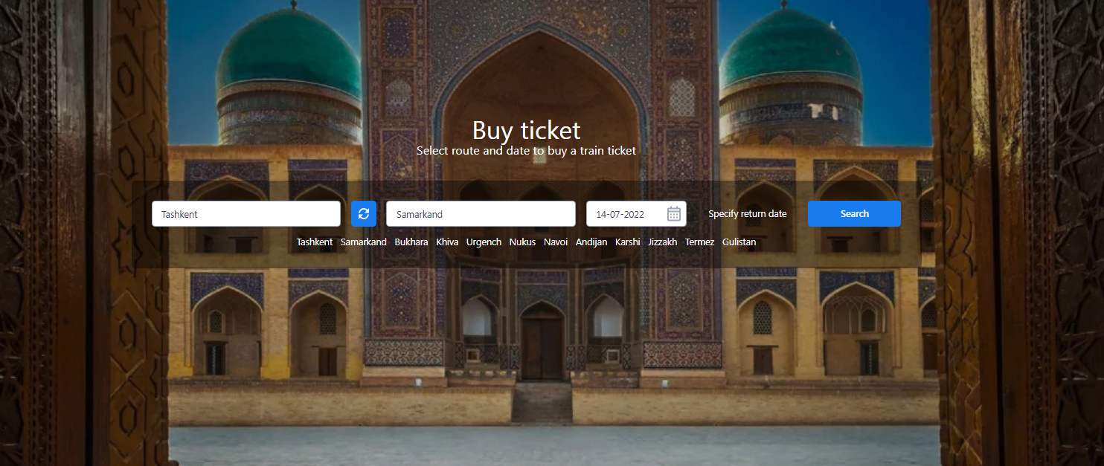
STEP 1 – SELECT THE TRAIN
From the list of available trains, select the desired train and the desired class of cars from and click the "SELECT CAR and SEAT" button at the bottom of the screen. For the convenience of users are all available on the selected date of the train with the availability of seats in the cars and the cost of tickets. Please note that at this stage information is shown only about the available seats of the train. In case of their absence the information is not shown. In addition, you can also select other departure dates at the top of the screen.
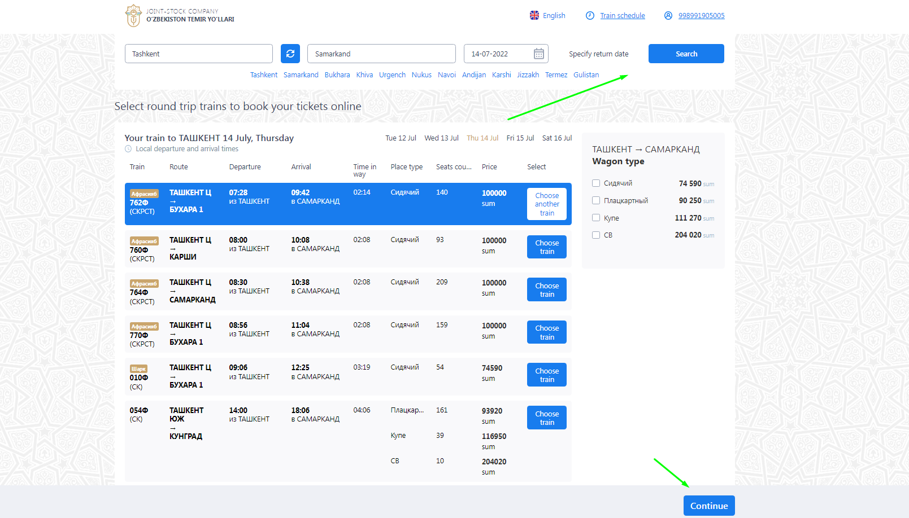
. Attention! To proceed to the next step, you need to go through the standard registration and authorization procedure, specifying the name, surname and e-mail address. 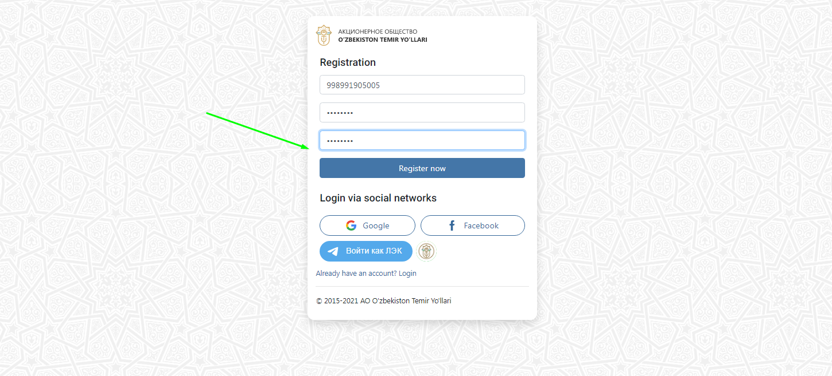
STEP 2 - CHOICE OF CAR AND SEAT
Then on the scheme of the car the place is chosen (light-free, dark-sold, the chosen place-green). Also for convenience, additional services provided in the car are displayed: extra food and bed linen. After choosing a place, the user fills in personal passport data and enters all the necessary information in the appropriate fields. If necessary, you can select the "Add child" function. Thus, an adult passenger can register a child up to five years old in his seat free of charge. Also, if necessary, you can select seats for 3 more passengers and enter all the necessary data. Then you need to click "CONFIRM ORDER".
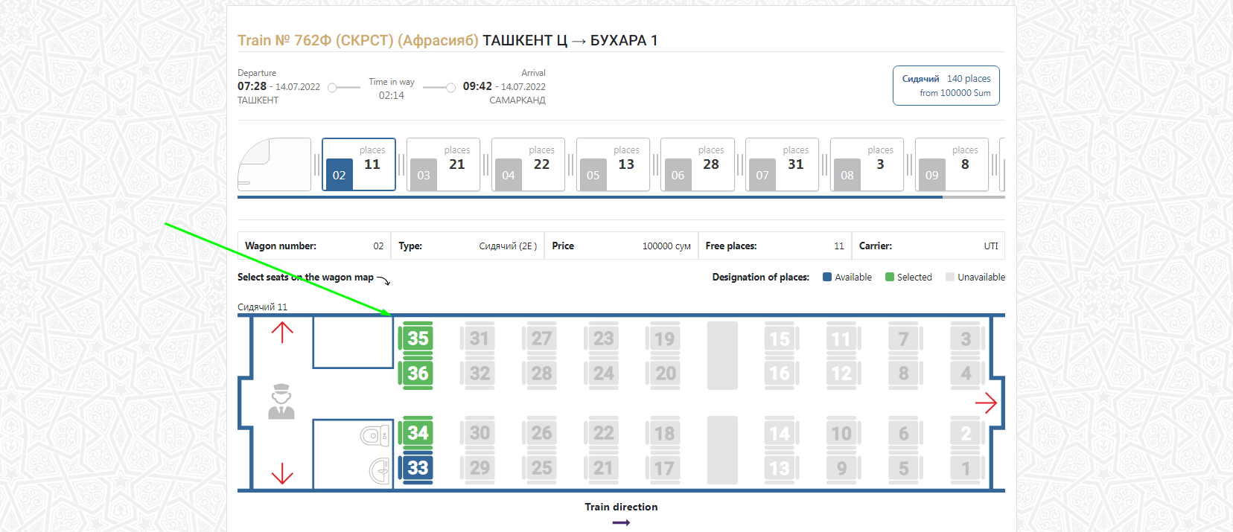

Attention! The passenger's personal data must correspond to the data specified in the identity document. If you issue an electronic ticket to a country where a passport is required, the ticket is issued exclusively for it (for example, Tashkent-Rybachye). If you issue a ticket outside Uzbekistan with children, then in accordance with the established procedure it is necessary to issue a ticket for a child with a child's passport. If you are a non-resident of the Republic of Uzbekistan, the electronic ticket is also issued on the passport with which the passenger intends to travel. If the personal data in the document are indicated in two fonts (Cyrillic and Latin), the information in the order is filled in Latin font. If the personal data in the document are specified only in Russian, the information in the order is filled in Cyrillic. In case of an error in the personal data of passengers or details of documents proving their identity, you need to make an adjustment before the payment of the order.

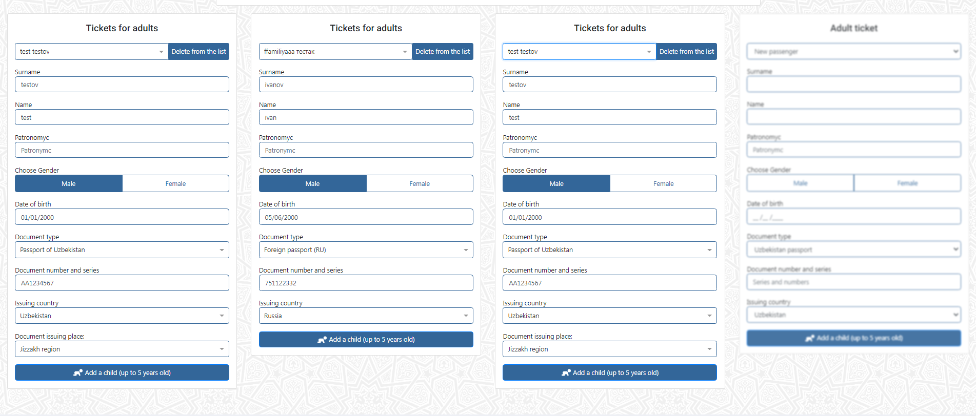
STEP 3-ORDER CONFIRMATION
At this stage, the passenger must check all the data entered. If the input is correct, it is necessary to put a "tick" at the bottom of the screen before the inscription "I agree to the Terms of purchase of electronic tickets" and click "ENTER CARD and PAY".
Attention! On the passage of 3 and 4 steps is given 15 minutes. If the passenger does not have time to make payment during this time, the order is canceled.
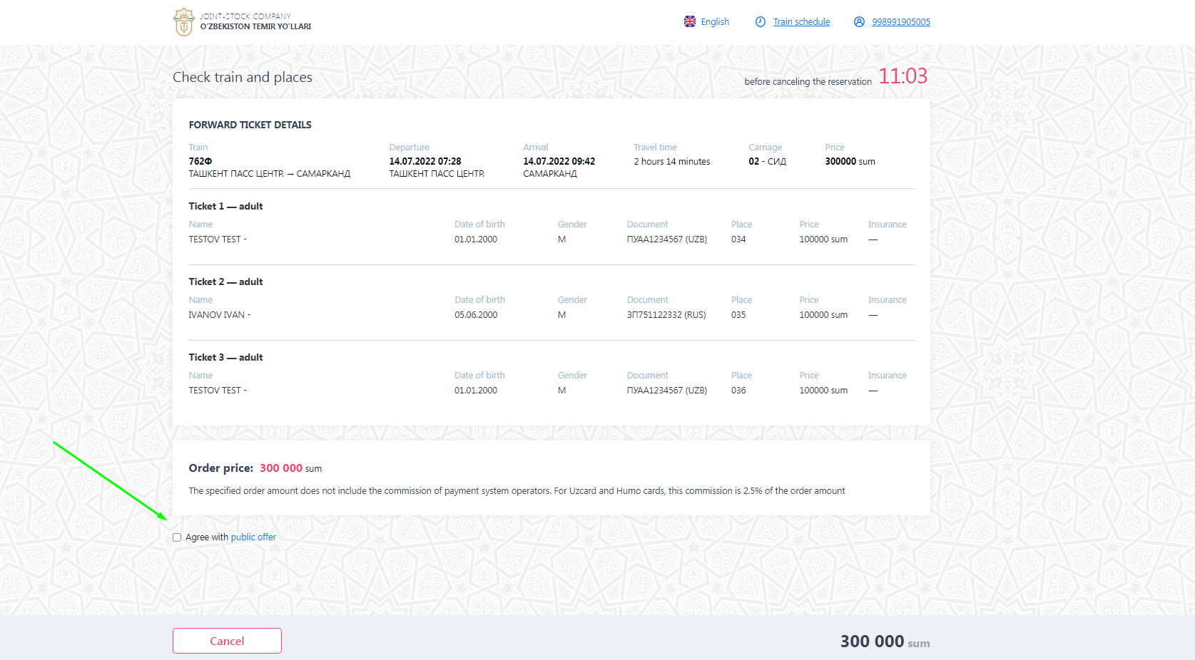

STEP 4-PAYMENT
Then fill in the fields "card Number", "card validity" and click "CONTINUE". Cards of national payment systems as well as Visa/Master/Mir/Google Pay/Apple Pay/Union Pay are accepted for payment

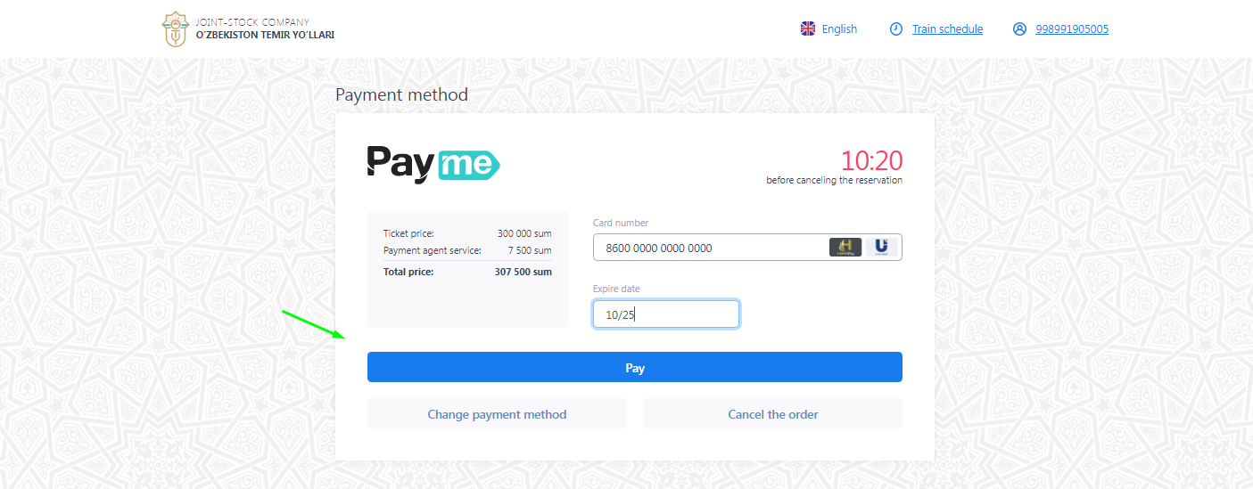
After payment of the electronic ticket on the website the electronic travel document with details of a trip and number of Your electronic ticket (14 digits) is formed.
In your personal account you can print out an e-ticket, cancel or restore the electronic registration for the train, cancel the order, as well as make a refund of the e-ticket. 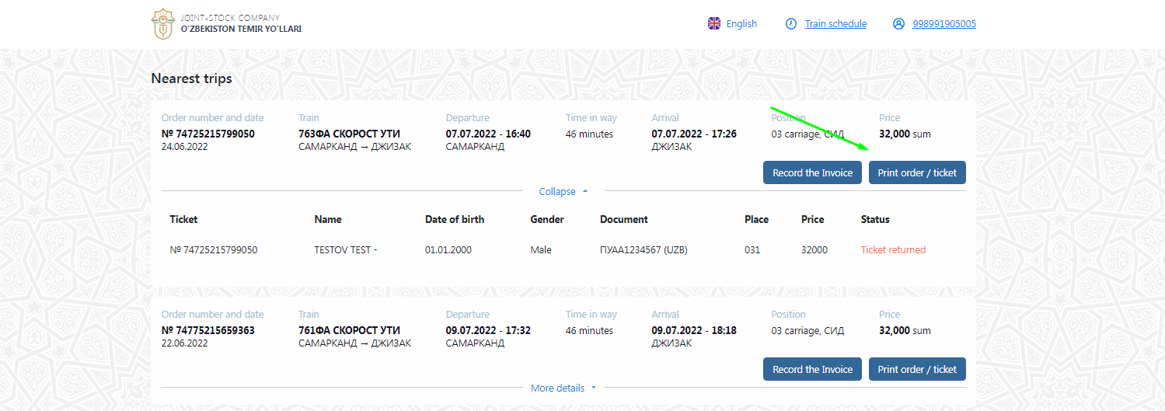
A printout of an electronic ticket for domestic flights is not required. If you have issued an electronic ticket for an interstate flight, then in accordance with interstate agreements, you need to get a ticket at the ticket offices of the railway station — on a strict reporting form, which will need to be presented at the request of inspectors in other states, as well as for business trip reporting.
Attention! This manual is intended only to help with the issuance of electronic tickets. For more information, follow the link. https://chipta.railway.uz/ru/home

How to return e-tickets?
You can return both the entire order and separately any e-ticket from the order. There are two ways to do this:

1) You can make a refund of the ticket online through your personal account and by going to "My new orders"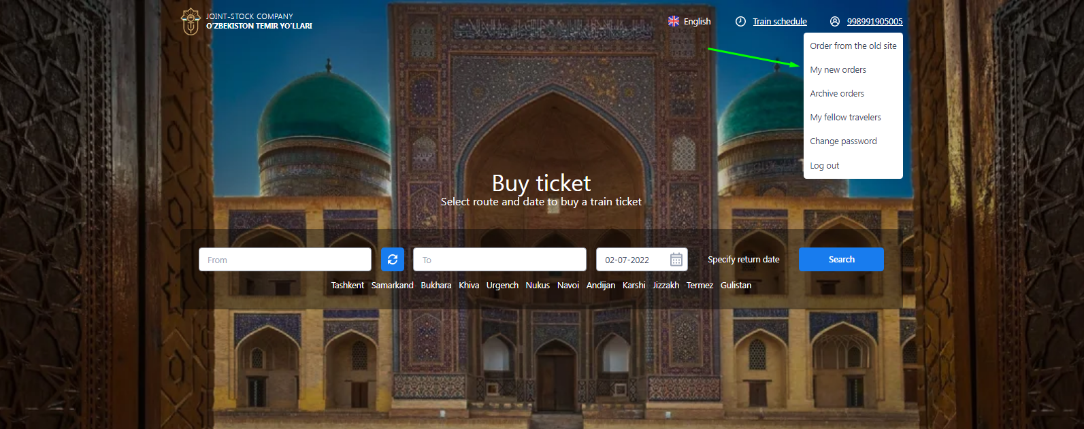
The refund on the website is only available for tickets paid by bank card and purchased on the website as well as in the mobile application.

https://chipta.railway.uz/ru/cabinet/orders To do this, click the "Issue a refund" button at the bottom 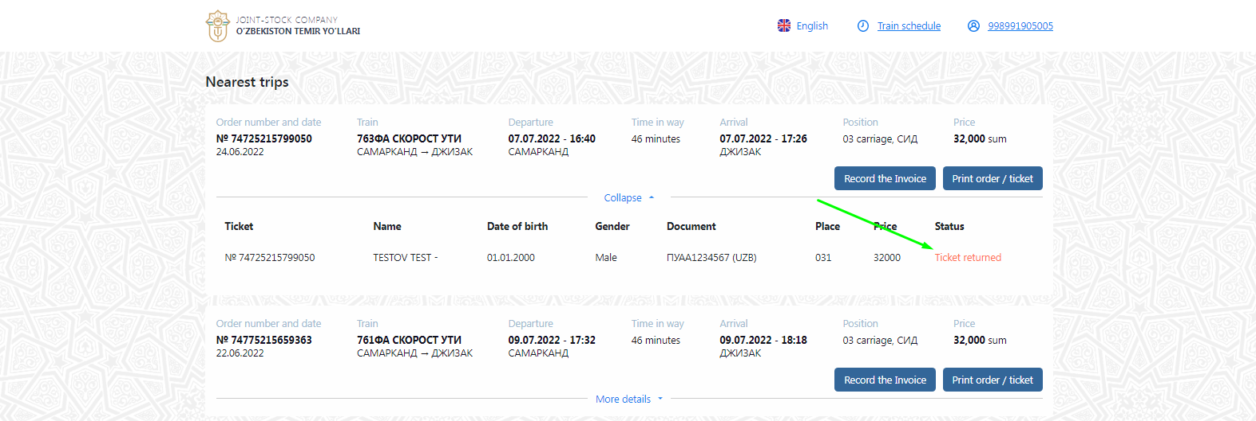

2) You can make a refund of the ticket at the ticket office of the railway station.

• What penalties are there for returning a purchased train ticket?
When submitting an electronic travel document, the passenger is charged a fine for the return of 5,000 soums (for each seat) According to the Rules of transportation of passengers, baggage, cargo baggage by rail of the Republic of Uzbekistan from November 15, 2019:
- when returning unused electronic travel documents to the railway ticket office no later than 24 hours before the departure of the passenger train, the passenger is charged a fine of 5,000 soums for the refund operation;
- if unused electronic travel documents are returned less than 24 hours, but no later than 6 hours before the departure of the train, a fine of 5000 soums is charged for the refund operation + 50% of the cost of the reserved seat;
- if unused electronic travel documents are returned less than 6 hours before departure, but no more than 1 hour after departure of the train, a fine of 5000 soums is charged for the refund operation + 100% of the cost of the reserved seat;
- if the electronic unused travel documents are returned to the railway ticket office later than an hour after the departure of the passenger train, the amount (full cost) of the travel document is not refundable;
You can get the electronic version of the "Rules of transportation of passengers, baggage and cargo by rail of the Republic of Uzbekistan" by following the link on the Internet http://lex.uz/pages/getpage.aspx?lact_id=2001189

